NET511 Cisco Networking Capstone Practical Assignment
Student Name: Lerato Modise
Student Number: 20260925
Module: Networks 511
Institution: CTU Training Solutions
Submission Date: 12/03/2026

Table of Contents
1. Week 1 – OSI Model and TCP

Week 1 – OSI Model and TCP/IP Exploration

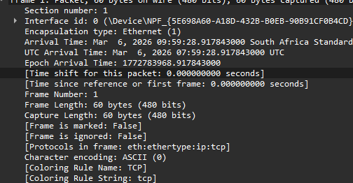

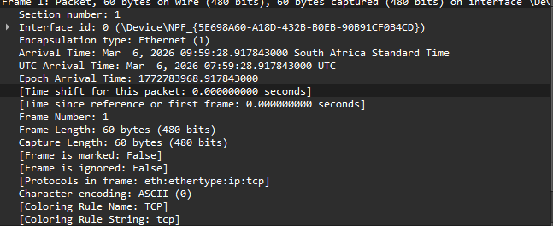

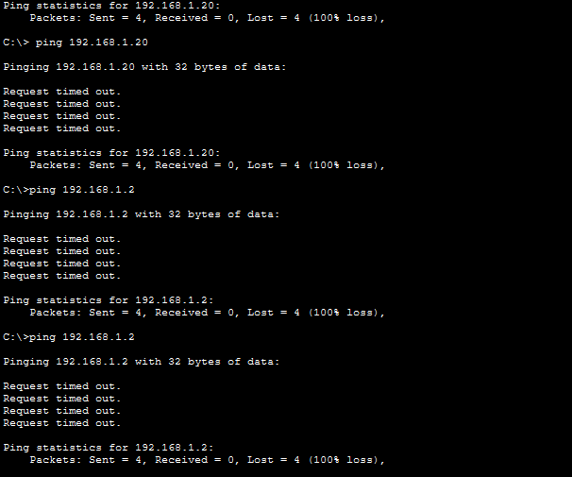

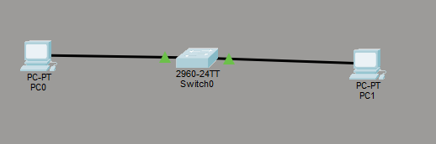

Week 2 – Network Topologies and Connection

