Smart Student Profile Processor
GitHub repository link: https://github.com/SternGeorge17/SmartStudentProfileProcessor

Console Application:
Example 1:
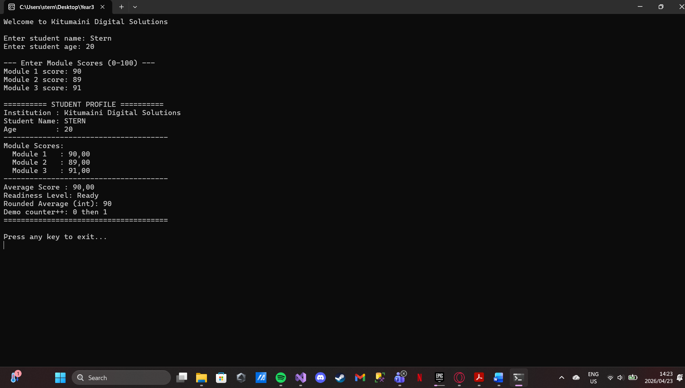
Example 2:
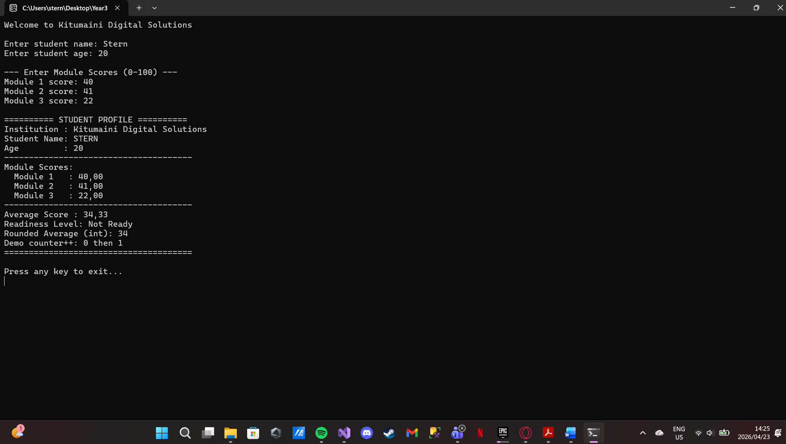

Windows form Application:
Example 1:
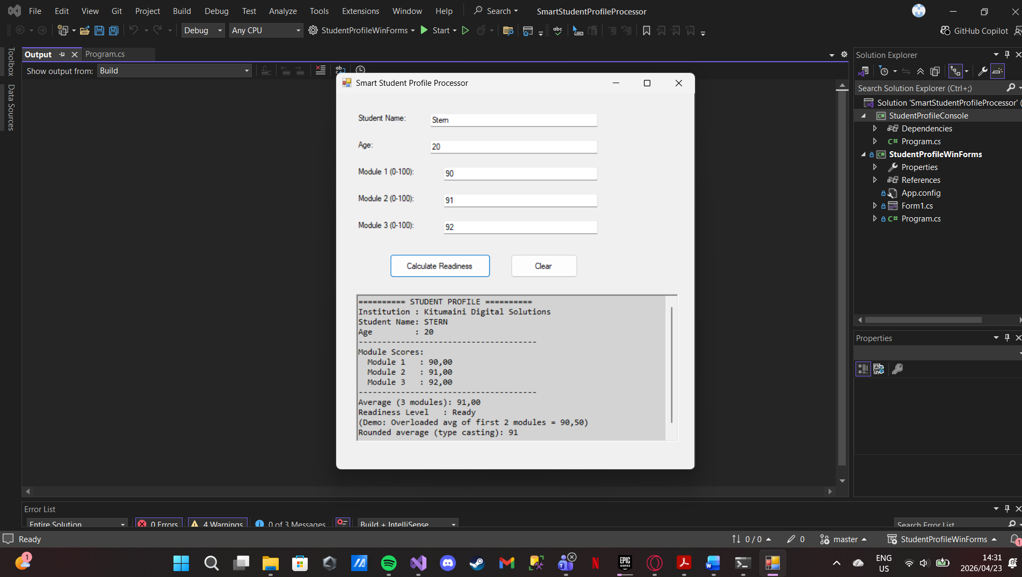
Example 2:
