How To Rebuild CDMS Db Indexes

Table of Contents

Overview 1

Instructions 2

Establish the Threholds 2

Using the Tool 3

# Overview

Periodically, we must rebuild the indexes on CDMS_PROD and PALUUT_PROD. Manually, the process takes 30-45 minutes per database. GC created a script that automates the task. The script requires a little bit of setup, but once that is done, the script runs by itself and rebuilds all the indexes that exceed the threshold, within a few minutes.

Threshold: What are we talking about? According to documentation, typically the DBA should rebuild table indexes when they exceed 20% fragmentation. But what about when the percent fragmentation will not go lower than 50? Several foreign key indexes seem to jump from 0% to 50%, and cannot be reduced below that percentage. We even had the DBA (Coleen) from CRITFIC come over for a visit and offer her insight.

Basically, the DBA manually rebuilds the indexes and determines/identifies just how low we can get the percentage, and make a note of that level. The next time around, rather than trying to get every index to 0% fragmentation, the DBA uses the notes and reduces the fragmentation to that point, whatever it is, and no further. If 50% is the best we can get, then that is what the *threshold* is. This *threshold* varies by database table.

If the threshold increases for some reason, the script will show the error. The DBA than manually reviews the index, and adjusts the *threshold* number as necessary.

# Instructions

## Establish the Threholds

Use the following SQL script located here (C:\gcprograms\IndexRebuilderTool\IndexRebuilderTool\DbScripts\GetListOfTablesAndIndexes.sql) to generate the initial list of tables in the database.

Save the results as a .csv file called TableIndexListCdmsPriv.csv, or TableIndexListPaluut.csv, as applicable.

Remove any lines for odd tables, such as the following, and save the file.



Now save the file as TableIndexListCdmsPrivMasterCopy.csv, or TableIndexListPaluutMasterCopy.csv, as applicable according to the database you are working on.

Close the TableIndexList.csv file; we will work with the …MasterCopy.csv file now.

The first time through, the DBA manually rebuilds each index in the list, for each database, and annotates in a **4th column**,how low the percentage can go. This task is tedious but necessary. The result looks like the following image. Note the far right column.

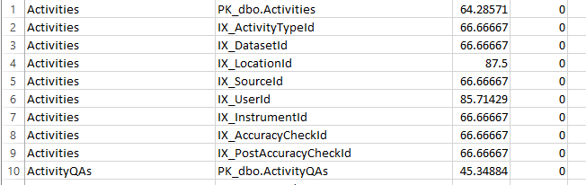

After rebuilding all the indexes and annotating the level, save and close the …MasterCopy.csv file.

**Make a backup copy of the …MasterCopy.csv file.** In the event something isn’t right, and the master copy gets ruined, you will still have your backup copy. Otherwise, you must recreate the …mastercopy.csv.

We are now ready to use an automated tool to build the script file that we will use, Index Rebuilder Tool. The tool is located here: \\gis-data02\GISArchv\Software\gcPrograms\IndexRebuilderTool.

## Using the Tool

Open the Index Rebuilder Tool. This tool **DOES NOT** do the rebuilding itself. However, the tool refers to the TableIndexList.csv and …MasterCopy.csv (for the threshold) files, to generates the script that you will run on the actually database that it is generated for.

The tool appears a shown below.

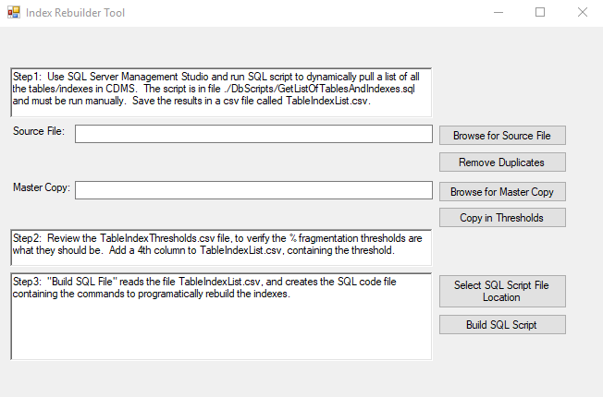

The general idea of the tool is to start at the top and work your way to the bottom.

* Click the *Browse for Source File* button
* Select the applicable TableIndexList file
  + TableIndexListCdmsPriv.csv
  + TableIndexListPaluut.csv
* Click the *Remove Duplicates* button
  + If any table/index entries are listed more than once, this part removes them
* Click the *Browse for Master Copy* button
* Select the applicable …MasterCopy.csv
  + TableIndexListCdmsPrivMasterCopy.csv
  + TableIndexListPaluutMasterCopy.csv
* Click the *Copy in Thresholds* button
  + Copies the thresholds from the 4th column of the …mastercopy.csv into the working copy
* Click the *Select SQL Script File Location*
  + You have a chance to set the name and path of the resulting SQL script to whatever you want
* Click the *Build SQL Script* button
  + The tool now generates the SQL script that you will use on the applicable database it was created for
* Use a text editor and open the resulting SQL Script file
* Open SSMS
* Open a *New Query* tab
* Copy/paste the contents of the SQL Script file into the new query
* Execute the SQL Script
  + Feedback regarding the index rebuild process will show in the Results pane of SSMS, and it appears like the following

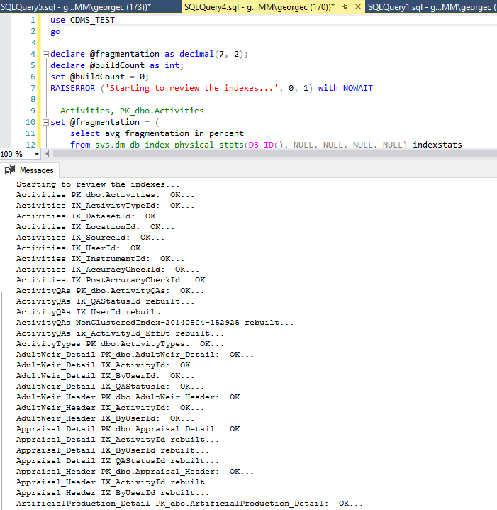

* + Explanation of the results
    - Any row ending with OK… means that the percent fragmentation of the index DID NOT exceed the threshold, so the tool left the index alone; the tool DID NOT rebuild that index
    - Any row ending with rebuilt… indicates the tool rebuilt that index
      * The tool will try 20 times to rebuild the index, and reduce it below the threshold
      * After 20 unsuccessful attempts, the script will mark the row, for the DBA to revisit manually