Data Science and AI for Business –

Class 2 – Data Visualization and Exploratory Data Analysis

Instructions:
Today we will be looking at a data set from King County, WA (Seattle area). This data comes from Kaggle and includes homes sold between May 2014 and May 2015. You can download the data set KingCountyHousing from Brightspace => Data Sets.
Import the data into Orange using the File Widget.
Here is the description of the columns of the data frame:
- id - Unique ID for each home sold
- date - Date of the home sale
- price - Price of each home sold
- bedrooms - Number of bedrooms
- bathrooms - Number of bathrooms, where .5 accounts for a room with a toilet but no shower
- sqft_living - Square footage of the apartments interior living space
- sqft_lot - Square footage of the land space
- floors - Number of floors
- waterfront - A dummy variable for whether the apartment was overlooking the waterfront or not
- view - An index from 0 to 4 of how good the view of the property was
- condition - An index from 1 to 5 on the condition of the apartment,
- grade - An index from 1 to 13, where 1-3 falls short of building construction and design, 7 has an average level of construction and design, and 11-13 have a high quality level of construction and design.
- sqft_above - The square footage of the interior housing space that is above ground level
- sqft_basement - The square footage of the interior housing space that is below ground level
- yr_built - The year the house was initially built
- yr_renovated - The year of the house’s last renovation
- zipcode - What zipcode area the house is in
- lat - Lattitude
- long - Longitude
- sqft_living15 - The square footage of interior housing living space for the nearest 15 neighbors
- sqft_lot15 - The square footage of the land lots of the nearest 15 neighbors

Check each feature to make sure the data types seem correct given their description above. You have four options: Categorical, Numerical, Text, and Date. Specifically think about:
- Id
- Datetime
- View, condition, grade, waterfront. Are these numerics, or are they categoricals?
Connect the File widget to Distributions and also to Data Tables.
We are most interested in Price, so let’s look at that in Distributions. It is quite skewed. Create a transformed version, called logPrice by passing the data through a Formula widget (you can right-click on the line between File and Distributions, choose Insert Widget and then Formula)
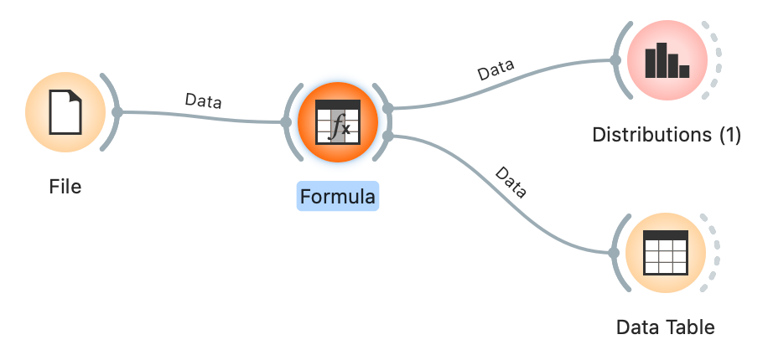

Explore some of the other features. Do you see any interesting outliers? Focus on Bedrooms. There is one large value that looks like an outlier. Using data table – sort by Bedrooms to see that data point. Do you think this is a legit value, or an error that should be removed? If you think it should be removed, adding a Select Rows widget, and use a filter to remove it.

Lets start our analysis. How has the size of lots changed over time? Use the Scatterplot widget to plot yr_built vs. sqft_living.
- There is a lot of overplotting. Play with the Opacity and Symbol Size sliders so you can see the trend better.
- sqft_living also looks like it could use a transformation. Go back to the formula widget and create log_sqft_living. Now return to the scatterplot and put log_sqft_living as the Y-axis. Can you see the trend better? Play with opacity again.
- Click “Show Regression Line”. How would you interpret this regression line?
- Explore other relationships. For instance…how does log_sqft_living relate to log_price?
- You can use the Color option within Scatterplot to explore multi-dimensional relationships. Using one of your existing scatterplots – try coloring by Waterfront to see the impact on price of a Waterfront home.

What about Condition? The data doesn’t tell us if Condition=1 is good or bad. How can we tell from the data? Use Box Plot widget to explore the relationship between Condition and other features like log_price and sqft_living. Do you think Condition=1 or Condition=5 reflects a house in better condition?

Maps
- Because we have a latitude and a longitude, we can make a very crude map of the Seattle area. Make a scatterplot with X=Longitude and Y=Latitidue. You’ll see a very crude outline of the Seattle area. Now color by yr_built and you can see when the different parts of Seattle were built up.
- For better maps, install the Geo Add-on, and

Once again, lets see how well GenAI does. Provide a prompt such as “Perform an exploratory data analysis on this data set, consisting of data from King County sales in 2015. Look for any obvious outliers, or features that need transformation, and report on any interesting relationships between features.” Did it find most of the relationships that you would have expected it to find?

