Class 7 – Neural Networks

We are going to create some data sets to see how well different models do
- Open Paint Data widget
- Change names of Variable X to X1 and Variable U to X2 (just to indicate these are both features.
- Create data by “painting” : create two data sets that are mostly separated but overlap a little bit: (something like this)
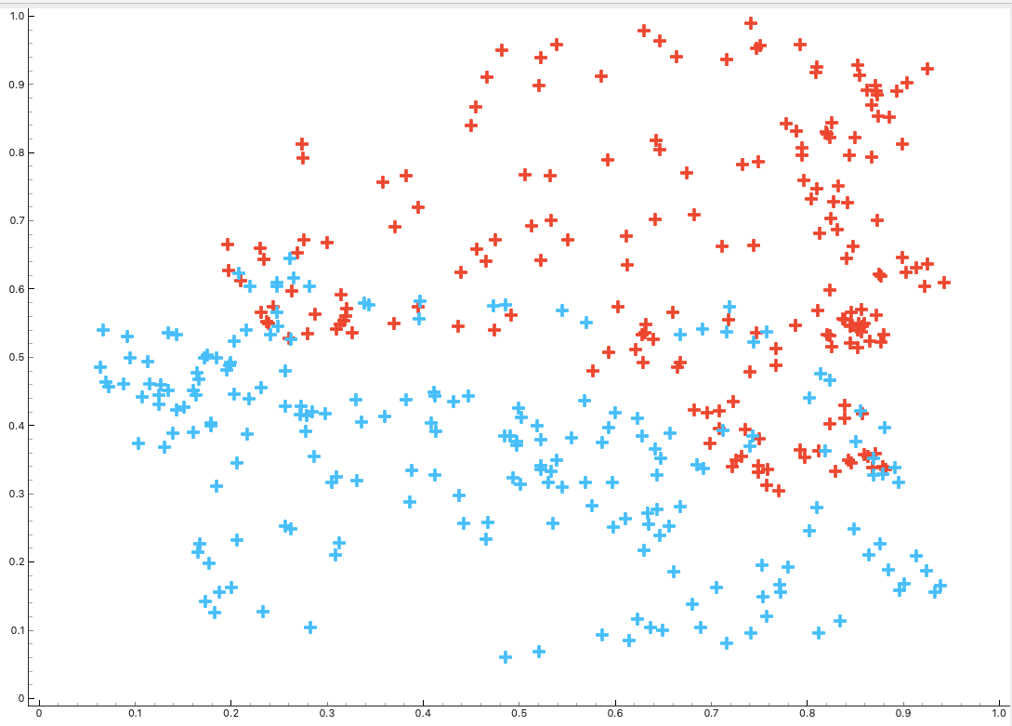
- Now connect to Test and Score (5-fold CV), and back-connect Test and Score to Logistic Regression and SVM (kernel=RBF, otherwise, use defaults). Which performs best? Maybe try playing with the options to see if you can maximize your AUC.
- Now hit Clear on Paint Data and create another data set with X1 making a circle, and X2 an X through it: SVM now does much better – Logistic Regression cannot handle the non-linearity well.
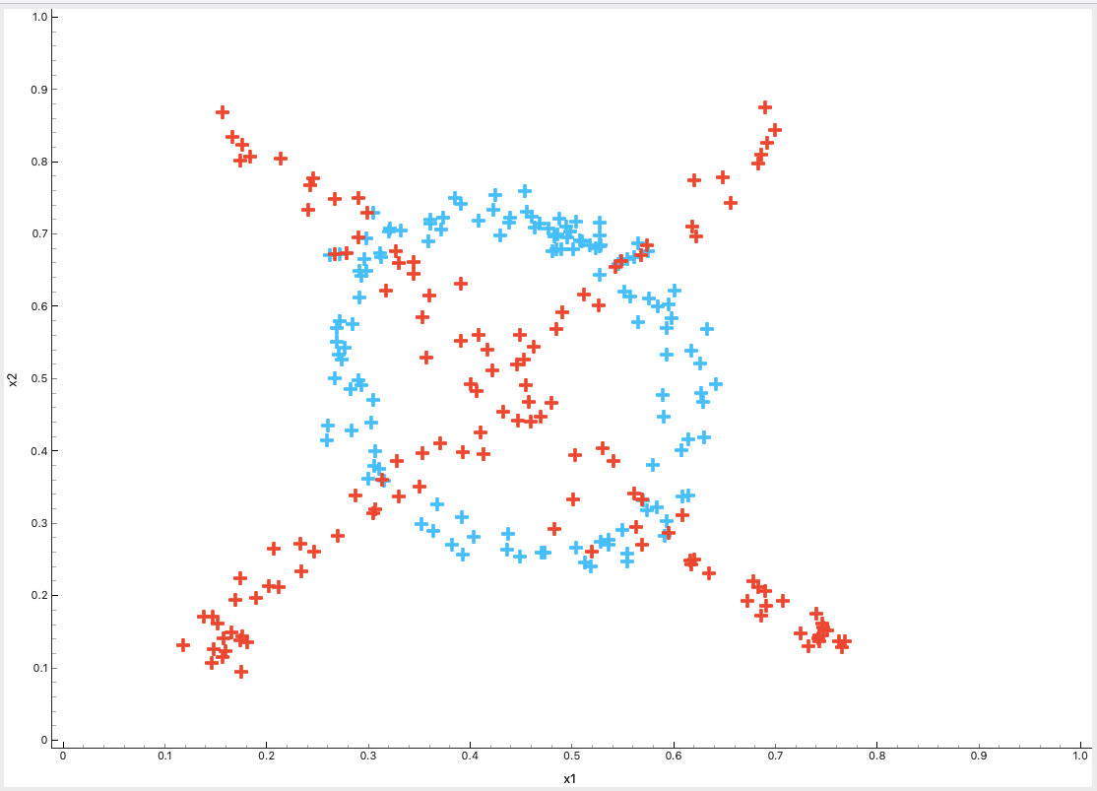

- Now connect Test and Score to Scatterplot(X=x1; y=x2; Color= Logistic Regression and Shape = Class). This is now colored by the prediction of logistic regression. You can see that it is trying to fit a linear separator and causing a lot of misclassifications. Now change Color to SVM, and you can see it only misclassifies at the intersections of the shapes, where you would expect some confusion.

- Add a Neural Network model (5 Hidden Layers, Activation=Logistic, Solver =L-BFGS-B). How well does it do? Now bump the hidden layers up to 20. Hit Apply. Neural nets are excellent in fitting challenging, non-linear curves!
- Now you can play with all of your parameters to find the best model.
=======================
- Now in a different thread, download and input the Telco-churn data. Compare Logistic Regression and Neural Net performance by setting up the tableau below. (this will take a while to run once you connect Explain Model but be patient – it will run!). Explain Model uses a “SHAP Value plot to show the relationship between the features and the target, and give feature importance. More about SHAP here. 