Orange Exercise – Class 9 – Similarities
Financial Analysis – Pharmaceutical Companies
Copy data set from this link. The data consists of a small set of 21 Pharmaceutical firms. We are interested in seeing which firms have similar financial metrics, and if those metrics align with analyst grades of their stocks.
Take a look at Distributions, the data seems well-behaved
Now connect to k-Means (Normalize columns, Clusters=5)
Connect to two different Data Tables
On the first one, sort by Cluster and highlight one of them, then sort by another column to see which values of the column correspond to a given cluster

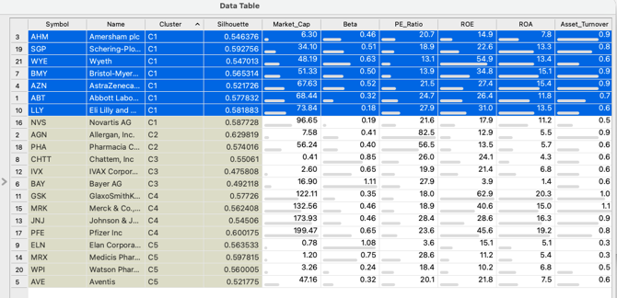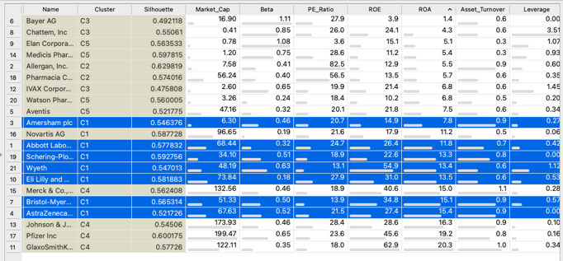

For the second Data Table, connect Centroids to Data on the connector between the widgets:
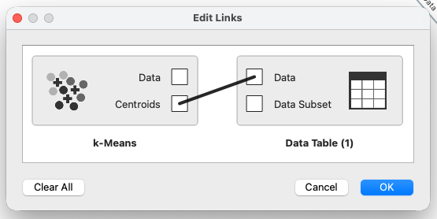
Then you can see the actual values of the feature means, and you can see what values define the cluster. For instance, here I can see that Cluster C3 scores high on Beta and Leverage.
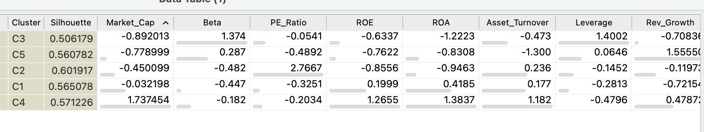Connect k-Means to Scatter Plot, and color by cluster. Inspect – for instance – Market Cap (X) with ROA (Y). Finally compare Cluster (X) with Median_Recommendation (Y). Remember median recommendation was not used in the clustering, so here we get to see how the different clusters that we found impact the recommendation given to the pharmaceutical companies.
Now lets do Hierarchical Clustering. Connect File => Distances (Compare Rows, Euclidean(Normalized)) => Hierarchical Clustering (annotation = Name). Look at the dendrogram to see the clusters. Its interactive too! Click on Height Ratio, and move the line in order to move the “cut point” to identify different numbers of clusters.

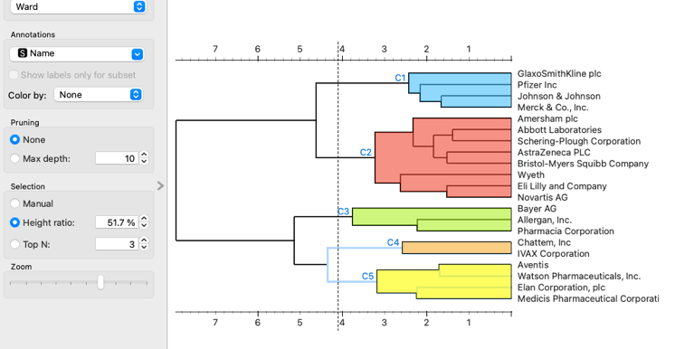

Class Preference Data:
Now lets learn about you guys!! Here is the data for you to download and input into Orange.
This is the data from ALL of my sections this year. So First do the following:
Select Rows to filter Section to include only your class.
Select Columns to identify either Caffeine OR Extroversion as Target. (Ignore the other one for now)
Now, this is your data, so have fun with it!
Start by looking at Distributions so you can see the overall answers to the questions across all questions. Look at Feature Statistics : what are the 3 most popular and 3 least popular items in your class?
Similarity Between Classmates: Now connect to Distances (Compare Rows and Distance Metric = Manhattan) and then to Distance Matrix (Labels = Name). These are distances between you and your classmates! Who are you most and least similar to? (remember that these are distances so low values = similarity!)
A fun way to view this data is by connecting Distances to Distance Map (use one of the divergent color schemes). Can you figure out who the two most similar people in the class are?
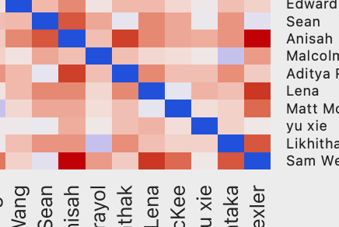

Hierarchical Clustering: Connect Distances to Hierarchical Clustering. Find 8 clusters, are you with your project teammates?? Can you now find the two most similar students? Note how different the results from different linkages are.

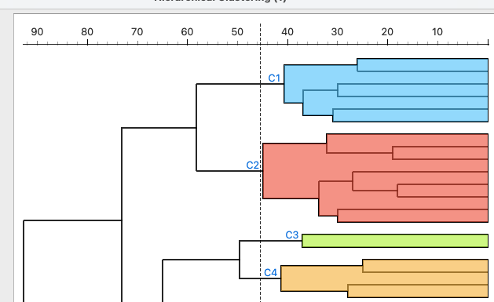

Connect the Hierarchical cluster to Box Plot (subgroup=Cluster) and see how the different clusters distinguish themselves:
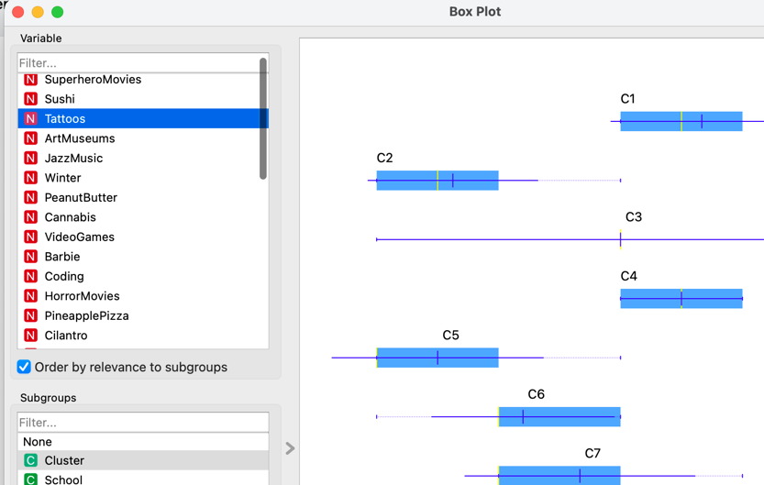

Finally, lets see if we can predict Extroversion (remember, it was not used as part of the clustering). Connect Select Rows => Test and Score and then back-connect to kNN. The RMSE is not too good (RMSE around 22). You can see how bad this model is by connecting Test and Score to Scatter Plot, and plotting X=Extroversion vs. Y=kNN. Almost no relationship between our prediction and truth!!

More fun!
- Use a Distance Widget with distance on the columns to see correlations between the items.
- See what separates the students from different schools
