HW0 – Intro to Orange

In this class, you will have hands on experience with real-world data and we will cover several ways of exploring and analyzing data sets without the need to code, including generative AI tools and UI-driven no-code tools. One of those options is a tool called Orange. Orange is a user-friendly drag-and-drop tool that makes basic data science and machine learning tasks easy for those who do not want to learn coding.
This introductory task – to be completed before the first day of class – is simply to make sure that you can download and use the Orange tool. We will cover using the tool itself during the first class.
If you have any troubles installing or starting with Orange, or with anything below, please email me right away!

- Go to https://orangedatamining.com/download and download the appropriate version of Orange for your laptop.
- Install the software and verify that it installed correctly
- Open the software, you should see the main window (with a bunch of icons on the left). Click File=>New to start a new project.
- Click the “File” button on the left. A “File” icon should appear in the main window. (This is what it looks like on my Mac):

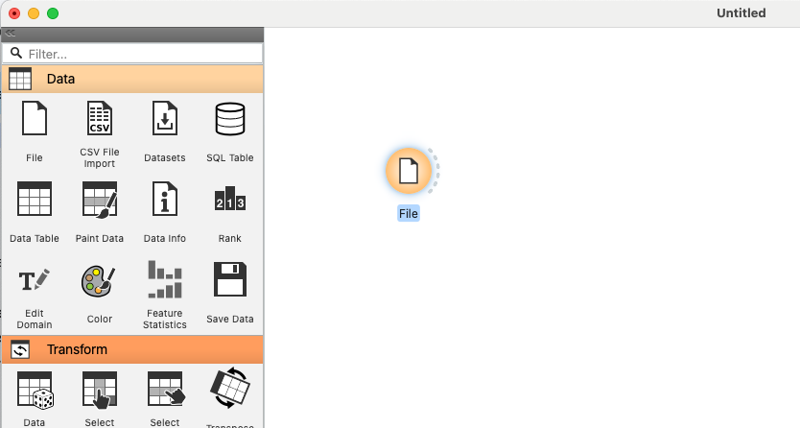

- Double click on the icon to open a dialog window. Under File, there should be several pre-populated datasets in a drop-down menu. Select one that interests you (the heart disease one is interesting).
- Now click on Data Table, and a data table icon should appear next to File. Connect File to Data Table by drawing a line with the mouse between the two icons. It should look like this:

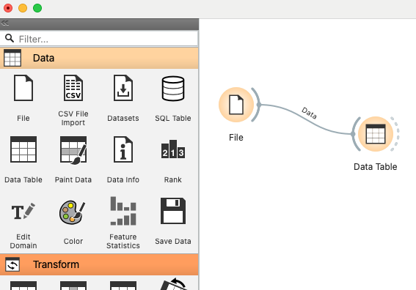
- Now click on Data Table, and you should see your data. The rows are observations and the columns are features. You can explore the data here in the data table and learn about it by sorting the columns (e.g. what is the highest cholesterol value?)
That’s it (for now)! You will learn how to explore and model the data by building the graphical workflow from the components on the left. Feel free to play around with the tool, perhaps starting with some data visualizations like histograms or boxplots.
I encourage you to watch a few of the Orange “getting started” videos.

