HW3 Rubric – DS4B Managerial

HW 3 Rubric – 2 points for each problem done perfect, 1 point for not perfect, 0 for poor effort or simply wrong. They might get different answers than below due to different optimizations of parameters, etc. I don’t expect you to re-run everyone’s analysis, just try and see if it seems plausible and if you can find obvious error. You should error on the side of giving credit…especially if you cannot verify why something is wrong. Ask me if you want to discuss anything.
Total Points : 16

#1: I got best depth = 5 but they might get something different due to randomness.
#2: they should report their 3 top features and come up with a hypothesis. The best answers will actually look at the tree to see the relationship, but full credit here just requires them to think and comment on each of the three.
#3: For me, AUC for C=1 and 100 were the same, and C=0.01 was worse. I would choose C=1 because performance is the same and it is stronger regularlization, as noted in the problem. They should get something similar.
#4: With C=1 about half of the coefficients are reduced to zero. If they selected a different C in problem #3 they will get a different answer (higher C = less regularization = less zero coefficients) Full credit if consistent. They should also report on Neural net AUC.
#5 For me the best model is the Logistic with a lift around 2.8. (I expect them to get similar, but they might have a different result). They should have a descriptive sentence similar to: This means that when I market to 10% of my customer base, the best model (Logistic Regresssion) performs 2.8x better than than a model that randomly selects a label.
#6: #9 Here we might see different answers, depending on the perspective they used. If you calculate the average revenue per customer it is around $777 (might be different due to randomness). The cost of the marketing is $2000. So, this is what I expect:
Cost / Benefit is
 | Truth = Churn | Truth= NoChurn
Predict = T | $577.6 (or close to it - annual value of customer) | -$200
Predict = F | 0 | 0

I will also accept:
Cost / Benefit:
 | Truth = Churn | Truth= NoChurn
Predict = T | $577.6 (or close to it - annual value of customer) | 577.77
Predict = F | 0 | 777.57

Which is the matrix from the perspective of the corporation.

#7. This was a little confusing to some because the orientation of the confusion matrix that comes out of Orange is different than above – the Truth is on the rows and the Predict is on the columns. They would have to have made sure that the matrices line up. You might need to check their work if they provided it.
So for instance, my tree model had this confusion matrix:
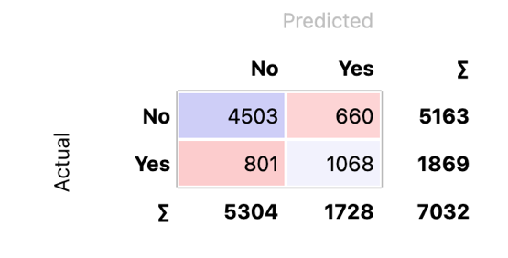
And so the profit was 1068*577 – 200*660 = $484k
Tree: $484k
NN: $448k
Logistic: $479k
So the Tree model is best. This may be hard to check if they did it right, so just do your best and use your judgement.

#8 From the confusion matrix above, I see that n=7032. There are overall 1869/7032 = 26.6% of the population that are actually churners. If I label 1728 cases as churn, then that means 26.6 (or 459) of them will – at random – be churners, and 1269 will not be. The profit for that random model is 459*577 – 200*1269= $11k. In other words, my model saved the company $484k - $11k = $473k as compared to a random model.

