HW3 - Predicting MegaTelCo Churn
After discussing the churn problem at TelCo with Nadia for a while (remember her?), you've finally defined an adequate target variable for churn and gathered relevant data to predict it. Moreover, the marketing department has come up with an amazing retention offer: the offer is guaranteed to convince customers to extend their contract for an extra year after receiving it. Unfortunately, the offer is quite expensive; it costs $200.
It is your job to use data from previous contract expirations to build a churn predictive model and make a recommendation of whom to target with the offers. You have assembled the best historical data set you can at this point, which includes:

Gender: Whether the customer is a male or a female
SeniorCitizen: Whether the customer is a senior citizen or not (1, 0)
Partner: Whether the customer has a partner or not (Yes, No)
Dependents: Whether the customer has dependents or not (Yes, No)
Tenure: Number of months the customer has stayed with the company
PhoneService: Whether the customer has a phone service or not (Yes, No)
MultipleLines: Whether the customer has multiple lines or not (Yes, No, No phone service)
InternetService: Customer’s internet service provider (DSL, Fiber optic, No)
OnlineSecurity: Whether the customer has online security or not (Yes, No, No internet service)
OnlineBackup: Whether the customer has online backup or not (Yes, No, No internet service)
DeviceProtection: Whether the customer has device protection or not (Yes, No, No internet service)
TechSupport: Whether the customer has tech support or not (Yes, No, No internet service)
StreamingTV: Whether the customer has streaming TV or not (Yes, No, No internet service)
StreamingMovies: Whether the customer has streaming movies or not (Yes, No, No internet service)
Contract: The contract term of the customer (Month-to-month, One year, Two year)
PaperlessBilling: Whether the customer has paperless billing or not (Yes, No)
PaymentMethod: The customer’s payment method (Electronic check, Mailed check, Bank transfer (automatic), Credit card (automatic))
MonthlyCharges: The amount charged to the customer monthly
Churn: Target: Whether the customer churned or not shortly after contract expiration (Yes or No)
Load the Data and make sure that all features are correctly labelled given the above descriptions, and make sure Churn is listed as the target.
*Of course*, normally we would do some detailed exploratory work! But we have high confidence in the data quality and there are no missing values, so let’s proceed.
1. Build the best model using you can on the TRAINING set using Decision Tree. Use 5-fold Cross-Validation and Stratify across the folds. Use the following options for the Tree parameters and choose the one with the best AUC:
Set Min number of instances in leaves= 20
Do not split subsets smaller than = 50
Maximal Tree Depth = Try all values between 2 and 10 to find the one that scores best on AUC. What is the best depth of tree to use?
I got best depth = 5, but you may get different based on randomness
2. Calculate the feature importances from the tree. For the top 3 most important features, explain how you think they might correlate with churn.
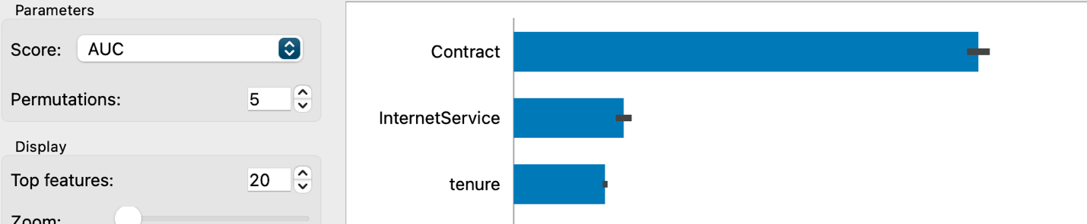

This answer could be using your intuition, or actually looking at the tree. For Contract, the month-to-month contracts result in much more churn (first split of the tree) . for Internet Service, those with Fiber optic had a higher churn rate (not sure why!) – I actually would have expected bundling other services to be less churn. Higher Tenure definitely would result in less churn.
3 . Now fit Logistic Regression using Lasso regularization. Test the following values of the shrinkage hyperparameter C=[0.01,1,100], and report on which value of C results in the highest AUC. (if there is a tie, choose the one with the strongest regularization).
My AUC 0.843 for C=1 and C=100, I would choose C=1 because it is stronger regularlization. C=0.01 is definitely worse.

4. Connect Logistic Regression to Data Table. How many of the Lasso coefficients have shrunk all the way to zero? What does this mean? Also fit a Neural Network with default parameters (optimize if you want but not required) and see how well it does (AUC).
With C=1 about half of the coefficients are reduced to zero. Neural net for me has a lower AUC.
5. Connect Test and Score to Performance Curve, click Lift Curve, and Target = Yes. Assume you can send a retention offer to 10% of your test set. Move the threshold line and see which curve has the highest lift at that spot. Which model is best and what is the lift? Write a sentence interpreting what the lift means.
For me it is the Logistic with a lift around 2.8. This means that when I market to 10% of my customer base, the best model (Logistic Regresssion) performs 2.8x better than than a model that randomly selects a label.
6. What is the cost / benefit matrix for implementing this model? HINT: The cost is given in the problem description. Remember that everyone who receives the offer takes it. The benefit comes when we make the offer to a customer whose actual Churn value is 1. (i.e. they would have left us but we saved them). We can assume each customer generates the same revenue - equal to the average of MonthlyCharges. Report the benefit as a YEARLY value.
Cost / Benefit is
 | Truth = Churn | Truth= NoChurn
Predict = T | $577.6 (or close to it - annual value of customer) | -$200
Predict = F | 0 | 0

I will also accept:
 | Truth = Churn | Truth= NoChurn
Predict = T | $577.6 (or close to it - annual value of customer) | 577.77
Predict = F | 0 | 777.57

Which is the money made by the corporation.
7. Connect Test and Score to Confusion Matrix. Using the cost/benefit matrix above, calculate profit for the three different models. Which is best?
This may have been a little confusing to some because the orientation of the confusion matrix that comes out of Orange is different than above – the Truth is on the rows and the Predict is on the columns. So for instance, my tree model had this confusion matrix:
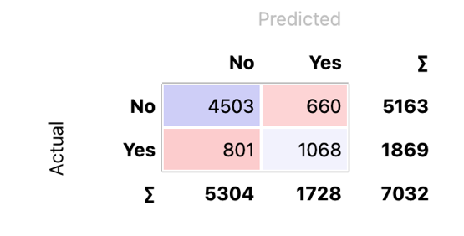
And so the profit was 1068*577 – 200*660 = $484k
Tree: $484k
NN: $448k
Logistic: $479k
So the Tree model is best.
8. Now it is performance review season, and you are looking for a raise!! Estimate the amount of money you made for the company by using your model. Look at the Confusion Matrix for the model with the best profit. Now, calculate the profit that you would have gotten from a “dumb” model. Assume the same size of the test set overall, and assume you predict the same number of churners, and assume the same overall percentage of churn. If you were to choose the churners at random, what would the Confusion Matrix be? Calculate the profit, and report on the amount of money the company will make by using your model, vs selecting people at random
From the confusion matrix above, I see that n=7032. There are overall 1869/7032 = 26.6% of the population that are actually churners. If I label 1728 cases as churn, then that means 26.6 (or 459) of them will – at random – be churners, and 1269 will not be. The profit for that random model is 459*577 – 200*1269= $11k. In other words, my model saved the company $484k - $11k = $473k as compared to a random model.

