Содержание
1 Постановка задачи 3
Приложение А 4
Приложение Б 8

Постановка задачи
Программа состоит из двух частей: первая часть зашифровывает текст, вторая – расшифровывает.

Примечания:
- шифровка происходит следующим образом: текст, записанный в строку, помещается в матрицу по спирали, начиная с центра, а после считывается слева на право начиная с первой строки;
- расшифровка происходит следующим образом текст, записанный в строку, помещается в матрицу слева на право, начиная с первой строки, а после считывается по спирали, начиная с центра;
- текст для шифровки/расшифровки берется из текстового файла Text.txt;
- указания для шифровки/расшифровки берутся из текстового файла Encryption.txt;
- каждое указание состоит из двух частей: способа шифровки/расшифровки и количества повторений;
- способ шифровки /расшифровки – строка из 2 символов, указывающие направление спирали. Первый символ обозначает сторону света для первого «шага», второй символ – вращение по или против часовой. Первый символ обязательно должен быть 1-им из 4-ех значений: S(South), N(North), E(East), W(West). Второй символ обязательно должен быть 1-им из 2-ух значений: F (по часовой), B (против часовой);
- количество повторений – целое число, указывающие количество повторений определенного направления;
- программа выводит на экран зашифрованный/расшифрованный текст.

Приложение А
(обязательное)
Исходный код программы
Часть №1 – Зашифровка текста
Program Encoding;
//program encrypts text from text file 'Text',
//by method described in file 'Encryption'

{$APPTYPE CONSOLE}

Uses
SysUtils;

Var
Ciphertext : array of string [255];

//Ciphertext - Ciphertext

i, j, n, step, y, x, LineElNum, lgth : Integer;

//n - num of repetition
//step - step for matrix traversal
//y, x - coordinates
//LineElNum - Line Element Number
//lgth - length of distance traveled

Side, Route : Char;

//Side - Side of world
//Route - direction of rotation

CurS, Course, CurText : String ;

//CurS - Current String
//Course - encoding Course
//CurText - Current Text

CurFile : Text;

//CurFile - Current File

FirstChangeSign, SecondChangeSign: procedure (var i: Integer);

//FirstChangeSign,SecondChangeSign-variables to Change Sign

FirstMove, SecondMove : procedure (var i, j: Integer);

//FirstMove, SecondMove - variables to matrix motion

(*Procedure for moves to side*)
Procedure Sideways (var x, y: Integer);
begin
//pointer moves to side
x := x + step
end;

(*Procedure for moves rectilinearly*)
Procedure Rectilinearly (var x, y: Integer);
begin
//pointer moves rectilinearly
y := y + step
end;

(*Procedure for Change sign of step*)
Procedure Change (var step: Integer);
begin
//Change sign of step
step := step * (-1)
end;

(*Procedure for Keep sign of step*)
Procedure Keep (var step: Integer);
begin
end;

Begin
//program assign with a text file with the text to read it //and reads it
Assign (CurFile, 'D:\Вадик\Разминочка\2\2\Text.txt');
Reset (CurFile);
while not Eof(CurFile) do
begin

//text reads to variable CurText
Readln (CurFile, Curs);
CurText := Concat(CurText, curs)
end;
Close (CurFile);

//if root of num of characters in string is integer,
//then space for array size of this root is allocated
if Frac (Sqrt(Length(CurText))) < 0.000000001 then
SetLength (Ciphertext, trunc(Sqrt(Length(CurText))))

//else space is allocated for 1 greater than root
else
SetLength(Ciphertext,trunc(Sqrt(Length(CurText))) + 1);

//if root is odd, it increases it by one
if not Odd ( Length (Ciphertext)) then
SetLength (Ciphertext, Length (Ciphertext) + 1);

//if extra space was allocated - aligns the string with //spaces
if Length(CurText) <> Sqr (Length (Ciphertext)) then
for i:=1 to Sqr(Length (Ciphertext))-Length(CurText) do
CurText := CurText + ' ';

//program assign with a text file with the encryption to read it and reads it
Assign(CurFile,'D:\Вадик\Разминочка\2\2\Encryption.txt');
Reset (CurFile);

//until the entire file is encoded, program will encode it
while not Eof(CurFile) do
begin

//read data from file
Readln (CurFile, Course);
Readln (CurFile, n);

//initializing
Side := Course[1];
Route := Course[2];

//cycle to retry the encoding
while n >0 do
begin

//initializing
if (Side = 'S') or (Side = 'E') then
step := 1
else
step := -1;
LineElNum := 1;
y := Length (Ciphertext) div 2 ;
x := y + 1;
FirstMove := Sideways;
SecondMove := Sideways;

//if side is south or north - FirstMove is Rectilinearly
if (Side = 'S') or (Side = 'N') then
FirstMove := Rectilinearly

//else - SecondMove is Rectilinearly
else
SecondMove := Rectilinearly;

//initializing data
FirstChangeSign := Keep;
SecondChangeSign := Keep;

//if movement is to east or west and forward or to north or //south and back -
//second change of sign changes it
if((Side = 'E') or (Side = 'W')) and (Route = 'F') or
((Side = 'S')or (Side = 'N')) and (Route ='B') then
SecondChangeSign := Change

//else first change of sign changes it
else
FirstChangeSign := Change;

//initializing
lgth := 1;

//while lgth less then length of Ciphertext - encrypt text
while lgth < Length(Ciphertext) do
begin

//cycle for first move
for i := 1 to lgth do
begin
Ciphertext [y,x] := CurText [LineElNum];
FirstMove(x, y);
inc(LineElNum)
end;

//change sign step
FirstChangeSign(step);

//cycle for second move
for j := 1 to lgth do
begin
Ciphertext [y,x] := CurText [LineElNum];
SecondMove (x,y);
inc (LineElNum)
end;

//change sign step
SecondChangeSign (step);
lgth := lgth + 1
end;

//after all movements you need to walk one more time
for i := 1 to lgth do
begin
Ciphertext [y,x] := CurText [LineElNum];
FirstMove(x, y);
inc(LineElNum)
end;

//initializing for next loop
CurText:='';
for i:=0 to Length (Ciphertext) - 1 do
for j:=1 to Length (Ciphertext) do
CurText := Concat (CurText, Ciphertext[i,j]);
n:= n -1;
end;
end;
Close (CurFile);

//data output
for i := 0 to Length (Ciphertext) - 1 do
for j := 1 to Length (Ciphertext) do
Write (Ciphertext[i,j]);
Readln
end.

Часть №2 – Расшифровка текста
Program Decoding;
//program encrypts text from text file 'Text',
//by method described in file 'Encryption'

{$APPTYPE CONSOLE}

Uses
SysUtils;

Var
Ciphertext : array of string [255];

//Ciphertext - Ciphertext

i, j, n, step, y, x, LineElNum, lgth : Integer;

//n - num of repetition
//step - step for matrix traversal
//y, x - coordinates
//LineElNum - Line Element Number
//lgth - length of distance traveled

Side, Route : Char;

//Side - Side of world
//Route - direction of rotation

CurS, Course, CurText : String ;

//CurS - Current String
//Course - encoding Course
//CurText - Current Text

CurFile : Text;

//CurFile - Current File

FirstChangeSign, SecondChangeSign: procedure (var i: Integer);

//FirstChangeSign,SecondChangeSign-variables to Change Sign

FirstMove, SecondMove : procedure (var i, j: Integer);

//FirstMove, SecondMove - variables to matrix motion

(*Procedure for moves to side*)
Procedure Sideways (var x, y: Integer);
begin
//pointer moves to side
x := x + step
end;

(*Procedure for moves rectilinearly*)
Procedure Rectilinearly (var x, y: Integer);
begin
//pointer moves rectilinearly
y := y + step
end;

(*Procedure for Change sign of step*)
Procedure Change (var step: Integer);
begin
//Change sign of step
step := step * (-1)
end;

(*Procedure for Keep sign of step*)
Procedure Keep (var step: Integer);
begin
end;

Begin
//program assign with a text file with the text to read it //and reads it
Assign (CurFile, 'D:\Вадик\Разминочка\2\2\Text.txt');
Reset (CurFile);
while not Eof(CurFile) do
begin

//text reads to variable CurText
Readln (CurFile, Curs);
CurText := Concat(CurText, curs)
end;
Close (CurFile);

//if root of num of characters in string is integer,
//then space for array size of this root is allocated
if Frac (Sqrt(Length(CurText))) < 0.000000001 then
SetLength (Ciphertext, trunc(Sqrt(Length(CurText))))

//else space is allocated for 1 greater than root
else
SetLength(Ciphertext,trunc(Sqrt(Length(CurText))) + 1);

//if root is odd, it increases it by one
if not Odd ( Length (Ciphertext)) then
SetLength (Ciphertext, Length (Ciphertext) + 1);

//if extra space was allocated - aligns the string with //spaces
if Length(CurText) <> Sqr (Length (Ciphertext)) then
for i:=1 to Sqr(Length (Ciphertext))-Length(CurText) do
CurText := CurText + ' ';

//program assign with a text file with the encryption to read it and reads it
Assign(CurFile,'D:\Вадик\Разминочка\2\2\Encryption.txt');
Reset (CurFile);

//until the entire file is encoded, program will encode it
while not Eof(CurFile) do
begin

//read data from file
Readln (CurFile, Course);
Readln (CurFile, n);

//initializing
Side := Course[1];
Route := Course[2];

//cycle to retry the encoding
while n >0 do
begin

//initializing
if (Side = 'S') or (Side = 'E') then
step := 1
else
step := -1;
LineElNum := 1;
y := Length (Ciphertext) div 2 ;
x := y + 1;
FirstMove := Sideways;
SecondMove := Sideways;

//if side is south or north - FirstMove is Rectilinearly
if (Side = 'S') or (Side = 'N') then
FirstMove := Rectilinearly

//else - SecondMove is Rectilinearly
else
SecondMove := Rectilinearly;

//initializing data
FirstChangeSign := Keep;
SecondChangeSign := Keep;

//if movement is to east or west and forward or to north or //south and back -
//second change of sign changes it
if((Side = 'E') or (Side = 'W')) and (Route = 'F') or
((Side = 'S')or (Side = 'N')) and (Route ='B') then
SecondChangeSign := Change

//else first change of sign changes it
else
FirstChangeSign := Change;

//initializing
for i:=0 to Length (ciphertext) - 1 do
for j:=1 to Length (ciphertext) do
ciphertext[i,j]:=CurText[i*length(ciphertext)+j];
lgth := 1;

//while lgth less then length of Ciphertext - encrypt text
while lgth < Length(Ciphertext) do
begin

//cycle for first move
for i := 1 to lgth do
begin
CurText [LineElNum] := ciphertext [y,x];
FirstMove(x, y);
inc(LineElNum)
end;

//change sign step
FirstChangeSign(step);

//cycle for second move
for j := 1 to lgth do
begin
CurText [LineElNum] := ciphertext [y,x];
SecondMove (x,y);
inc (LineElNum)
end;

//change sign step
SecondChangeSign (step);
lgth := lgth + 1
end;

//after all movements you need to walk one more time
for i := 1 to lgth do
begin
CurText [LineElNum] := ciphertext [y,x];
FirstMove(x, y);
inc(LineElNum)
end;
n:= n -1;
end;
end;
Close (CurFile);

//data output
Writeln(CurText);
Readln
end.

Приложение Б
(обязательное)
Тестовые наборы
Раздел 1: Проверка работы программы в различных ситуациях
Тест 1

Тестовая ситуация: Проверка зашифровки текста
Исходные данные: Text.txt = 018723456; Encryption.txt = NB
5
WF
1
EB
4
SF
3
Ожидаемый результат: 018723456
Полученный результат:

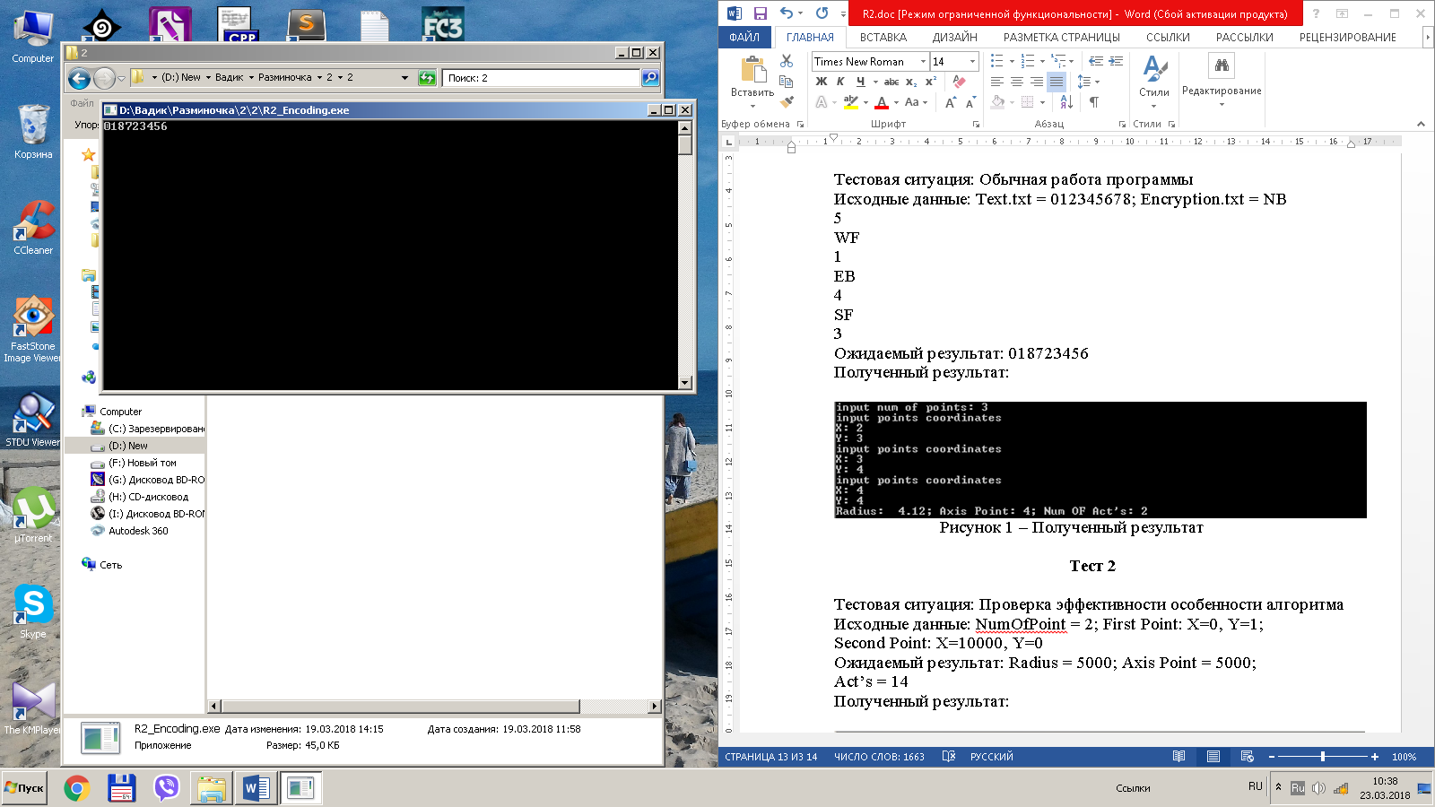
Рисунок 1 – Полученный результат

Тест 2

Тестовая ситуация: Проверка расшифровки текста
Исходные данные: Text.txt = 018723456; Encryption.txt = SF
3
EB
4
WF
1
NB
5
Ожидаемый результат: 012345678
Полученный результат:

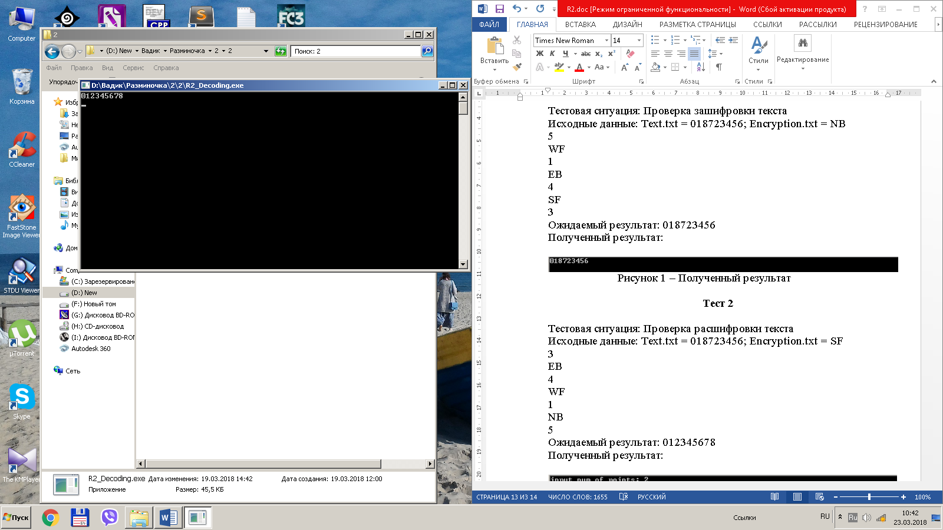
Рисунок 2 – Полученный результат

