About the Project/Project Title
This project was a mock collaboration w/ a company named “Grazioso Salvare”, which is an animal rescue shelter. This project utilizes MongoDB and Dash to access a Mongo database with all of the data used to represent the animals on their database.

Motivation
This project was motivated by me wanting to create something official for a portfolio in the future. While fun personal projects are important, I like to have something professional looking.

Getting Started
To start, install all of the included files and ensure they are in the SAME FOLDER! MongoDB is the core choice of what was used as a database here, due to it's python integration and the ability to use CRUD core functions to manipulate the database.

Installation
To run this project, you will need Jupyter Notebook and Mongosh installed to work with this. Ensure the .py file is in the same directory as your notebook file.

Usage
This project can be used as a reference for future dashboard projects of your own to display Mongo database information in a clear and concise way.

Screenshots
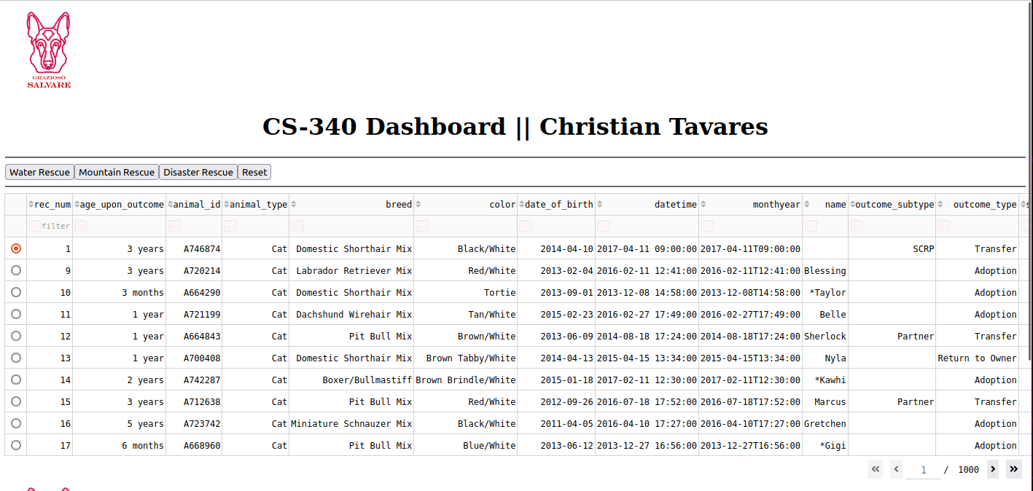

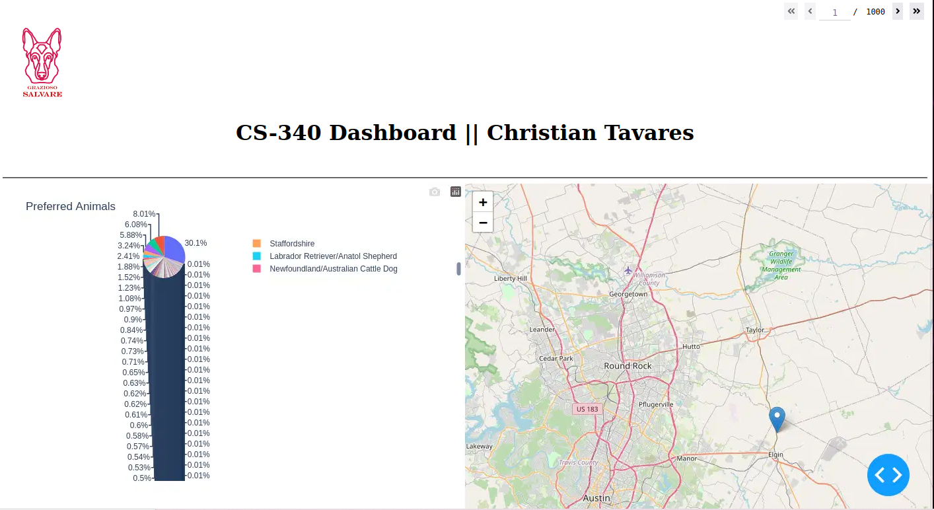

Roadmap/Features (Optional)
There are no planned additional features at the present moment, however it is always possible that I will add more functionality to this later on. Possibilities include more sorting features, new layouts, better readability, etc.

Contact
CTavares: https://github.com/CTava1993

