Q 5 Salary Data

Ana Paula Felix de Queiroz

### Question 5:

#### - Are specific job titles being offered to candidates of a specific nationality?

Job_title_subgroup x country_of_citizenship

#### - Does the nationality of the candidate affect the status of case?

country_of_citizenship x case_status

#### - Does job subtitle of the candidate affect the status o the case?

Job_title_subgroup x case_status

# Data pre processing

It is important to notice that for this analysis we had a significant amount of missing values values on the column of interest. for instance we have a data set with 167278 observations but for column country of citizenship we have a total of 124106 missing values. Nevertheless, we will proceed with the analysis using the remaining 43172 observations.  
Since we are focusing our analysis on data related jobs we are also excluding all the job subtitles unrelated to data, as well

## The following objects are masked from df:  
##   
## CASE_NUMBER, CASE_RECEIVED_DATE, CASE_STATUS,  
## COLLEGE_MAJOR_REQUIRED, COUNTRY_OF_CITIZENSHIP, DECISION_DATE,  
## EDUCATION_LEVEL_REQUIRED, EMPLOYER_NAME,  
## EXPERIENCE_REQUIRED_NUM_MONTHS, EXPERIENCE_REQUIRED_Y_N,  
## FULL_TIME_POSITION_Y_N, JOB_TITLE, JOB_TITLE_SUBGROUP, order,  
## PAID_WAGE_PER_YEAR, PAID_WAGE_SUBMITTED, PAID_WAGE_SUBMITTED_UNIT,  
## PREVAILING_WAGE_PER_YEAR, PREVAILING_WAGE_SOC_CODE,  
## PREVAILING_WAGE_SOC_TITLE, PREVAILING_WAGE_SUBMITTED,  
## PREVAILING_WAGE_SUBMITTED_UNIT, VISA_CLASS, WORK_CITY,  
## WORK_POSTAL_CODE, WORK_STATE, WORK_STATE_ABBREVIATION

## [1] 133012 28

#### - Are specific job titles being offered to candidates of a specific nationality?

In other words, we want to know if there a significant difference in number of hiring for a particular job subtitle considering country of citizenship.  
First we conducted an analysis in python looking at the top10 countries with higher hiring frequency. We then looked at the frequency of job subtitle in each of these countries.  
  
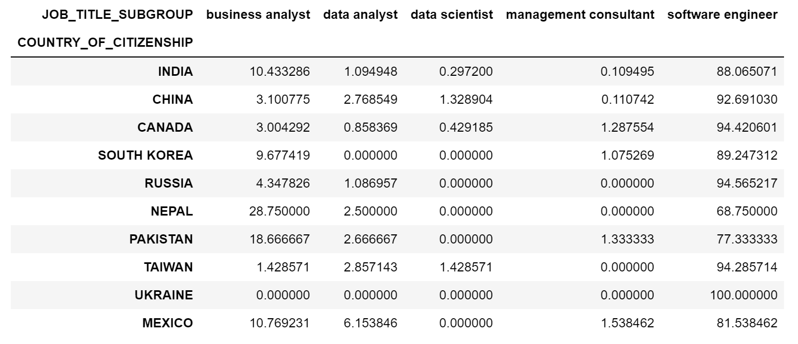

Key takeaways considering the top 10 countries with higher hiring percentage:

* Across the board, for all top 10 countries, software engineers are the most sought-after of all data-related job titles.
* Over 90% of candidates from Canada, Russia, Taiwan, and China are hired for software engineering jobs.
* Candidates from Ukraine are hired exclusively as software engineers.
* Nepal has the highest percentage of individuals hired as business analysts, with over 28% of the job title pool, followed by Pakistan with over 18%.
* Candidates from Mexico are the most hired for data analyst positions, with over 6% of the hiring pool for job titles.
* China and Taiwan have the highest percentage of individuals hired as data scientists, with over 1.4% and 1.3%, respectively.
* Candidates from Pakistan have the highest percentage of individuals hired as management consultants, with over 1.3% of the hiring pool for job titles.
* 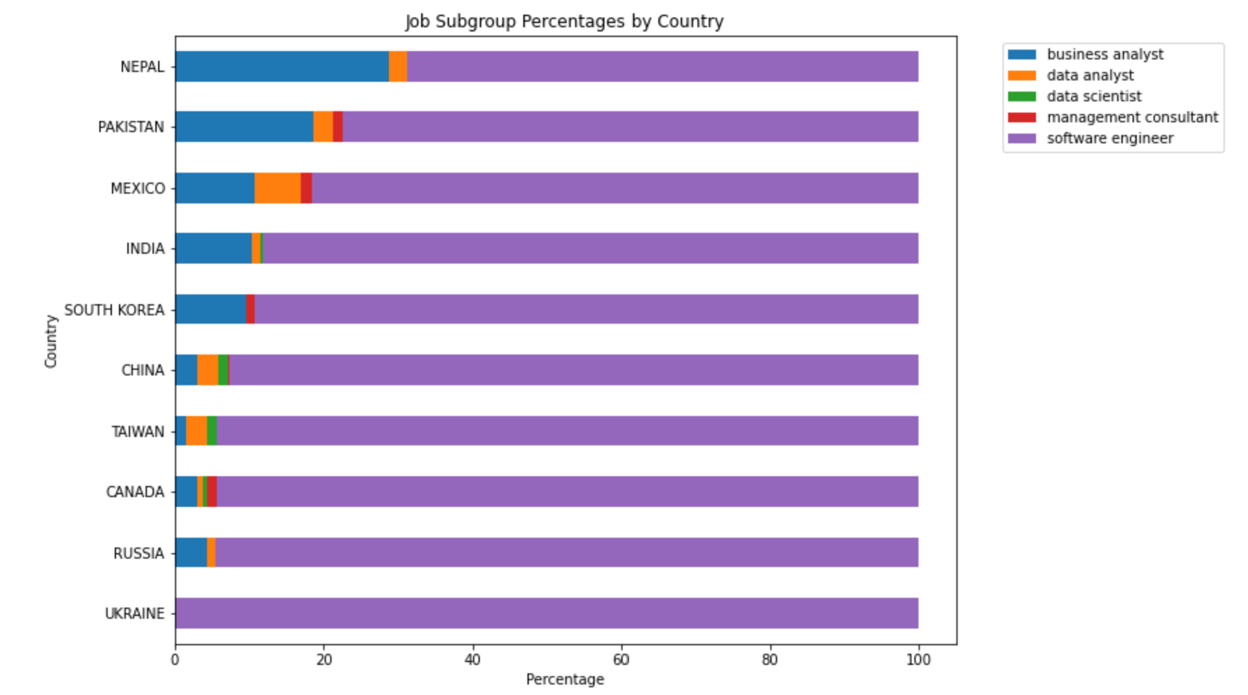

#### - Does the nationality of the candidate affect the status of case?

We wanted to investigate whether the nationality of the candidate affects the status of the case (positive or negative) in the context of immigration applications.

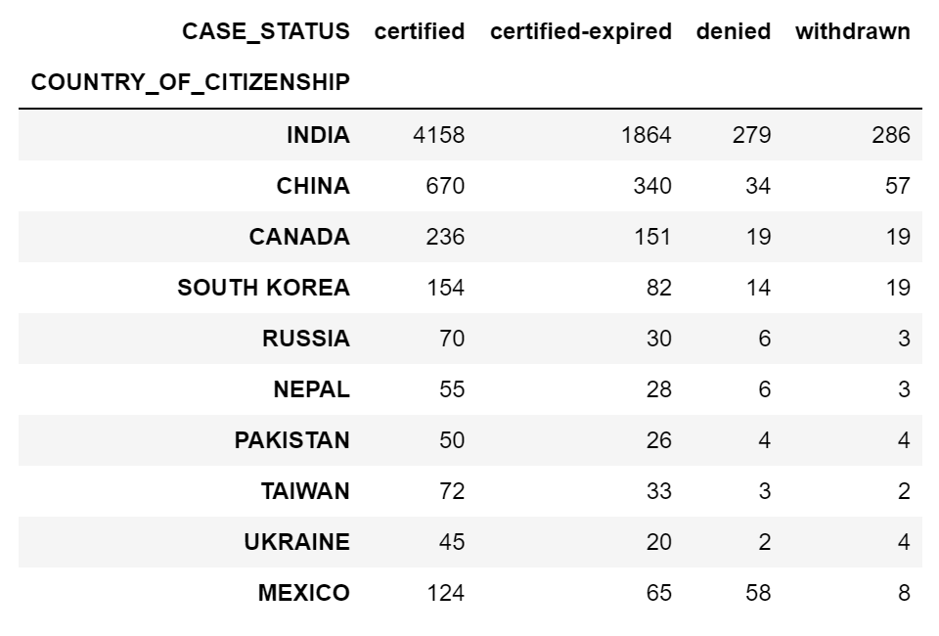

The following tests aimed to investigate the relationship between nationality and case status (positive or negative) To achieve this, we categorized certified withdraw, certified-expired, and certified as positive, and denied as negative. We employed logistic regression analysis and ANOVA to assess the significance of nationality as a predictor of case status.

Our logistic regression analysis showed a significant relationship (p < 0.001) between the predictor variable (country) and the response variable (positive or negative status), as indicated by the significant intercept. However, upon analyzing the individual coefficients for different countries, not all of them were found to be significant (p > 0.05).

Given the sparse nature of the data and the non-conformity of the model assumptions, we ran a Monte Carlo simulation and a Fisher test. Both these tests yielded non-significant results. Therefore, we can conclude that the nationality of the candidate does not influence the case status in this dataset. Nonetheless, it is essential to consider other factors that may affect the case status in actual cases.

## Warning in chisq.test(status[, -1]): Chi-squared approximation may be incorrect

##   
## Pearson's Chi-squared test  
##   
## data: status[, -1]  
## X-squared = 31.17, df = 27, p-value = 0.2642

## Warning: package 'brglm2' was built under R version 4.2.3

##   
## Call:  
## glm(formula = cbind(Positive, Negative) ~ factor(country), family = binomial,   
## data = new_status)  
##   
## Deviance Residuals:   
## [1] 0 0 0 0 0 0 0 0 0 0  
##   
## Coefficients:  
## Estimate Std. Error z value Pr(>|z|)   
## (Intercept) 3.10459 0.32324 9.605 <2e-16 ***  
## factor(country)CHINA 0.58543 0.38868 1.506 0.132   
## factor(country)INDIA 0.03631 0.32927 0.110 0.912   
## factor(country)MEXICO 1.05430 1.05835 0.996 0.319   
## factor(country)NEPAL -0.59228 0.53354 -1.110 0.267   
## factor(country)PAKISTAN -0.22820 0.60710 -0.376 0.707   
## factor(country)RUSSIA -0.01354 0.60485 -0.022 0.982   
## factor(country)SOUTH KOREA 0.71313 0.78452 0.909 0.363   
## factor(country)TAIWAN 1.12952 1.05782 1.068 0.286   
## factor(country)UKRAINE 1.06980 1.05824 1.011 0.312   
## ---  
## Signif. codes: 0 '***' 0.001 '**' 0.01 '*' 0.05 '.' 0.1 ' ' 1  
##   
## (Dispersion parameter for binomial family taken to be 1)  
##   
## Null deviance: 1.4580e+01 on 9 degrees of freedom  
## Residual deviance: 8.2157e-15 on 0 degrees of freedom  
## AIC: 54.96  
##   
## Number of Fisher Scoring iterations: 4

## Analysis of Deviance Table (Type II tests)  
##   
## Response: cbind(Positive, Negative)  
## LR Chisq Df Pr(>Chisq)  
## factor(country) 14.58 9 0.1031

##   
## Fisher's Exact Test for Count Data with simulated p-value (based on  
## 10000 replicates)  
##   
## data: cont_table  
## p-value = 0.1471  
## alternative hypothesis: two.sided

#### Does job subtitle of the candidate affect the status o the case?

To begin, we used Python to create a stacked bar chart to visualize the relationship between job title subgroup and case status. The chart indicated that there may not be a significant difference in case status frequency between job title subgroups. However, to confirm this, we conducted a chi-square test for independence.

The results of the chi-square test suggested that there is a significant association between job title subgroup and case status. The extremely low p-value (< 2.2e-16) indicated that the null hypothesis of independence between the two variables can be rejected. Therefore, we can conclude that the job title subgroup of the candidate does indeed have an effect on the case status.

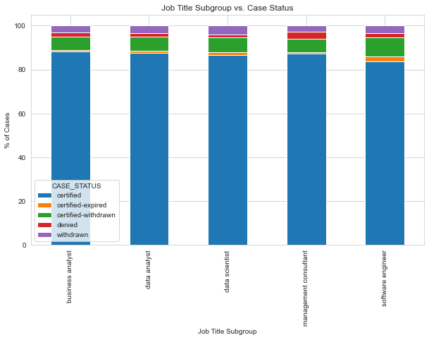

##   
## BA DA DS MC SE  
## C 24562 3358 1062 671 83320  
## CE 192 39 16 5 2201  
## CW 1700 246 82 49 8668  
## D 505 62 17 23 1922  
## W 852 135 50 22 3253

## Length Class Mode   
## statistic 1 -none- numeric   
## parameter 1 -none- numeric   
## p.value 1 -none- numeric   
## method 1 -none- character  
## data.name 1 -none- character  
## observed 25 table numeric   
## expected 25 -none- numeric   
## residuals 25 table numeric   
## stdres 25 table numeric

## [1] "There is a significant association between job title subgroup and case status."

To further explore this, we created a mosaic graph, which provided a more detailed understanding of the relationship between job title subgroup and case status. We found that business analysts are more likely to be certified compared to software engineers, and are less likely to have their certification expired or withdrawn. Data analysts are less likely to have their certification expired or withdrawn compared to software engineers.

On the other hand, software engineers are more likely to have a denied visa and are less likely to have a certified case status compared to business analysts. They are also more likely to have their certification expired, which suggests that companies didn’t move forward with the hiring after their case was certified, as well as have their certification withdrawn, indicating that the application was withdrawn before the certification was granted. In conclusion, the job title subgroup of the candidate is a significant factor affecting the status of their case, and this information could be useful for companies in their hiring process.

## Loading required package: grid

## starting httpd help server ... done

