NOTES EN VRAC

Notes

- Faire H2 avant H1! Pour être sûr qu’on ait bien une autocorrélation entre point voisin

- remplacer H1 par H3 : un moyen pour avoir du signal, parce que vu la taille de nos placettes on risque de ne rien voir au niveau biomasse.

- pour interaction sans effet principal : potentiellement des biais, demander à Marie Pierre Etienne !

- décorrélation ?

*We might be interested in whether the constraint lies in the change from texture to texture or not?*

En guyane pour les terres très argileuses, on peut retrouver des microstructures au sein de agrégats, ce qui assure quand même une bonne porosité malgré la finesse de la texture. On ne sait pas comment les racines réponde à ces microstructures mais on peut supposer que ce soit moins contraignant.

Nous ce qui nous intéresse c’est le passage de sable à limon. Dans les limons il y aurait moins cette microstructuration

La fosse 4 pourrait presque nous servir de fosse témoin par rapport à l’effet du limon : on pourrait la retirer des donnée pour l’annalyse de base, et peut être l’ajouter ensuite pour comparaison

package ade4, dudi.mix permet de mélanger des variables quali et quanti -> pourrait servir pour l’analyse de corrélation avec le mica

Question GIACOMO :

– interesting species for our study ? With root strategy well know ?

Do CCA or something else

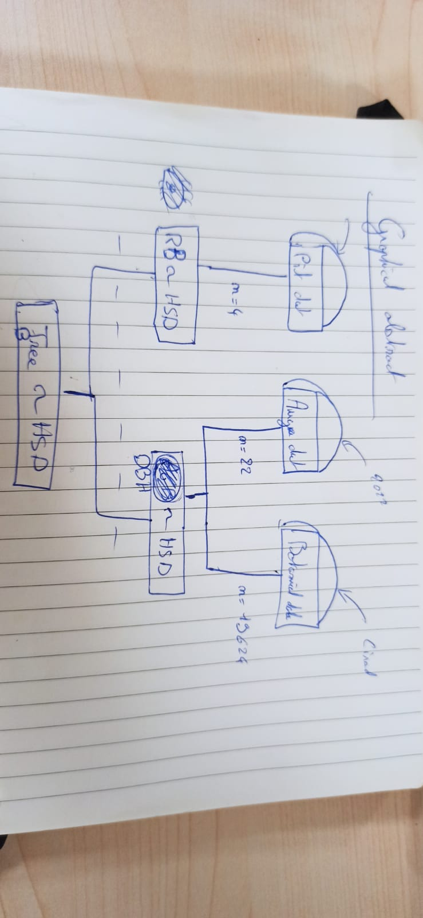

# Introduction

In the field of tropical ecology, a big part is understanding the way tropical forest communities are structured, and what environmental factors influence their dynamics. There is quite some information about what and how certain factors influence the structuring and dynamics of the community through modification of aboveground parts of trees (sources!). However, the belowground part of the tree has often been neglected, with only a recent increase in information regarding the role of roots on ecosystem processes. For example, Bardgett et al. (2014) saw that roots significantly contribute to the carbon cycle by influencing the input of carbon into the soil, with belowground carbon storage being twice as much as in the atmosphere (Schlesinger 1991). Concurrently, root exudates can play a key role in shaping nutrient availability and stability of the soil (Bardgett et al., 2014) (more sources?). The understanding of root processes and constraints might therefore *open a new world of knowledge* on ecosystem processing, and therefore also on the structuring and dynamics of tropical forests.

Trees will absorb nutrients and water through their roots, a process that subsequently impacts the overall growth of the trees (Craine et al., 2012, might want to add another source). The root distribution in the soil can give us information about their ability to take up nutrients and water (Freschet et al., 2021). For example, fine roots at surface depths correspond to soil horizons that are rich in nutrients, whereas deeper roots are more linked with increasing the available *uptake area of water and nutrients* of the tree (source from PA, find somewhere maybe in root bible).

Understanding the dynamics of water movement in the soil profile is crucial in studying soil-forest interactions, as water availability in the soil plays a pivotal role in supporting plant growth, as emphasized by Guehl (1984). The water retention in soil is influenced by factors such as soil depth, texture, and organic matter content, as highlighted by Wall and Heiskanen (2003). Schenk and Jackson (2002) indicate that roots decrease strongly with soil depth for all systems globally. In addition, soil texture influences hydrologic and biogeochemical processes in forest ecosystems, therefore also likely influencing the capacity of roots to absorb nutrients and water (Silver et al., 2000; Soong et al., 2020). There are several classification types of soil texture. For our work, the French soil texture triangle (Jamagne, 1977) was used.

Humbel (1978) showed that there is a link between the soil drainage type and root establishment. They *show* that in soils with superficial lateral drainage the roots decrease exponentially and more than 80% are present in the first 20 cm. Superficial lateral drainage is a drainage type in which there is a fleeting waterlogged water table that appears during heavy rains (Ferry et al., 2003). *Might add that drainage type and topography are very strongly linked?*

Humbel (1978) also seems to show a negative relationship between silt and root presence.

Our research endeavours to unravel the potential constraints imposed by silt on tree roots within the context of the Paracou Research Station in French Guiana. Our main hypothesis treats the question whether particle size in soil, more specifically the presence of a silt horizon, poses a constraint to the growth of trees, considering both roots and aboveground biomass. More specifically, we want to look at the influence of silt horizon (rather horizons with high silt content) on the root concentration (or density). We further look at if aboveground biomass (DBH, basal area, diversity, …) is influenced by the occurrence of a certain silt horizon (or again horizons high in silt) and whether a difference can be observed between intermediate and high silt content regarding their effect.

With our study, we aim to shed light on the intricate relationships between soil texture, root growth, and aboveground biomass. By addressing these questions, we aspire to contribute valuable leads for the broader understanding of how soil characteristics, specifically the presence of a horizons high in silt, may influence the ecological dynamics of tree ecosystems.

! (1) It is not necessarily the presence and distribution of roots that determine water and nutrient uptake from given soil depths, but the root activity might differ among the soil horizons and is not constant in time (Gessler et al., 2002; Kulmatiski & Beard, 2013; Volkmann et al., 2016a).!! (from root bible, think about this)

* They say that because of this root resource uptake data and data on root distribution and architecture are two complementary data sets with different information

Root bible: relating measurements of above-ground properties to uptake of soil resources of specific roots or soil depths is not straightforward.

1. Does particle size in soil, more specifically the presence of a silt horizon, pose a constraint to the growth of trees, considering both roots and aboveground biomass?

a.1) Do roots react differently to soil texture, taking the diameter of the roots into account?

a.2) How does the depth of the silt horizon impact the concentration of the roots?

a.4) Is aboveground biomass (DBH, basal area, diversity, …) influenced by the occurrence of a certain silt horizon?

a.4.1) Is there a difference between intermediate and big concentrations of silt in the effect? How does the silt effect vary with the silt concentration?

Our research endeavours to unravel the potential constraints imposed by silt on tree roots within the context of the Paracou Research Station in French Guiana. Our main hypothesis treats the question whether particle size in soil, more specifically the presence of a silt horizon, poses a constraint to the growth of trees, considering both roots and aboveground biomass. More specifically, we want to look at the influence of silt horizon (rather horizons with high silt content) on the root concentration (or density). We further look at if aboveground biomass (DBH, basal area, diversity, …) is influenced by the occurrence of a certain silt horizon (or again horizons high in silt) and whether a difference can be observed between intermediate and high silt content regarding their effect.

With our study, we aim to shed light on the intricate relationships between soil texture, root growth, and aboveground biomass. By addressing these questions, we aspire to contribute valuable leads for the broader understanding of how soil characteristics, specifically the presence of a horizons high in silt, may influence the ecological dynamics of tree ecosystems.

# Material and Methods

The work was carried out as part of the ALT-project (Amazonian Landscapes in Transition 2022-2025) of the AMAP/CIRAD lab/research unit. The ALT-project looks at how climate change impacts the regeneration potential in the forest understory and canopy tree dynamics. More specifically, our project will contribute to the PhD thesis of Vincyane Badouard about environmental determinants of the spatial distribution of understorey species in tropical forests. The pit data campaign took place within the master's degree module “Forêts tropicales humides” of 2023. Another campaign was conducted in 2022 in the same context (auger data). In this paper we only describe the methodology of the pit data sampling we conducted within our own project. To look at the methodology for auger data sampling, see (**cite the article the last year group made**). All the data are available on [GitHub](github.com:CThion/M2_EFT_projet_pedologie.git).

## Study site

The study took place in the research station of Paracou in French Guiana (5°18’N; 52°53’W), a private domain of 40 000ha owned by CNES (National Centre for Space Studies) which comprises 16 permanent plots followed by the French research centre CIRAD for over 35 years (*Portal - Paracou Research Station, a Large Scale Forest Disturbance Experiment in Amazonia*, n.d.). The sampling took place on plot number 16 of the project’s 9ha sampling plot, more precisely outside of the subdivisions 24 and 25 (**see fig. map to insert**). The soil type in this area is mostly acrisol (add source – Epron et al. 2006). The depth of the soils is restricted by a modified loamy saprolite, typically encountered at a depth of around 1 m. This saprolite, characterized by low permeability, plays a crucial role in influencing the water drainage patterns across the site's topography, as highlighted by Ferry et al. (2003).

## Botanical data

The botanical data correspond to the 2020 inventory of Guyafor tree database, which monitors all trees of DBH superior to 10cm. **In the P16**, those data were completed with data from the ALT project, which included all trees of height superior to 1.30m. The whole P16 botanical dataset has a total of 19136 individuals.

## Pit data

Pit excavation allows to gather root distribution data (**root bible**).

Four pits were sampled during September 11-16, 2023. They were located outside of the P16 plot, next to the subplots 23-25, to avoid disturbances. For this reason, we did not have any botanical data for the location of our pits.

All pits were dug onslopes, which represent the largest proportion of the plot's surface area and correspond to a superficial lateral drainage (SLD) (**source**). We defined the topography in-situ by identifying the three main positions: hilltop, slope and lowlands. For prospection, we used the auger when possible and looked at differences in the occurrence of silt. The aim was to find as many different pits as possible regarding silt deposits to be able to conclude on differences in the rooting depth. Once the placement of the pits was determined, they were dug with pickaxes and spades*.* These rectangular pits had to be at least 100cm deep and 50cm wide to fit the frame used later for root counting and to describe the soil horizons.

After cleaning the exposed soil surface in the pits, the different horizons were determined on one side of the pit. This was done by looking at changes of colour and texture (Ferry et al., 2003). For each horizon, depth and root diameters were measured. The percentage of coarse elements, the abundance of mica, texture class, soil humidity, colour, structure, compactness, and percentage of mottles were estimated and ordinally classified. The texture was analysed by touch while humidifying a soil sample (Jahn et al., 2006) and using the soil texture triangle (Jamagne, 1977). Two sides of the pit were used to count the roots, which also allowed us to maximize the use of the pit. To count the roots, we used a grid (1m high, 50 cm wide) subdivided in squares of 10x10 cm, a method corresponding with the recommendations of (**source**). The roots were counted in each square and were grouped by diameter (< 2 mm, 2-5 mm, 5-10 mm and ≥ 10 mm). In the end we took samples of the soil in each pit at 5 cm, 20 cm, 40 cm, 60 cm, 80 cm and 100 cm to store in the laboratory.

## Auger data

In addition to our pit data, we used a 36 augers sample, collected in 2022 in the P16 of Paracou. Auger sampling is generally prioritised to reduce the disturbance of the soil, as well as to collect many soil samples representing the soil variation of the plot (Cools & De Vos, 2013). Each auger was 100 cm deep. The augers were dispersed at 33 m intervals within the plot (**figure 1**). The percentage of coarse elements, the abundance of mica, texture class, soil humidity, colour, structure, compactness and the percentage of mottles were recorded, all of which were also sampled and used during our study. In contrast to our research focus, root abundance was not sampled. However, this dataset is of great value for our analysis as the auger samples were extracted from the P16 and allow comprehensive botanical inventory. Pits data and augers data are spatially and temporarily close enough to the auger points to allow reasonable comparison.

## Data analysis

### 2.3.1. Auger and botanical data

Located using the closest tree location.

To focus on silt effect, we regrouped soil texture classes into three different categories of silt concentration: low (A, Alo, AS), intermediate (SL, SA, S), and high (LSA, LAS).

For the data of 2022, we dispose of 36 auger data. We excluded 14 of them that had missing or uncertain value of texture. Then we had a dataset of 22 augers.

To get the AGB, we considered tree inventory data in a 10m rayon circle around each augur. The rayon value has been chosen considering the potential silt horizon variation speed. We know that speed variation can vary along the topography (**source**). The smaller it goes, the longer the radius can be. To estimate the HDS variation speed, we calculated the autocorrelation of HSD over all the 16 augers (**annexe X**) using QGIS (**version XYZ**), we calculated the autocorrelation between HSD, to see if the silt behaves continuously (**figure 1**). Depending on this autocorrelation, we will decide of the maximum area around each auger in which me can extrapolate texture data.

We also looked at the correlation between HSD and topography (**figure 1**). The topography classes were simply chosen as **……**

The mica content of the different soil layers has been estimated visually and classified into categories from 0 (no presence) to 3 (high presence). A Chi-squared test was done to quantitatively assess the association between silt and mica content in different horizons of the auger data. A mosaic plot visually shows the relationship between the variables. (*Mention mosaic plot here? I would say not necessary, only show in Results part*).

### 2.3.2. Pit data

We conduct the same data treatment of texture, mica, and coarse element as for the auger dataset.

For aggregation of root density and horizon characterization, we chose to round horizon thickness, so that it can be overlapped with the counting grid of 50 10x10 cm squares.

We discriminated the horizons according to the texture variable: as long as the texture stays coherent, it stays the same texture category. In the field, the horizon was defined according to the texture, but also colour and other factors.

Given the small sample size of 4 pits, only a visual analysis can be done, and tendencies deducted.

# Results

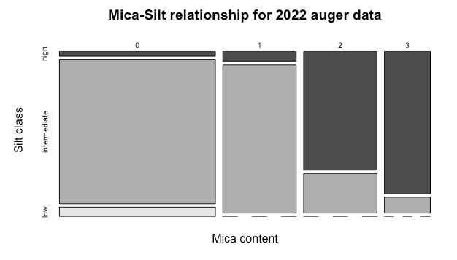The mica and silt content were significant (Auger data from 2022, the test on the pit data from 2023, was abandoned due to small sample size). The relationship is shown in a mosaic plot in Fig.x *(inserted here just for us to look at it quickly*). Mica content higher Silt content in the different soil layers

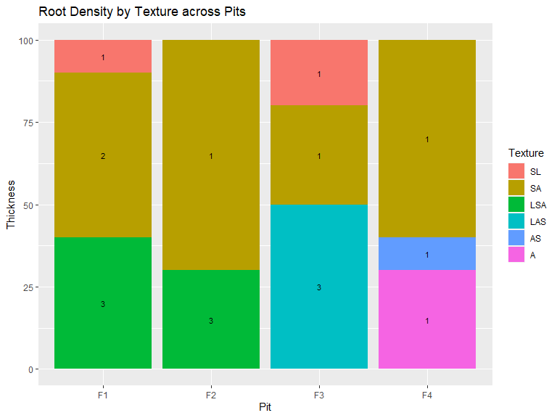

Figure : micas quantity per horizon

## Root data

* No difference of root biomass over the different textures

## Above ground biomass

Lorem ipsum

# 4 Discussion

Map of high silt depths and topography -> check whether there is a correlation between silt depth and topography

If yes -> silt does not explain community structuring more than topography, is an additional characteristic to examine community distribution, but acts in a similar way as topography.

Also possibly correlated because topography and drainage type are linked, is there a link between drainage type and texture appearances?

Mushrooms ? They talk a bit about it in (Soong et al., 2020)

Given that our plot area is small, we should have taken into consideration the past perturbation of the plot (tree falls).

Limitations

* Subjectivity with colours and texture
* Only 4 pits so limited information, some pits were very different in soil horizon than others even in short distance, more information is always better to make more significant conclusions
* Didn’t look at trees around, did not determine them, have no idea (as we were not allowed in P16 where the above biomass was determined by another group)
* Observers bias (roots were counted by different individuals, as were other variables too)

From root bible:

Advantages and drawbacks. Soil trench profile provides crucial information on root distribution in relation to soil spatial heterogeneity. They can also be used to take soil and root samples at different depths or to install probes or minirhizotrons (Maeght et al., 2013). The major drawback is that this method is destructive, laborious and time consuming, limiting the number of replications. It is often difficult to distinguish roots especially fine roots of herbaceous species. It provides only a two-dimensional root distribution; predictions of RLD from RID requires laborious calibrations based on the sampling of soil monoliths from the trench wall.

# 5 Conclusion

# 6 References

Bardgett, R. D., Mommer, L., & De Vries, F. T. (2014). Going underground: Root traits as drivers of ecosystem processes. *Trends in Ecology & Evolution*, *29*(12), 692–699. https://doi.org/10.1016/j.tree.2014.10.006

Cools, N., & De Vos, B. (2013). Forest soil: Characterization, sampling, physical, and chemical analyses. In *Developments in Environmental Science* (Vol. 12, pp. 267–300). Elsevier. https://doi.org/10.1016/B978-0-08-098222-9.00015-7

Craine, J. M., Engelbrecht, B. M. J., Lusk, C. H., McDowell, N. G., & Poorter, H. (2012). Resource limitation, tolerance, and the future of ecological plant classification. *Frontiers in Plant Science*, *3*. https://doi.org/10.3389/fpls.2012.00246

Ferry, B., Freycon, V., & Paget, D. (2003). Genèse et fonctionnement hydrique des sols sur socle cristallin en Guyane. *Revue Forestière Française*, *55*(sp), 37–59. https://doi.org/10.4267/2042/5786

Freschet, G. T., Pagès, L., Iversen, C. M., Comas, L. H., Rewald, B., Roumet, C., Klimešová, J., Zadworny, M., Poorter, H., Postma, J. A., Adams, T. S., Bagniewska-Zadworna, A., Bengough, A. G., Blancaflor, E. B., Brunner, I., Cornelissen, J. H. C., Garnier, E., Gessler, A., Hobbie, S. E., … McCormack, M. L. (2021). A starting guide to root ecology: Strengthening ecological concepts and standardising root classification, sampling, processing and trait measurements. *New Phytologist*, *232*(3), 973–1122. https://doi.org/10.1111/nph.17572

Humbel, F.-X. (1978). *Caractérisation, par des mesures physiques, hydriques et d’enracinement, de sols de Guyane française à dynamique de l’eau superficielle* (extrait de l’A.F.E.S 2; Science du sol). ORSTOM.

Jahn, R., Blume, H. P., Asio, V. B., Spaargaren, O., & Schad, P. (2006). *Guidelines for soil description, 4th edition* (p. ). FAO. https://library.wur.nl/WebQuery/wurpubs/355777

*Portal—Paracou research station, a large scale forest disturbance experiment in Amazonia*. (n.d.). Retrieved 27 September 2023, from https://paracou.cirad.fr/website