HLA Workshop

Installation Guide

Anthony Angelo, Netser Heruty, Daniel Smith

5 Oct 2021

Table of Contents

# Introduction

This document provides prescriptive guidance for using installing the HLA Workshop

# Prerequisites

Following is a list of prerequisite tools and accesses needed to perform a full HLA Workshop installation.This document provides prescriptive guidance for using installing the HLA Workshop:

* Access to an AWS Account with full admin privileges
* AWS CLI
* Bash Terminal Access (e.g., WSL for Windows, MacOS Terminal or another Linux)
* Terraform (e.g., Terraform v0.12.31)
* Ansible (e.g., v4.5.0)

# Deploy your NOW Instance

## Request a new NOW Instance

1. Navigate to [NOW HI](https://support.servicenow.com/now)
2. Search for “new internal instance request”
3. Request a new instance as follows, using the latest available application version: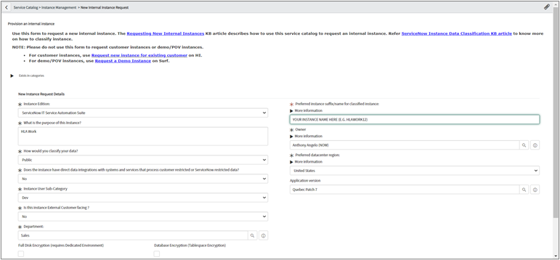

## Upgrade your NOW Instance to latest Rome version

1. Navigate to [NOW HI](https://support.servicenow.com/now)
2. Select your Instance from the Instances Dashboard
3. Upgrade your instance to latest Rome version & patch level as follows: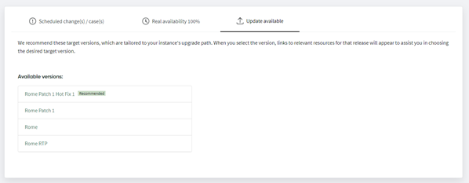

## Install the required ITOM plugins for the Workshop

1. Login to your NOW Instance as an Administrator
2. Navigate to the **System Definition > Plugins** and install the following plugins

|  |  |  |
| --- | --- | --- |
| Plugin Name | Plugin ID | Notes |
| Agent Client Collector Monitoring | com.snc.sa.metric | 10 Minutes to install |
| Service Mapping | com.snc.service-mapping | 20 Minutes to install |