A developer as an early Adopter, a Cooperator, and a Supporter

# Raisa Cuiujuclu

Email: [blue.apple30k@gmail.com](mailto:blue.apple30k@gmail.com)

Portfolio: https://raisa412.github.io/

Behance: <https://www.behance.net/shcool>

Linkedin: https://www.linkedin.com/in/raisa-cuiujuclu-28a352205/

Summary

Innovative Front End Developer with over 4 years of experience building and maintaining responsive websites in the recruiting industry.

I seek to secure the position of Senior Front End Developer and hope to share my skills, expertise, and experience with your team and valuable clients.

Preferred Salary: $33/hr

Skills

- Tech Degree in Front End Development

- Bachelor’s Degree in Computer Science

- Proficient in HTML5, CSS 3, Javascript, AJAX, and Typescript

- Adept in using Front End frameworks – Angular, Vue, React(+ Flask)

- Adept in using DB language – MySQL, MongoDB, PostgreSQL

- Adept in using Backend frameworks – Node.js, Express framework

- Keen understanding of responsive design principles and UI / UX design skills

- Experienced in using Functional and Unit Testing methods

- Creative problem solver, Possess a knack for teamwork, and comfortable working cross-functional

My development life

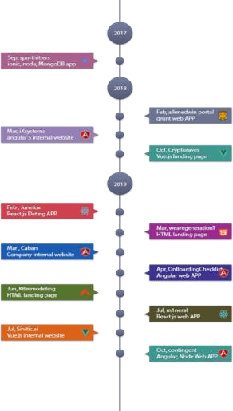

2017.9 ~ 2018.2 Sporthitters sports betting system

Link: http://sporthitters.com/

Role: Full stack developer

Skill: Ionic framework, Node.js, Express framework, MongoDB, stripe & paypal payment system integration

2018.2 ~ 2018.3 allenedwin operations portal

Link: https://portal.allenedwin.com/

Role: Full stack developer

Skill: Grunt, SVN

2018.3 ~ 2018.10 iXsystems company internal website

Link: internal website

Role: Frontend developer

Skill: Angular 5, Angular material, typescript, SCSS, Git, Jira

2018.11 ~ 2019.2 Cryptoraves landing page

Link: https://cryptoraves.space/

Role: Frontend developer

Skill: Vue.js, CSS, UI / UX design, Git

2019.3 wearegenerationT website

Link: https://www.wearegenerationt.com/

Role: Frontend developer

Skill: HTML, CSS, jQuery

2019.3 ~ 2019.4 Caban systems company internal website

Link: internal website

Role: Frontend developer

Skill: Angular 5, Angular material, typescript, SCSS, firebase 2019.4 ~ 2019.6 OnBoardingChecklist Questionnaire APP

Link: internal website

Role: Frontend developer

Skill: Angular 5, Angular material, typescript, SCSS, AWS

2019.6 ~ 2019.7 KBremodeling shopping site

Link: http://kbremodeling.us/

Role: Full stack developer

Skill: CI framework, UI/UX design, HTML, CSS

2019.7 m1neral landing page

Link: https://m1neral.com/

Role: frontend developer

Skill: React.js, CSS, HTML

2019.7 ~ 2019.10 Sinitic AI translator APP

Link: https://www.sinitic.ai/

Role: frontend developer

Skill: Vue.js, CSS, HTML, Jira, GitLab, Docker

2019.10 ~ 2020.12 Contingent company internal website

Link: internal website

Role: Full stack developer

Skill: Node.js, Angular 8, Jest, Cypress, Firebase, Google Cloud, Git