Plan

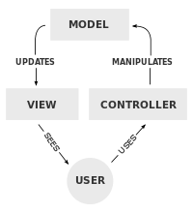

Model-View-Controller

Model – Store information, etc.

View – Rendering

Controller – Acts upon models

Entity Component Systems – Ashley

Entities – Storage of Components

Components – Storage of information

Systems – Act upon component information

Player Entity – Position Component

Movement System – Position Component – x++, y++

Decoupled

View – Rendering

RenderComponent

* Sprite sprite

PositionComponent

* Vector3 pos

RenderSystem acts upon entities with RenderComponent, PositionComponent

* SpriteBatch batch
* Foreach entity with RenderComponent and PositionComponent

Draw sprite at pos