**PROBLEM-1**

**AIM:-**

Print linked list

**CODE:-**

class Node {

int data;

Node next;

Node(int data) {

this.data = data;

this.next = null;

}

}

class Solution {

void printList(Node head) {

Node temp = head;

while (temp != null) {

System.out.print(temp.data + " ");

temp = temp.next;

}

System.out.println();

}

}

public class Main {

public static void main(String[] args) {

Node head = new Node(49);

head.next = new Node(10);

head.next.next = new Node(30);

Solution sol = new Solution();

sol.printList(head);

}

}

**OUTPUT:-**

**PROBLEM-2**

**AIM:-**

Remove duplicates from a sorted list

**CODE:**-

class Solution {

    public ListNode deleteDuplicates(ListNode head) {

        ListNode res = head;

        while (head != null && head.next != null) {

            if (head.val == head.next.val) {

                head.next = head.next.next;

            } else {

                head = head.next;

            }

        }

        return res;

    }

}

**OUTPUT:-**

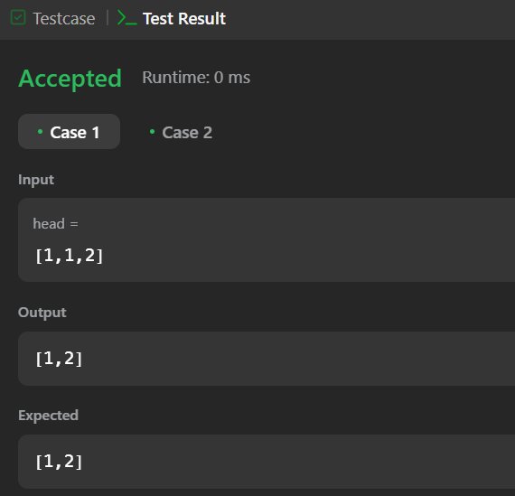

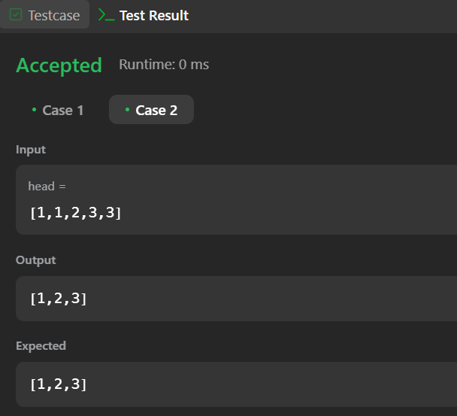

**PROBLEM-3**

**AIM:-**

Reverse a linked list

**CODE:-**

class Solution {

public ListNode reverseList(ListNode head) {

ListNode node = null;

while (head != null) {

ListNode temp = head.next;

head.next = node;

node = head;

head = temp;

}

return node;

}

}

**OUTPUT:-**

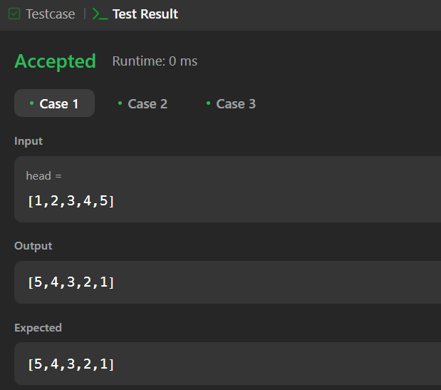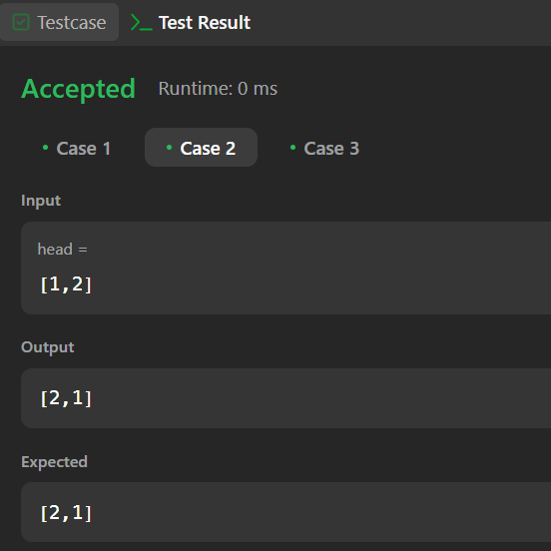

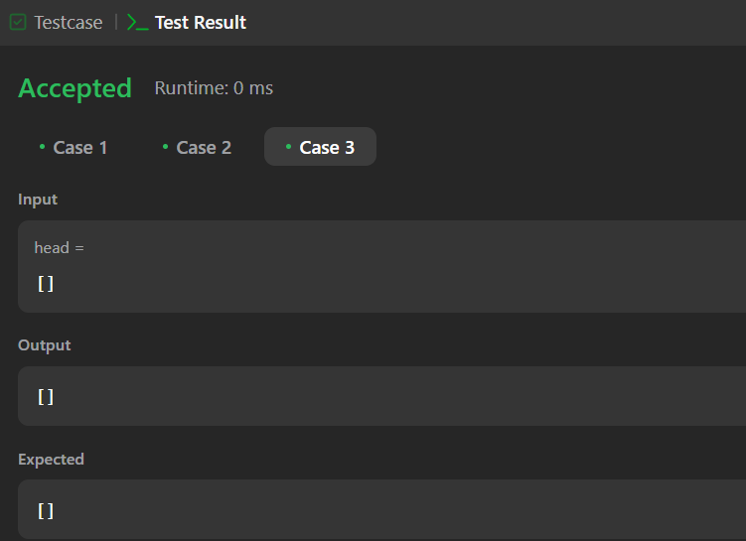

**PROBLEM-4**

**AIM:-**

Delete middle node of a list

**CODE:-**

class Solution {

    public ListNode deleteMiddle(ListNode head) {

        ListNode counter = head;

        int count = 0;

        while(counter != null){

            counter = counter.next;

            count++;

        }

        ListNode curr = head;

        if(count == 1){

            return curr.next;

        }

        int middle = (count/2) - 1;

        count = 0;

        while(count != middle){

            curr = curr.next;

            count++;

        }

        curr.next = curr.next.next;

        return head;

    }

}

**OUTPUT:-**

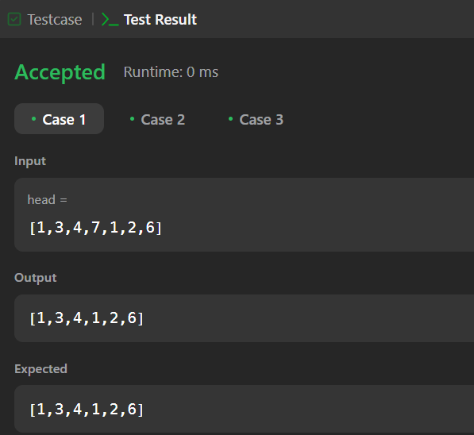 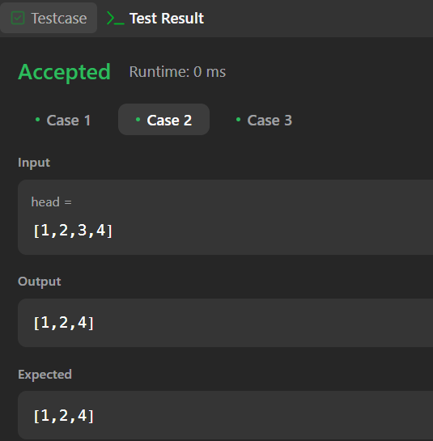

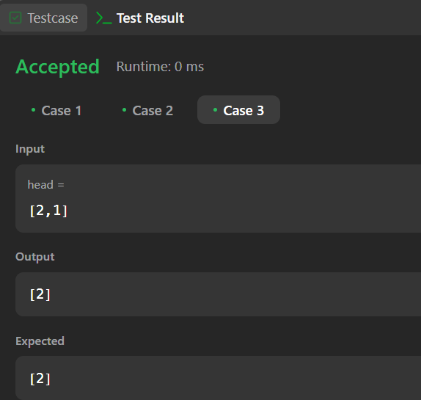

**PROBLEM-5**

**AIM:-**

Merge two sorted linked lists

**CODE:-**

class Solution {

    public ListNode mergeTwoLists(ListNode list1, ListNode list2) {

        ListNode dummy = new ListNode();

        ListNode cur = dummy;

        while (list1 != null && list2 != null) {

            if (list1.val > list2.val) {

                cur.next = list2;

                list2 = list2.next;

            } else {

                cur.next = list1;

                list1 = list1.next;

            }

            cur = cur.next;

        }

        cur.next = (list1 != null) ? list1 : list2;

        return dummy.next;

    }

}

**OUTPUT:-**

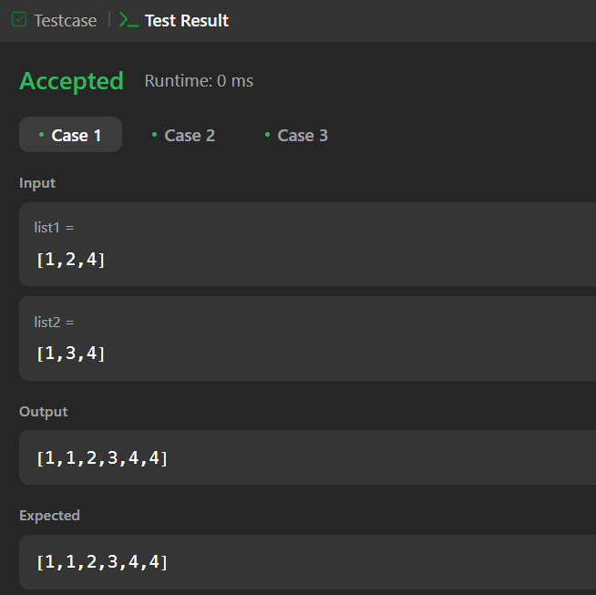 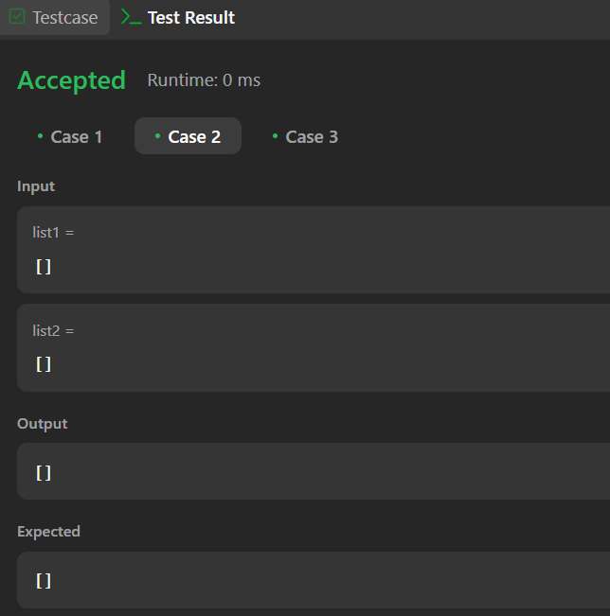

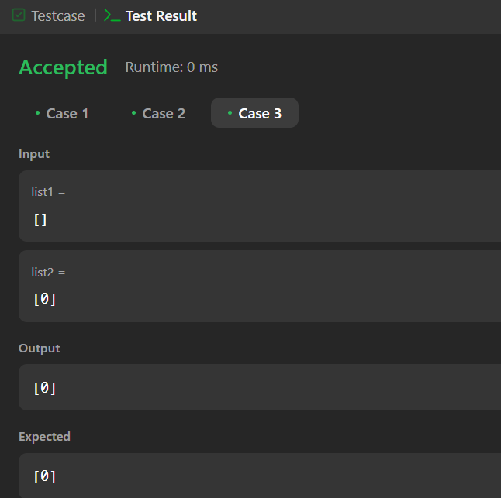

**PROBLEM-6**

**AIM:-**

Remove duplicates from sorted lists 2

**CODE:-**

class Solution {

    public ListNode deleteDuplicates(ListNode head) {

        ListNode ans = new ListNode(1000, head);

        ListNode cur = ans;

        while (cur.next != null && cur.next.next != null) {

            if (cur.next.val == cur.next.next.val) {

                int val = cur.next.val;

                while (cur.next != null && cur.next.val == val) {

                    cur.next = cur.next.next;

                }

            } else {

                cur = cur.next;

            }

        }

        return ans.next;

    }

}

**OUTPUT:-**

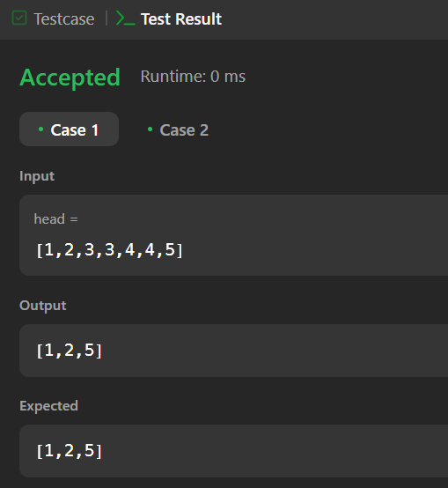

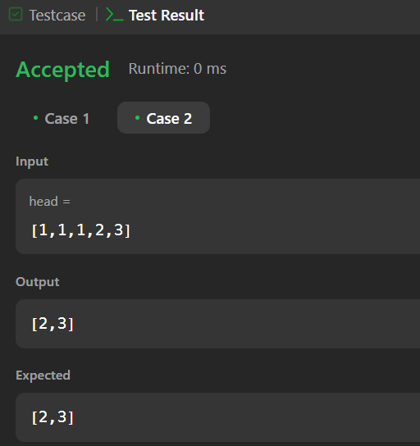

**PROBLEM-7**

**AIM:-**

Detect a cycle in a linked list

**CODE:-**

public class Solution {

    public boolean hasCycle(ListNode head) {

        ListNode fast = head;

        ListNode slow = head;

        while (fast != null && fast.next != null) {

            fast = fast.next.next;

            slow = slow.next;

            if (fast == slow) {

                return true;

            }

        }

        return false;

    }

}

**OUTPUT:-**

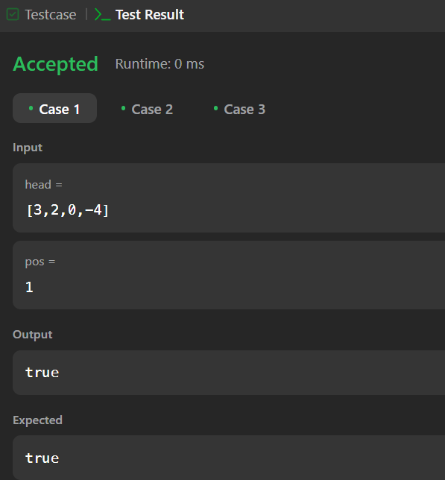 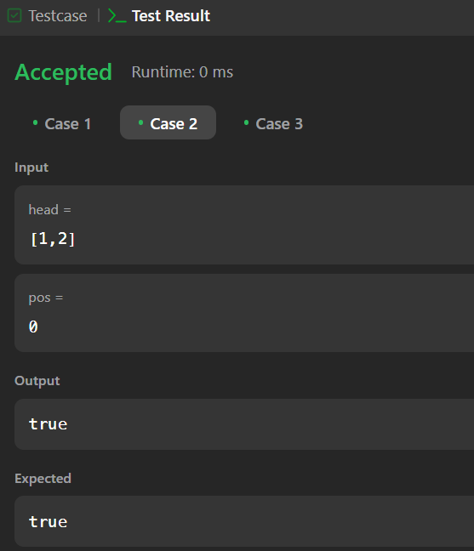

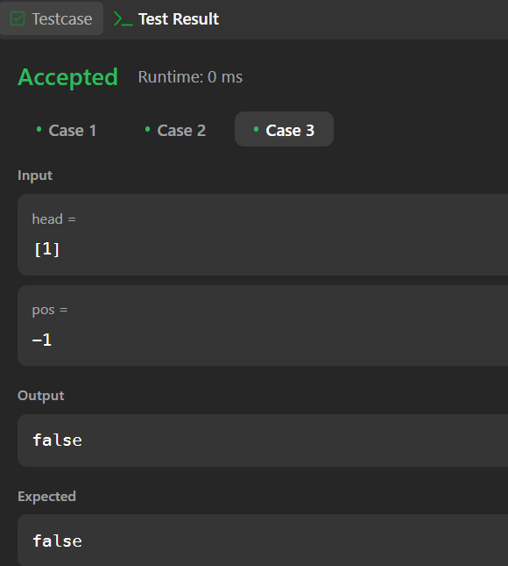

**PROBLEM-8**

**AIM:-**

Reverse linked list 2

**CODE:-**

class Solution {

public ListNode reverseBetween(ListNode head, int left, int right) {

if (head == null || left == right) {

return head;

}

ListNode dummy = new ListNode(0);

dummy.next = head;

ListNode prev = dummy;

for (int i = 0; i < left - 1; i++) {

prev = prev.next;

}

ListNode cur = prev.next;

for (int i = 0; i < right - left; i++) {

ListNode temp = cur.next;

cur.next = temp.next;

temp.next = prev.next;

prev.next = temp;

}

return dummy.next;

}

}

**OUTPUT:-**

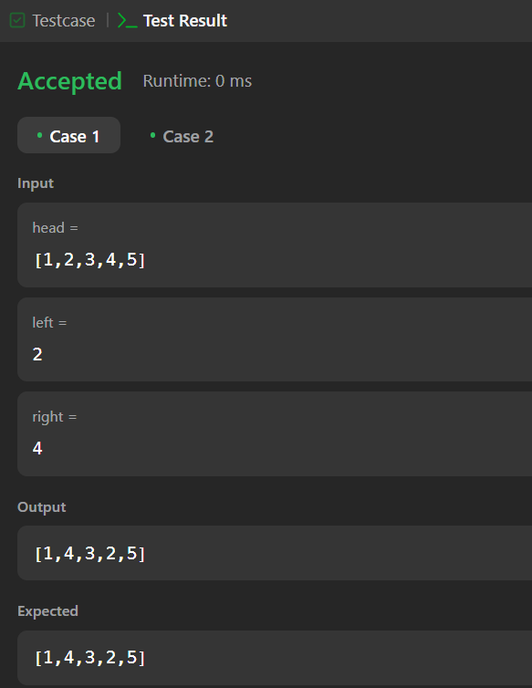

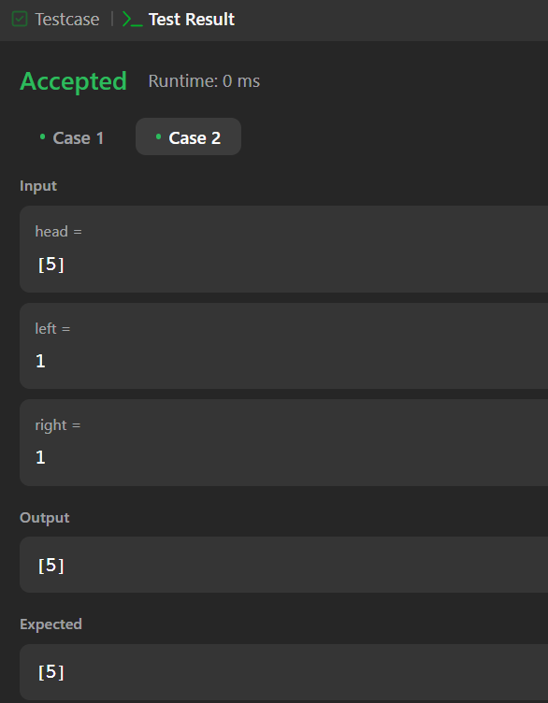

**PROBLEM-9**

**AIM:-**

Rotate a list

**CODE:-**

class Solution {

public ListNode rotateRight(ListNode head, int k) {

if (head == null || head.next == null || k == 0) {

return head;

}

int length = 1;

ListNode temp = head;

while (temp.next != null) {

temp = temp.next;

length++;

}

temp.next = head;

k = k % length;

k = length - k;

while (k-- > 0) {

temp = temp.next;

}

head = temp.next;

temp.next = null;

return head;

}

}

**OUTPUT:-**

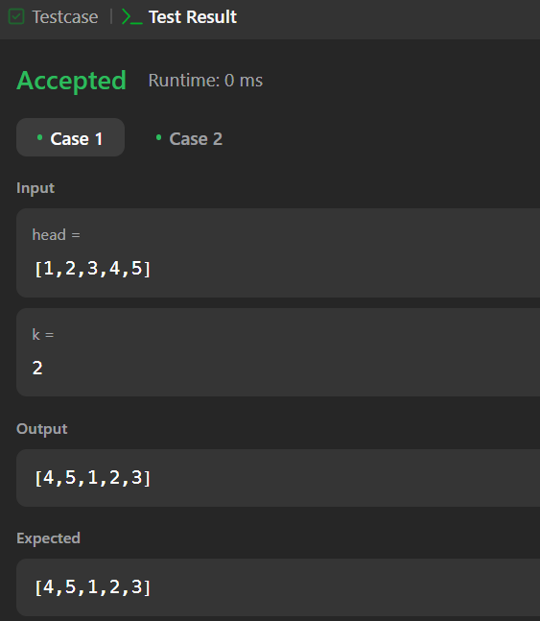

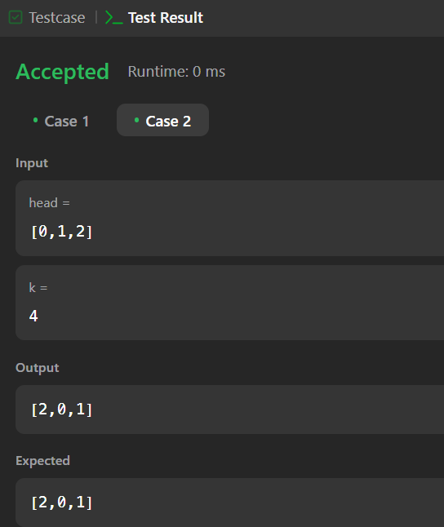

**PROBLEM-10**

**AIM:-**

Merge k sorted lists

**CODE:-**

class Solution {

public ListNode mergeKLists(ListNode[] lists) {

if (lists == null || lists.length == 0) {

return null;

}

return mergeKListsHelper(lists, 0, lists.length - 1);

}

private ListNode mergeKListsHelper(ListNode[] lists, int start, int end) {

if (start == end) {

return lists[start];

}

if (start + 1 == end) {

return merge(lists[start], lists[end]);

}

int mid = start + (end - start) / 2;

ListNode left = mergeKListsHelper(lists, start, mid);

ListNode right = mergeKListsHelper(lists, mid + 1, end);

return merge(left, right);

}

private ListNode merge(ListNode l1, ListNode l2) {

ListNode dummy = new ListNode(0);

ListNode curr = dummy;

while (l1 != null && l2 != null) {

if (l1.val < l2.val) {

curr.next = l1;

l1 = l1.next;

} else {

curr.next = l2;

l2 = l2.next;

}

curr = curr.next;

}

curr.next = (l1 != null) ? l1 : l2;

return dummy.next;

}

}

**OUTPUT:-**

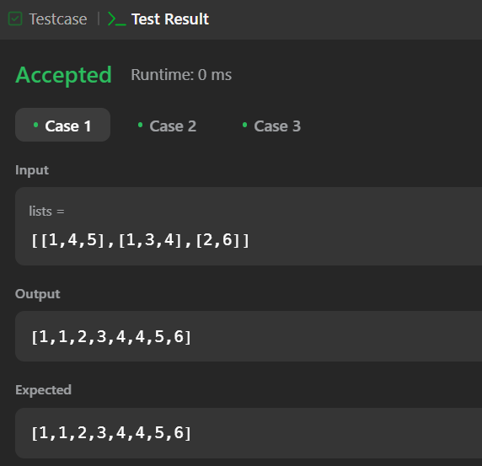

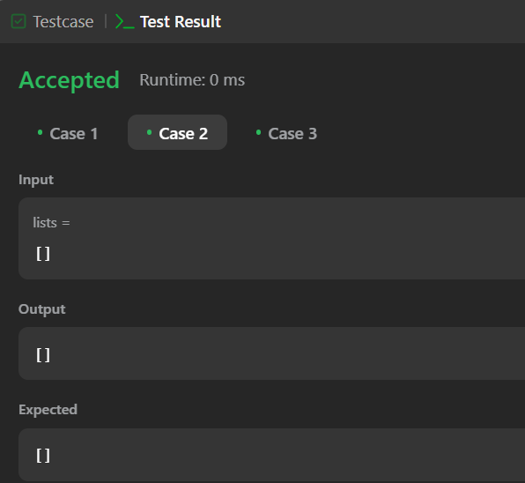

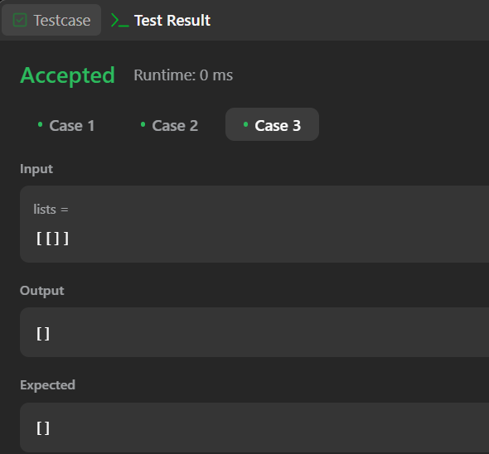

**PROBLEM-11**

**AIM:-**

Sort List

**CODE:-**

class Solution {

    public ListNode sortList(ListNode head) {

        if (head == null || head.next == null) return head;

        ListNode slow = head, fast = head.next;

        while (fast != null && fast.next != null) {

            slow = slow.next;

            fast = fast.next.next;

        }

        ListNode mid = slow.next;

        slow.next = null;

        ListNode left = sortList(head);

        ListNode right = sortList(mid);

        return merge(left, right);

    }

    private ListNode merge(ListNode l1, ListNode l2) {

        ListNode dummy = new ListNode(0);

        ListNode tail = dummy;

        while (l1 != null && l2 != null) {

            if (l1.val < l2.val) {

                tail.next = l1;

                l1 = l1.next;

            } else {

                tail.next = l2;

                l2 = l2.next;

            }

            tail = tail.next;

        }

        tail.next = (l1 != null) ? l1 : l2;

        return dummy.next;

    }

}

**OUTPUT:-**

