**Problem 1**

**Aim:**

Longest Nice Substring

**Code:**

class Solution {

public:

string longestNiceSubstring(string s) {

string output = "";

int count = 0;

for(int i = 0;i<s.length();i++){

int smallMask=0;

int largeMask = 0;

char ch = s[i];

int chint = 0;

if(ch>=65 &&ch<=90){

chint = ch-'A';

largeMask = 1<<chint;

}

else{

chint = ch-'a';

smallMask = 1<<chint;

}

for(int j = i+1;j<s.length();j++){

ch = s[j];

if(ch>=65 &&ch<=90){

chint = ch-'A';

largeMask |= 1<<chint;

}

else{

chint = ch-'a';

smallMask |= 1<<chint;

}

//checking for nice

if((smallMask^largeMask) == 0){

if(count<j-i+1){

count = j-i+1;

string temp(s.begin()+i,s.begin()+j+1);

output = temp;

}

}

}

}

return output;

}

};

**Output:**

Case 1 Case 2 Case 3

**Problem 2**

**Aim:**

Reverse Bits

**Code:**

class Solution {

public:

uint32_t reverseBits(uint32_t n) {

uint32_t result = 0;

for (int i = 0; i< 32; i++) {

int bit = n &1; // Extract the least significant bit

result = (result << 1) | bit; // Append the bit to the result

n = n >>1; // Right-shift n to process the next bit

}

return result;

}

};

**Output:**

Test Case 1Test Case 2

**Problem 3**

**Aim:**

Number of 1 bits

**Code:**

class Solution {

public:

int hammingWeight(int n) {

bitset<32> b(n);

int ans=0;

for(size_ti=0;i<b.size();i++){

if(b[i]==1) ans++;

}

return ans;

}

};

**Output:**

Case 1 Case 2 Case 3

**Problem 4**

**Aim:**

Max Subarray

**Code:**

class Solution {

public:

int maxSubArray(vector<int>&nums) {

int res = nums[0];

int total = 0;

for (int n :nums) {

if (total < 0) {

total = 0;

}

total += n;

res = max(res, total);

}

return res;

}

};

**Output:**

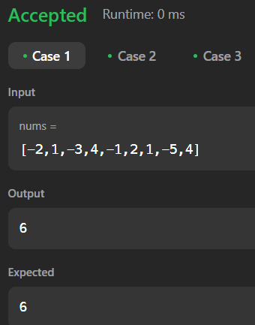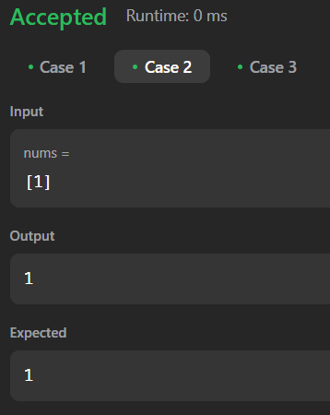

Case 1 Case 2 Case 3

**Problem 5**

**Aim:**

Search 2d matrix 2

**Code:**

class Solution {

public:

bool searchMatrix(vector<vector<int>>& matrix, int target) {

int n = matrix.size(), m = matrix[0].size();

int row = 0, col = m - 1;

while (row < n && col >= 0) {

if (matrix[row][col] == target) return true;

else if (matrix[row][col] < target) row++;

else col--;

}

return false;

}

};

**Output:**

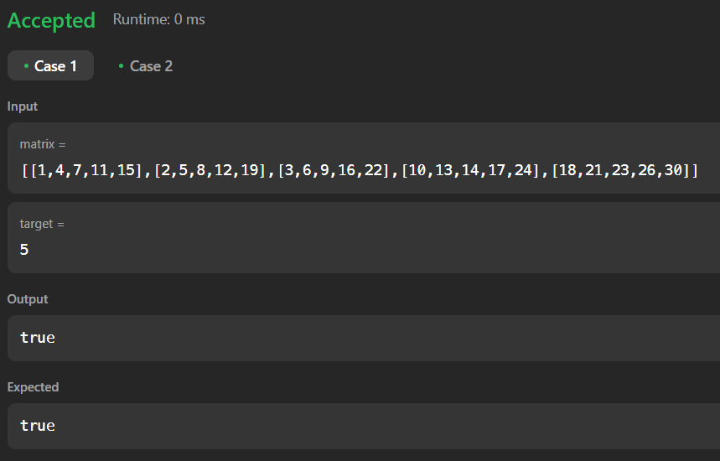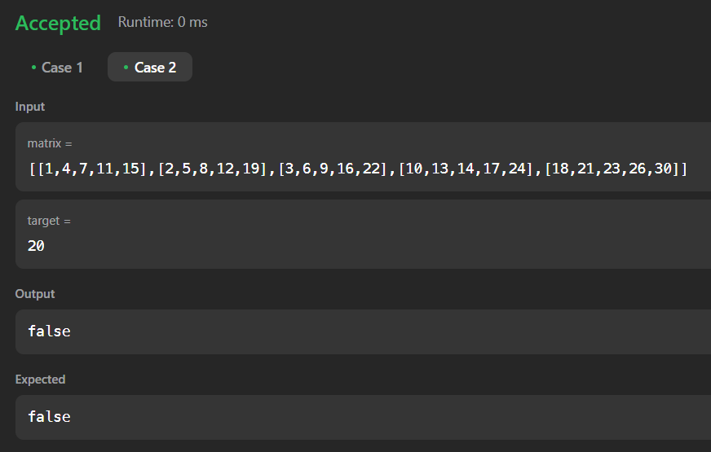

Case 1 Case 2

**Problem 6**

**Aim:**

Super Pow

**Code:**

class Solution {

private:

int solve(int base, int power, int mod) {

int ans = 1;

while (power > 0) {

if (power & 1) {

ans = (ans * base) % mod;

}

base = (base * base) % mod;

power >>= 1;

}

return ans;

}

public:

int superPow(int a, vector<int>& b) {

a%=1337;

int n = b.size();

int m = 1140;

int expi = 0;

for(int i : b){

expi = (expi*10+i)%m;

}

if (expi == 0) {

expi = m;

}

return solve(a,expi,1337);

}

};

**Output:**

Case 1 Case 2 Case 3

**Problem 7**

**Aim:**

Beautiful Array

**Code:**

class Solution {

public:

int partition(vector<int>&v, int start, int end, int mask)

{

int j = start;

for(int i = start; i<= end; i++)

{

if((v[i] & mask) != 0)

{

swap(v[i], v[j]);

j++;

}

}

return j;

}

void sort(vector<int>& v, int start, int end, int mask)

{

if(start >= end) return;

int mid = partition(v, start, end, mask);

sort(v, start, mid - 1, mask << 1);

sort(v, mid, end, mask << 1);

}

vector<int>beautifulArray(int N) {

vector<int>ans;

for(int i = 0; i< N; i++) ans.push_back(i + 1);

sort(ans, 0, N - 1, 1);

return ans;

}

};

**Output:**

Case 1 Case 2

**Problem 8**

**Aim:**

The Skyline Problem

**Code:**

class Solution {

public:

vector<vector<int>>getSkyline(vector<vector<int>>& buildings) {

int edge_idx = 0;

vector<pair<int, int>> edges;

priority_queue<pair<int, int>>pq;

vector<vector<int>> skyline;

for (int i = 0; i<buildings.size(); ++i) {

const auto &b = buildings[i];

edges.emplace_back(b[0], i);

edges.emplace_back(b[1], i);

}

std::sort(edges.begin(), edges.end());

while (edge_idx<edges.size()) {

int curr_height;

const auto &[curr_x, _] = edges[edge_idx];

while (edge_idx<edges.size() &&

curr_x == edges[edge_idx].first) {

const auto &[_, building_idx] = edges[edge_idx];

const auto &b = buildings[building_idx];

if (b[0] == curr_x)

pq.emplace(b[2], b[1]);

++edge_idx;

}

while (!pq.empty() &&pq.top().second <= curr_x)

pq.pop();

curr_height = pq.empty() ? 0 :pq.top().first;

if (skyline.empty() || skyline.back()[1] != curr_height)

skyline.push_back({curr_x, curr_height});

}

return skyline;

}

};

**Output:**

Case 1 Case 2

**Problem 9**

**Aim:**

Reverse Pairs

**Code:**

class SegTree {

private:

int tree_size;

vector<int> tree;

void update(int lx, int rx, int ni, int idx) {

if (rx - lx == 1) {

tree[ni]++;

return;

}

int m = (lx + rx) >> 1;

if (idx< m)

update(lx, m, ni * 2 + 1, idx);

else

update(m, rx, ni * 2 + 2, idx);

tree[ni] = tree[ni * 2 + 1] + tree[ni * 2 + 2];

}

int query(int l, int r, int lx, int rx, int ni) {

if (l >= rx || r <= lx)

return 0;

if (l <= lx && r >= rx)

return tree[ni];

int m = (lx + rx) >> 1;

return query(l, r, lx, m, ni * 2 + 1) + query(l, r, m, rx, ni * 2 + 2);

}

public:

SegTree(int n) {

tree_size = 1;

while (tree_size< n)

tree_size<<= 1;

tree = vector<int>(tree_size * 2);

}

void update(int idx) {

update(0, tree_size, 0, idx);

}

int query(int l, int r) {

return query(l, r + 1, 0, tree_size, 0);

}

};

class Solution {

public:

int reversePairs(vector<int>&nums) {

int n = nums.size();

set<long long> values;

for(const auto&num : nums) {

values.insert(num);

values.insert(2LL * num);

}

int last_index = 0;

unordered_map<long long, int>values_indices;

for(const auto&val : values)

values_indices[val] = last_index++;

SegTreeseg_tree(last_index);

int ans = 0;

for(int i = 0; i< n; ++i) {

ans += seg_tree.query(values_indices[2LL * nums[i]] + 1, last_index);

seg_tree.update(values_indices[nums[i]]);

}

return ans;

}

};

**Output:**

Case 1 Case 2

**Problem 10**

**Aim:**

Longest increasing subsequence 2

**Code:**

class Solution {

public:

vector<int>tree;

void update(int node,intst,intend,inti,intval){

if(st==end){

tree[node]=max(tree[node],val);

return;

}

int mid=(st+end)/2;

if(i<=mid){

update(node*2,st,mid,i,val);

}else{

update(node*2+1,mid+1,end,i,val);

}

tree[node]=max(tree[node*2],tree[node*2+1]);

}

int query(int node,intst,intend,intx,int y){

if(x>end || y<st) return -1e9;

if(st>=x && end<=y){

return tree[node];

}

int mid=(st+end)/2;

int left=query(2*node,st,mid,x,y);

int right=query(2*node+1,mid+1,end,x,y);

return max(left,right);

}

int lengthOfLIS(vector<int>&nums, int k) {

int n=nums.size();

if(n==1) return 1;

int m=*max_element(nums.begin(),nums.end());

tree.clear();

tree.resize(4*m+10);

for(int i=n-1;i>=0;i--){

int l=nums[i]+1,r=min(nums[i]+k,m);

int x=query(1,0,m,l,r);

if(x==-1e9) x=0;

update(1,0,m,nums[i],x+1);

}

return tree[1];

}

};

**Output:**

Case 1 Case 2 Case 3