# Experiment-4

**Name:** Ayushi **UID:** 22BET10234

**Branch:** BE-IT **Section/Group:** 22BET_IOT-702/B

**Semester:** 6th **Date of Performance:** 14/02/25

**Subject Name:** AP LAB-II **Subject Code:** 22ITP-351

**Problem-1**

**1. Aim:**

Given a string s, return the longest substring of s that is nice. If there are multiple, return the substring of the earliest occurrence. If there are none, return an empty string.

**2. Objective:**

* To implement a string s for every letter of the alphabet that s contains, it appears both in uppercase and lowercase.
* To return an empty string.

## 3. Code:

Class Solution

{

Public:

string longestNiceSubstring(string s) {

        if (s.size() < 2) return "";

        unordered_set<char> st(begin(s), end(s));

        for (int i = 0; i < s.size(); i++) {

             if (st.find((char) toupper(s[i])) == end(st) || st.find((char) tolower(s[i])) == end(st)) {

                string s1 = longestNiceSubstring(s.substr(0, i));

                string s2 = longestNiceSubstring(s.substr(i + 1));

                return s1.size() >= s2.size() ? s1 : s2;

            }

        }

        return s;

    }

};

## 4.Output:

## 

**Fig.1.Longest Nice Substring**

**Problem-2**

**1. Aim:**

Reverse bits of a given 32 bits unsigned integer and they should not affect your implementation, as the integer's internal binary representation is the same, whether it is signed or unsigned.

**2. Objective:**

* There is no unsigned integer type.
* Return the reversed list.

## 3. Code:

## Class Solution {

## public:

## uint32_t  reverseBits(uint32_t n) {

## uint32_t result= 0;

## for(int i=0; i<32; i++)

## result = (result<<1) + (n>>i &1);

## 

## return result;

## }

## };

## 4.Output:

## 

**Fig.2:Reverse Bits**

# Problem-3

# 1.Aim:

# Given a positive integer n, write a function that returns the number of set bits in its binary representation also known as the Hamming Weight.

**2.Objective:**

* To implement a function to print number of 1 bits.
* To return the number of set bits in its binary representation .

## 3.Code:

## class Solution {

## public:

## int hammingWeight(int n) {

## int count = 0;

## while (n ) {

## n = n & (n - 1);

## count++;

## }

## return count;

## 

## }

## };

## 4.Output:

## 

**Fig.3:Number of 1 bits**

# Problem-4

**1.Aim:**Given an integer array nums, find the subarray with the largest sum, and return *its sum*.

**2.Objective:**

## To find the subarray with the largest sum

## To return the sum of integer array nums.

## 3.Code:

## class Solution {

## public:

## int maxSubArray(vector<int>& nums) {

## int maxSum = INT_MIN;

## int currentSum = 0;

## for (int i = 0; i < nums.size(); i++) {

## currentSum += nums[i];

## if (currentSum > maxSum) {

## maxSum = currentSum;

## }

## if (currentSum < 0) {

## currentSum = 0;

## }

## }return maxSum;

## }

## };

## 4.Output:

## 

**Fig.4:MaxSubarray**

# Problem-5

**1.Aim:**Write an efficient algorithm that searches for a value target in an m x n integer matrix matrix..

**2.Objective:**

## Integers in each row are sorted in ascending from left to right.

## Integers in each column are sorted in ascending from top to bottom.

## 3.Code:

## class Solution {

## public:

## bool searchMatrix(vector<vector<int>>& matrix, int target) {

## int m = matrix.size(), n = m ? matrix[0].size() : 0, r = 0, c = n - 1;

## while (r < m && c >= 0) {

## if (matrix[r][c] == target) {

## Return true;

## }

## matrix[r][c] > target ? c-- : r++;

## }

## Return false;

## }

## };

## 4.Output:

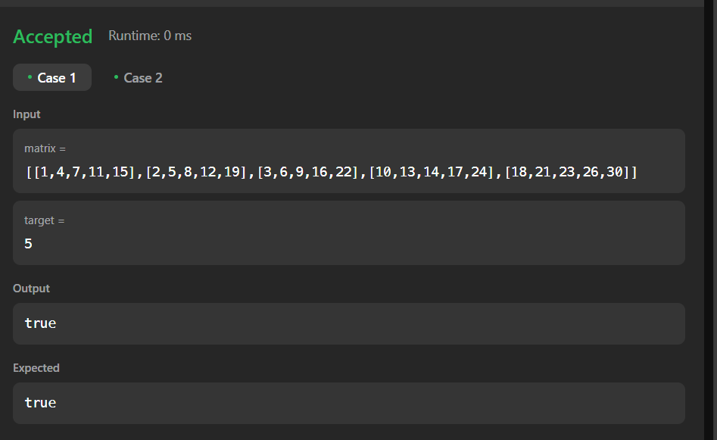

**Fig.5:Search 2d matrix**