# Experiment-5

**Name:** Aayushi Sinha **UID:** 22BET10268

**Branch:** BE-IT **Section/Group:** 22BET_IOT-702/B

**Semester:** 6th **Date of Performance:**21/02/25

**Subject Name:** AP LAB-II **Subject Code:** 22ITP-351

**Problem-1**

**1.Aim:**

Given an array of intervals where intervals[i] = [starti, endi], merge all overlapping intervals, and return an array of the non-overlapping intervals that cover all the intervals in the input.

**2.Objective:**

* Sort intervals by start time.
* Iterate through intervals and merge overlapping ones.
* Store merged intervals in a new list.
* Time Complexity: O(nlogn)) due to sorting.

## 3.Code:

class Solution {

public:

    vector<vector<int>> merge(vector<vector<int>>& intervals) {

        if (intervals.empty()) return {};

        sort(intervals.begin(), intervals.end());

        vector<vector<int>> merged;

        merged.push_back(intervals[0]);

        for (int i = 1; i < intervals.size(); ++i) {

            if (intervals[i][0] <= merged.back()[1]) {

                // Merge overlapping intervals

                merged.back()[1] = max(merged.back()[1], intervals[i][1]);

            } else {

                merged.push_back(intervals[i]);

            }

        }

        return merged;

    }

};

## 4.Output:

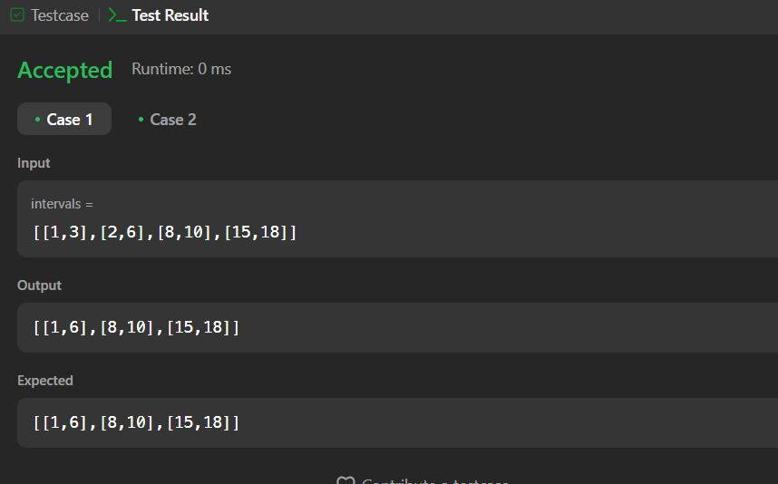

**Problem-2**

**1.Aim:**

Given the array nums after the possible rotation and an integer target, return the index of target if it is in nums, or -1 if it is not in nums.You must write an algorithm with O(log n) runtime complexity.

**2.Objective:**

* Use binary search to identify which half of the array is sorted.
* If the target lies within the sorted half, search there.
* Otherwise, search in the other half.
* Time Complexity: O(log(n))due to binary search.

## 3.Code:

## #include <vector>

## using namespace std;

## class Solution {

## public:

## int search(vector<int>& nums, int target) {

## int left = 0, right = nums.size() - 1;

## 

## while (left <= right) {

## int mid = left + (right - left) / 2;

## 

## if (nums[mid] == target) return mid;

## 

## if (nums[left] <= nums[mid]) {

## if (nums[left] <= target && target < nums[mid]) {

## right = mid - 1;

## } else {

## left = mid + 1;

## }

## } else {

## if (nums[mid] < target && target <= nums[right]) {

## left = mid + 1;

## } else {

## right = mid - 1; }}}

## 

## return -1; }

## };

## 4.Output:

## 

# Problem-3

# 1.Aim: Given an integer array nums, reorder it such that nums[0] < nums[1] > nums[2] < nums[3].

**2.Objective:**

* Develop an efficient algorithm that rearranges the elements of the array to ensure alternating peaks and valleys, thereby maintaining the given wiggle pattern.
* Ensure the implementation works within the given constraints and handles edge cases effectively.
* Optimize the algorithm to achieve the best possible time complexity for practical use.

## 3.Code:

## class Solution {

## public:

## void wiggleSort(vector<int>& nums) {

## vector<int> sorted_nums = nums;

## sort(sorted_nums.begin(), sorted_nums.end());

## int n = nums.size();

## int mid = (n - 1) / 2;

## int end = n - 1;

## for (int i = 0; i < n; i++) {

## nums[i] = (i % 2 == 0) ? sorted_nums[mid--] : sorted_nums[end--];

## }

## }

## };

## 4.Output:

# Problem-4

**1.Aim:**

Write an efficient algorithm that searches for a value target in an m x n integer matrix matrix. This matrix has the following properties:

Integers in each row are sorted in ascending from left to right.

Integers in each column are sorted in ascending from top to bottom.

**2.Objective:**

* Develop an efficient search algorithm that finds a target value in an m x n matrix while utilizing its sorted properties.
* Implement a method that ensures an optimal time complexity better than a brute-force approach.
* Utilize a binary search or step-wise elimination technique to efficiently locate the target.

## 3.Code:

## class Solution {

## public:

## bool searchMatrix(vector<vector<int>>& matrix, int target) {

## if (matrix.empty() || matrix[0].empty())

## return false;

## int m = matrix.size(), n = matrix[0].size();

## int row = 0, col = n - 1;

## while (row < m && col >= 0) {

## if (matrix[row][col] == target)

## return true;

## else if (matrix[row][col] > target)

## col--;

## else

## row++;

## }

## return false;

## }

## };

## 4.Output:

# 

# Problem-5

**1.Aim:** A peak element is an element that is strictly greater than its neighbors.

Given a 0-indexed integer array nums, find a peak element, and return its index. If the array contains multiple peaks, return the index to any of the peaks.

**2.Objective:**

* Develop an efficient algorithm to identify a peak element in an array.
* Ensure the algorithm runs in O(log n) time complexity using binary search.
* Handle edge cases where the peak might be at the beginning or end of the array.
* Allow flexibility in returning any peak element when multiple peaks exist.

## 3.Code:

## class Solution {

## public:

## int findPeakElement(vector<int>& nums) {

## int left = 0, right = nums.size() - 1;

## 

## while (left < right) {

## int mid = left + (right - left) / 2;

## if (nums[mid] > nums[mid + 1]) {

## right = mid;

## } else {

## left = mid + 1;

## }

## }

## return left;

## }

## };

## 4.Output:

## 

# Problem-6

**1.Aim:**

To find the median of two sorted arrays without merging them, using binary search, in O(log(min(m, n))) time complexity.

**2.Objective:**

* Reduce the problem size by searching only in the smaller array.
* The algorithm swaps arrays to always perform binary search on the smaller array.

## 3.Code:

## class Solution {

## public:

## double findMedianSortedArrays(vector<int>& nums1, vector<int>& nums2) {

## if (nums1.size() > nums2.size()) {

## return findMedianSortedArrays(nums2, nums1);

## }

## int x = nums1.size();

## int y = nums2.size();

## int low = 0, high = x;

## while (low <= high) {

## int partitionX = (low + high) / 2;

## int partitionY = (x + y + 1) / 2 - partitionX;

## int maxLeftX = (partitionX == 0) ? INT_MIN : nums1[partitionX - 1];

## int minRightX = (partitionX == x) ? INT_MAX : nums1[partitionX];

## int maxLeftY = (partitionY == 0) ? INT_MIN : nums2[partitionY - 1];

## int minRightY = (partitionY == y) ? INT_MAX : nums2[partitionY];

## if (maxLeftX <= minRightY && maxLeftY <= minRightX) {

## if ((x + y) % 2 == 0) {

## return (max(maxLeftX, maxLeftY) + min(minRightX, minRightY)) / 2.0;

## } else {

## return max(maxLeftX, maxLeftY);

## }

## } else if (maxLeftX > minRightY) {

## high = partitionX - 1;

## } else {

## low = partitionX + 1;

## }

## }

## return 0.0;

## }

## };

## 4.Output:

## 

# Problem-7

**1.Aim:**

To efficiently find the k-th smallest element in an n × n sorted matrix, where each row and column is sorted in ascending order, using Binary Search

**2.Objective:**

* Implement an approach better than O(n²) (which is the brute-force approach).
* Implement Binary Search or Min-Heap (Priority Queue) to achieve an efficient solution.

## 3.Code:

## class Solution {

## public:

## int kthSmallest(vector<vector<int>>& matrix, int k) {

## int n = matrix.size();

## int left = matrix[0][0], right = matrix[n - 1][n - 1];

## while (left < right) {

## int mid = left + (right - left) / 2;

## int count = countLessEqual(matrix, mid, n);

## if (count < k) {

## left = mid + 1;

## } else {

## right = mid;

## }

## }

## return left;

## }

## private:

## int countLessEqual(vector<vector<int>>& matrix, int mid, int n) {

## int count = 0, row = n - 1, col = 0;

## while (row >= 0 && col < n) {

## if (matrix[row][col] <= mid) {

## count += (row + 1); // All elements in this column above are also ≤ mid

## col++; // Move right

## } else {

## row--; // Move up

## }

## }

## return count;

## }

## };

## 4.Output:

## 