# Experiment-3

**Name:** Riya Thakur **UID:** 22BET10171

**Branch:** BE-IT **Section/Group:** 22BET_IOT-702/A

**Semester:** 6th **Date of Performance:**31/01/25 **Subject Name:** AP LAB-II **Subject Code:** 22ITP-351

## Problem-1

**1.Aim:**

Given head, the head of a linked list, determine if the linked list has a cycle in it.

There is a cycle in a linked list if there is some node in the list that can be reached again by continuously following the next pointer. Internally, pos is used to denote the index of the node that tail's next pointer is connected to. Note that pos is not passed as a parameter.

Return true if there is a cycle in the linked list. Otherwise, return false.

**2.Objective:**

* There is a cycle in a linked list if there is some node in the list that can be reached again by continuously following the next pointer.
* Internally, pos is used to denote the index of the node that tail's next pointer is connected to.

Note that pos is not passed as a parameter.

* Return true if there is a cycle in the linked list. Otherwise, return false

**3.Code:**

class Solution { public:

bool hasCycle(ListNode* head) {

ListNode* slow = head; ListNode* fast = head; while (fast != nullptr && fast->next != nullptr) { slow = slow->next; fast = fast->next->next; if (slow == fast) return true;

} return false;

}

};

**4.Output:**



**Fig.1.Detect a cycle in a linkedlist**

## Problem-2

**1.Aim:**

Reverse a linked List- the head of a singly linked list and two integers left and right where left <= right, reverse the nodes of the list from position left to position right, and return the reversed list.

**2.Objective:**

* Given the head of a singly linked list and two integers left and right where left <= right, reverse the nodes of the list from position left to position right,
* return the reversed list.

**3.Code:**

class Solution {

public:

ListNode* reverseBetween(ListNode* head, int left, int right) { if (!head || left == right) return head;

ListNode* dummy = new ListNode(0); dummy->next = head;

ListNode* prev = dummy;

for (int i = 1; i < left; ++i) { prev = prev->next;

}

ListNode* start = prev->next;

ListNode* then = start->next;

for (int i = 0; i < right - left; ++i) { start->next = then->next; then->next = prev->next; prev->next = then; then = start->next;

}

return dummy->next;

}

};

**4.Output:**



**Fig.2:Reverse LinkedList**

# Problem-3

**1.Aim:** Rotate List-Given the head of a linked list, rotate the list to the right by k places.

**2.Objective:**

* Given the head of a singly linked list and two integers left and right where left <= right, reverse the nodes of the list from position left to position right,
* return the reversed list.

**3.Code:**

class Solution { public:

ListNode* rotateRight(ListNode* head, int k) { if(head==NULL ||head->next==NULL)return head;

int n=0;//n is length

ListNode* temp=head; ListNode* tail=NULL; while(temp!=NULL){ if(temp->next==NULL)tail=temp; temp=temp->next;

n++;

}

k=k%n; if(k==0)return head;

//I have to place temp at (n-k) position temp=head; for(int i=1;i<n-k;i++)

{

temp=temp->next;

}

tail->next=head; head=temp->next; temp->next=NULL;

return head;

}

};

**4.Output:**



**Fig.3:Rotate List**

# Problem-4

**1.Aim:** The aim of this code is to merge k sorted linked lists into a single sorted linked list efficiently.

**2.Objective:**

* Efficient Merging: Use a min-heap (priority queue) to merge k sorted linked lists while maintaining the overall sorted order.
* Optimize Time Complexity: Achieve an optimal time complexity of O(N log k), where N is the total number of elements and k is the number of lists.

**3.Code:**

class Solution { public:

ListNode* mergeKLists(vector<ListNode*>& lists) { priority_queue<ListNode*, vector<ListNode*>, Compare> minHeap;

// Push the head of each linked list into the min-heap for (ListNode* list : lists) { if (list) minHeap.push(list);

}

ListNode dummy(0); // Dummy node to simplify list construction ListNode* tail = &dummy;

// Extract the smallest element and insert the next element from that list while (!minHeap.empty()) {

ListNode* node = minHeap.top(); minHeap.pop(); tail->next = node; tail = tail->next;

if (node->next) { minHeap.push(node->next);

}

}

return dummy.next;

}

};

**4.Output:**

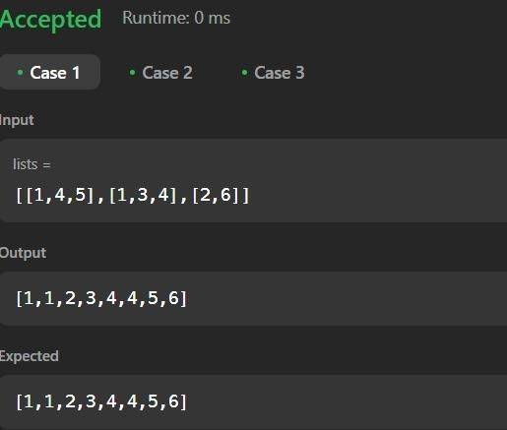

**Fig.4:Single Sorted LinkedList**

# Problem-5

**1.Aim:** Given the head of a linked list, return the list after sorting it in ascending order.

**2.Objective:**

* Implement an Efficient Sorting Algorithm.
* Implement an efficient algorithm like Merge Sort to achieve O(N log N) time complexity.

**3.Code:**  class Solution { public:

// Function to find the middle node of the linked list

ListNode* findMiddle(ListNode* head) {

ListNode* slow = head;

ListNode* fast = head;

ListNode* prev = nullptr;

while (fast && fast->next) { prev = slow; slow = slow->next; fast = fast->next->next;

}

if (prev) prev->next = nullptr; // Split the list into two halves return slow;

}

// Function to merge two sorted linked lists ListNode* merge(ListNode* l1, ListNode* l2) {

if (!l1) return l2; if (!l2) return l1;

if (l1->val < l2->val) { l1->next = merge(l1->next, l2); return l1; } else { l2->next = merge(l1, l2->next); return l2;

}

}

// Function to sort the linked list using merge sort ListNode* sortList(ListNode* head) { if (!head || !head->next) return head; // Base case: 0 or 1 node

ListNode* mid = findMiddle(head); // Find middle

ListNode* left = sortList(head); // Sort first half

ListNode* right = sortList(mid); // Sort second half

return merge(left, right); // Merge both sorted halves

}

};

**4.Output:**

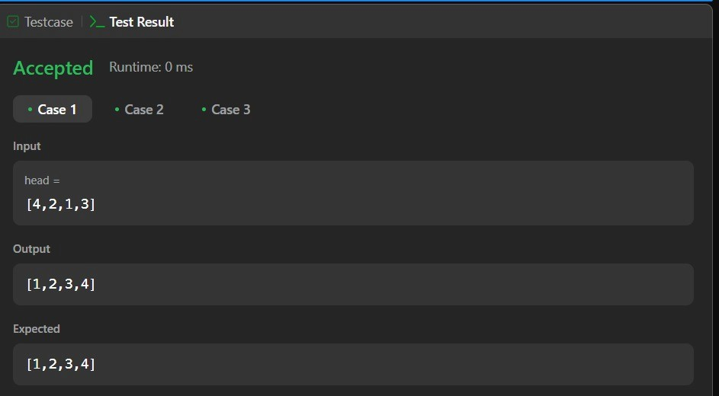

**Fig.5:Sort List HW**