**Experiment - 7**

**Name: Armaan UID: 22BCS12007**

**Aim:** To solve leet code problems

Dynamic programming(Basic problems)

1. Problem : Climbing stairs

Code:

class Solution {

public int climbStairs(int n) {

if (n <= 2) return n;

int[] dp = new int[n + 1];

dp[1] = 1;

dp[2] = 2;

for (int i = 3; i <= n; i++) {

dp[i] = dp[i - 1] + dp[i - 2];

}

return dp[n];

}

}

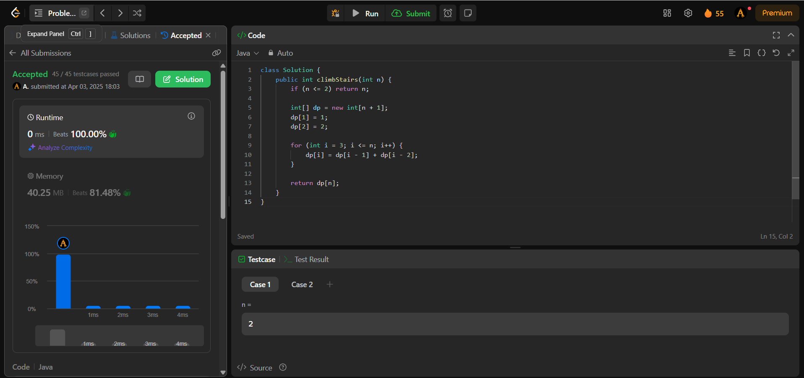Output :

1. Problem: Maximum subarray

Code:

class Solution {

public int maxSubArray(int[] nums) {

int res = nums[0];

int total = 0;

for (int n : nums) {

if (total < 0) {

total = 0;

}

total += n;

res = Math.max(res, total);

}

return res;

}

}

Output:

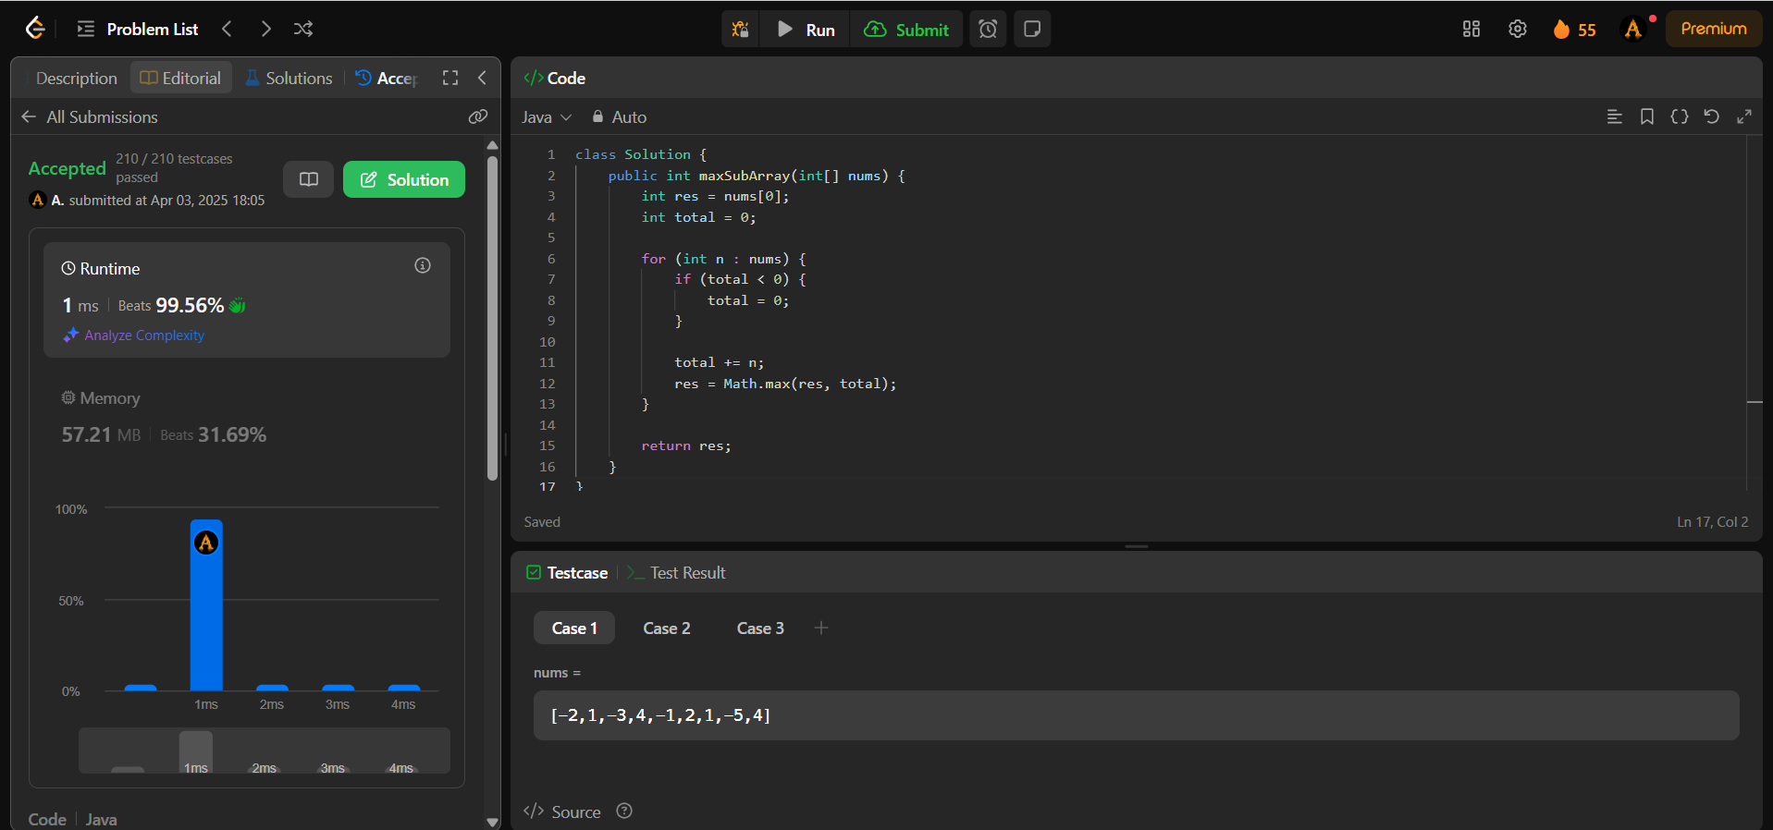

**Dynamic Programming (Intermediate Problems)**

1. Problem: Jump game

Code:

class Solution {

public boolean canJump(int[] nums) {

int goal = nums.length - 1;

for (int i = nums.length - 2; i >= 0; i--) {

if (i + nums[i] >= goal) {

goal = i;

}

}

return goal == 0;

}

}

Output:

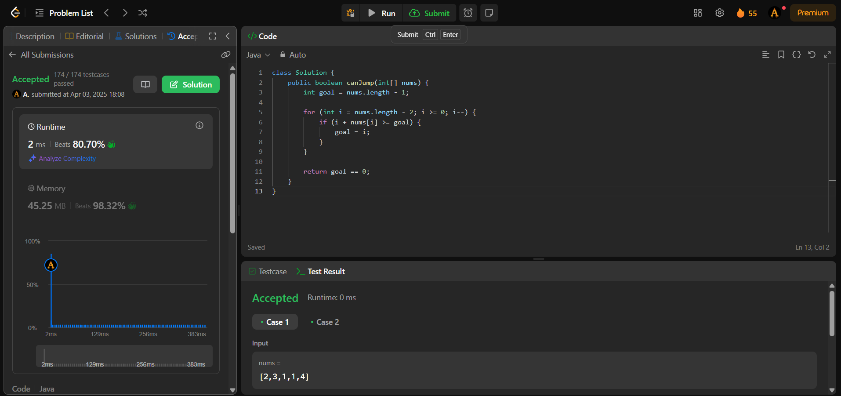

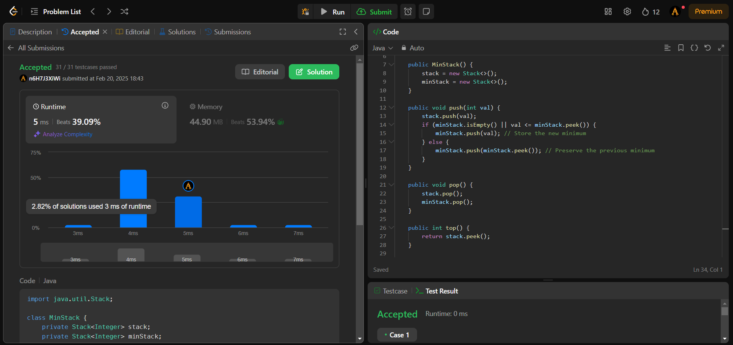

1. Problem: Unique Paths

Code:

class Solution {

    public int uniquePaths(int m, int n) {

        int[] aboveRow = new int[n];

        Arrays.fill(aboveRow, 1);

        for (int row = 1; row < m; row++) {

            int[] currentRow = new int[n];

            Arrays.fill(currentRow, 1);

            for (int col = 1; col < n; col++) {

                currentRow[col] = currentRow[col - 1] + aboveRow[col];

            }

            aboveRow = currentRow;

        }

        return aboveRow[n - 1];

    }

}

Output:

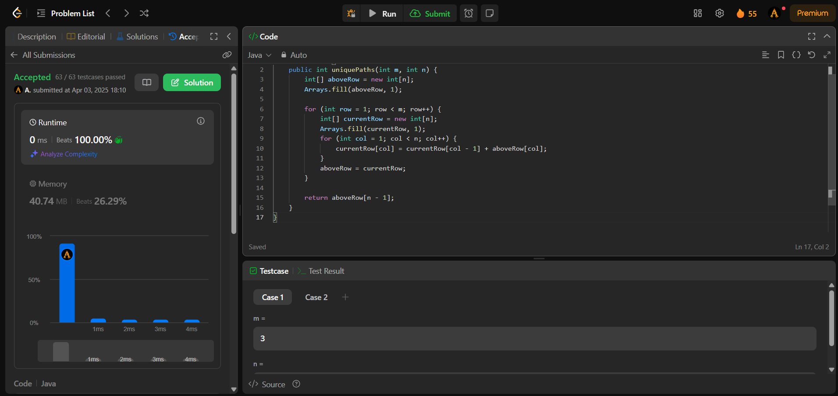

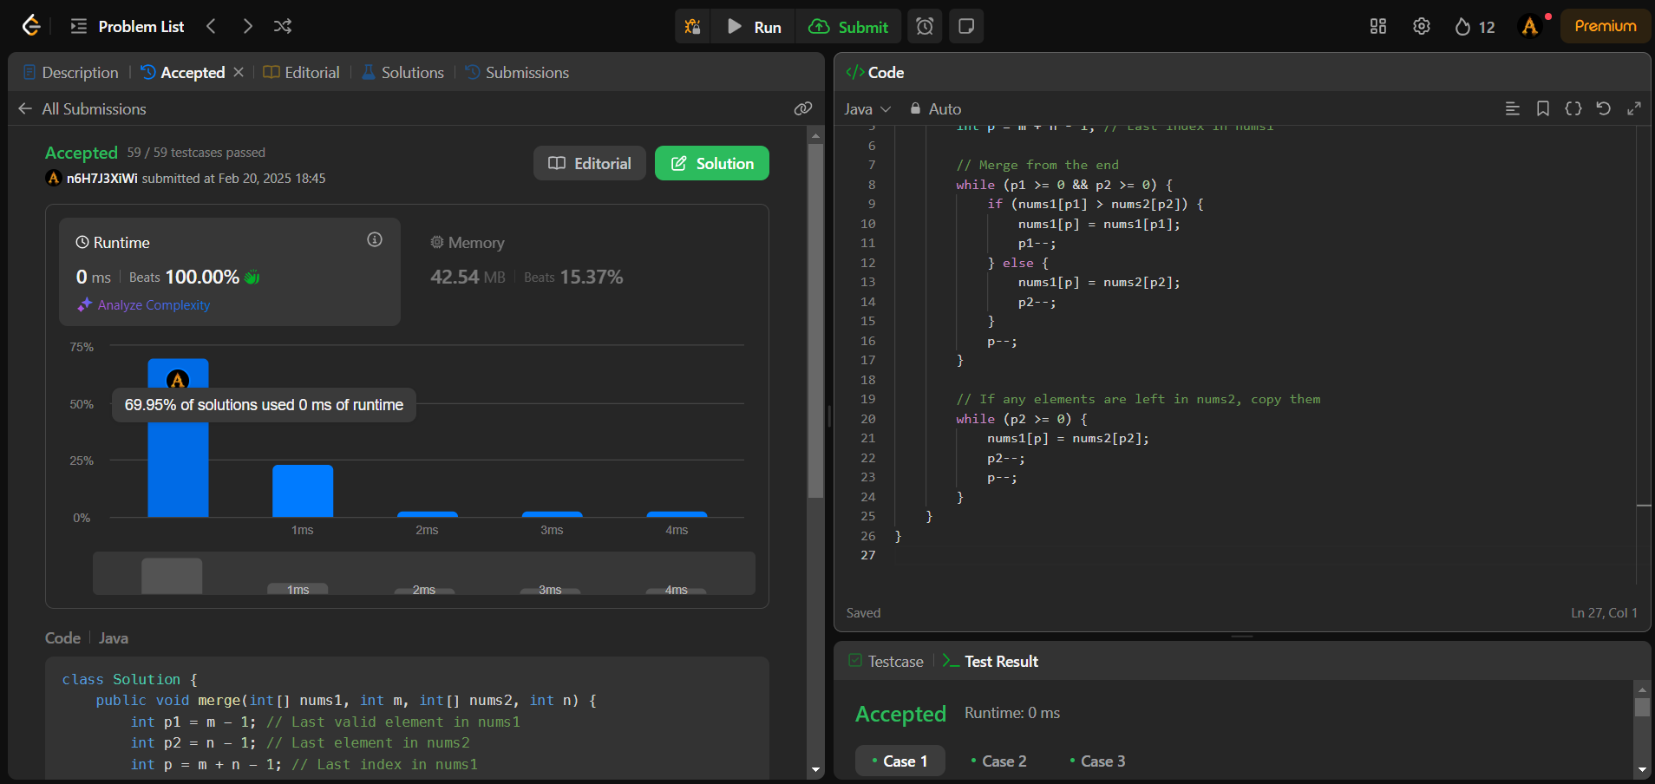

**Dynamic Programming (Advanced Problems)**

1. Problem: Maximum product subarrays

Code:

class Solution {

public int maxProduct(int[] nums) {

int res = Integer.MIN_VALUE;

for (int n : nums) {

res = Math.max(res, n);

}

int curMax = 1, curMin = 1;

for (int n : nums) {

int temp = curMax * n;

curMax = Math.max(temp, Math.max(curMin * n, n));

curMin = Math.min(temp, Math.min(curMin * n, n));

res = Math.max(res, curMax);

}

return res;

}

}

Output:

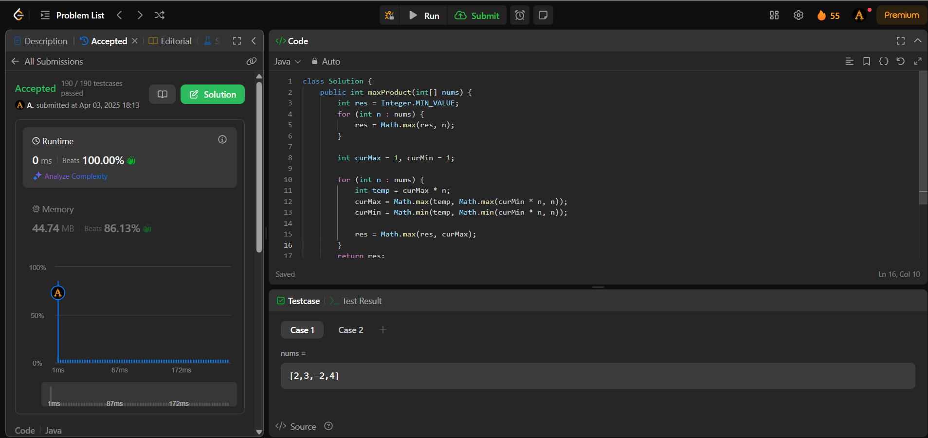

1. Problem: Decode ways

Code:

class Solution {

public int numDecodings(String s) {

if (s.charAt(0) == '0') {

return 0;

}

int n = s.length();

int[] dp = new int[n + 1];

dp[0] = dp[1] = 1;

for (int i = 2; i <= n; i++) {

int one = Character.getNumericValue(s.charAt(i - 1));

int two = Integer.parseInt(s.substring(i - 2, i));

if (1 <= one && one <= 9) {

dp[i] += dp[i - 1];

}

if (10 <= two && two <= 26) {

dp[i] += dp[i - 2];

}

}

return dp[n];

}

}

Output:

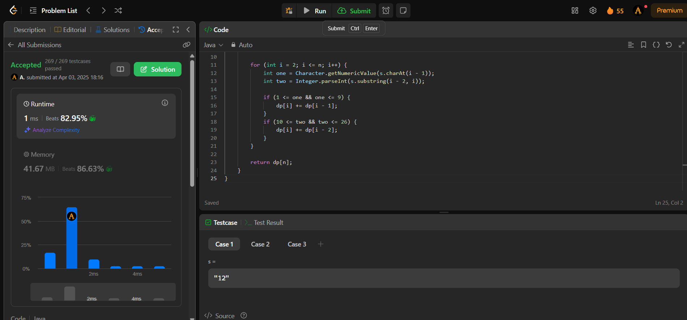

**Dynamic Programming (More Challenges)**

1. Problem: Perfect Squares

Code:

class Solution {

public int numSquares(int n) {

int[] dp = new int[n + 1];

Arrays.fill(dp, Integer.MAX_VALUE);

dp[0] = 0;

for (int i = 1; i <= n; ++i) {

int min_val = Integer.MAX_VALUE;

for (int j = 1; j * j <= i; ++j) {

min_val = Math.min(min_val, dp[i - j * j] + 1);

}

dp[i] = min_val;

}

return dp[n];

}

}

Output:

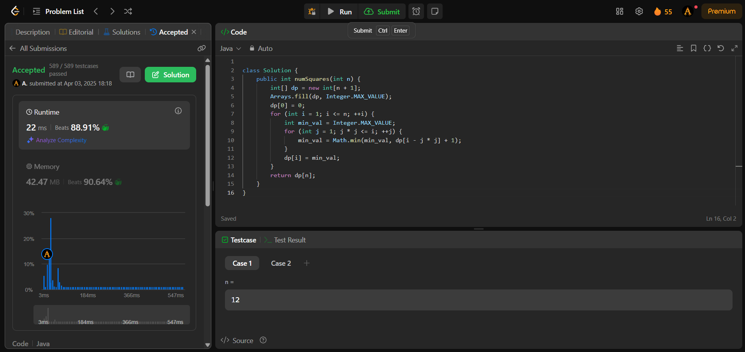

1. Problem: Word Break

Code:

class Solution {

public boolean wordBreak(String s, List<String> wordDict) {

boolean[] dp = new boolean[s.length() + 1];

dp[0] = true;

for (int i = 1; i <= s.length(); i++) {

for (String w : wordDict) {

int start = i - w.length();

if (start >= 0 && dp[start] && s.substring(start, i).equals(w)) {

dp[i] = true;

break;

}

}

}

return dp[s.length()];

}

}

Output:

