**Experiment 7**

**Student Name: Ramit Chaturvedi UID:22BCS15597**

**Branch: CSE Section/Group:614-B**

**Semester: 6 Date of Performance:07-04-25**

**Subject Name: AP LAB-II Subject Code: 22CSP-351**

Q 1) <https://leetcode.com/problems/climbing-stairs/submissions/1595821802/>

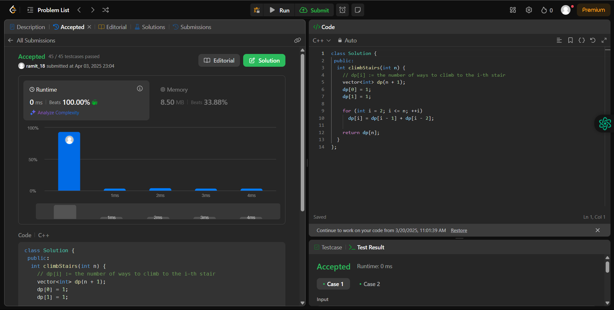

Q 2) <https://leetcode.com/problems/maximum-subarray/>

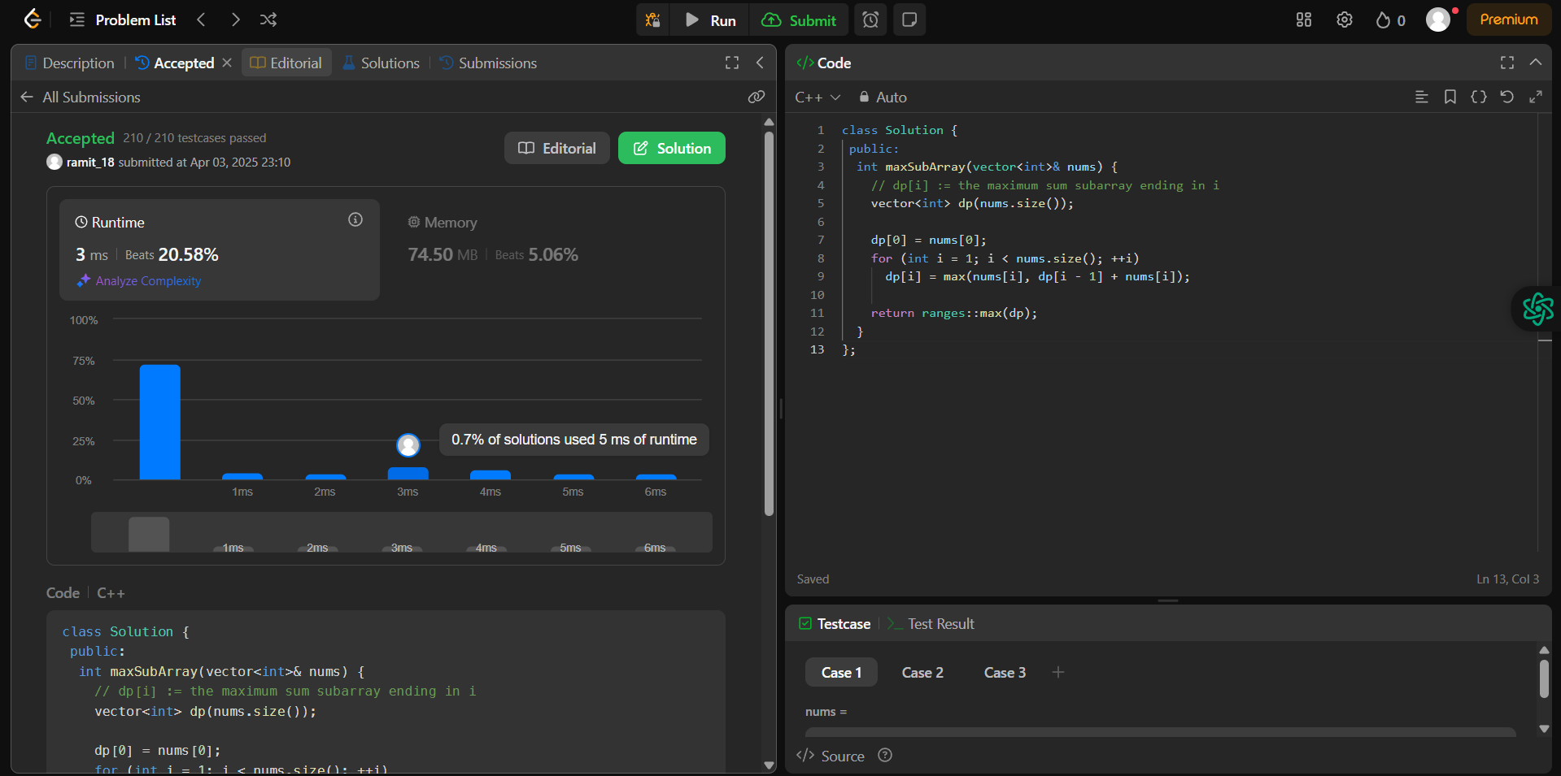

3) <https://leetcode.com/problems/house-robber/submissions/1595830498/>

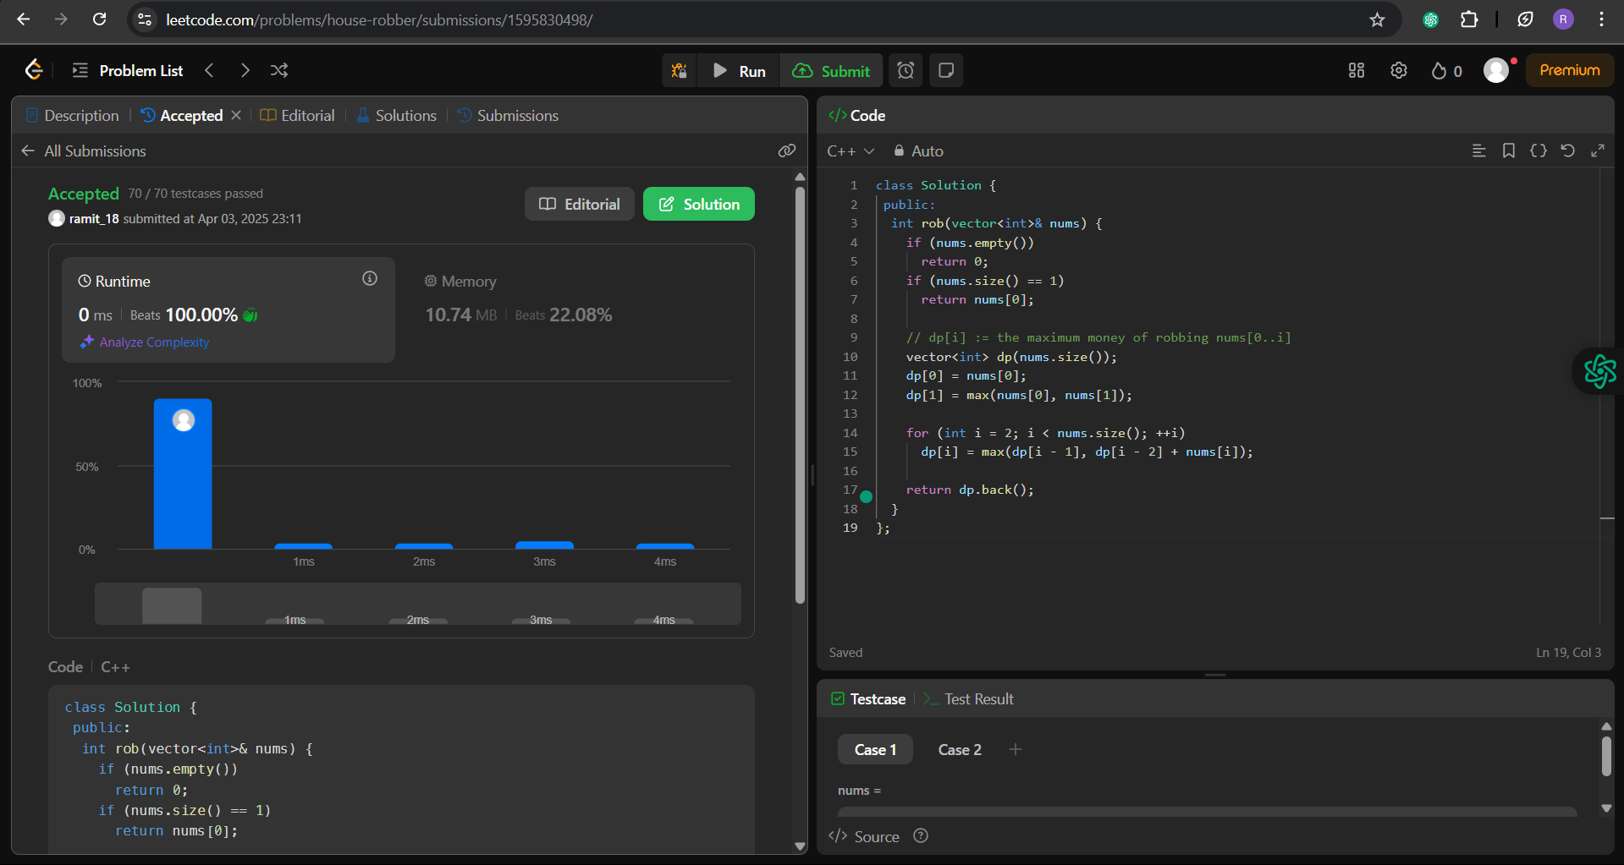

4) https://leetcode.com/problems/jump-game/submissions/1595834694/

