**Experiment - 1**

**Name: Armaan UID: 22BCS12007**

**Aim:** To solve JAVA problems

1. Problem : String Analysis (Easy Level)

Code:

import java.util.Scanner;

public class StringAnalysis {

public static void main(String[] args) {

Scanner scanner = new Scanner(System.in);

System.out.print("Enter a string: ");

String input = scanner.nextLine();

int vowels = 0, consonants = 0, digits = 0, specialChars = 0;

input = input.toLowerCase(); // Convert to lowercase for easier comparison

for (int i = 0; i < input.length(); i++) {

char ch = input.charAt(i);

if (Character.isLetter(ch)) {

if ("aeiou".indexOf(ch) != -1) {

vowels++;

} else {

consonants++;

}

} else if (Character.isDigit(ch)) {

digits++;

} else if (!Character.isWhitespace(ch)) {

specialChars++;

}

}

System.out.println("Vowels: " + vowels);

System.out.println("Consonants: " + consonants);

System.out.println("Digits: " + digits);

System.out.println("Special Characters: " + specialChars);

}

}

Output :

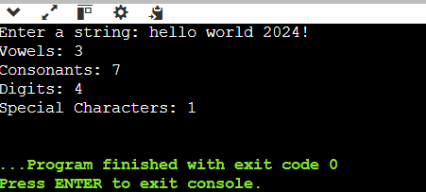

1. Problem: Matrix Operations (Medium Level)

Code:

import java.util.Scanner;

public class MatrixOperations {

public static void main(String[] args) {

Scanner scanner = new Scanner(System.in);

// Input Matrix 1

System.out.println("Enter rows and columns of Matrix 1:");

int r1 = scanner.nextInt();

int c1 = scanner.nextInt();

int[][] matrix1 = new int[r1][c1];

System.out.println("Enter elements of Matrix 1:");

for (int i = 0; i < r1; i++)

for (int j = 0; j < c1; j++)

matrix1[i][j] = scanner.nextInt();

// Input Matrix 2

System.out.println("Enter rows and columns of Matrix 2:");

int r2 = scanner.nextInt();

int c2 = scanner.nextInt();

int[][] matrix2 = new int[r2][c2];

System.out.println("Enter elements of Matrix 2:");

for (int i = 0; i < r2; i++)

for (int j = 0; j < c2; j++)

matrix2[i][j] = scanner.nextInt();

// Addition and Subtraction only if dimensions match

if (r1 == r2 && c1 == c2) {

System.out.println("\nAddition:");

printMatrix(add(matrix1, matrix2));

System.out.println("\nSubtraction:");

printMatrix(subtract(matrix1, matrix2));

} else {

System.out.println("\nAddition and Subtraction not possible due to dimension mismatch.");

}

// Multiplication condition: c1 == r2

if (c1 == r2) {

System.out.println("\nMultiplication:");

printMatrix(multiply(matrix1, matrix2));

} else {

System.out.println("\nMultiplication not possible due to dimension mismatch.");

}

}

static int[][] add(int[][] a, int[][] b) {

int rows = a.length, cols = a[0].length;

int[][] result = new int[rows][cols];

for (int i = 0; i < rows; i++)

for (int j = 0; j < cols; j++)

result[i][j] = a[i][j] + b[i][j];

return result;

}

static int[][] subtract(int[][] a, int[][] b) {

int rows = a.length, cols = a[0].length;

int[][] result = new int[rows][cols];

for (int i = 0; i < rows; i++)

for (int j = 0; j < cols; j++)

result[i][j] = a[i][j] - b[i][j];

return result;

}

static int[][] multiply(int[][] a, int[][] b) {

int r1 = a.length, c1 = a[0].length, c2 = b[0].length;

int[][] result = new int[r1][c2];

for (int i = 0; i < r1; i++)

for (int j = 0; j < c2; j++)

for (int k = 0; k < c1; k++)

result[i][j] += a[i][k] * b[k][j];

return result;

}

static void printMatrix(int[][] matrix) {

for (int[] row : matrix) {

for (int val : row)

System.out.print(val + " ");

System.out.println();

}

}

}

Output:

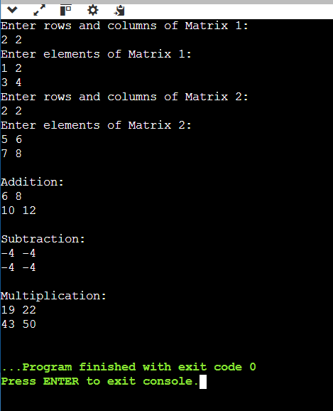

1. Problem: Basic Banking System (Hard Level)

Code:

import java.util.Scanner;

class BankAccount {

// Private variables (Encapsulation)

private String name;

private String accountNumber;

private double balance;

// Constructor

public BankAccount(String name, String accountNumber, double initialBalance) {

this.name = name;

this.accountNumber = accountNumber;

this.balance = initialBalance;

}

// Getters

public String getName() {

return name;

}

public String getAccountNumber() {

return accountNumber;

}

public double getBalance() {

return balance;

}

// Setters

public void setName(String name) {

this.name = name;

}

// Deposit method

public void deposit(double amount) {

if (amount > 0) {

balance += amount;

System.out.println("Deposit successful! Current Balance: " + balance);

} else {

System.out.println("Invalid deposit amount.");

}

}

// Withdraw method

public void withdraw(double amount) {

if (amount > balance) {

System.out.println("Error: Insufficient funds. Current Balance: " + balance);

} else if (amount <= 0) {

System.out.println("Invalid withdrawal amount.");

} else {

balance -= amount;

System.out.println("Withdrawal successful! Current Balance: " + balance);

}

}

}

public class BankingSystem {

public static void main(String[] args) {

Scanner scanner = new Scanner(System.in);

// Create Account

System.out.println("Create Account:");

System.out.print("Name: ");

String name = scanner.nextLine();

System.out.print("Account Number: ");

String accountNumber = scanner.nextLine();

System.out.print("Initial Balance: ");

double initialBalance = scanner.nextDouble();

BankAccount account = new BankAccount(name, accountNumber, initialBalance);

// Perform operations

System.out.print("\nDeposit: ");

double depositAmount = scanner.nextDouble();

account.deposit(depositAmount);

System.out.print("Withdraw: ");

double withdrawAmount = scanner.nextDouble();

account.withdraw(withdrawAmount);

scanner.close();

}

}

Output:

