**Name: Udit**

**UID: 22BCS16515**

**Q 1.) Longest Nice Substring (leet-1768)**

**Sol:**

class Solution {

    public String longestNiceSubstring(String s) {

        Set<Character> charSet = new HashSet<>();

        for (int i = 0; i < s.length(); i++) {

            charSet.add(s.charAt(i));

        }

        for (int i = 0; i < s.length(); i++) {

            if (charSet.contains(Character.toUpperCase(s.charAt(i))) &&

                    charSet.contains(Character.toLowerCase(s.charAt(i)))) {

                continue;

            }

            String s1 = longestNiceSubstring(s.substring(0, i));

            String s2 = longestNiceSubstring(s.substring(i+1));

            return s1.length()>= s2.length() ? s1 : s2;

        }

        return s;

    } }

**OUTPUT:**

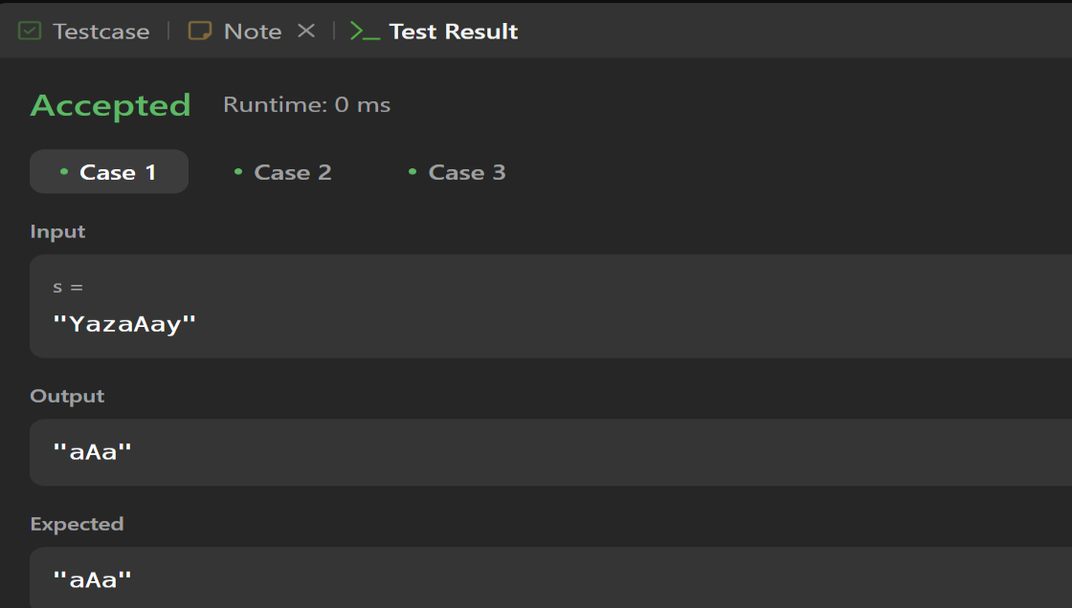

**Q 2). Reverse Bits (leet-190)**

**Solution:**

public class Solution {

    public int reverseBits(int n) {

        int result = 0;

        for(int i = 0; i<32; i++){

            int lsb = n & 1;

            int reverse = lsb <<(31-i);

             result = result | reverse;

             n = n >> 1;

        }

        return result;

    }

}

**OUTPUT:**

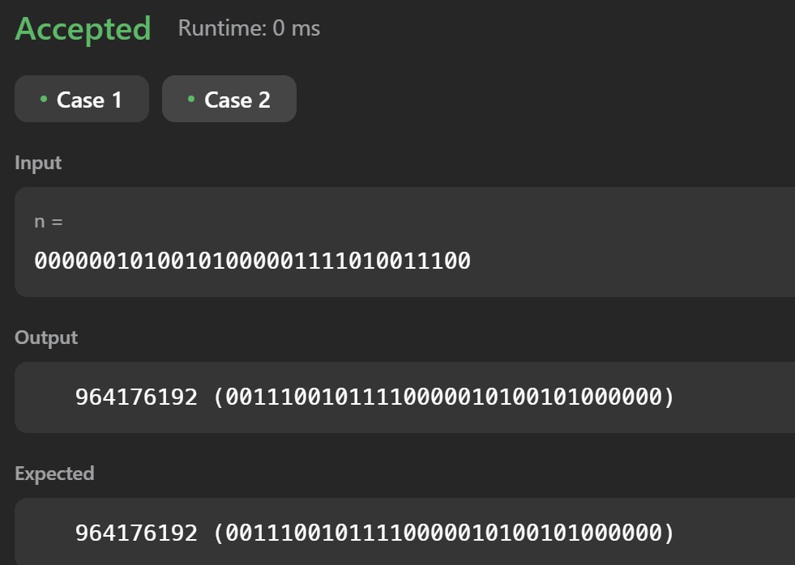

**Q3). Number of 1 Bits (leet-191)**

**Solution:**

class Solution {

    public int hammingWeight(int n) {

        int count = 0;

        while(n>0){

            if((n & 1) != 0){

                count++;

            }

            n = n>>1;

        }

        return count;

    }

}

**OUTPUT:**

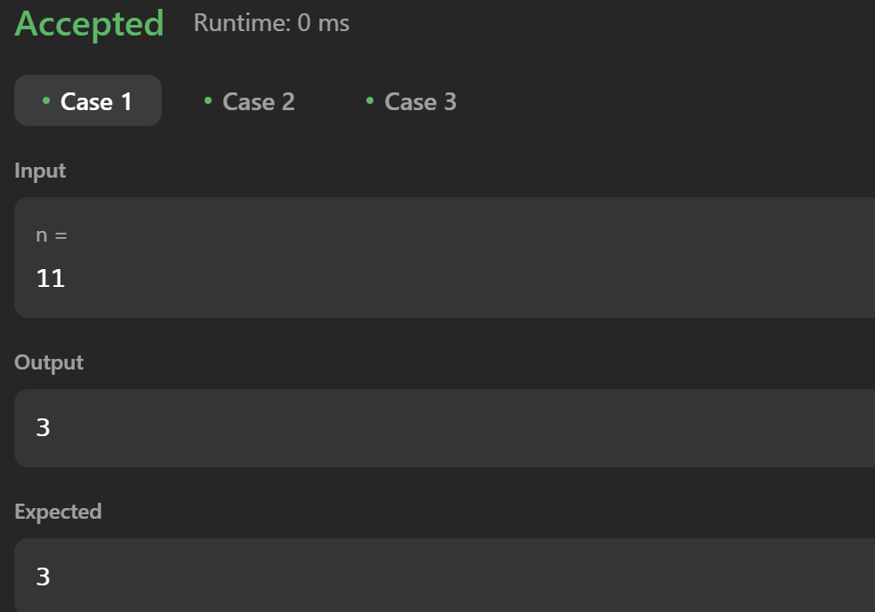

**Q 4). Maximum Subarray(leet-53)**

**Solution:**

class Solution {

public int maxSubArray(int[] nums) {

int maxSum = Integer.MIN_VALUE;

int currentSum = 0;

for (int i = 0; i < nums.length; i++) {

currentSum += nums[i];

if (currentSum > maxSum) {

maxSum = currentSum;

}

if (currentSum < 0) {

currentSum = 0;

}

}

return maxSum;

}

}

**OUTPUT:**

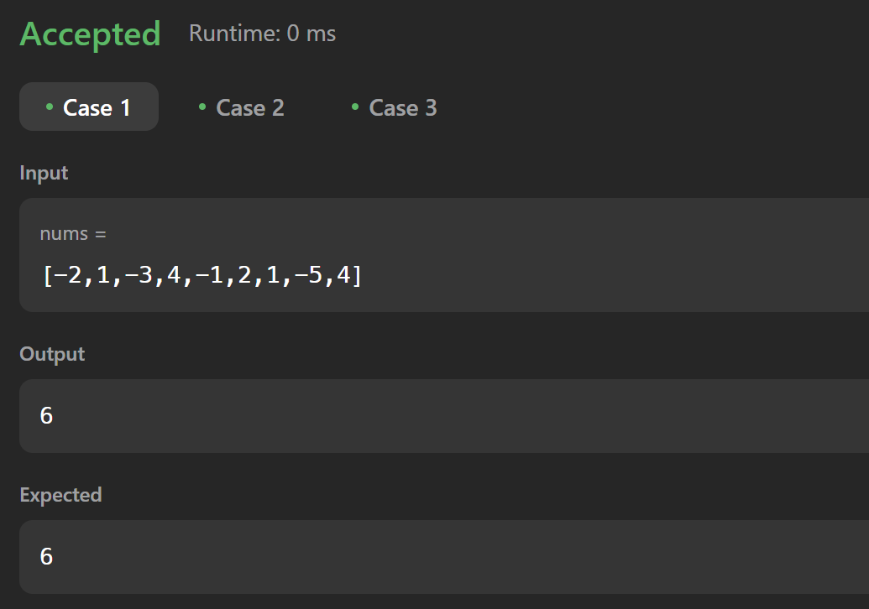

**Q 5 Search a 2D Matrix II (leet-240)**

public class Solution {

    public boolean searchMatrix(int[][] matrix, int target) {

        int rows = matrix.length;

        int cols = matrix[0].length;

        int r = rows - 1;

        int c = 0;

        while (r >= 0 && c < cols) {

            if (matrix[r][c] > target) {

                r --;

            } else if (matrix[r][c] < target) {

                c ++;

            } else {

                return true;

            }

        }

        return false;

    }

}

**OUTPUT:**

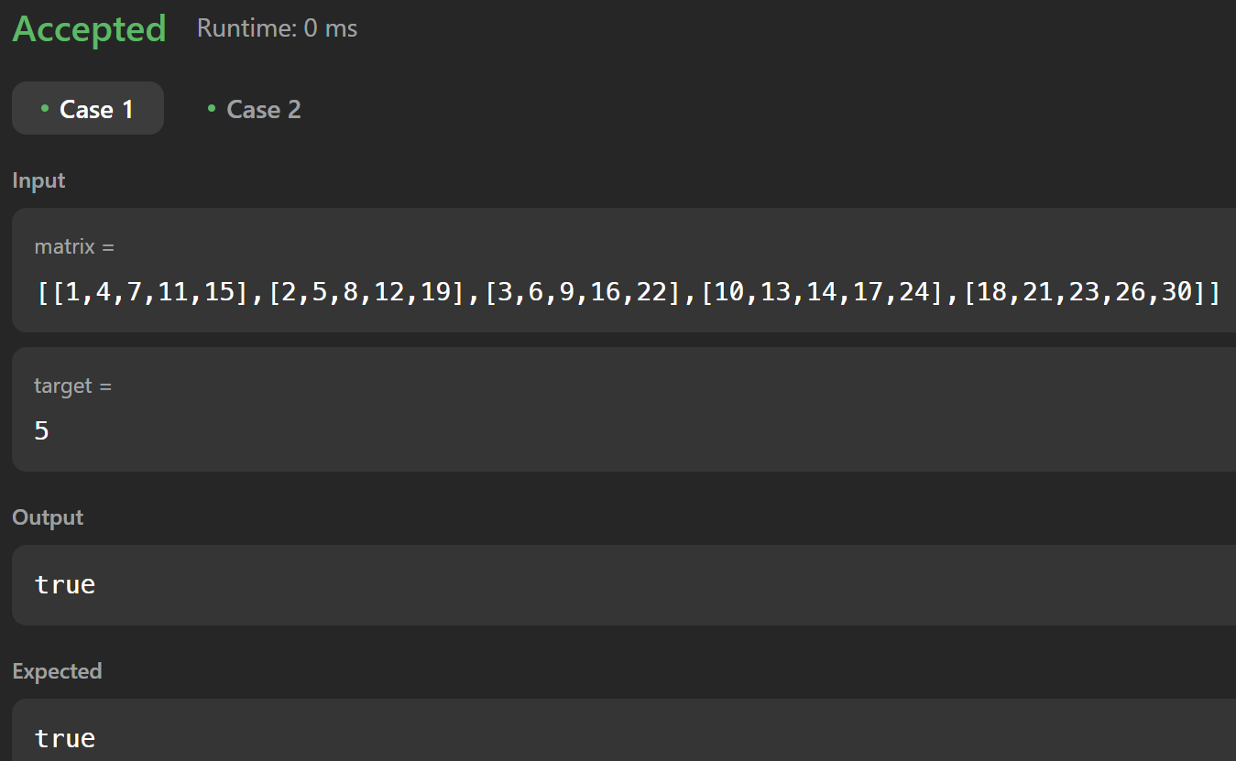

**Q 6 Super Pow (leet-372)**

**Solution:**

class Solution {

    public int superPow(int a, int[] b) {

        int num=0;

        for(int i:b){

            num=(num*10+i)%1140;

        }

        return binexpo(a,num,1337);

    }

    public int binexpo(int a, int b, int m){

        a%=m;

        int res=1;

        while(b>0){

            if((b&1)==1)

                res=(res*a)%m;

            a=(a*a)%m;

            b>>=1;

        }

        return res;

    }

}

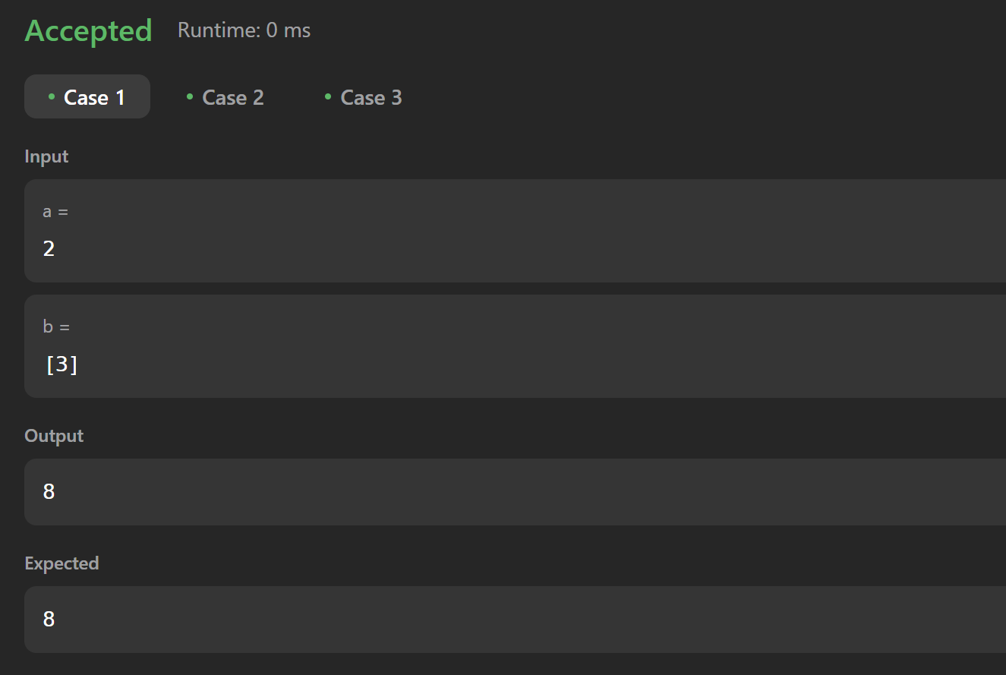**OUTPUT:**

**Q 7 Beautiful Array(leet-932)**

class Solution {

public int[] beautifulArray(int N) {

int[] res = new int[N];

if (N == 1)

{

return new int[] {1};

}

else if (N == 2)

{

return new int[] {1, 2};

}

else

{

int[] odds = beautifulArray((N + 1) / 2);

int[] even = beautifulArray(N / 2);

for (int i = 0; i < odds.length; i ++)

{

res[i] = odds[i] * 2 - 1;

}

for (int j = 0; j < even.length; j ++)

{

res[odds.length + j] = even[j] * 2;

}

}

return res;

}

}

**OUTPUT:**

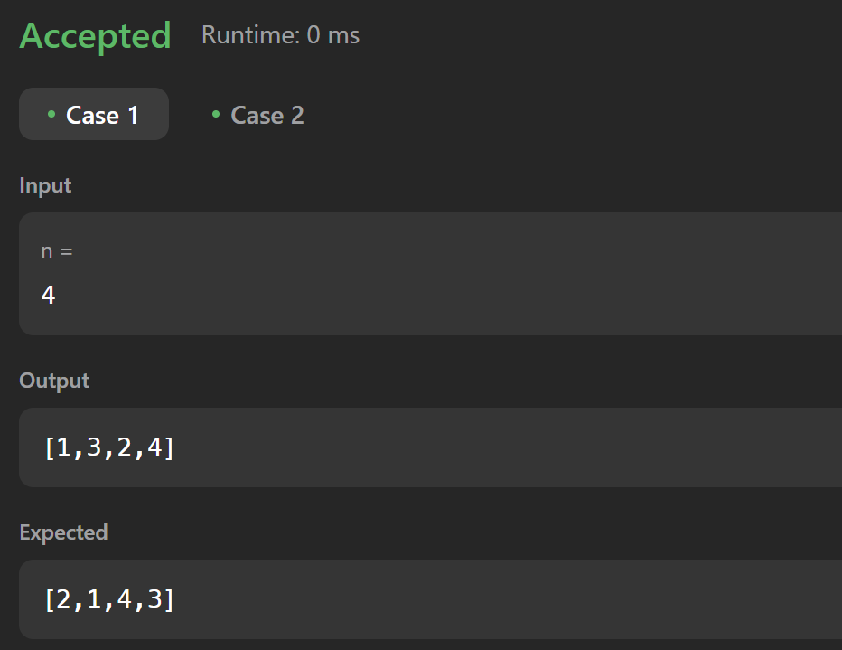

**Q 8 The Skyline Problem (leet-218)**

class Solution {

public List<List<Integer>> getSkyline(int[][] buildings) {

List<List<Integer>> list = new ArrayList<>();

List<int[]> lines = new ArrayList<>();

for (int[] building: buildings) {

lines.add(new int[] {building[0], building[2]});

lines.add(new int[] {building[1], -building[2]});

}

Collections.sort(lines, (a, b)->a[0]==b[0]?b[1]-a[1]:a[0]-b[0]);

TreeMap<Integer, Integer> map = new TreeMap<>();

map.put(0, 1);

int prev=0;

for (int[] line: lines) {

if (line[1]>0) {

map.put(line[1], map.getOrDefault(line[1], 0)+1);

} else {

int f = map.get(-line[1]);

if (f==1) map.remove(-line[1]);

else map.put(-line[1], f-1);

}

int curr = map.lastKey();

if (curr!=prev) {

list.add(Arrays.asList(line[0], curr));

prev=curr;

}

}

return list;

}

}

**OUTPUT:**

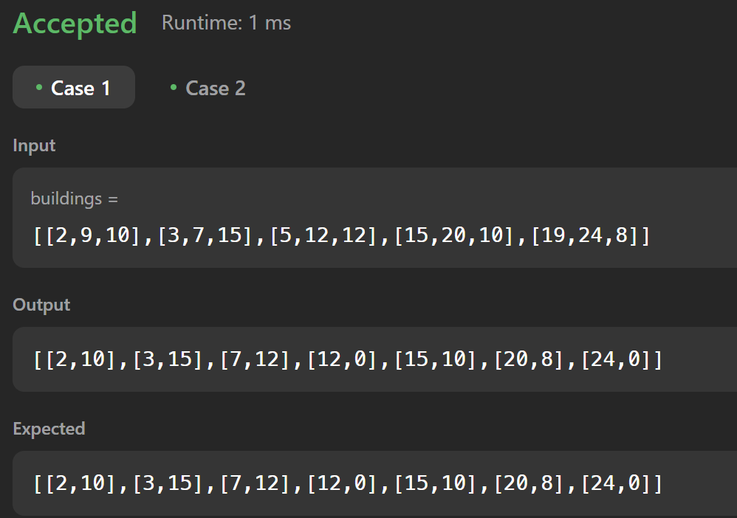

**Q 9 Reverse Pairs (leet-493)**

class Solution {

    public int reversePairs(int[] nums) {

        int ans = 0;

        List<Long> res = new ArrayList<>();

        res.add((long) nums[nums.length - 1] * 2);

        for (int i = nums.length - 2; i >= 0; i--) {

            ans += LessThanx(res, nums[i]);

            update(res, (long) nums[i] * 2);

        }

        return ans;

    }

    private int LessThanx(List<Long> res, long val) {

        if (res.get(0) >= val) {

            return 0;

        }

        if (res.get(res.size() - 1) < val) {

            return res.size();

        }

        int lo = 0, hi = res.size() - 1;

        while (lo < hi) {

            int mid = (lo + hi) / 2;

            if (res.get(mid) < val) {

                lo = mid + 1;

            } else {

                hi = mid;

            }

        }

        return lo;

    }

    private void update(List<Long> res, long val) {

        int index = Collections.binarySearch(res, val);

        if (index < 0) {

            index = -(index + 1);

        }

        res.add(index, val);

    }

}

**OUTPUT:**

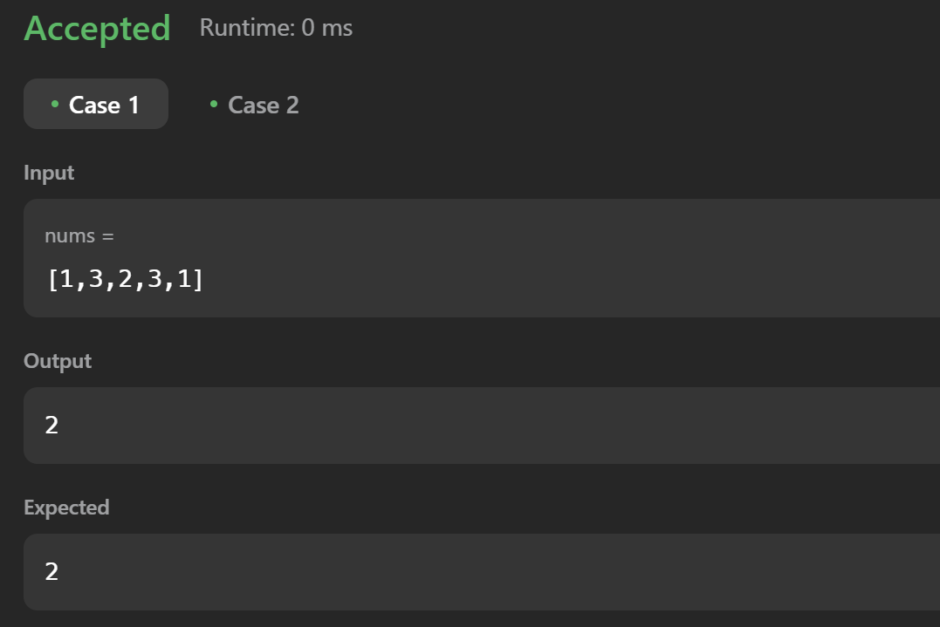

**Q 10 Longest Increasing Subsequence II (leet-2407)**

class Solution {

public int lengthOfLIS(int[] nums, int k) {

SegmentTree root = new SegmentTree(1, 100000);

int res = 0;

for (int num : nums) {

int preMax = root.rangeMaxQuery(root, num - k, num - 1);

root.update(root, num, preMax + 1);

res = Math.max(res, preMax + 1);

}

return res;

}

}

class SegmentTree {

SegmentTree left, right;

int start, end, val;

public SegmentTree(int start, int end) {

this.start = start;

this.end = end;

setup(this, start, end);

}

public void setup(SegmentTree node, int start, int end) {

if (start == end) return;

int mid = start + (end - start) / 2;

if (node.left == null) {

node.left = new SegmentTree(start, mid);

node.right = new SegmentTree(mid + 1, end);

}

setup(node.left, start, mid);

setup(node.right, mid + 1, end);

node.val = Math.max(node.left.val, node.right.val);

}

public void update(SegmentTree node, int index, int val) {

if (index < node.start || index > node.end) return;

if (node.start == node.end && node.start == index) {

node.val = val;

return;

}

update(node.left, index, val);

update(node.right, index, val);

node.val = Math.max(node.left.val, node.right.val);

}

public int rangeMaxQuery(SegmentTree node, int start, int end) {

if (node.start > end || node.end < start) return 0;

if (node.start >= start && node.end <= end) return node.val;

return Math.max(rangeMaxQuery(node.left, start, end), rangeMaxQuery(node.right, start, end));

}

}

**OUTPUT:**

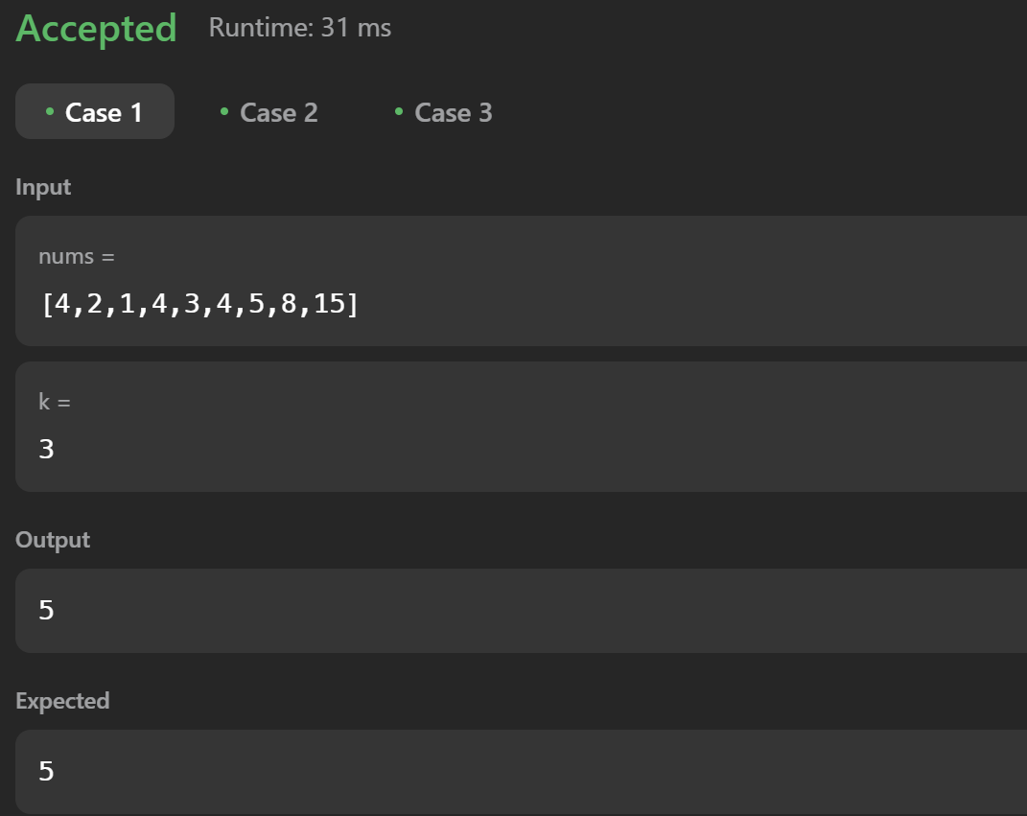

**Q 11 Merge Sorted Array(leet-88)**

class Solution {

public void merge(int[] nums1, int m, int[] nums2, int n) {

int midx = m - 1;

int nidx = n - 1;

int right = m + n - 1;

while (nidx >= 0) {

if (midx >= 0 && nums1[midx] > nums2[nidx]) {

nums1[right] = nums1[midx];

midx--;

} else {

nums1[right] = nums2[nidx];

nidx--;

}

right--;

} } }

**OUTPUT:**

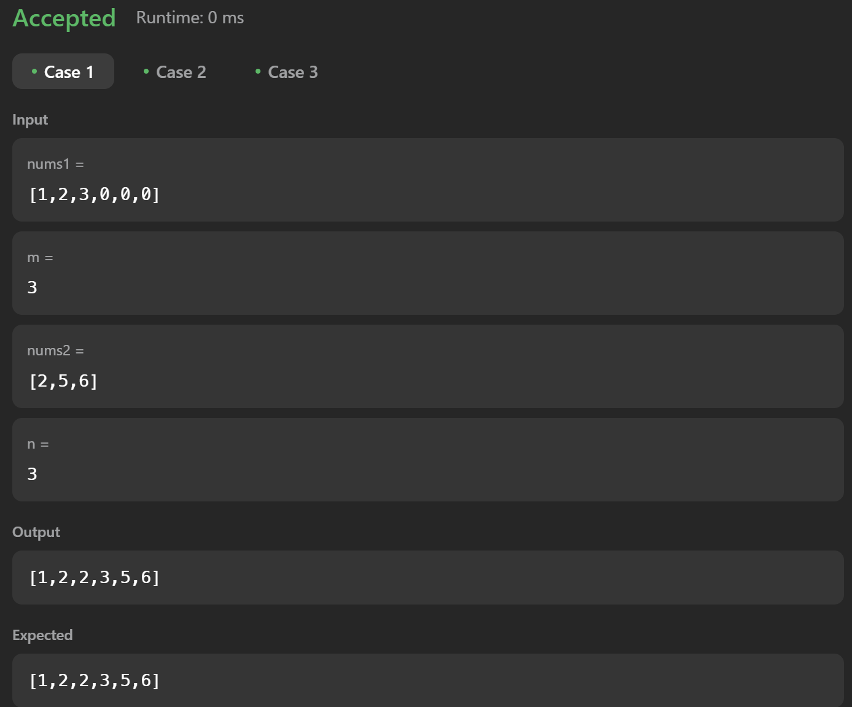

**Q 12 First Bad Version (leet-278)**

public class Solution extends VersionControl {

    public int firstBadVersion(int n) {

        int first = 1;

        int last = n;

    while (first <= last) {

       int mid = first + (last - first) / 2;

        if (isBadVersion(mid)) {

            last = mid - 1;

        } else {

            first = mid + 1;

        }

    }

    return first;

    }

}

**OUTPUT:**

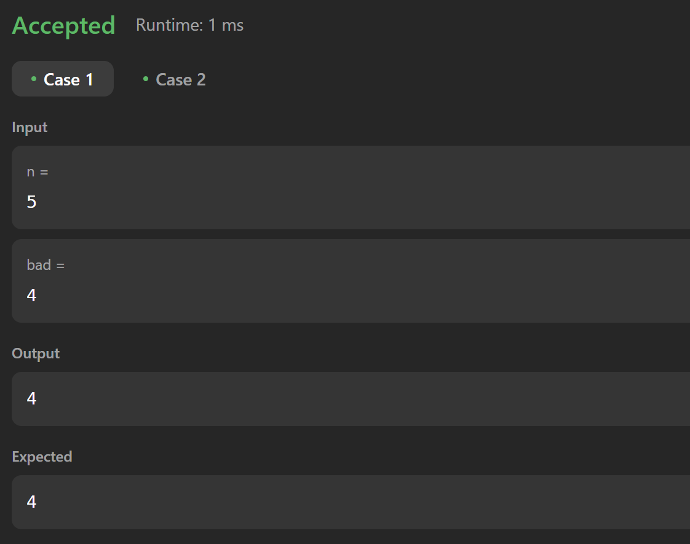

**Q 13 Sort Colors (leet-75)**

class Solution {

    public void sortColors(int[] nums) {

         int zeros = 0, ones = 0, n = nums.length;

        for(int num : nums) {

            if(num == 0) zeros++;

            else if(num == 1) ones++;

        }

        for(int i = 0; i < zeros; ++i) {

            nums[i] = 0;

        }

        for(int i = zeros; i < zeros + ones; ++i) {

            nums[i] = 1;

        }

        for(int i = zeros + ones; i < n; ++i) {

            nums[i] = 2;

        } } }

**OUTPUT:**

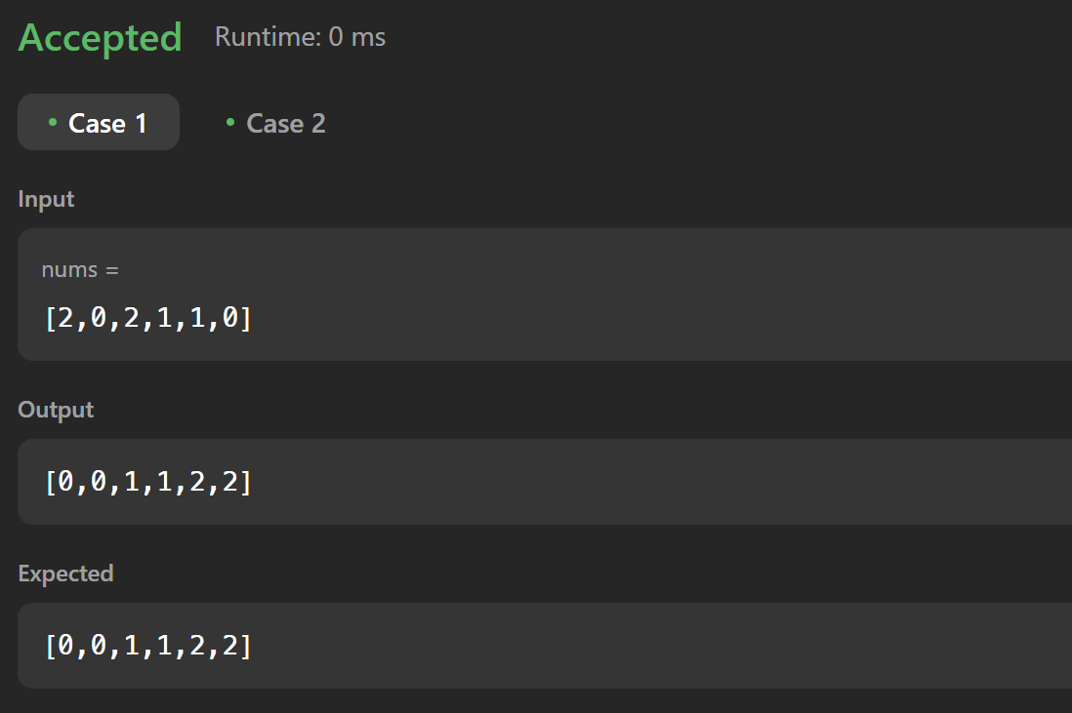

**Q 14 Top K Frequent Elements(leet-347)**

class Solution {

public int[] topKFrequent(int[] nums, int k) {

List<Integer>[] bucket = new List[nums.length + 1];

HashMap<Integer, Integer> hm = new HashMap<>();

for (int num : nums) {

hm.put(num, hm.getOrDefault(num,0) + 1);

}

for (int key : hm.keySet()) {

int freq = hm.get(key);

if (bucket[freq] == null) {

bucket[freq] = new ArrayList<>();

}

bucket[freq].add(key);

}

int[] ans = new int[k];

int pos = 0;

for (int i = bucket.length - 1; i >= 0; i--) {

if (bucket[i] != null) {

for (int j = 0; j < bucket[i].size() && pos < k; j++) {

ans[pos] = bucket[i].get(j);

pos++;

}

}

}

return ans;

}

}

**OUTPUT:**

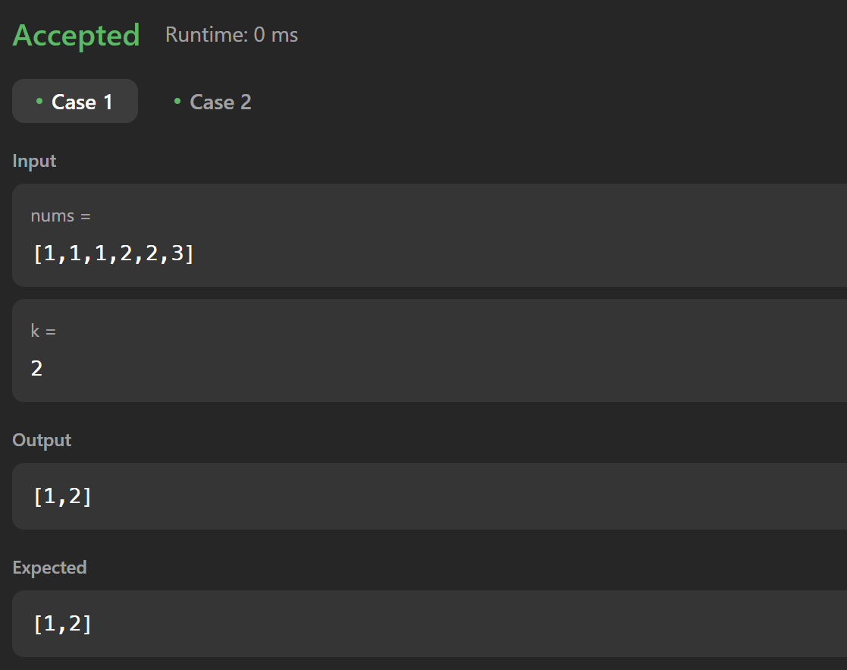

**Q 15 Kth Largest Element in an Array (leet-215)**

class Solution {

public int findKthLargest(int[] nums, int k) {

Arrays.sort(nums);

return nums[nums.length - k];

}

}

**OUTPUT:**

