**Assignment -2(AP)**

**Name:Akul UID: 22BCS10330 Section-605-B**

**Q 1 Longest Nice Substring**

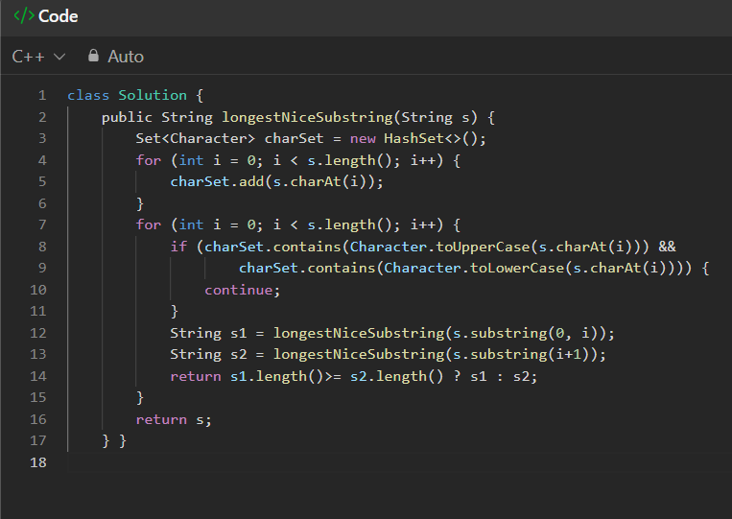**OUTPUT:**

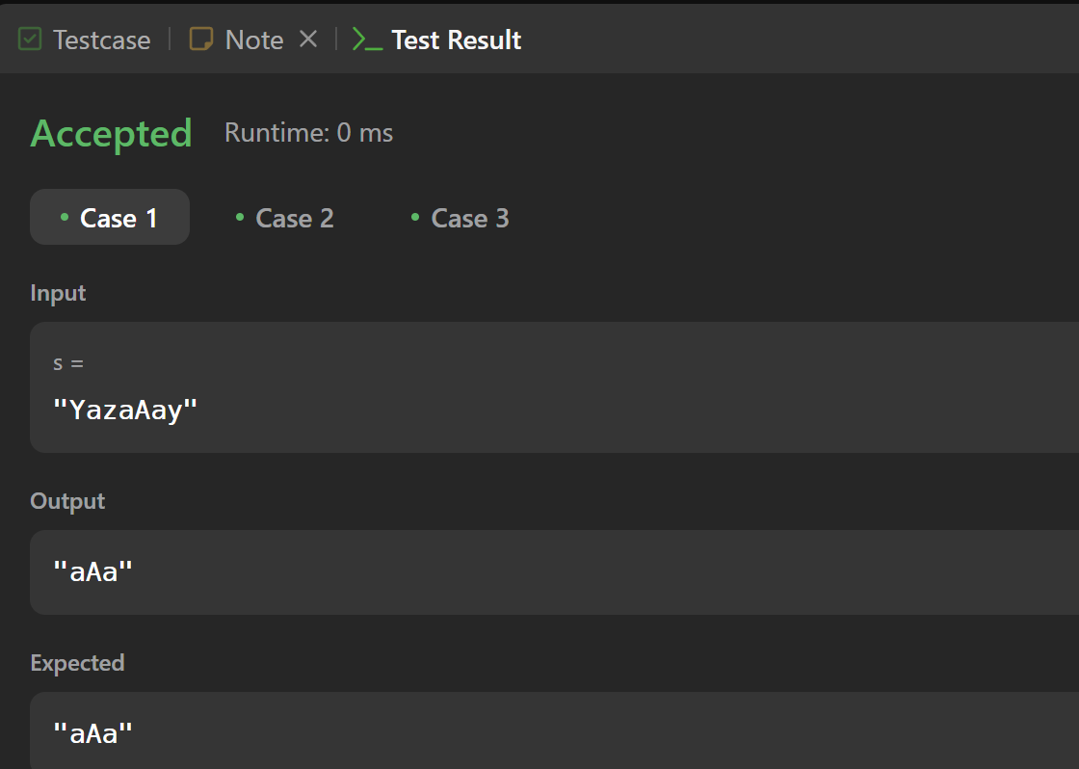

**Q 2 Reverse Bits**

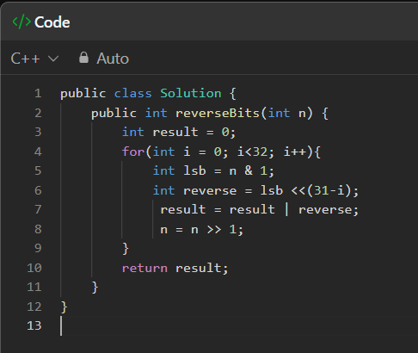

**OUTPUT:**

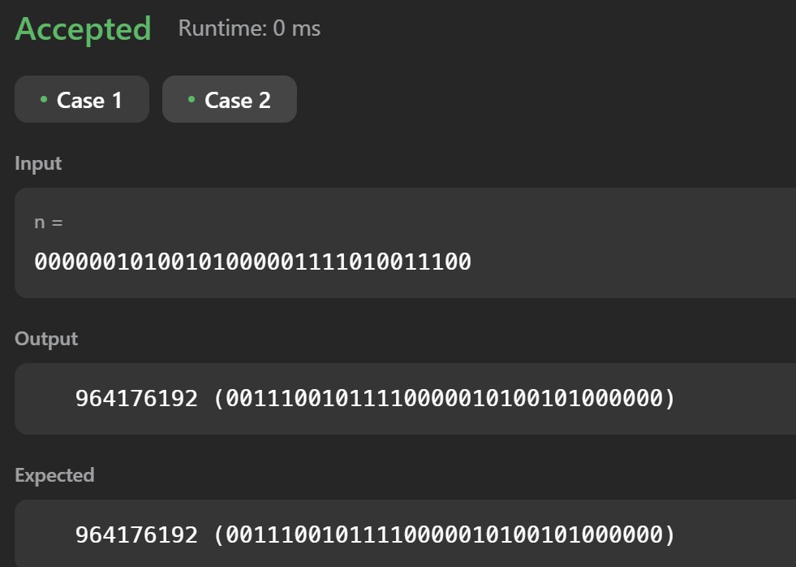

**Q3 Number of 1 Bits**

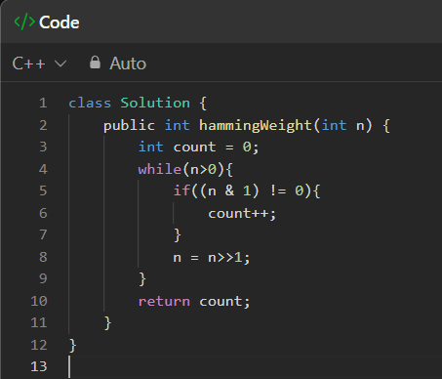

**OUTPUT:**

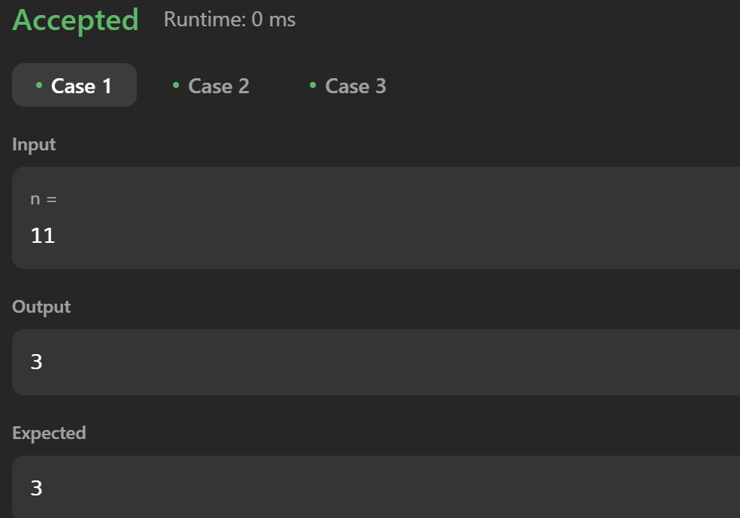

**Q 4 Maximum Subarray**

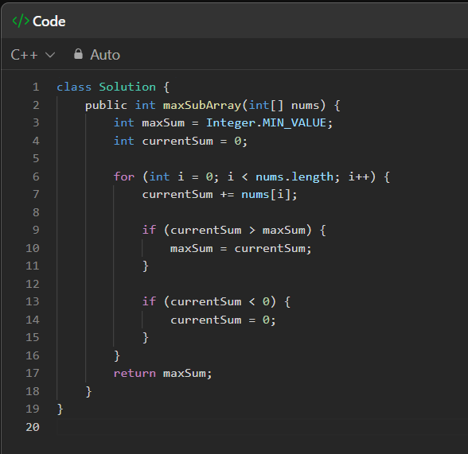

**OUTPUT:**

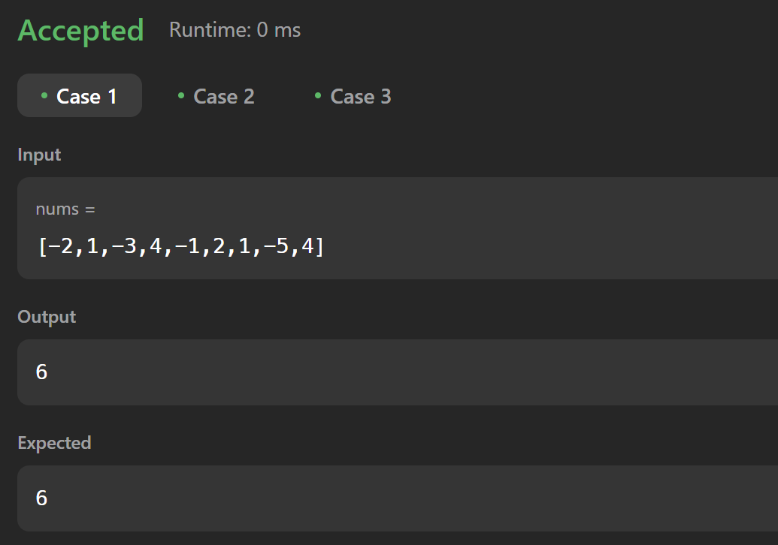

**Q 5 Search a 2D Matrix II**

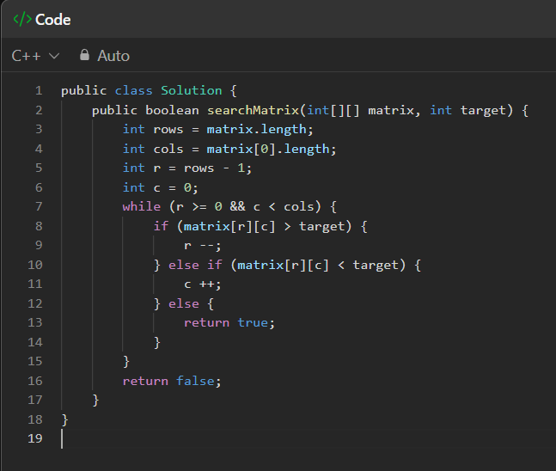

**OUTPUT:**

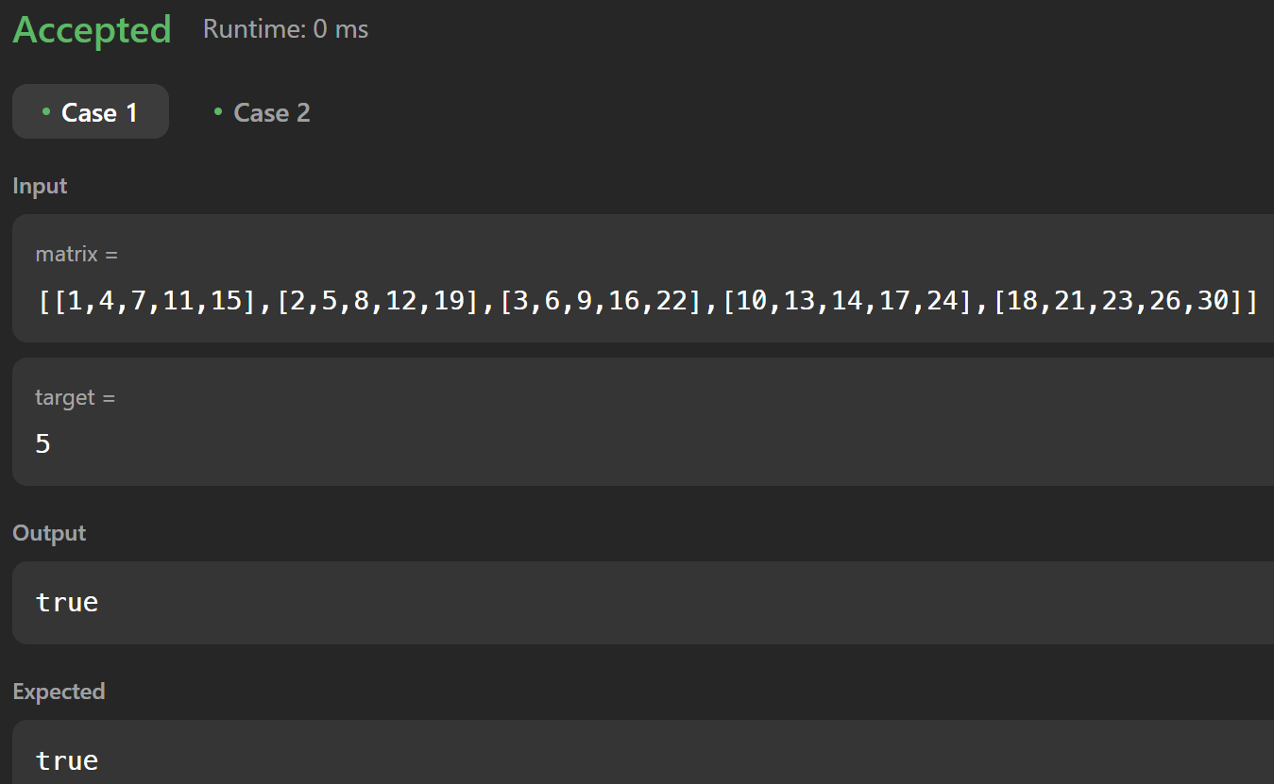

**Q 6 Super Pow**

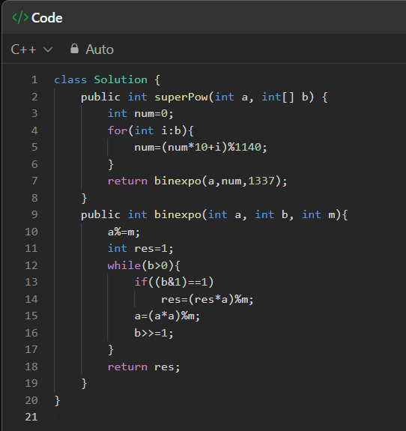

**OUTPUT:**

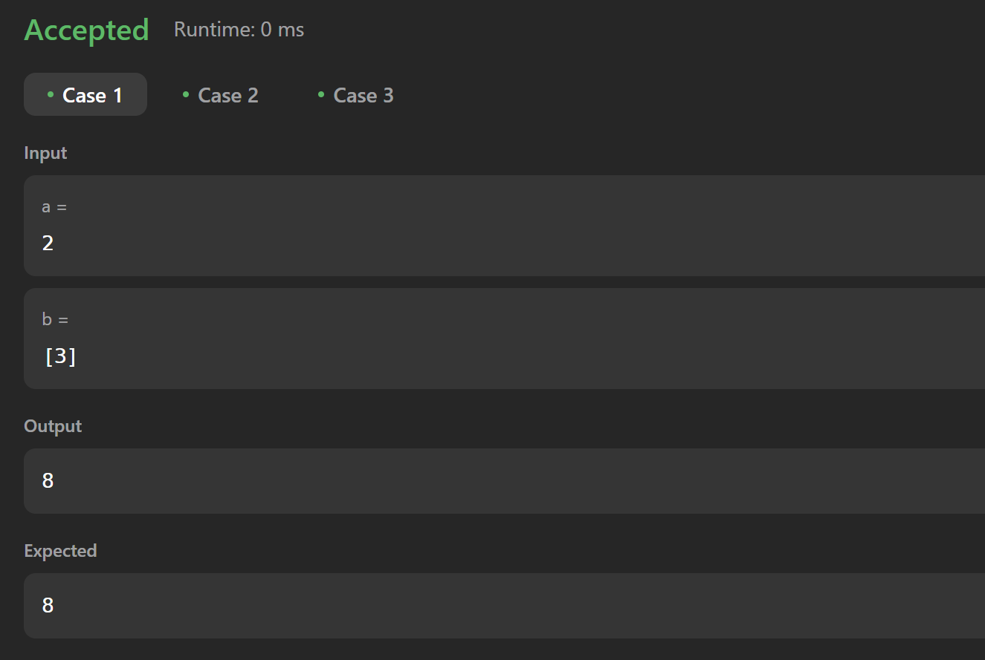

**Q 7 Beautiful Array**

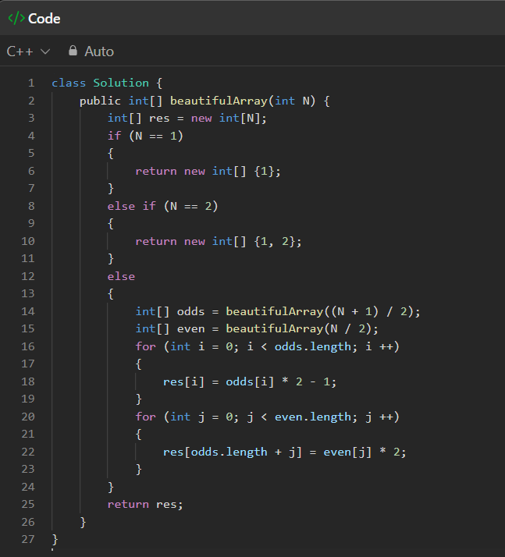

**OUTPUT:**

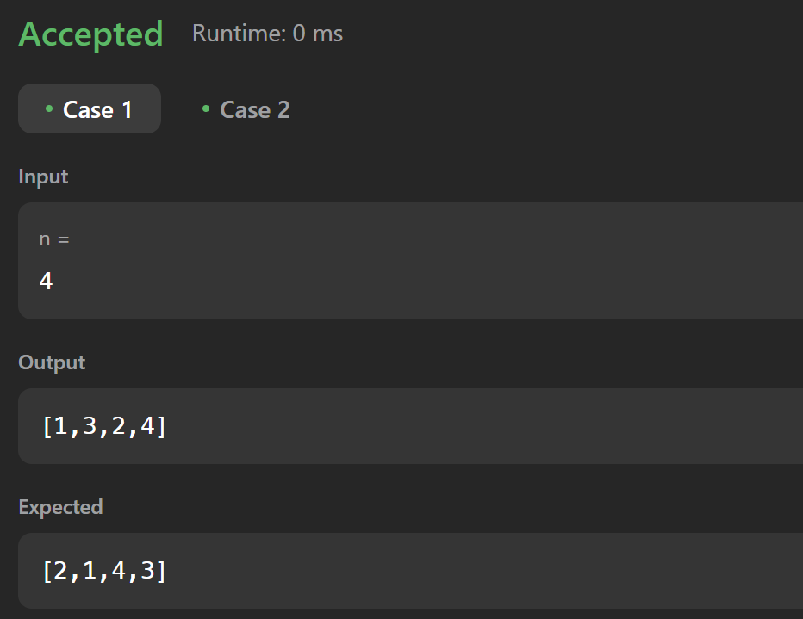

**Q 8 The Skyline Problem**

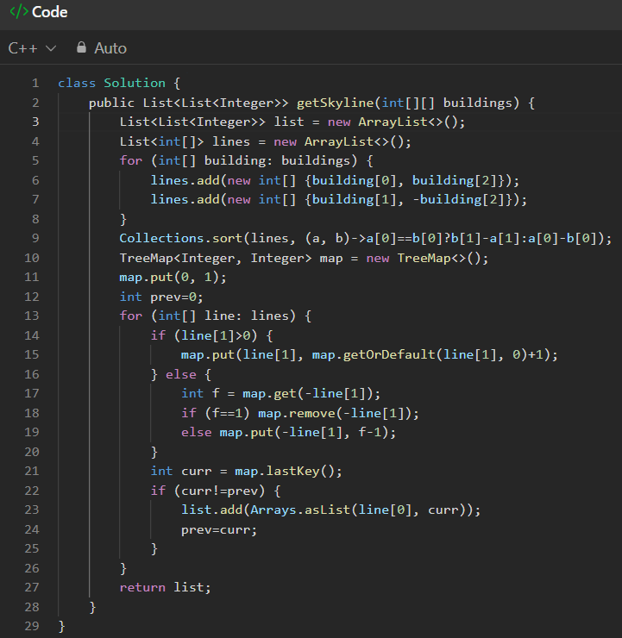

**OUTPUT:**

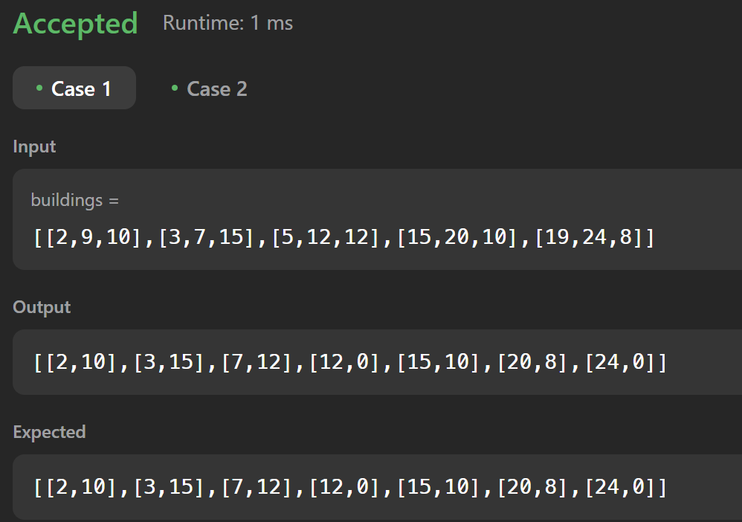

**Q 9 Reverse Pairs**

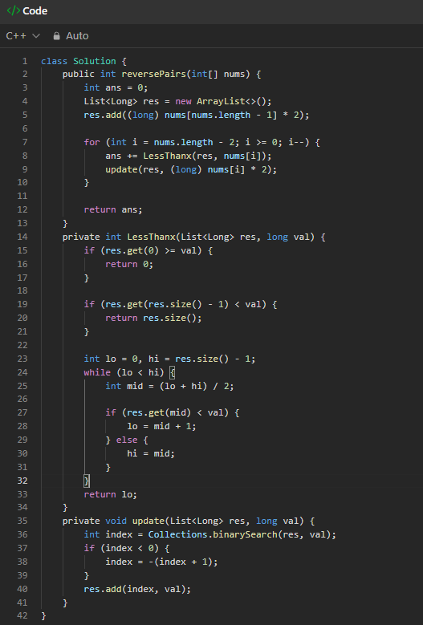

**OUTPUT:**

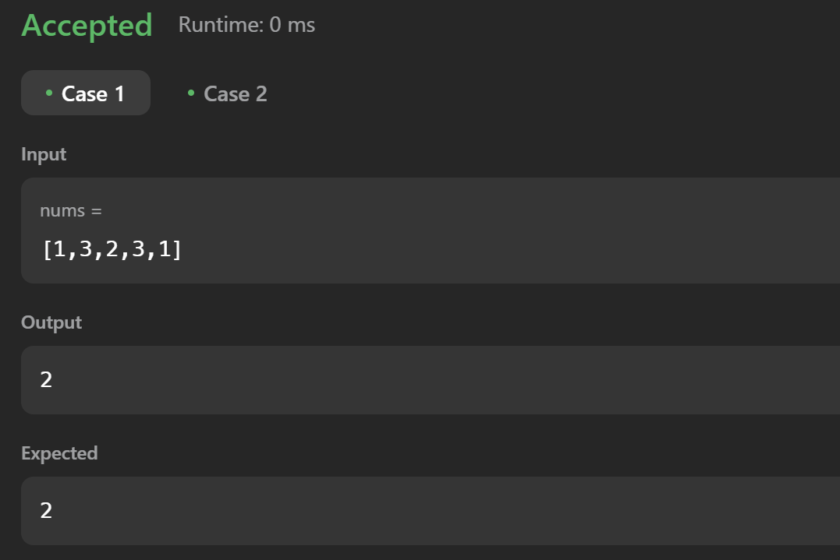

**Q 10 Longest Increasing Subsequence II**

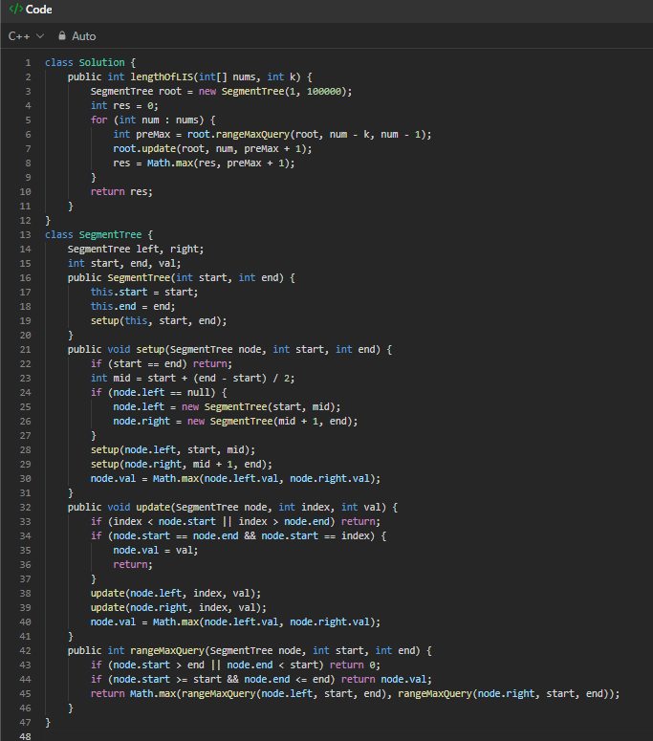

**OUTPUT:**

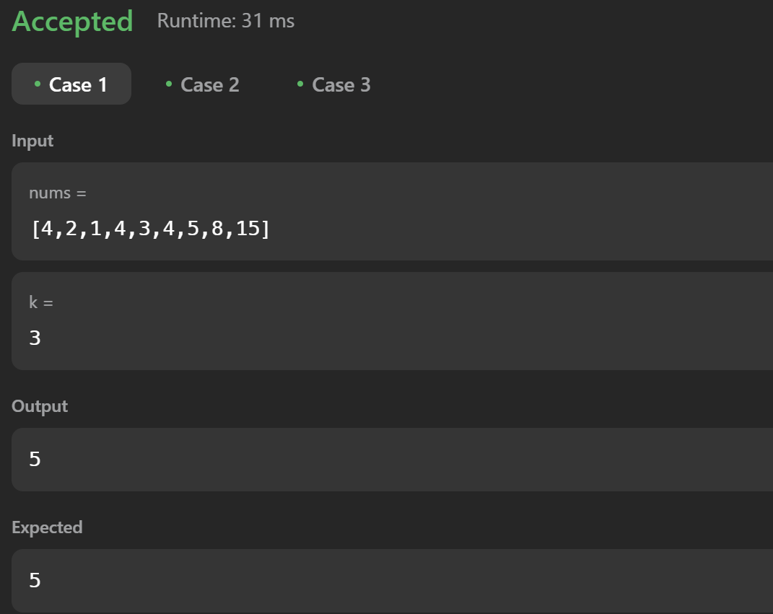

**Q 11 Merge Sorted Array**

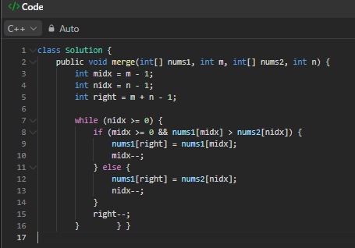

**OUTPUT:**

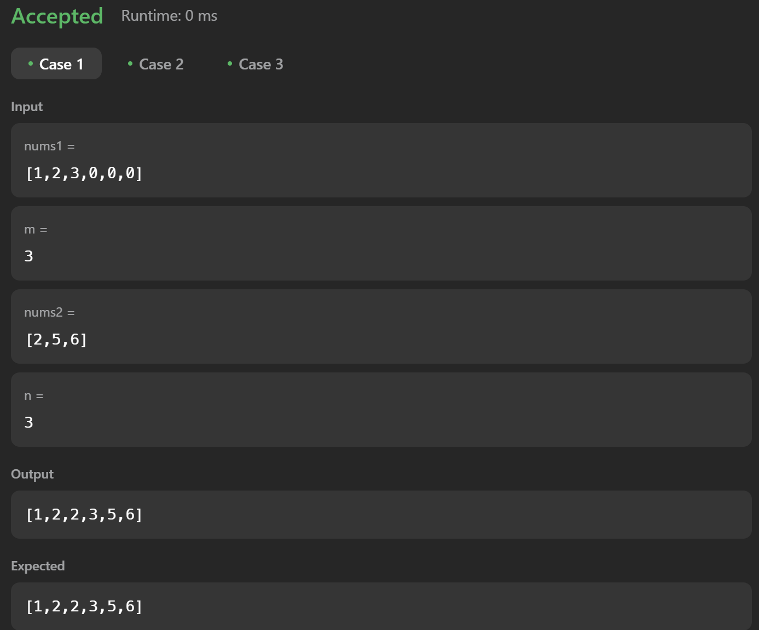

**Q 12 First Bad Version**

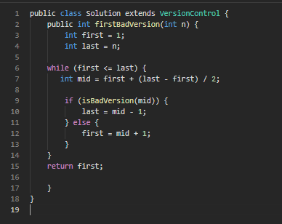

**OUTPUT:**

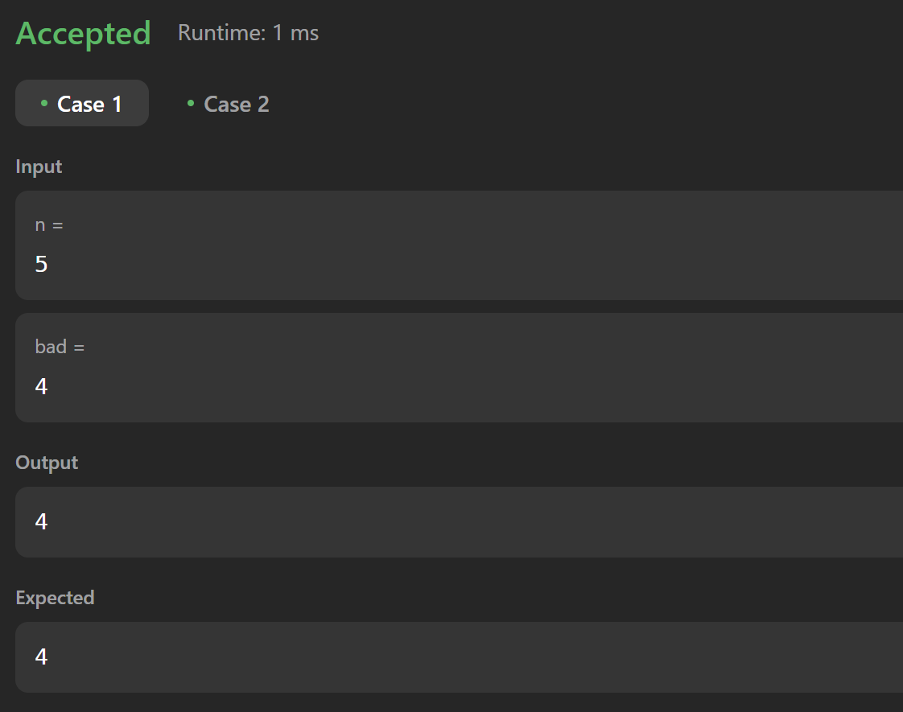

**Q 13 Sort Colors**

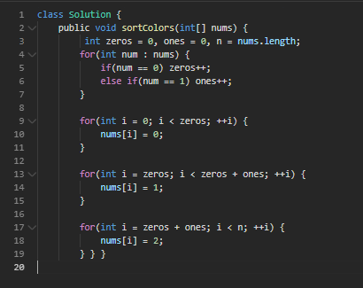

**OUTPUT:**

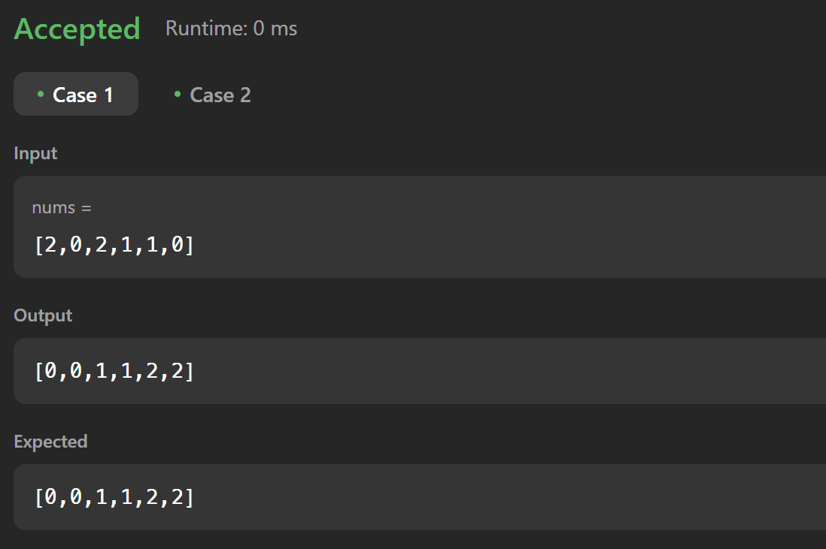

**Q 14 Top K Frequent Elements**

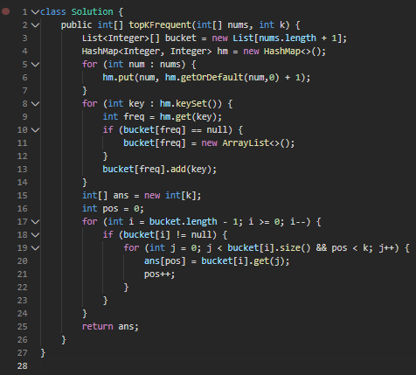

**OUTPUT:**

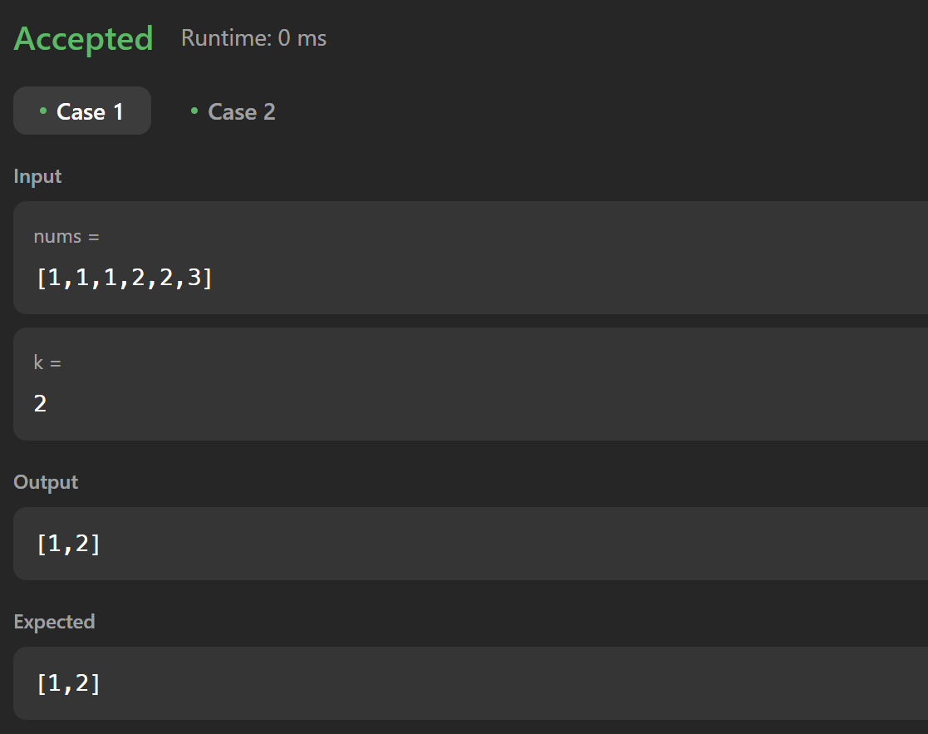

**Q 15 Kth Largest Element in an Array**

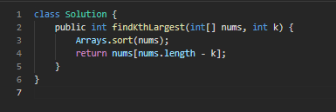

**OUTPUT:**

