Name – Khushmn Sangha UID – 22BCS14681

1. Longest nice subarray

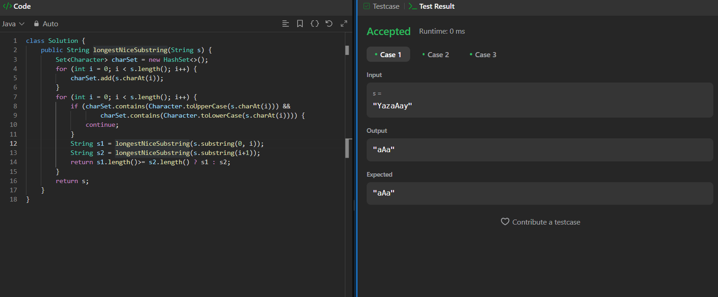

1. Number of 1’s

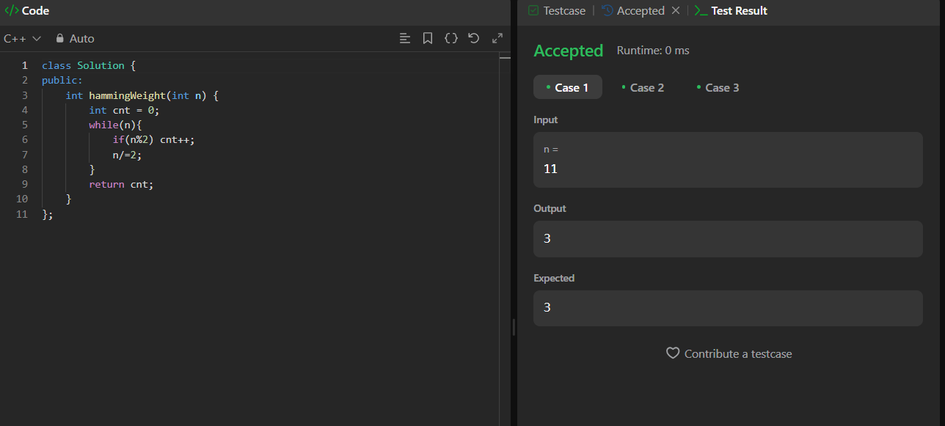

1. Reverse bits

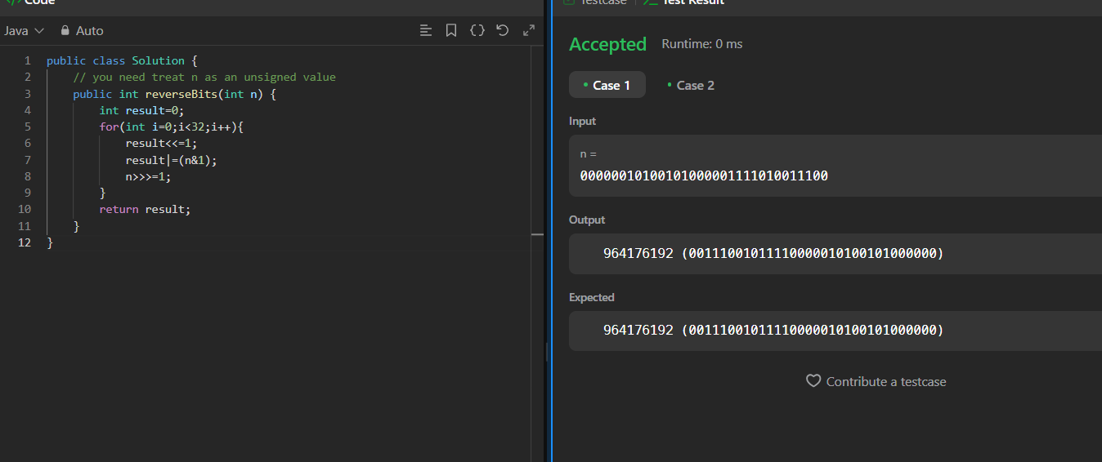

1. Maximum subarray

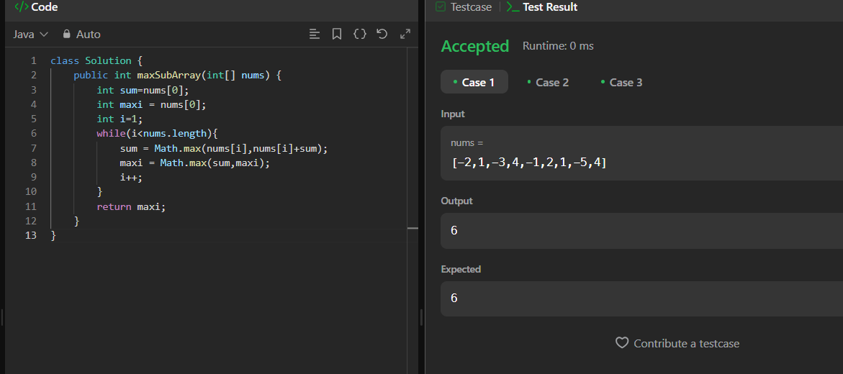

1. Search in 2d matrix

