**Experiment - 2**

**Name: Armaan UID: 22BCS12007**

**Aim:** To solve JAVA problems

1. Problem : Product Class (Easy Level)

Code:

import java.util.Scanner;

class Product {

// Attributes

private int id;

private String name;

private double price;

// Constructor

public Product(int id, String name, double price) {

this.id = id;

this.name = name;

this.price = price;

}

// Method to display product details

public void displayDetails() {

System.out.println("\nProduct Details:");

System.out.println("ID: " + id);

System.out.println("Name: " + name);

System.out.println("Price: " + price);

}

}

public class ProductDemo {

public static void main(String[] args) {

Scanner scanner = new Scanner(System.in);

// Taking product details from user

System.out.print("Product ID: ");

int id = scanner.nextInt();

scanner.nextLine(); // Consume newline

System.out.print("Name: ");

String name = scanner.nextLine();

System.out.print("Price: ");

double price = scanner.nextDouble();

// Creating product object

Product product = new Product(id, name, price);

// Display product details

product.displayDetails();

scanner.close();

}

}

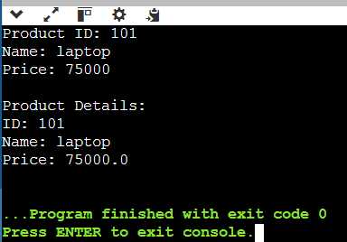Output :