ASSIGNMENT-3(AP)

22BCS15046(PRIYANSHU)

1(LONGEST NICE SUBSTRING)

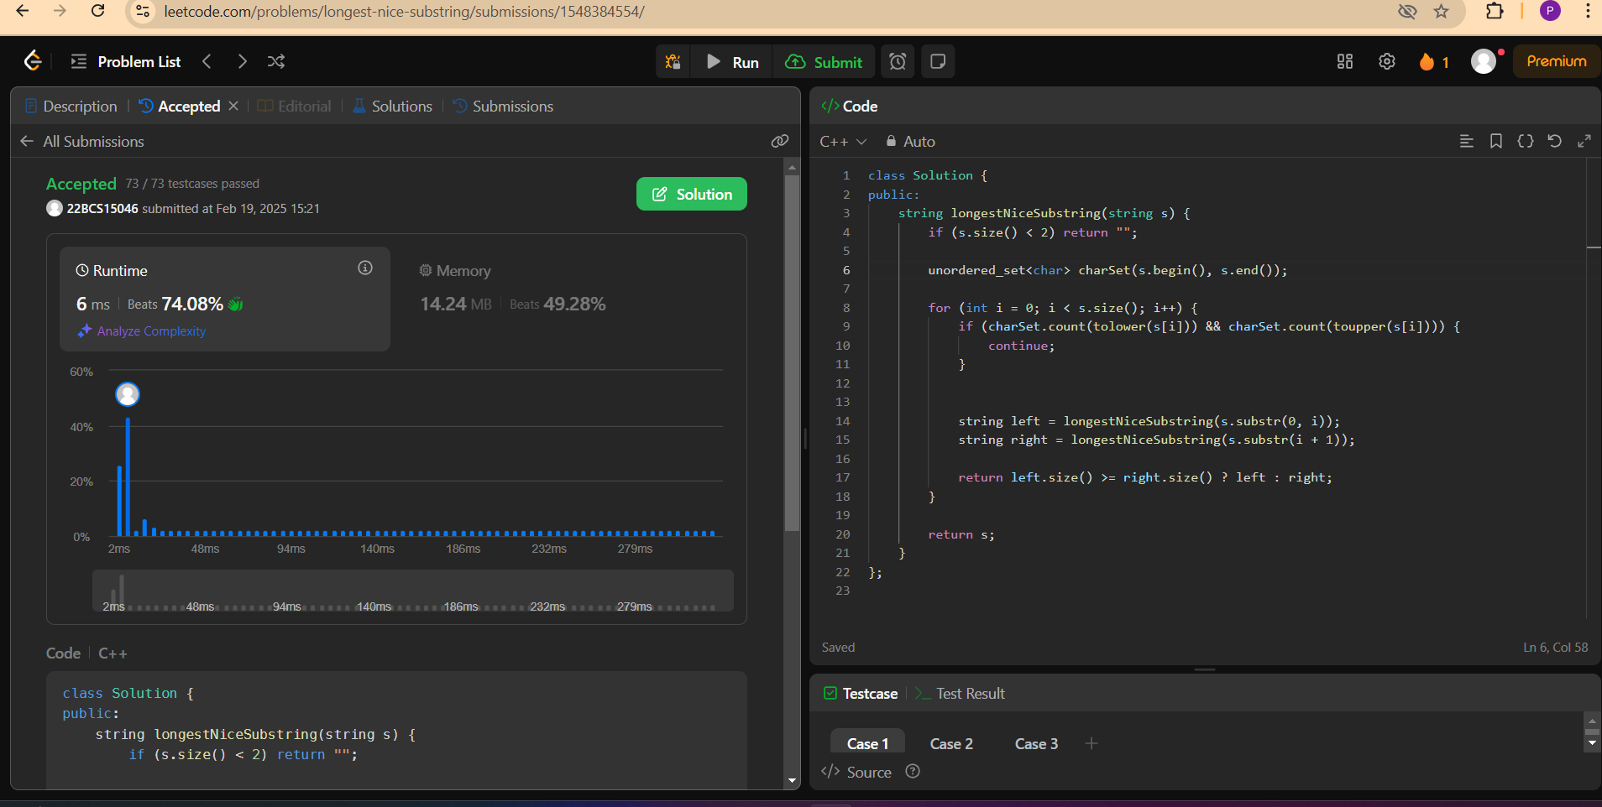

2(INORDER TRAVERSAL)

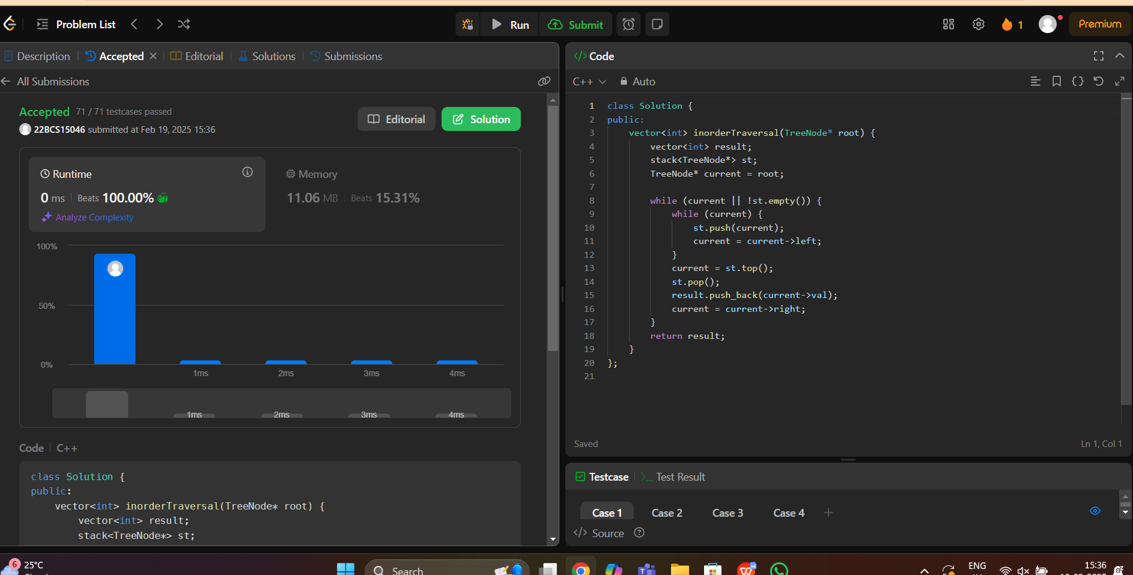

3(SYMMETRIC TREE)

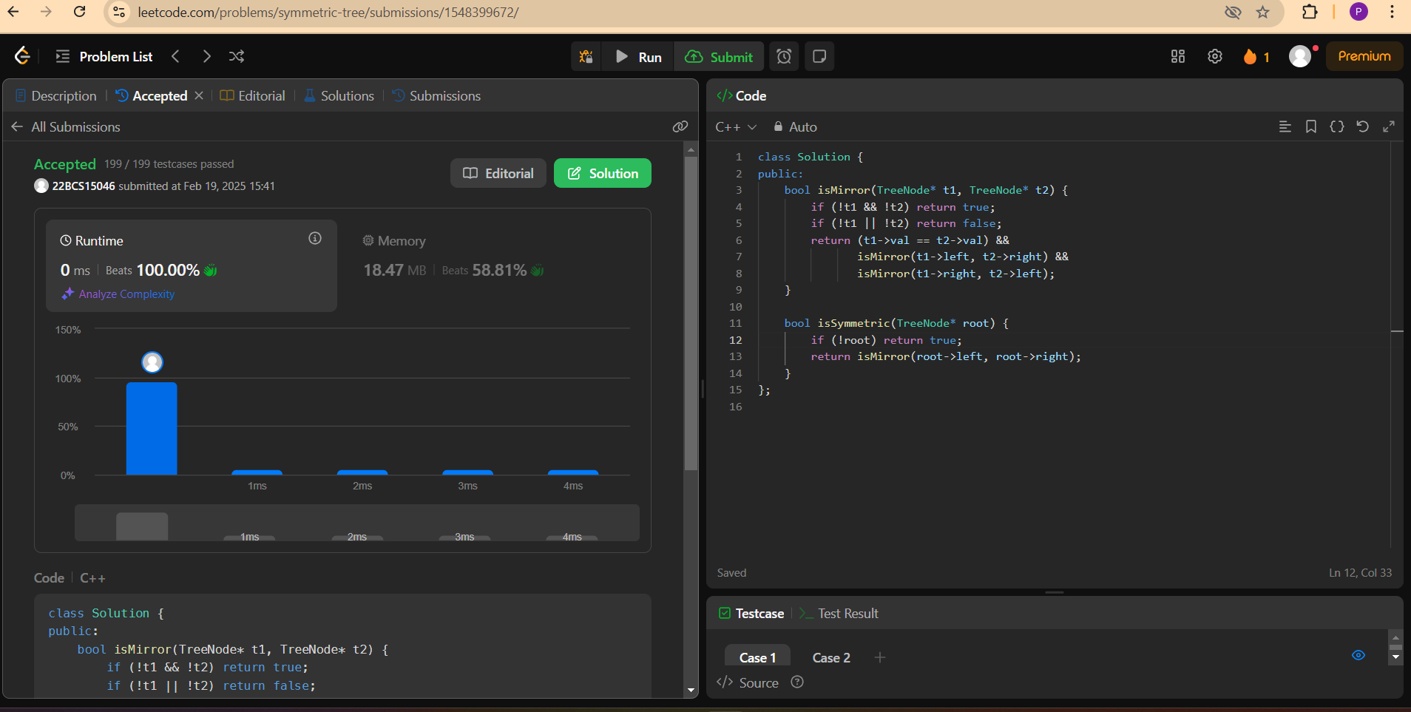

4(MAXIMUM DEPTH OF TREE)

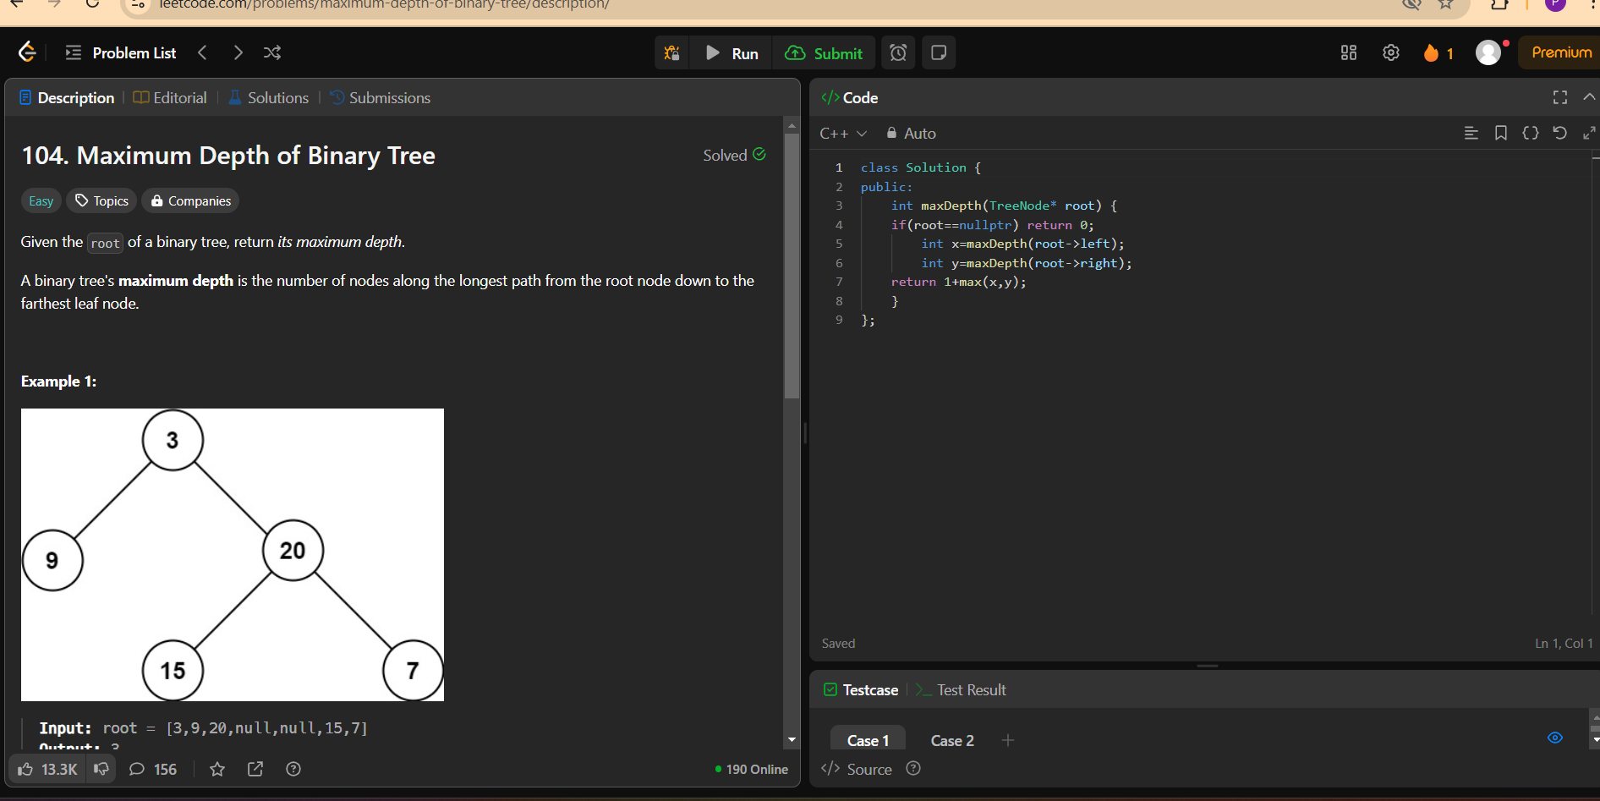

5(VALIDATE BINARY SEARCH TREE)

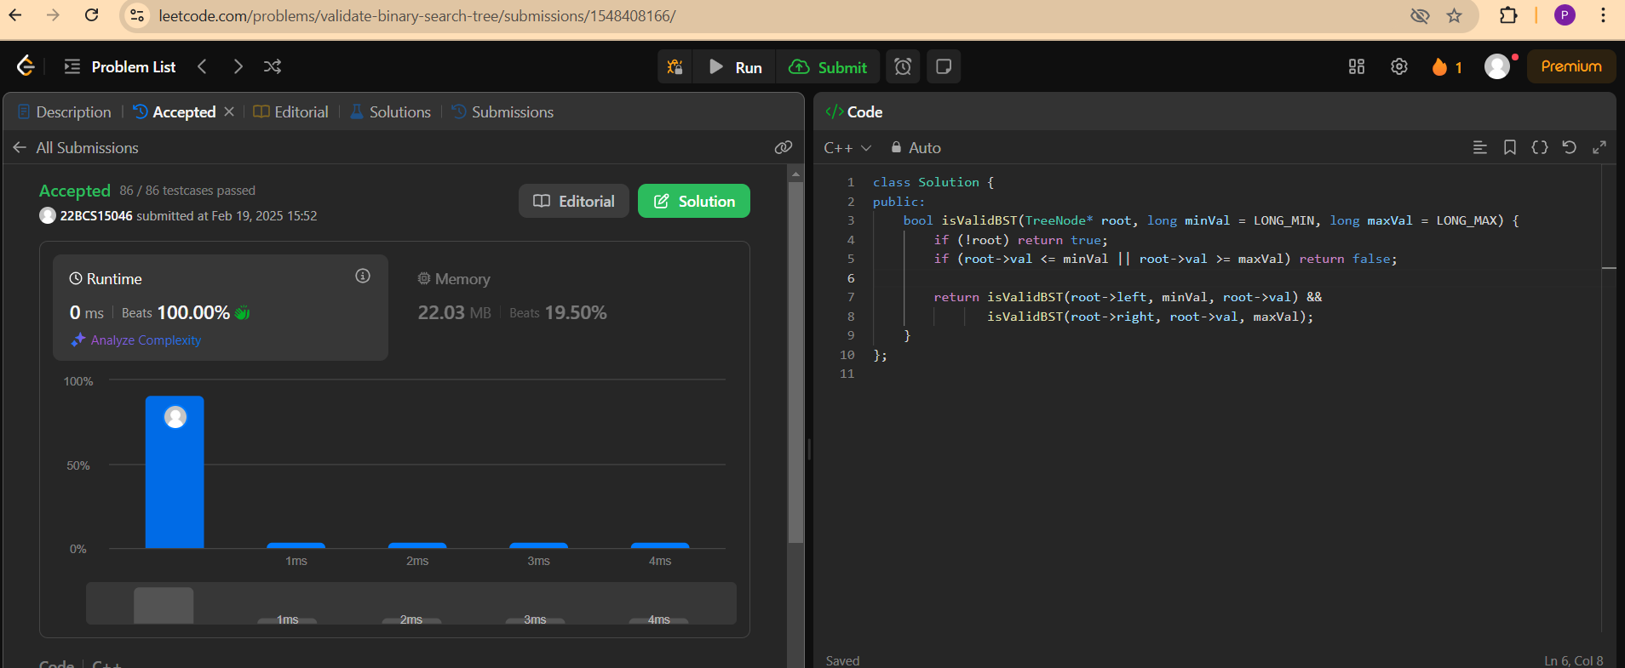

6(Kth SMALL ELEMENT IN BST)

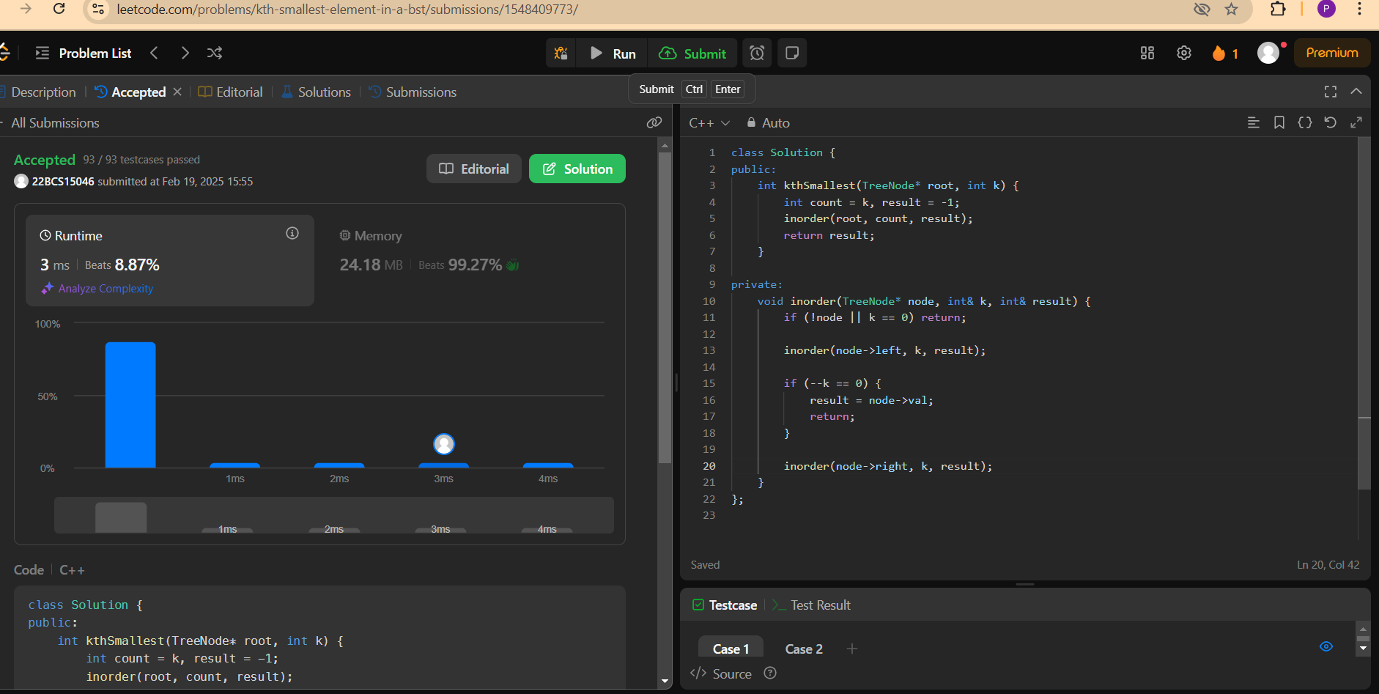

7(BINARY TREE LEVEL TRAVERSAL)

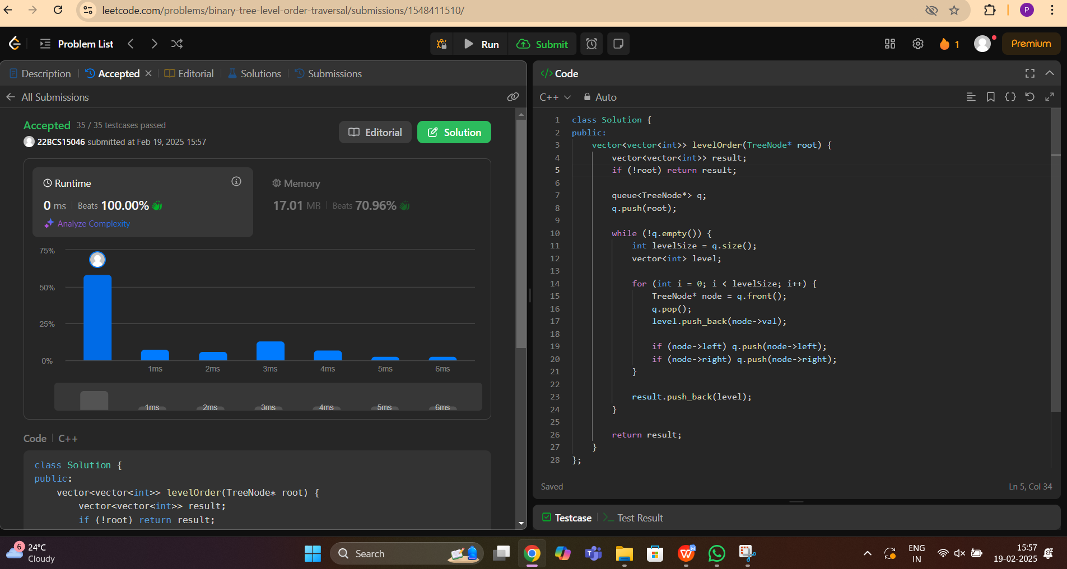

8(ZIGZAG LEVEL TRAVERSAL)

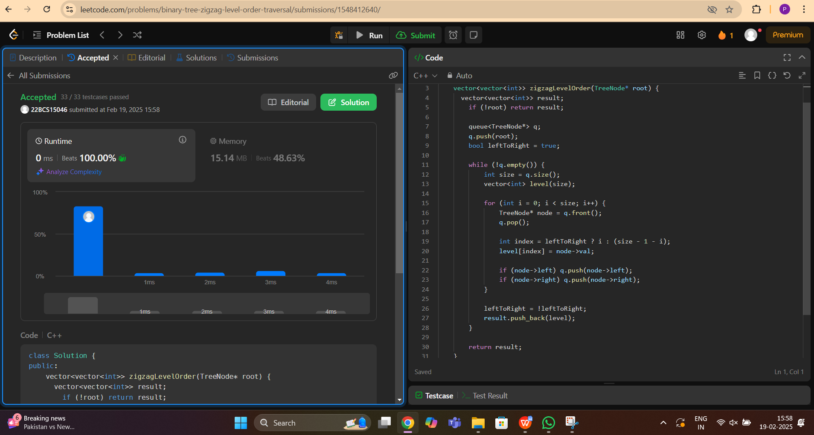

9(BINARY TREE RIGHT SIDE VIEW)

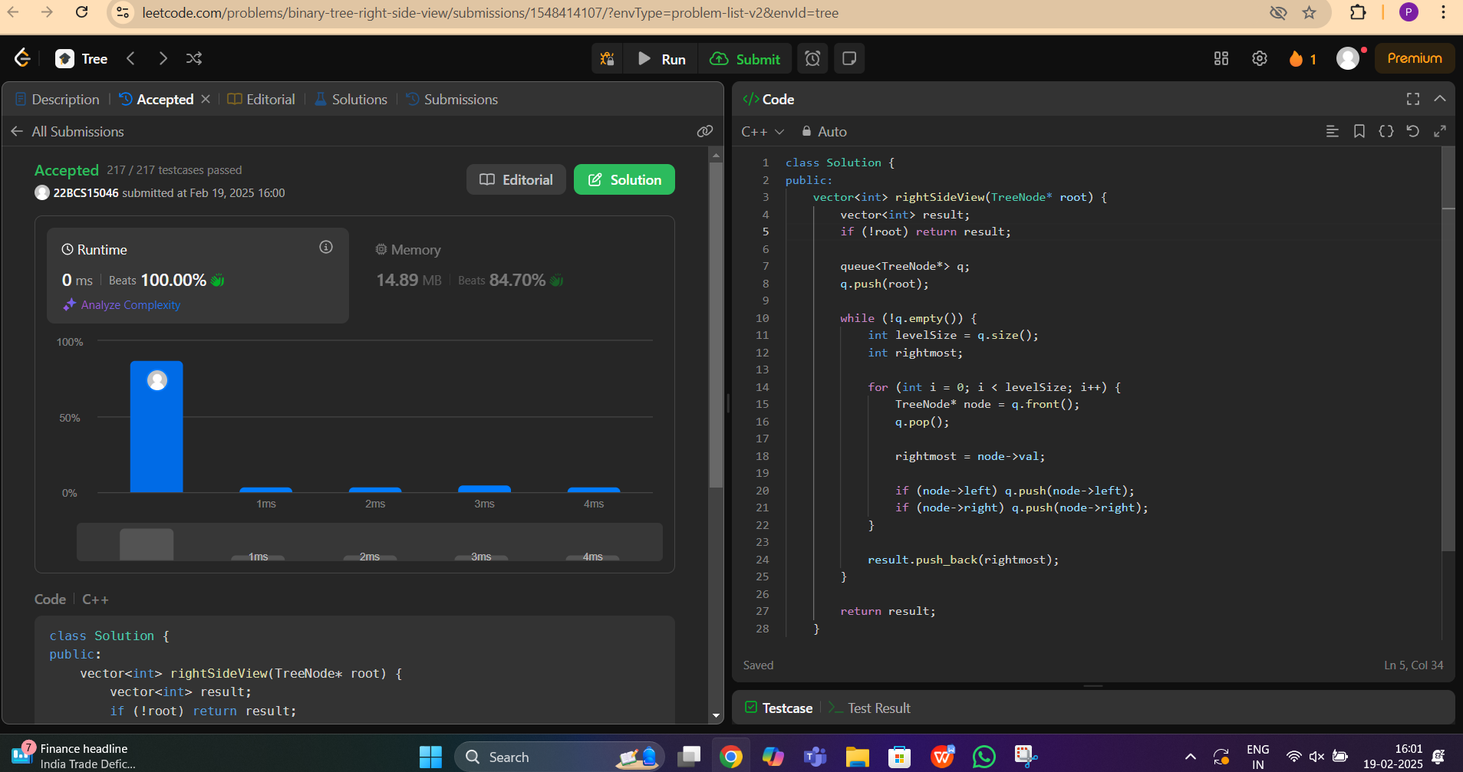

10(CONSTRUCT BST INORDER AND POSTORDER)

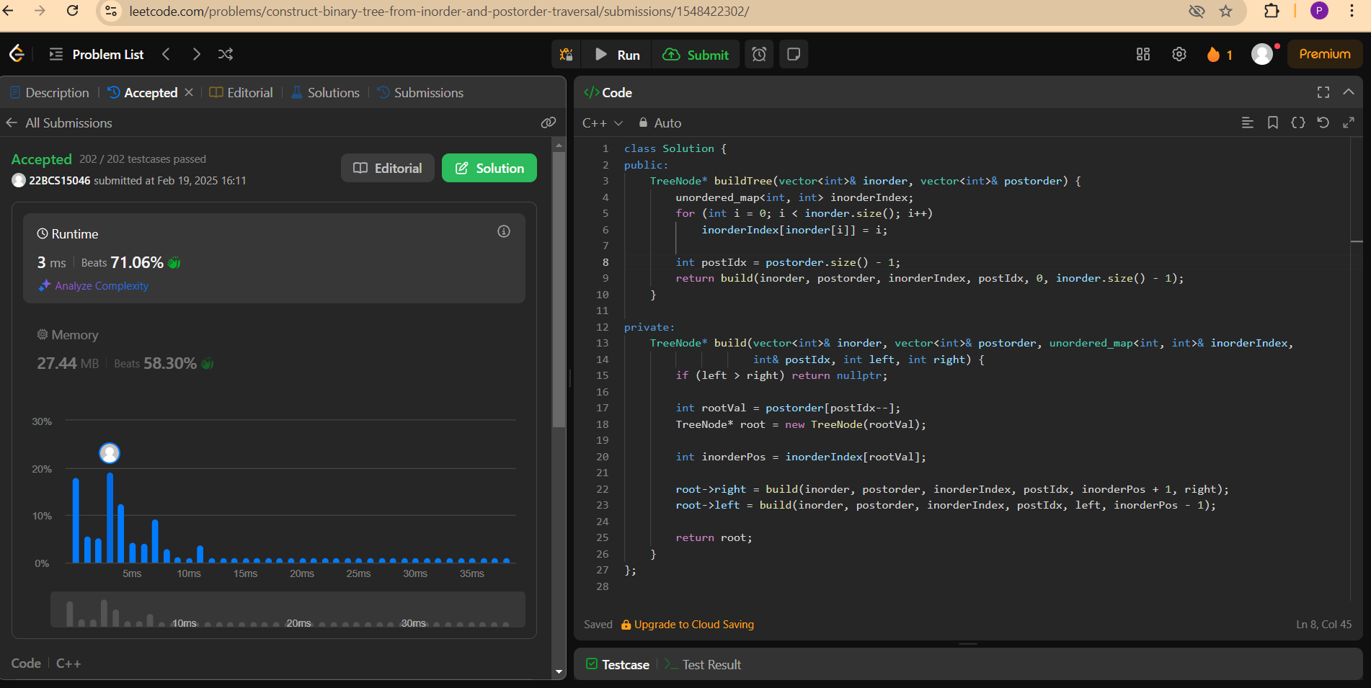

11(FIND BOTTOM LEFT TREE VALUE)

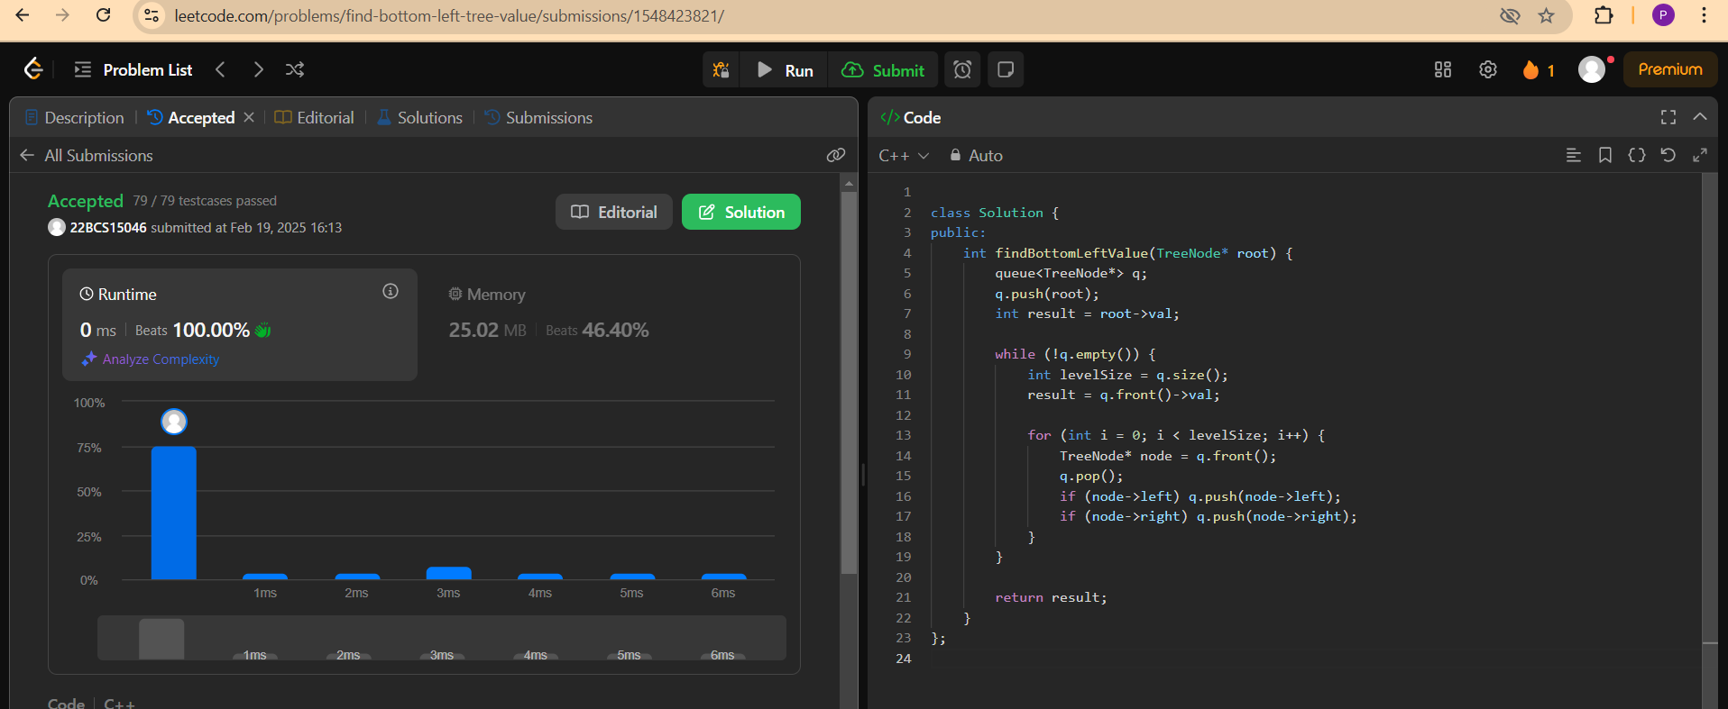

12(BINARY TREE MAXIMUM PATH SUM)

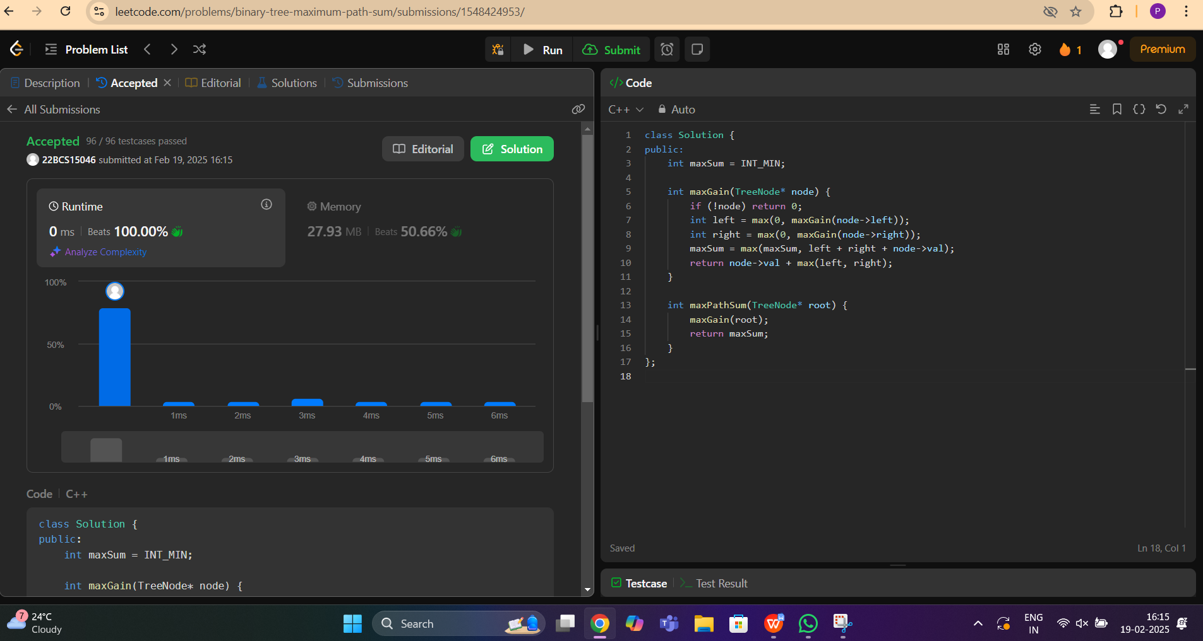

13(VERTICAL ORDER TRAVERSAL OF BST)

