Name: Aditya Jain UID: 22BCS15251

Batch: FL-IOT-601_A

**[1. Binary Tree Inorder Traversal](https://leetcode.com/problems/binary-tree-inorder-traversal/)**

class Solution { public:

vector<int> inorderTraversal(TreeNode* root) { vector<int> ans;

stack<TreeNode*> stack;

while (root != nullptr || !stack.empty()) { while (root != nullptr) { stack.push(root);

root = root->left;

}

root = stack.top(), stack.pop(); ans.push_back(root->val); root = root->right;

}

return ans;

}

};



[**2. Symmetric Tree**](https://leetcode.com/problems/symmetric-tree/)

class Solution { public:

bool isSymmetric(TreeNode* root) { return isSymmetric(root, root);

}

private:

bool isSymmetric(TreeNode* p, TreeNode* q) { if (!p || !q)

return p == q;

return p->val == q->val && // isSymmetric(p->left, q->right) && // isSymmetric(p->right, q->left);

}

};



# **3** .[Maximum Depth of Binary Tree](https://leetcode.com/problems/maximum-depth-of-binary-tree/description/)

class Solution { public:

int maxDepth(TreeNode* root) { if (root == nullptr)

return 0;

return 1 + max(maxDepth(root->left), maxDepth(root->right));

};

# [Validate Binary Search Tree](https://leetcode.com/problems/validate-binary-search-tree/description/)

class Solution { public:

bool isValidBST(TreeNode* root) { return isValidBST(root, nullptr, nullptr);

}

private:

bool isValidBST(TreeNode* root, TreeNode* minNode, TreeNode* maxNode) { if (root == nullptr)

return true;

if (minNode && root->val <= minNode->val) return false;

if (maxNode && root->val >= maxNode->val) return false;

return isValidBST(root->left, minNode, root) && isValidBST(root->right, root, maxNode);

}

};

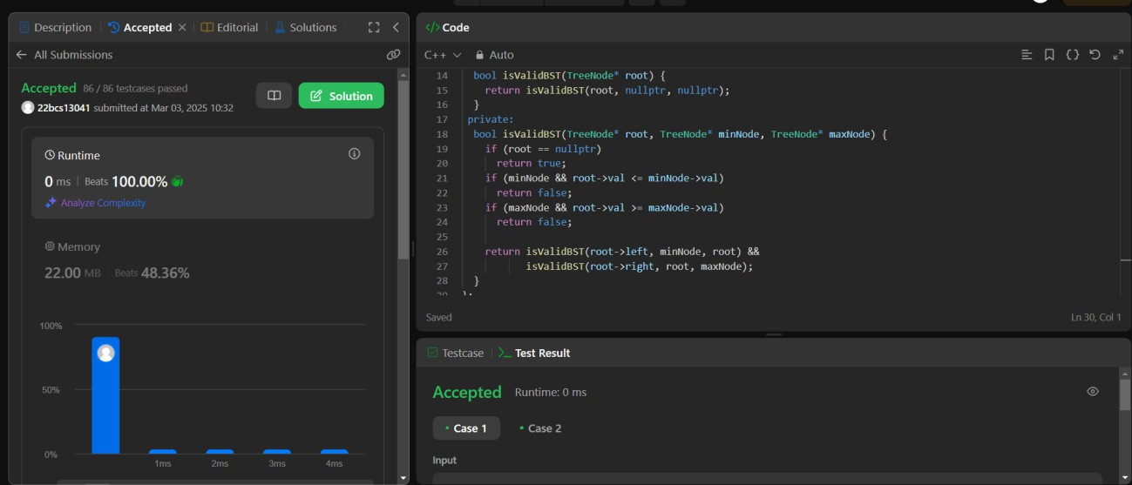

# [Kth Smallest Element in a BST](https://leetcode.com/problems/kth-smallest-element-in-a-bst/description/)

class Solution { public:

int kthSmallest(TreeNode* root, int k) {

const int leftCount = countNodes(root->left);

if (leftCount == k - 1) return root->val;

if (leftCount >= k)

return kthSmallest(root->left, k);

return kthSmallest(root->right, k - 1 - leftCount); // leftCount < k

}

private:

int countNodes(TreeNode* root) { if (root == nullptr)

return 0;

return 1 + countNodes(root->left) + countNodes(root->right);

}

};

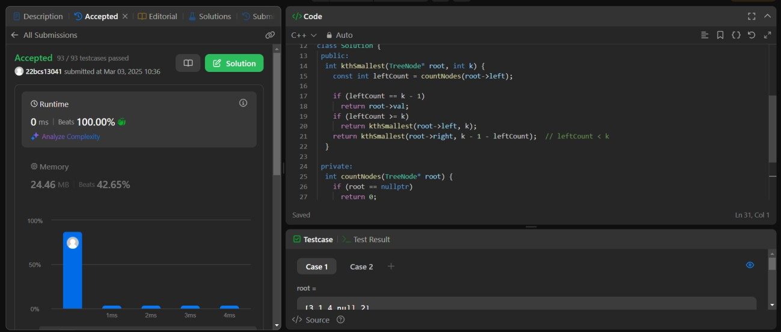

# [Binary Tree Level Order Traversal](https://leetcode.com/problems/binary-tree-level-order-traversal/description/)

class Solution { public:

vector<vector<int>> levelOrder(TreeNode* root) { if (root == nullptr)

return {};

vector<vector<int>> ans; queue<TreeNode*> q{{root}}; while (!q.empty()) {

vector<int> currLevel;

for (int sz = q.size(); sz > 0; --sz) { TreeNode* node = q.front(); q.pop();

currLevel.push_back(node->val); if (node->left)

q.push(node->left); if (node->right) q.push(node->right);

}

ans.push_back(currLevel);

}

return ans;

}

};



1. [Binary Tree Level Order Traversal II](https://leetcode.com/problems/binary-tree-level-order-traversal-ii/description/)

class Solution { public:

vector<vector<int>> levelOrderBottom(TreeNode* root) { if (root == nullptr)

return {};

vector<vector<int>> ans; queue<TreeNode*> q{{root}};

while (!q.empty()) {

vector<int> currLevel;

for (int sz = q.size(); sz > 0; --sz) { TreeNode* node = q.front(); q.pop();

currLevel.push_back(node->val); if (node->left)

q.push(node->left); if (node->right) q.push(node->right);

}

ans.push_back(currLevel);

}

ranges::reverse(ans); return ans;

}

};



1. [.Binary Tree Zigzag Level Order Traversal](https://leetcode.com/problems/binary-tree-zigzag-level-order-traversal/description/)

class Solution { public:

vector<vector<int>> zigzagLevelOrder(TreeNode* root) { if (root == nullptr)

return {};

vector<vector<int>> ans; deque<TreeNode*> dq{{root}}; bool isLeftToRight = true;

while (!dq.empty()) { vector<int> currLevel;

for (int sz = dq.size(); sz > 0; --sz) if (isLeftToRight) {

TreeNode* node = dq.front(); dq.pop_front();

currLevel.push_back(node->val);

if (node->left)

dq.push_back(node->left); if (node->right)

dq.push_back(node->right);

} else {

TreeNode* node = dq.back(); dq.pop_back();

currLevel.push_back(node->val); if (node->right) dq.push_front(node->right);

if (node->left) dq.push_front(node->left);

}

ans.push_back(currLevel);

isLeftToRight = !isLeftToRight;

}

return ans;

}

};



1. [Binary Tree Right Side View](https://leetcode.com/problems/binary-tree-right-side-view/description/)

class Solution { public:

vector<int> rightSideView(TreeNode* root) { if (root == nullptr)

return {};

vector<int> ans;

queue<TreeNode*> q{{root}};

while (!q.empty()) { const int size = q.size();

for (int i = 0; i < size; ++i) { TreeNode* node = q.front(); q.pop();

if (i == size - 1)

ans.push_back(node->val); if (node->left)

q.push(node->left); if (node->right) q.push(node->right);

}

}

return ans;

}

};

1. [Construct Binary Tree from Inorder and Postorder Traversal](https://leetcode.com/problems/construct-binary-tree-from-inorder-and-postorder-traversal/description/)

class Solution { public:

TreeNode* buildTree(vector<int>& inorder, vector<int>& postorder) { unordered_map<int, int> inToIndex;

for (int i = 0; i < inorder.size(); ++i) inToIndex[inorder[i]] = i;

return build(inorder, 0, inorder.size() - 1, postorder, 0, postorder.size() - 1, inToIndex);

}

private:

TreeNode* build(const vector<int>& inorder, int inStart, int inEnd, const vector<int>& postorder, int postStart, int postEnd, const unordered_map<int, int>& inToIndex) {

if (inStart > inEnd) return nullptr;

const int rootVal = postorder[postEnd]; const int rootInIndex = inToIndex.at(rootVal); const int leftSize = rootInIndex - inStart;

TreeNode* root = new TreeNode(rootVal);

root->left = build(inorder, inStart, rootInIndex - 1, postorder, postStart, postStart + leftSize - 1, inToIndex);

root->right = build(inorder, rootInIndex + 1, inEnd, postorder, postStart + leftSize, postEnd - 1, inToIndex);

return root;

}

};

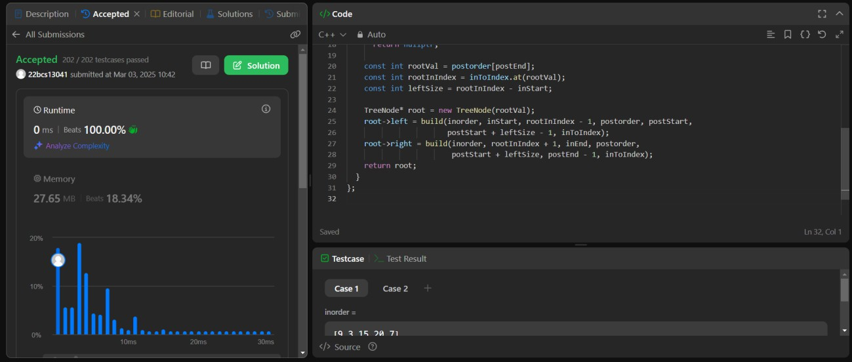

1. [Find Bottom Left Tree Value](https://leetcode.com/problems/find-bottom-left-tree-value/description/)

class Solution { public:

int findBottomLeftValue(TreeNode* root) { queue<TreeNode*> q{{root}};

TreeNode* node = nullptr;

while (!q.empty()) { node = q.front(); q.pop();

if (node->right) q.push(node->right); if (node->left) q.push(node->left);

}

return node->val;

}

};



1. [Binary Tree Maximum Path Sum](https://leetcode.com/problems/binary-tree-maximum-path-sum/description/)

class Solution { public:

int maxPathSum(TreeNode* root) { int ans = INT_MIN; maxPathSumDownFrom(root, ans); return ans;

}

private:

int maxPathSumDownFrom(TreeNode* root, int& ans) { if (root == nullptr)

return 0;

const int l = max(0, maxPathSumDownFrom(root->left, ans)); const int r = max(0, maxPathSumDownFrom(root->right, ans)); ans = max(ans, root->val + l + r);

return root->val + max(l, r);

}

};



1. [.Vertical Order Traversal of a Binary Tree](https://leetcode.com/problems/vertical-order-traversal-of-a-binary-tree/description/)

class Solution { public:

vector<vector<int>> verticalTraversal(TreeNode* root) { vector<vector<int>> ans;

map<int, multiset<pair<int, int>>> xToSortedPairs;

dfs(root, 0, 0, xToSortedPairs);

for (const auto& [_, pairs] : xToSortedPairs) { vector<int> vals;

for (const pair<int, int>& pair : pairs) vals.push_back(pair.second);

ans.push_back(vals);

}

return ans;

}

private:

void dfs(TreeNode* root, int x, int y,

map<int, multiset<pair<int, int>>>& xToSortedPairs) { if (root == nullptr)

return;

xToSortedPairs[x].emplace(y, root->val); dfs(root->left, x - 1, y + 1, xToSortedPairs); dfs(root->right, x + 1, y + 1, xToSortedPairs);

}

};

