**Experiment - 2**

**Name: Armaan UID: 22BCS12007**

**Aim:** To solve JAVA problems

1. Problem : Square Root Calculation (Easy Level)

Code:

import java.util.Scanner;

public class SquareRootCalculator {

public static void main(String[] args) {

Scanner scanner = new Scanner(System.in);

System.out.print("Enter a number: ");

String input = scanner.nextLine();

try {

double number = Double.parseDouble(input);

if (number < 0) {

throw new IllegalArgumentException("Cannot calculate the square root of a negative number.");

}

double result = Math.sqrt(number);

System.out.println("Square root: " + result);

} catch (NumberFormatException e) {

System.out.println("Error: Invalid input. Please enter a numeric value.");

} catch (IllegalArgumentException e) {

System.out.println("Error: " + e.getMessage());

}

scanner.close();

}

}

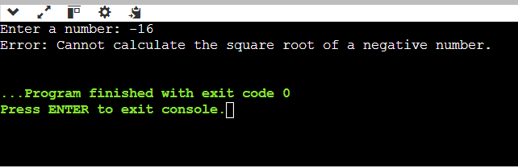Output :