Question: Find the difference

Code:

class Solution {

public char findTheDifference(String s, String t) {

int ssum = 0;

int tsum = 0;

for (int i = 0; i < s.length(); i++) {

ssum = ssum + (int) s.charAt(i);

}

for (int i = 0; i < t.length(); i++) {

tsum = tsum + (int) t.charAt(i);

}

int value = tsum - ssum;

return (char) value;

}

}

**Output:**

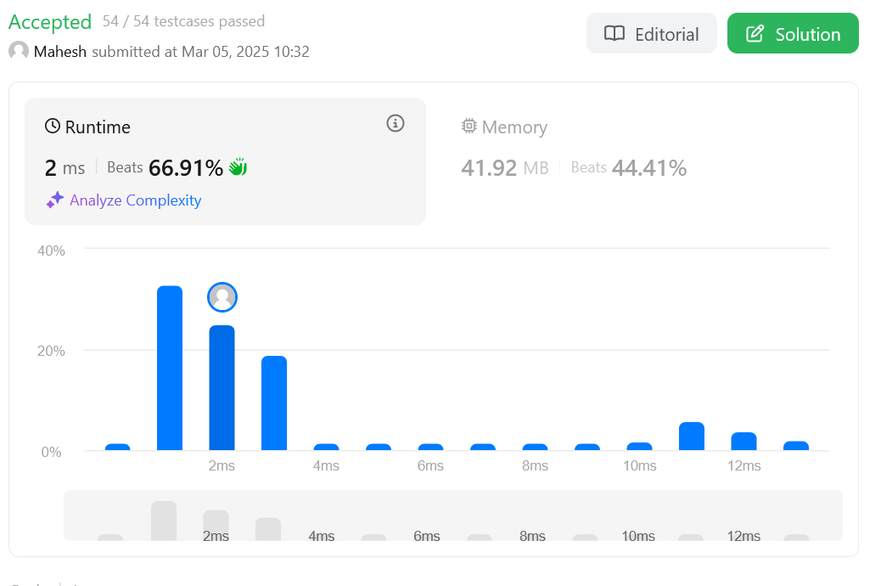

Question: Largest Perimeter Triangle

class Solution {

public int largestPerimeter(int[] nums) {

Arrays.sort(nums);

for (int i = nums.length - 1; i > 1; i--) {

if (nums[i] < nums[i - 1] + nums[i - 2])

return nums[i] + nums[i - 1] + nums[i - 2];

}

return 0;

}

}

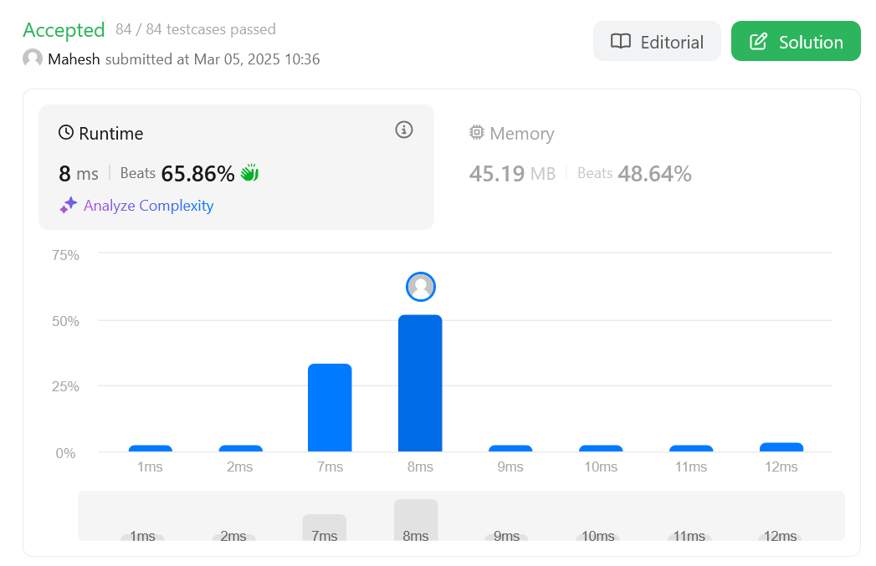

Question: Third Maximum Number

class Solution {

public int thirdMax(int[] nums) {

Integer max1 = null;

Integer max2 = null;

Integer max3 = null;

for (Integer n : nums) {

if (n.equals(max1) || n.equals(max2) || n.equals(max3))

continue;

if (max1 == null || n > max1) {

max3 = max2;

max2 = max1;

max1 = n;

} else if (max2 == null || n > max2) {

max3 = max2;

max2 = n;

} else if (max3 == null || n > max3) {

max3 = n;

}

}

return max3 == null ? max1 : max3;

}

}

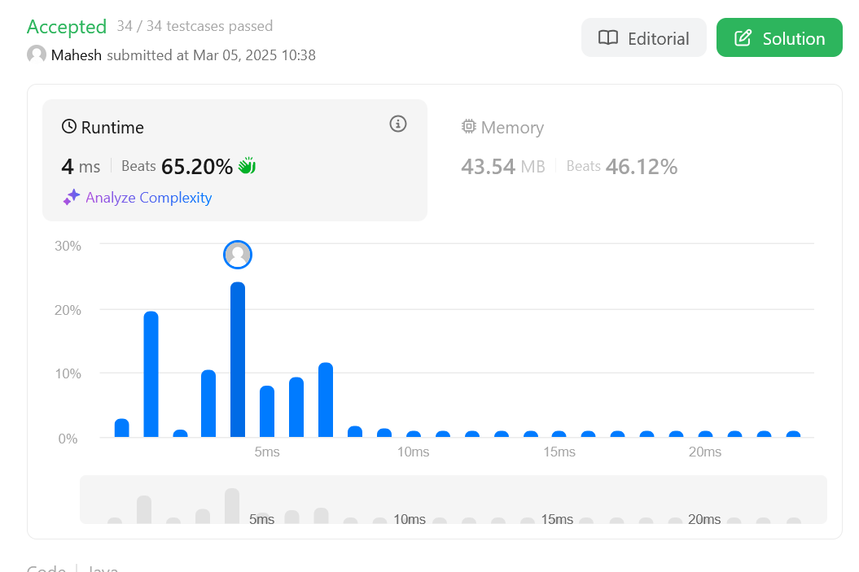

Question:: Sort Characters by frequency

class Solution {

public String frequencySort(String s) {

Map<Character, Integer> frequencyMap = new HashMap<>();

for (char c : s.toCharArray()) {

frequencyMap.put(c, frequencyMap.getOrDefault(c, 0) + 1);

}

PriorityQueue<Character> maxHeap = new PriorityQueue<>(

(a, b) -> frequencyMap.get(b) - frequencyMap.get(a));

maxHeap.addAll(frequencyMap.keySet());

StringBuilder result = new StringBuilder();

while (!maxHeap.isEmpty()) {

char c = maxHeap.poll();

result.append(String.valueOf(c).repeat(frequencyMap.get(c)));

}

return result.toString();

}

}

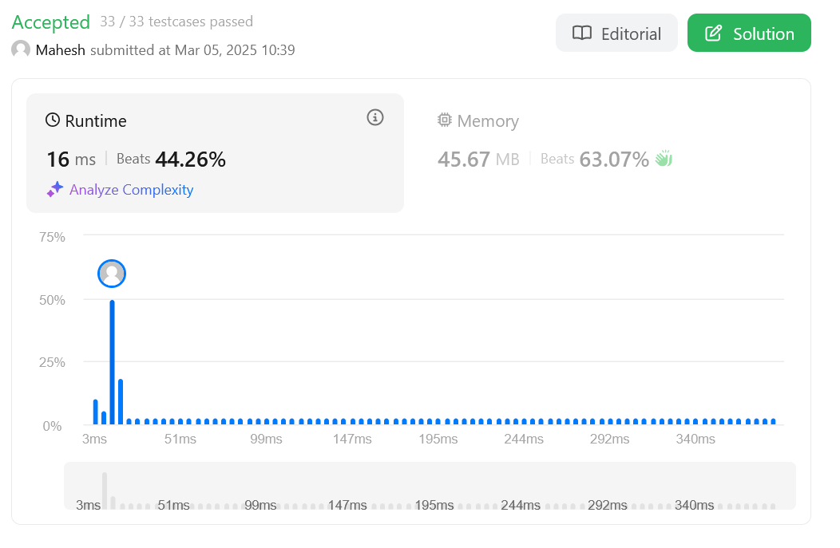

Question: Minimum Number of arrows to burst ballons

class Solution {

public int findMinArrowShots(int[][] segments) {

Arrays.sort(segments, (a, b) -> Integer.compare(a[1], b[1]));

int ans = 0, arrow = 0;

for (int i = 0; i < segments.length; i++) {

if (ans == 0 || segments[i][0] > arrow) {

ans++;

arrow = segments[i][1];

}

}

return ans;

}

}

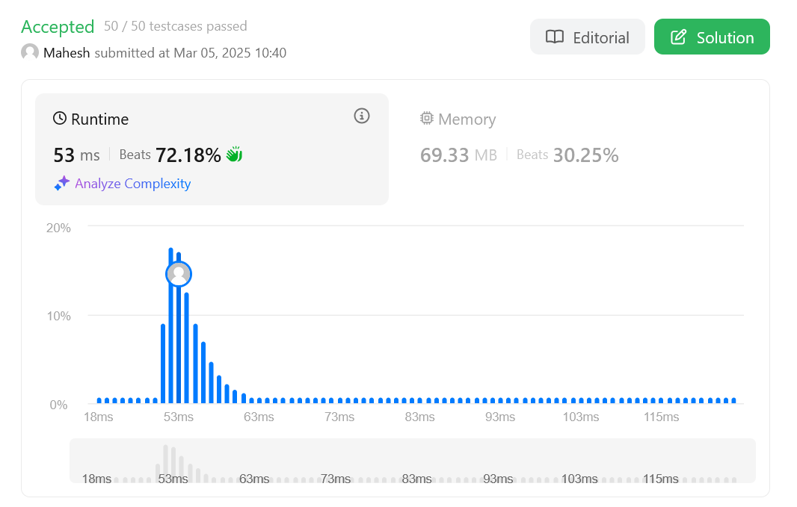

Question: Boats to save people

class Solution {

public int numRescueBoats(int[] people, int limit) {

Arrays.sort(people);

int left = 0, right = people.length - 1;

int boats = 0;

while (left <= right) {

if (people[left] + people[right] <= limit) {

left++;

}

right--;

boats++;

}

return boats;

}

}

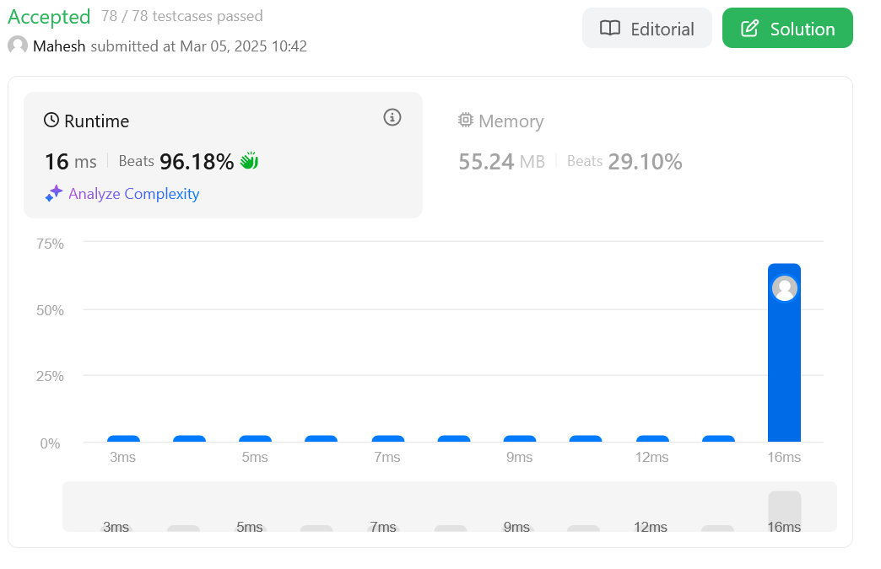

Question: K closest points to origin

class Solution {

public int[][] kClosest(int[][] points, int k) {

PriorityQueue<int[]> maxHeap = new PriorityQueue<>(

(a, b) -> Integer.compare((b[0] * b[0] + b[1] * b[1]), (a[0] * a[0] + a[1] * a[1])));

for (int[] point : points) {

maxHeap.add(point);

if (maxHeap.size() > k) {

maxHeap.poll();

}

}

int[][] result = new int[k][2];

for (int i = 0; i < k; i++) {

result[i] = maxHeap.poll();

}

return result;

}

}

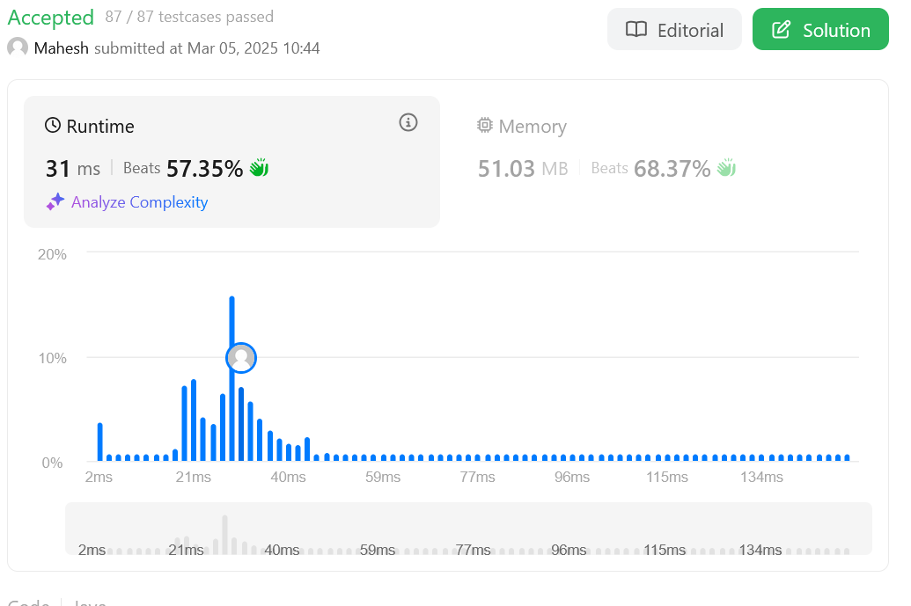

Question: Reduce array size to half

class Solution {

public int minSetSize(int[] arr) {

Map<Integer, Integer> freq = new HashMap<>();

for (int num : arr)

freq.put(num, freq.getOrDefault(num, 0) + 1);

List<Integer> counts = new ArrayList<>(freq.values());

counts.sort(Collections.reverseOrder());

int res = 0, cnt = 0, half = arr.length / 2;

for (int num : counts) {

cnt += num;

res++;

if (cnt >= half)

break;

}

return res;

}

}

