**ASSIGNMENT-5(AP)**

**Name:** Rattan Kaur Bajwa

**UID:** 22BCS16185

**Section:** 22BCS_FL_IOT-604

**Group:** A

389.[Find the diffrence](https://leetcode.com/problems/find-the-difference/description/)

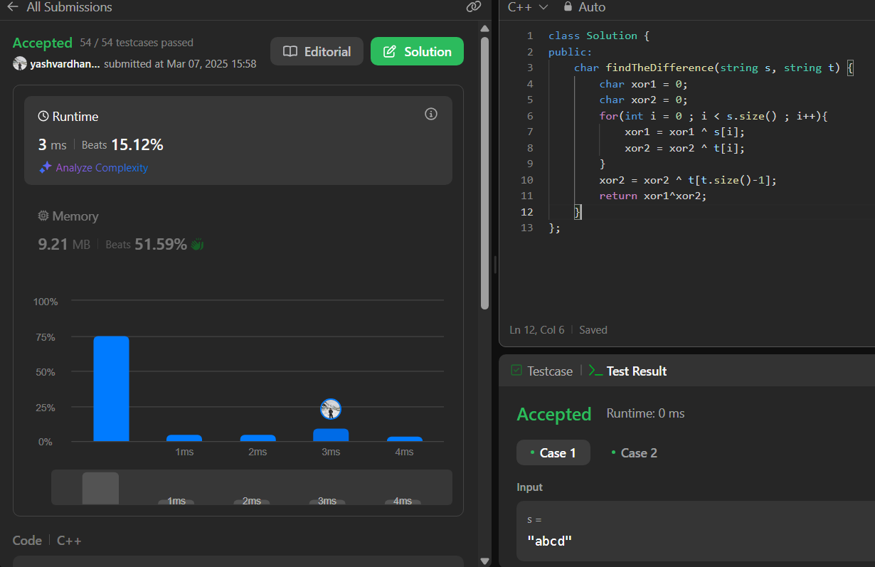  
976.[Largest Perimeter Triangle](https://leetcode.com/problems/largest-perimeter-triangle/description/)

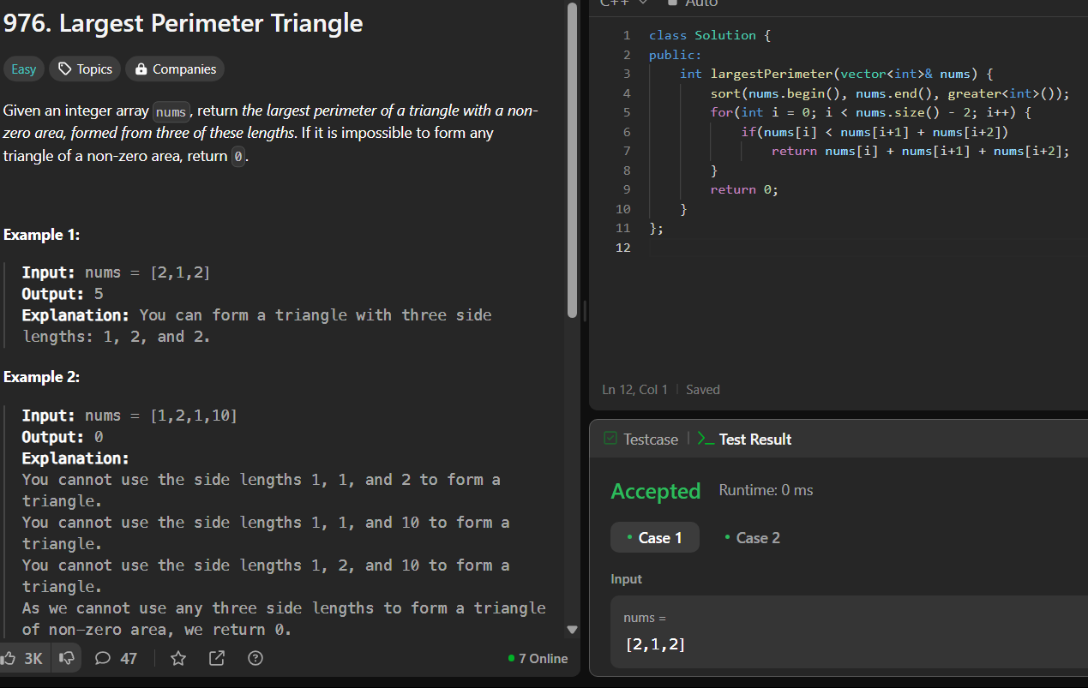

414.[Third Maximum Number](https://leetcode.com/problems/third-maximum-number/description/)

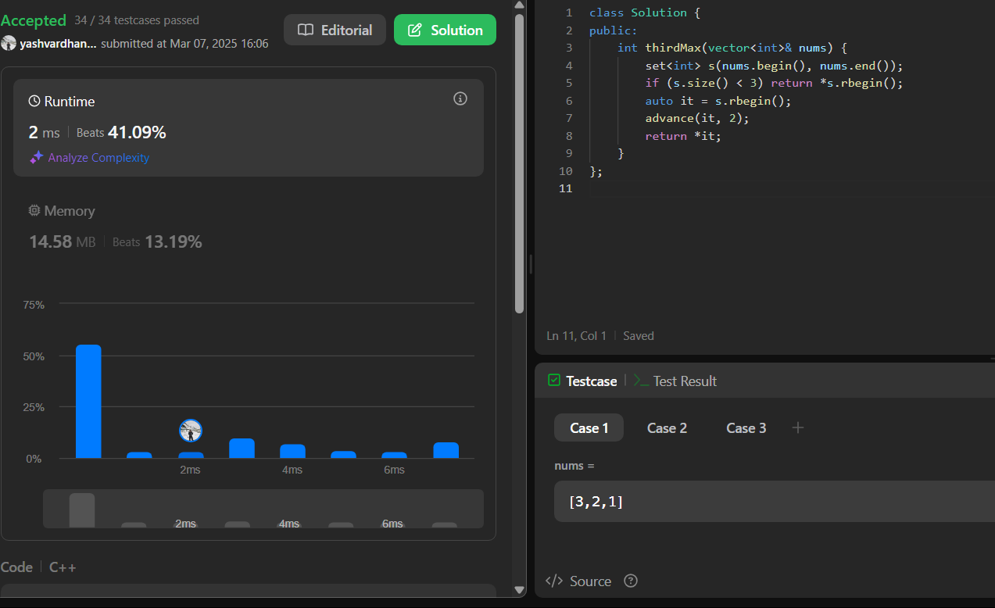

451.[Sort Characters By Frequency](https://leetcode.com/problems/sort-characters-by-frequency/description/)

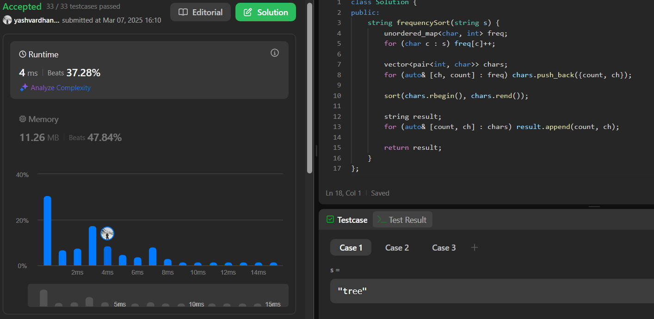

452.[Minimum Number of Arrows to Burst Balloons](https://leetcode.com/problems/minimum-number-of-arrows-to-burst-balloons/)

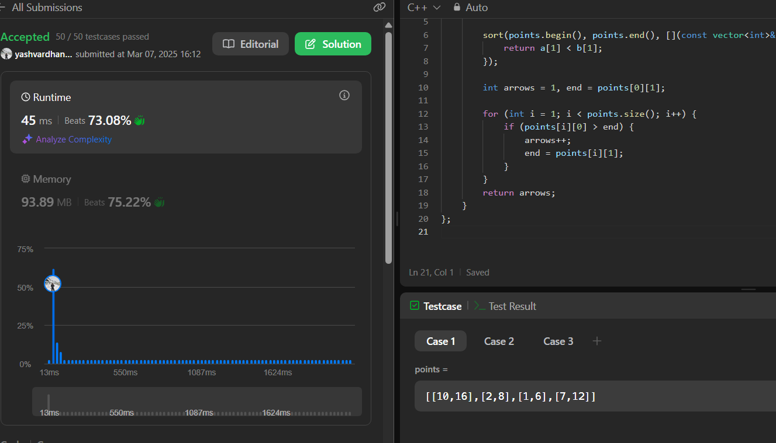

881.[Boats to Save People](https://leetcode.com/problems/boats-to-save-people/description/)

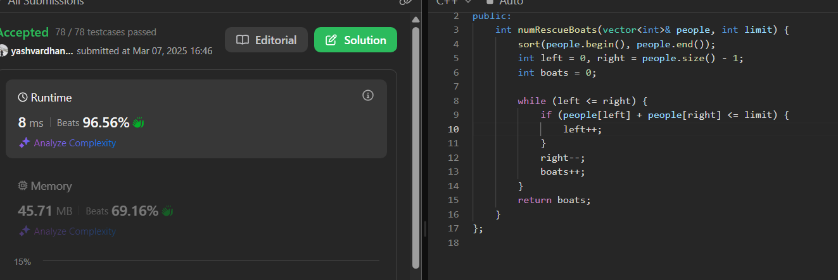

973.[K Closest Points to Origin](https://leetcode.com/problems/k-closest-points-to-origin/description/)

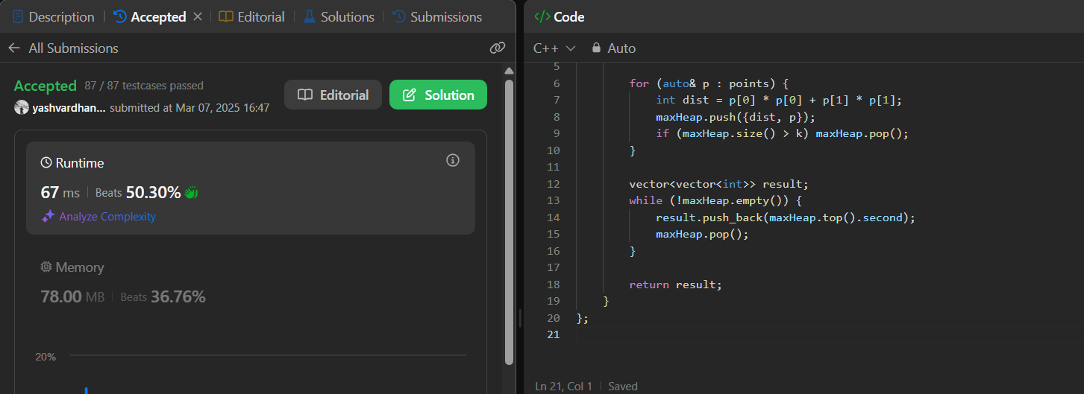

1338.[Reduce Array Size to The Half](https://leetcode.com/problems/reduce-array-size-to-the-half/description/)

