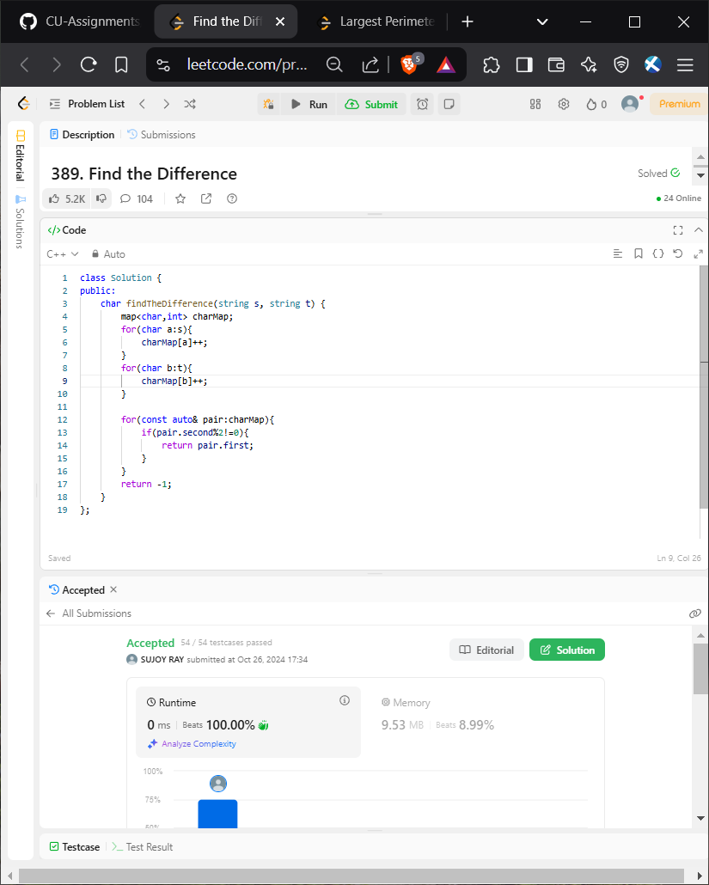

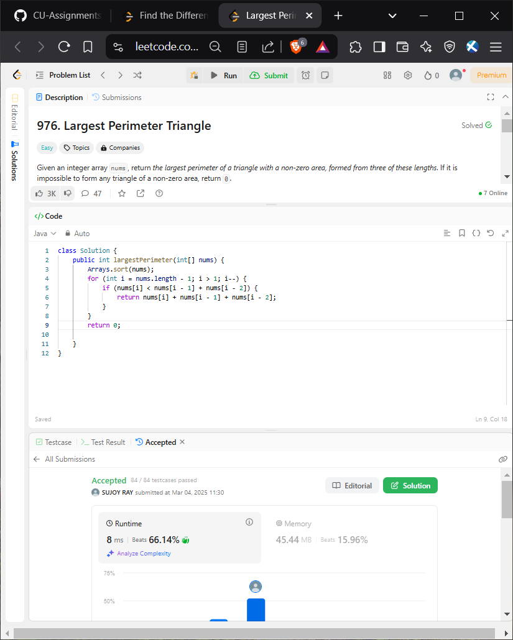

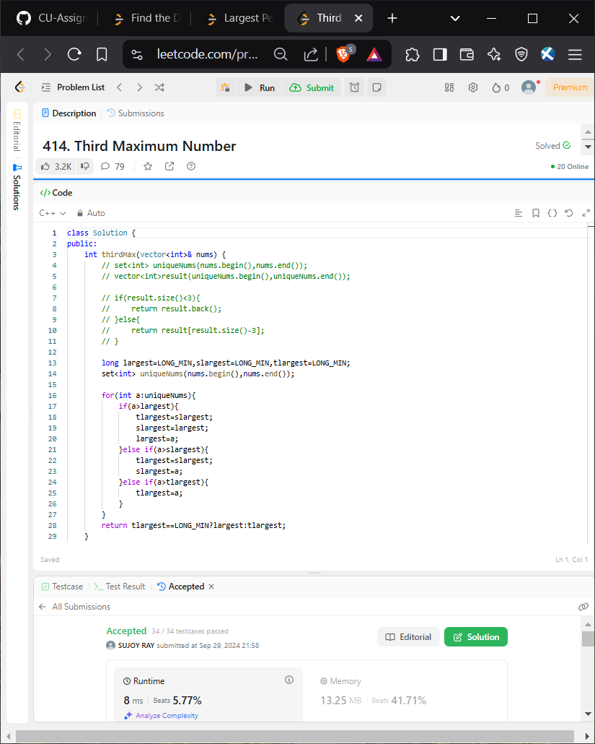

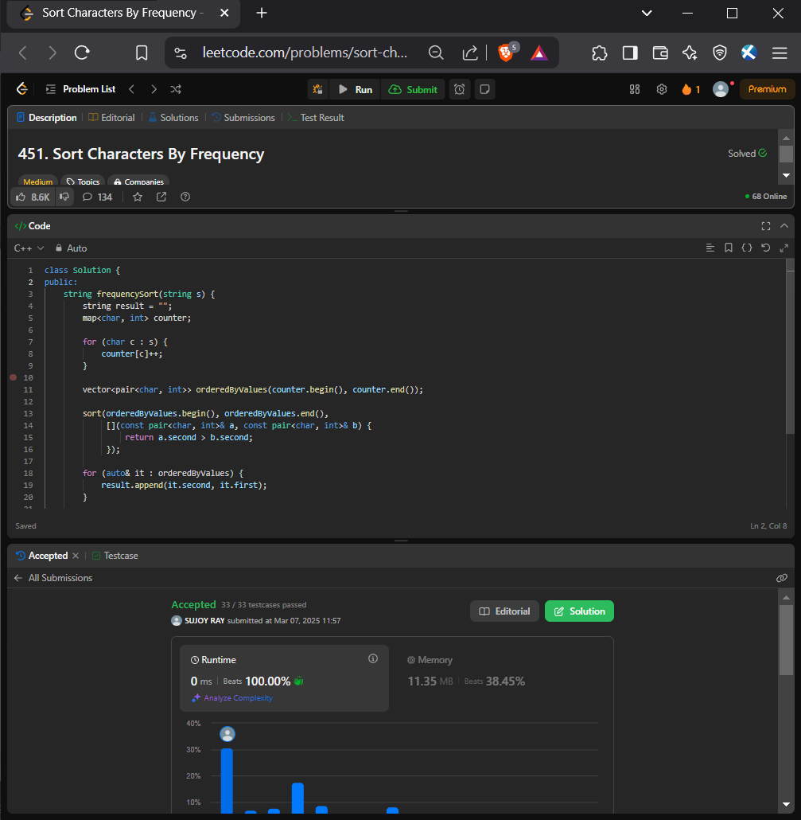

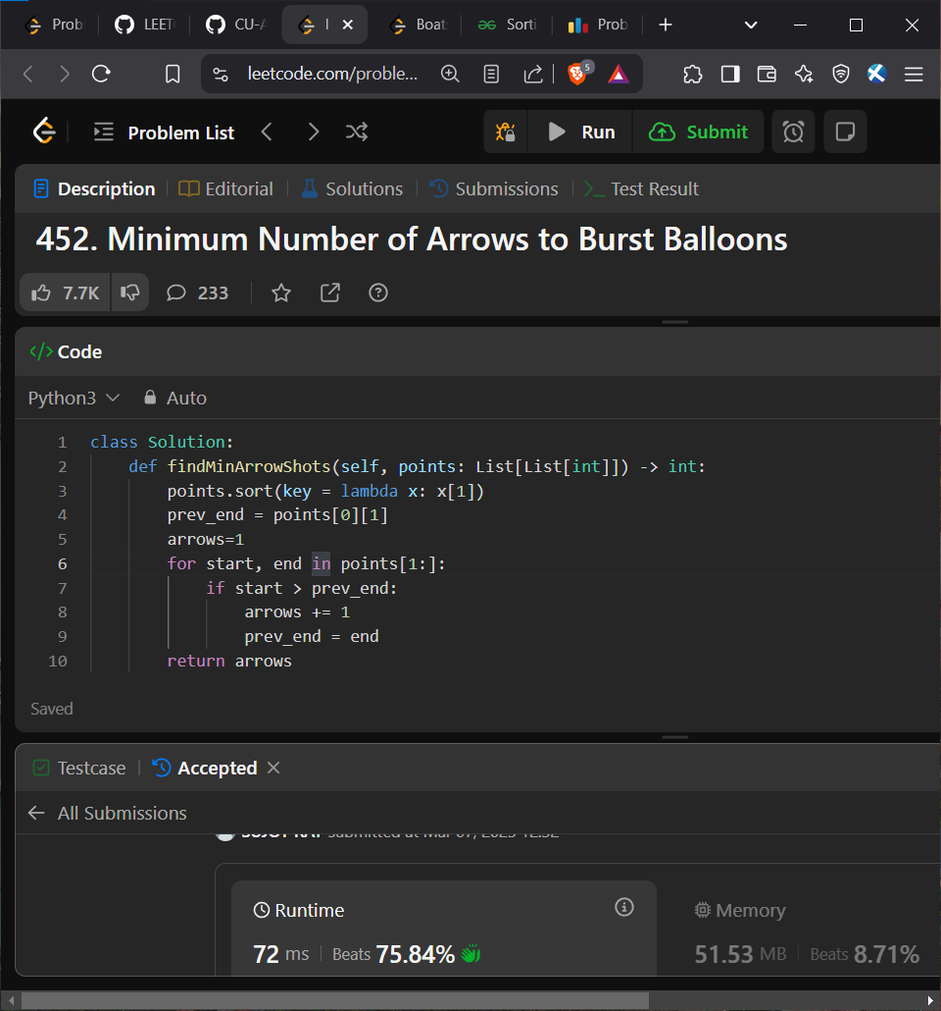



Reduce array size to half

class Solution {

public int minSetSize(int[] arr) {

int n = arr.length;

HashMap<Integer, Integer> cnt = new HashMap<>();

for (int x : arr) cnt.put(x, cnt.getOrDefault(x, 0) + 1);

int[] counting = new int[n + 1];

for (int freq : cnt.values()) ++counting[freq];

int ans = 0, removed = 0, half = n / 2, freq = n;

while (removed < half) {

ans += 1;

while (counting[freq] == 0) --freq;

removed += freq;

--counting[freq];

}

return ans;

}

}

