**ASSIGNMENT-5**

**Name:** Somil Kaushik **Section:** FL_IOT-603/A

**UID:** 22BCS15065

**389.** [**Find the difference**](https://leetcode.com/problems/find-the-difference/description/) class Solution { public:

char findTheDifference(string s, string t) {

unordered_map<char,int>mpp; for(int i=0;i<t.length();i++){ mpp[t[i]]++;

}

for(int i=0;i<s.length();i++){ mpp[s[i]]--;

}

for(auto it:mpp){ if(it.second>0){ return it.first;

} } return '0';

}};

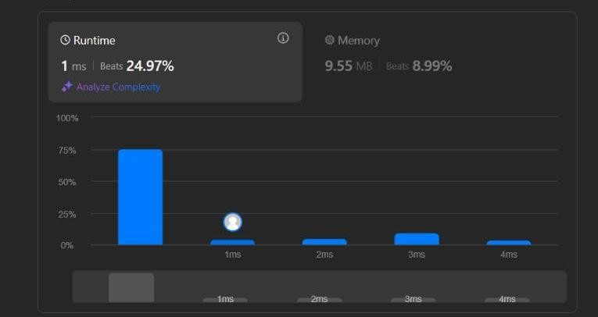

**976.**[**Largest Perimeter Triangle**](https://leetcode.com/problems/largest-perimeter-triangle/description/)

class Solution { public:

int largestPerimeter(vector<int>& nums) {

sort(nums.begin(),nums.end()); for(int i=nums.size()-1;i>1;i--){

if(nums[i]<nums[i-1]+nums[i-2]){

return nums[i]+nums[i-1]+nums[i-2];

} } return 0;

}

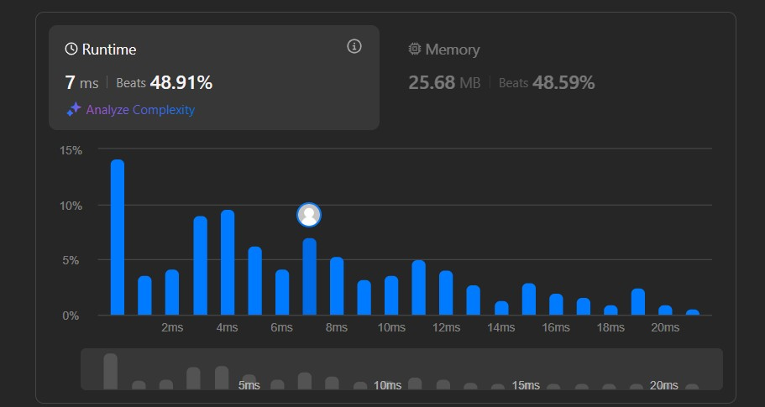

};

**414.**[**Third Maximum Number**](https://leetcode.com/problems/third-maximum-number/description/)

class Solution { public:

int thirdMax(vector<int>& nums) { sort(nums.begin(),nums.end()); int largest,seclargest,thirdlargest; largest= nums[0]; seclargest=nums[0]; thirdlargest=nums[0]; for(int i=0;i<nums.size();i++){

if(nums[i]>largest){ thirdlargest=seclargest; seclargest=largest; largest=nums[i];

}

else if(nums[i]>seclargest && nums[i]<largest){

thirdlargest=seclargest; seclargest=nums[i];

}

else if(nums[i]>thirdlargest && nums[i]<seclargest){

thirdlargest=nums[i];

} }

return ((nums.size()<=2 || seclargest==thirdlargest)?largest:thirdlargest); }

};

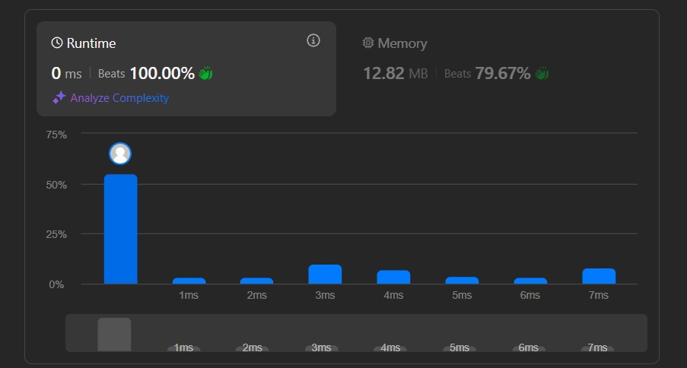

**451.**[**Sort Characters By Frequency**](https://leetcode.com/problems/sort-characters-by-frequency/description/) class Solution { public:

string frequencySort(string s) { auto cmp = [](const pair<char, int>& a, const pair<char, int>& b) { return a.second < b.second;

};

priority_queue<pair<char, int>, vector<pair<char, int>>, decltype(cmp)> pq(cmp);

unordered_map<char, int> hm;

for (char c : s) { hm[c]++;

}

for (const auto& entry : hm) { pq.push(make_pair(entry.first, entry.second));

}

string result = ""; while (!pq.empty()) { pair<char, int> p = pq.top(); pq.pop();

result.append(p.second, p.first);

}

return result;

}

};

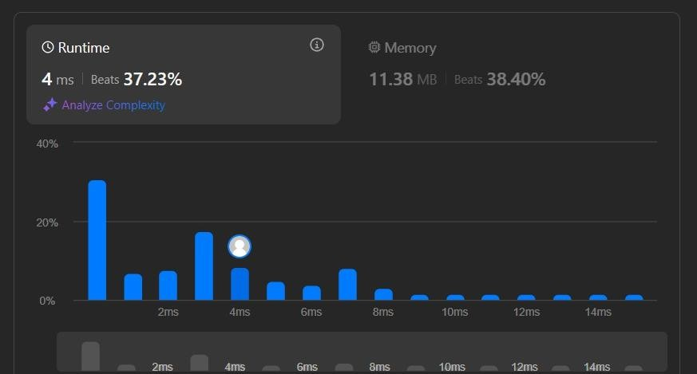

**881.**[**Boats to Save People**](https://leetcode.com/problems/boats-to-save-people/description/) class Solution { public:

int numRescueBoats(vector<int>& people, int limit) {

// sort vector sort(people.begin(),people.end()); int i = 0, j = people.size() - 1,cnt = 0; while(i <= j)

{

// lightest person + heaviest person sum <= limit

// they can go together if(people[i] + people[j] <= limit)

{

++i;

--j;

}

// if sum is over the limit, // heaviest will go alone.

else

--j;

++cnt; // number of boats

} return cnt;

}

};

