**Name:** Aditya Singh

**UID:** 22BCS15063

**Section:** FL_IOT_601 - A

**Assignment – 6 Solutions:-**

1. **Convert Sorted Array to Binary Search Tree:**

/*

* Definition for a binary tree node.

* struct TreeNode {

* int val;

* TreeNode *left;

* TreeNode *right;

* TreeNode() : val(0), left(nullptr), right(nullptr) {}

* TreeNode(int x) : val(x), left(nullptr), right(nullptr) {}

* TreeNode(int x, TreeNode *left, TreeNode *right) : val(x), left(left), right(right) {}

* };

*/

class Solution {

public:

TreeNode* BST(vector<int> &nums,int s, int e){

if(s>e) return NULL;

int mid=(s+e)/2;

TreeNode* node=new TreeNode(nums[mid]);

node->left=BST(nums,s,mid-1);

node->right=BST(nums,mid+1,e);

return node;

}

TreeNode* sortedArrayToBST(vector<int>& nums) {

if(nums.size()==0) return NULL;

TreeNode* root=BST(nums,0,nums.size()-1);

return root;

}

};

Result:-

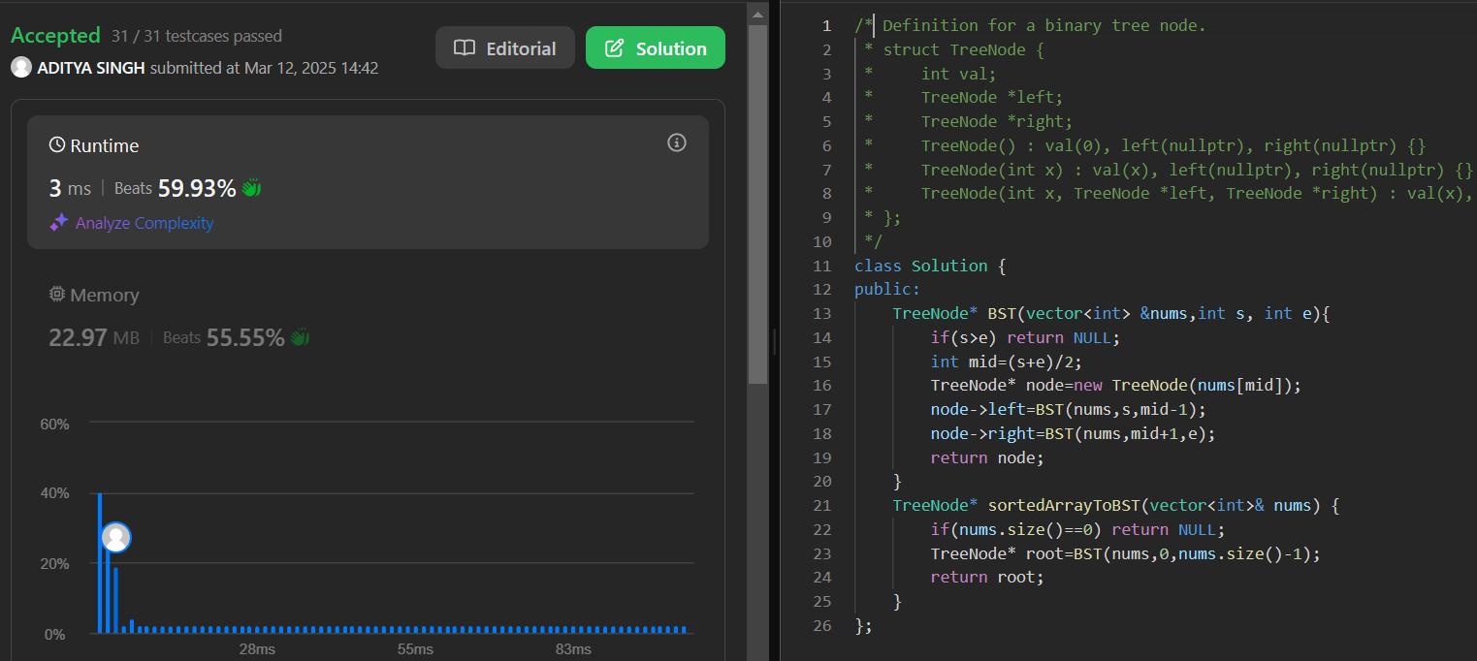

1. **Number of 1 Bits:**

class Solution {

public int hammingWeight(int n) {

int count = 0;

while(n != 0){

n &= (n-1);

count++;

}

return count;

}

}

Result:

1. **Sort an Array:**

class Solution {

public:

vector<int> sortArray(vector<int>& nums) {

int mini = *min_element(nums.begin(),nums.end());

int maxi = *max_element(nums.begin(),nums.end());

int range = maxi-mini+1;

vector<int> cnt(range,0);

for(auto ele : nums){

cnt[ele-mini]++;

}

int curr = 0;

for(int i=0;i<range;i++){

while(cnt[i] > 0){

nums[curr++] = i+mini;

cnt[i]--;

}

}

return nums;

}

};

Result:

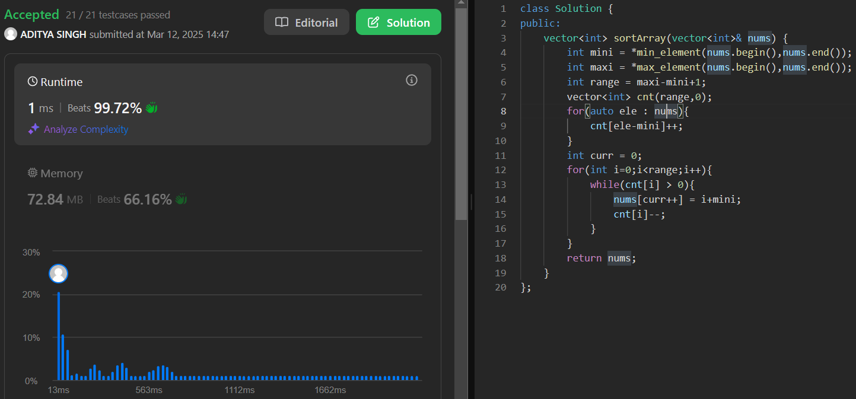

1. **Maximum Subarray:**

class Solution {

public:

int maxSubArray(vector<int>& nums) {

int ans = nums[0], f = nums[0];

for (int i = 1; i < nums.size(); ++i) {

f = max(f, 0) + nums[i];

ans = max(ans, f);

}

return ans;

}

};

Result:

1. **Beautiful Array:**

class Solution {

public:

vector<int> beautifulArray(int n) {

if (n == 1) return {1};

vector<int> left = beautifulArray((n + 1) >> 1);

vector<int> right = beautifulArray(n >> 1);

vector<int> ans(n);

int i = 0;

for (int& x : left) ans[i++] = x * 2 - 1;

for (int& x : right) ans[i++] = x * 2;

return ans;

}

};

Result:

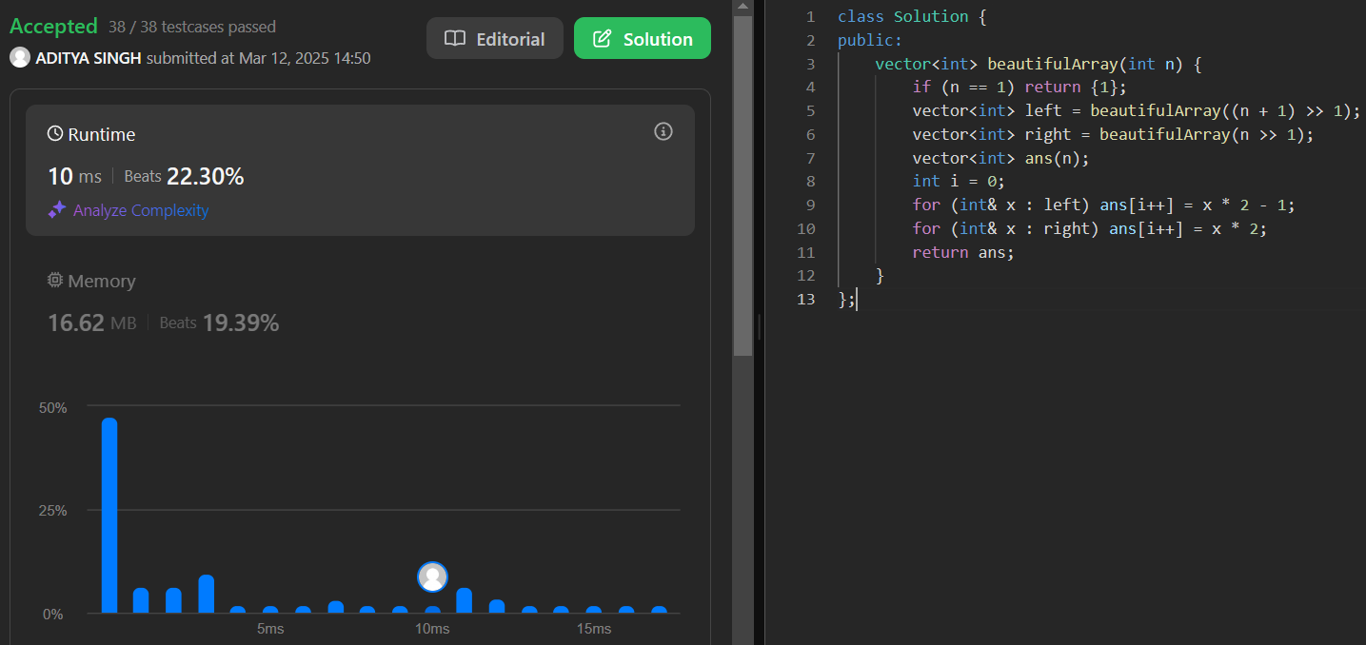

1. **Super Pow:**

class Solution {

const int base = 1337;

int powmod(int a, int k){

a %= base;

int result = 1;

for (int i = 0; i < k; ++i) result = (result * a) % base;

return result;

}

public:

int superPow(int a, vector<int>& b) {

if (b.empty()) return 1;

int last_digit = b.back();

b.pop_back();

return powmod(superPow(a, b), 10) * powmod(a, last_digit) % base;

}

};

Result:

1. **The Skyline Problem:**

class Solution {

public:

vector<vector<int>> getSkyline(vector<vector<int>>& buildings) {

int edge_idx = 0;

vector<pair<int, int>> edges;

priority_queue<pair<int, int>> pq;

vector<vector<int>> skyline;

for (int i = 0; i < buildings.size(); ++i) {

const auto &b = buildings[i];

edges.emplace_back(b[0], i);

edges.emplace_back(b[1], i);

}

std::sort(edges.begin(), edges.end());

while (edge_idx < edges.size()) {

int curr_height;

const auto &[curr_x, _] = edges[edge_idx];

while (edge_idx < edges.size() &&

curr_x == edges[edge_idx].first) {

const auto &[_, building_idx] = edges[edge_idx];

const auto &b = buildings[building_idx];

if (b[0] == curr_x)

pq.emplace(b[2], b[1]);

++edge_idx;

}

while (!pq.empty() && pq.top().second <= curr_x)

pq.pop();

curr_height = pq.empty() ? 0 : pq.top().first;

if (skyline.empty() || skyline.back()[1] != curr_height)

skyline.push_back({curr_x, curr_height});

}

return skyline;

}

};

Result:

