**ASSIGNMENT-6**

**NAME: SACHIN DADHWAL SEC: 605 /B**

**UID: 22BCS12149**

1. **108.**[**Convert Sorted Array to Binary Search Tree**](https://leetcode.com/problems/convert-sorted-array-to-binary-search-tree/description/)

You are given two strings s and t.

String t is generated by random shuffling string s and then add one more letter at a random position. Return the letter that was added to t.

**CODE:**

class Solution {

public:

    char findTheDifference(string s, string t) {

int arr[26]={0};

for(auto a:s){

    arr[a-'a']++;

}

for(auto i:t){

    if(!arr[i-'a']) return i;

    arr[i-'a']--; }

return 'e';    }};

**OUTPUT:**

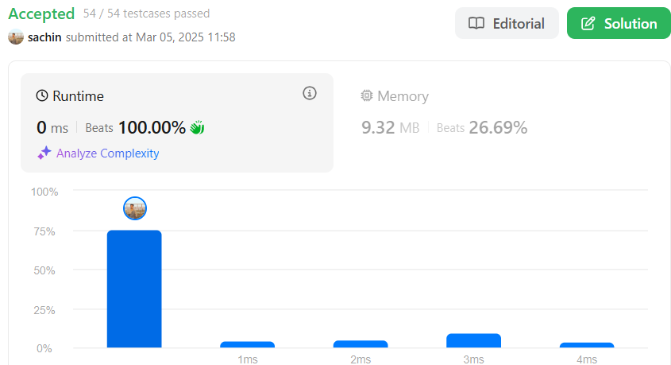

1. **976.**[**Largest Perimeter Triangle**](https://leetcode.com/problems/largest-perimeter-triangle/description/)**.**

Given an integer array nums, return *the largest perimeter of a triangle with a non-zero area, formed from three of these lengths*. If it is impossible to form any triangle of a non-zero area, return 0.

**CODE:**

class Solution {

public:

int largestPerimeter(vector<int>& nums) {

sort(nums.begin(),nums.end());

for(int i=nums.size()-1;i>1;i--){

if(nums[i]<nums[i-1]+nums[i-2]){

return nums[i]+nums[i-1]+nums[i-2];

}

}

return 0;

}

};

**OUTPUT:**



1. **414.**[**Third Maximum Number**](https://leetcode.com/problems/third-maximum-number/description/)**.**

Given an integer array nums, return *the third distinct maximum number in this array. If the third maximum does not exist, return the maximum number*.

**CODE:**

class Solution {

public int thirdMax(int[] nums) {

long max1 = Long.MIN_VALUE;

long max2 = Long.MIN_VALUE;

long max3 = Long.MIN_VALUE;

for (int i = 0; i < nums.length; i++) {

if (nums[i] > max1) {

max3 = max2;

max2 = max1;

max1 = nums[i];

} else if (nums[i] > max2 && nums[i] != max1) {

max3 = max2;

max2 = nums[i];

} else if (nums[i] > max3 && nums[i] != max1 && nums[i] != max2) {

max3 = nums[i];

}

}

return max3 == Long.MIN_VALUE ? (int) max1 : (int) max3;

}

}

**OUTPUT:**

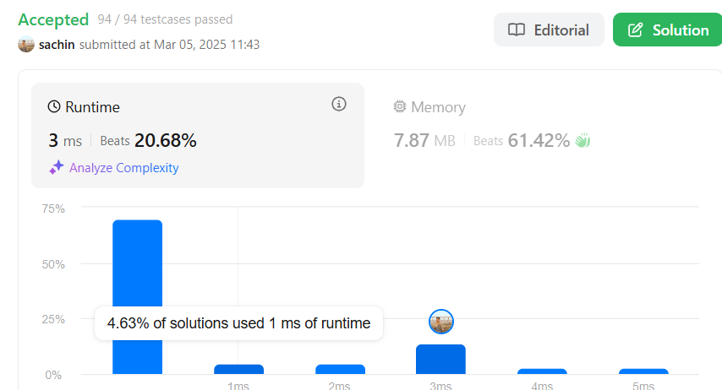

1. **451.**[**Sort Characters By Frequency**](https://leetcode.com/problems/sort-characters-by-frequency/description/)

Given a string s, sort it in decreasing order based on the frequency of the characters. The frequency of a character is the number of times it appears in the string.

Return *the sorted string*. If there are multiple answers, return *any of them*.

**CODE:**

class Solution {

public:

string frequencySort(string s) {

unordered_map<char, int> mp;

vector<pair<int, char>> v;

string ans = "";

// count character frequency

for(auto ch: s){

mp[ch]++;

}

// push from map to vector

for(auto i: mp){

v.push_back({i.second, i.first});

}

// sort the vector in decreasing order

sort(v.begin(), v.end(), greater<pair<int, char>>());

// add to final answer string

for(auto i: v){

while(i.first--) ans += i.second;

}

return ans;

}

};

**OUTPUT:**

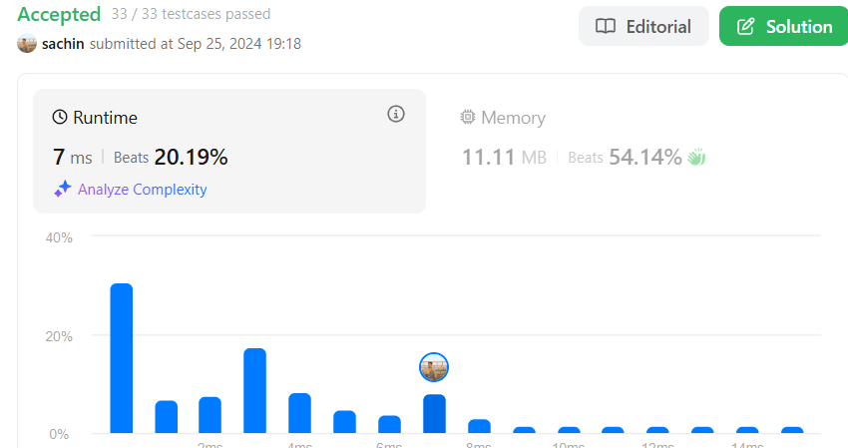

1. **452.**[**Minimum Number of Arrows to Burst Balloons**](https://leetcode.com/problems/minimum-number-of-arrows-to-burst-balloons/)**.**

There are some spherical balloons taped onto a flat wall that represents the XY-plane. The balloons are represented as a 2D integer array points where points[i] = [xstart, xend] denotes a balloon whose **horizontal diameter** stretches between xstart and xend. You do not know the exact y-coordinates of the balloons.

**CODE:**

class Solution {

public:

int findMinArrowShots(vector<vector<int>>& points) {

std::sort(points.begin(), points.end(), [](const auto& a, const auto& b) {

return a[0] < b[0];

});

int arrows = 1;

int end = points[0][1];

for (size_t i = 1; i < points.size(); ++i) {

if (points[i][0] > end) {

arrows++;

end = points[i][1];

} else {

end = std::min(end, points[i][1]);

}

}

return arrows;

}

};

**OUTPUT:**



1. **881.**[**Boats to Save People**](https://leetcode.com/problems/boats-to-save-people/description/)**.**

You are given an array people where people[i] is the weight of the ith person, and an **infinite number of boats** where each boat can carry a maximum weight of limit. Each boat carries at most two people at the same time, provided the sum of the weight of those people is at most limit.

**CODE:**

class Solution {

public int numRescueBoats(int[] people, int limit) {

int boats = 0;

Arrays.sort(people);

int i=0,j=people.length-1;

while(i<=j){

if((people[j]+people[i])<=limit){

i++;

}

j--;

boats++;

}

return boats;

}

}

**OUTPUT:**



1. **973.**[**K Closest Points to Origin**](https://leetcode.com/problems/k-closest-points-to-origin/description/)**.**

Given an array of points where points[i] = [xi, yi] represents a point on the **X-Y** plane and an integer k, return the k closest points to the origin (0, 0).

**CODE:**

class Solution {

public:

vector<vector<int>> kClosest(vector<vector<int>>& points, int k) {

// Max heap to store distances and corresponding points

priority_queue<pair<int, vector<int>>> maxHeap;

for (auto& point : points) {

int distance = point[0] * point[0] + point[1] * point[1];

maxHeap.push({distance, point});

if (maxHeap.size() > k) maxHeap.pop(); // Remove farthest point if size > k

}

vector<vector<int>> ans;

while (!maxHeap.empty()) {

ans.push_back(maxHeap.top().second);

maxHeap.pop();

}

return ans;

}

};

**OUTPUT:**



1. **1338.**[**Reduce Array Size to The Half**](https://leetcode.com/problems/reduce-array-size-to-the-half/description/)**.**

You are given an integer array arr. You can choose a set of integers and remove all the occurrences of these integers in the array.

**CODE:**

class Solution {

public:

int minSetSize(vector<int>& arr) {

int n = arr.size();

unordered_map<int, int> cnt;

for (int x : arr) ++cnt[x];

vector<int> counting(n + 1);

for (auto [_, freq] : cnt) ++counting[freq];

int ans = 0, removed = 0, half = n / 2, freq = n;

while (removed < half) {

ans += 1;

while (counting[freq] == 0) --freq;

removed += freq;

--counting[freq];

}

return ans;

}

};

**OUTPUT:**

