**Assignment Advance Programming Lab 6**

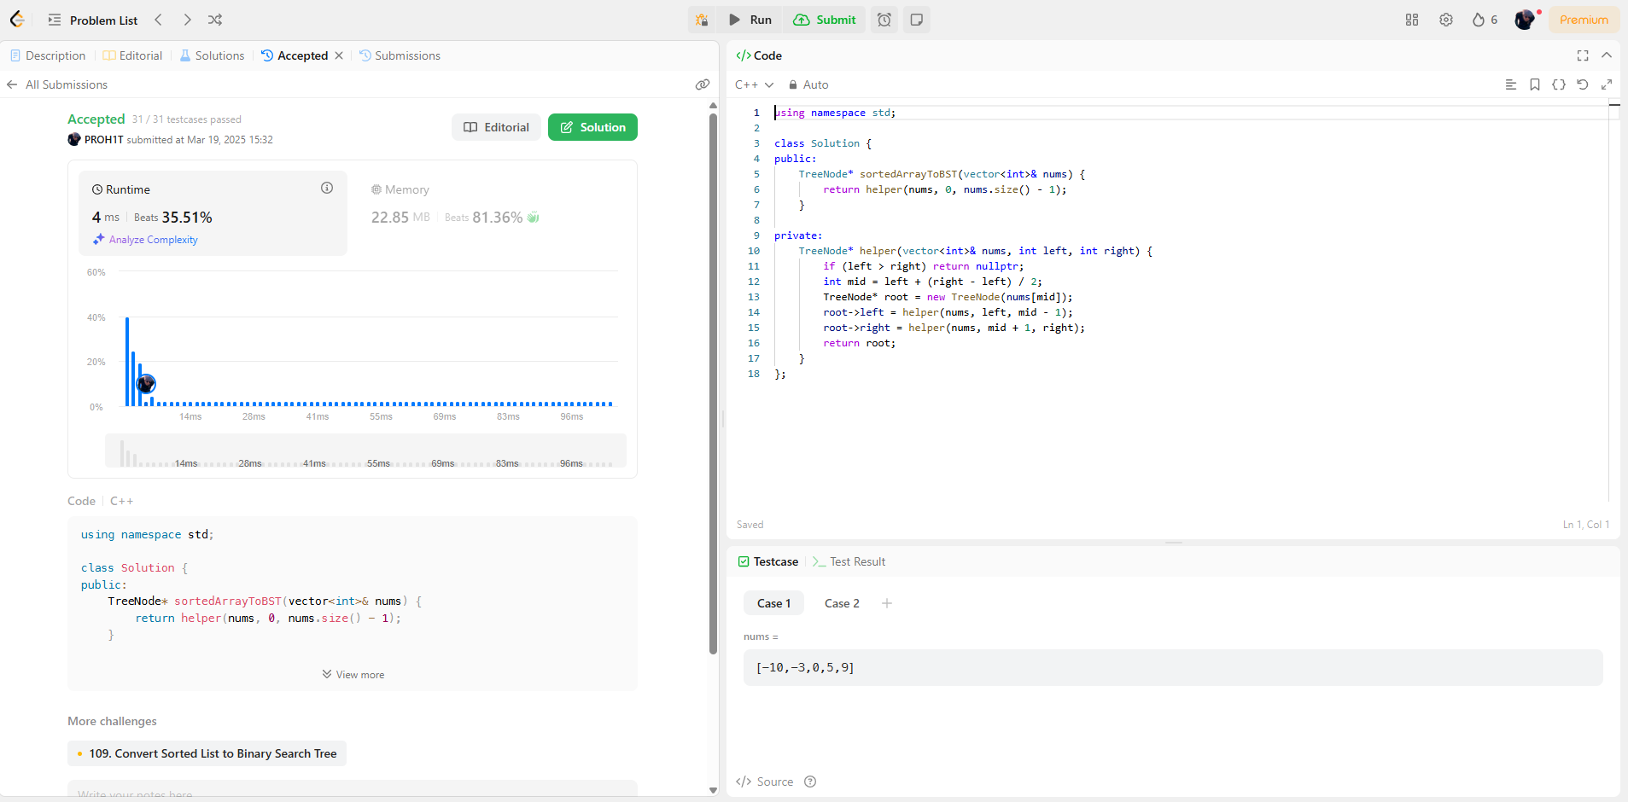[**108. Convert Sorted Array to Binary Search Tree**](https://leetcode.com/problems/convert-sorted-array-to-binary-search-tree/)

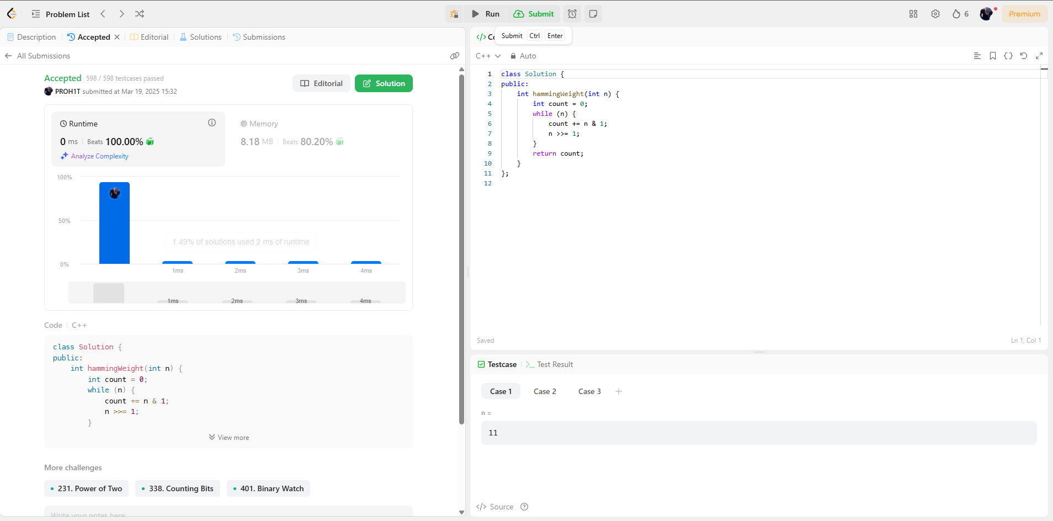[**191. Number of 1 Bits**](https://leetcode.com/problems/number-of-1-bits/)

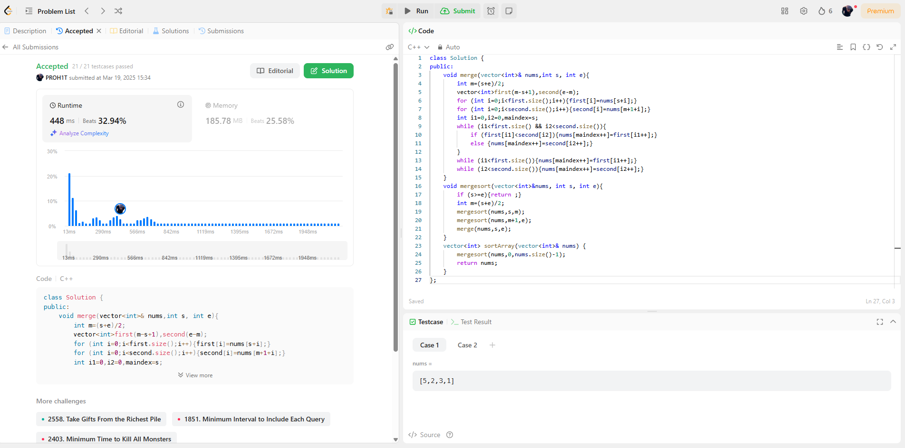[**912. Sort an Array**](https://leetcode.com/problems/sort-an-array/)

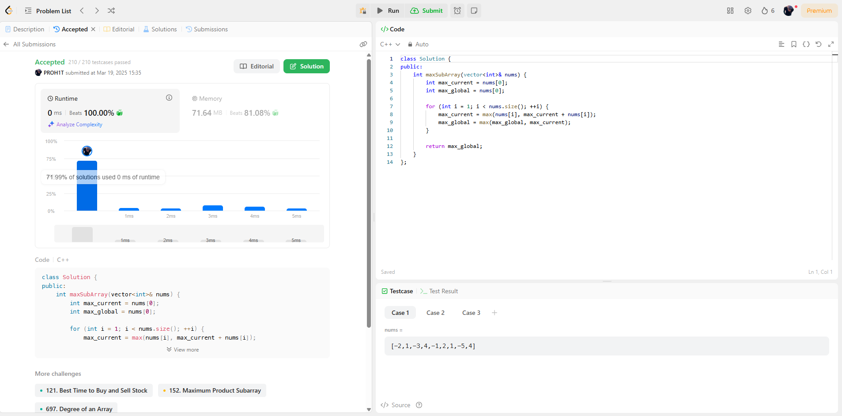[**53. Maximum Subarray**](https://leetcode.com/problems/maximum-subarray/)

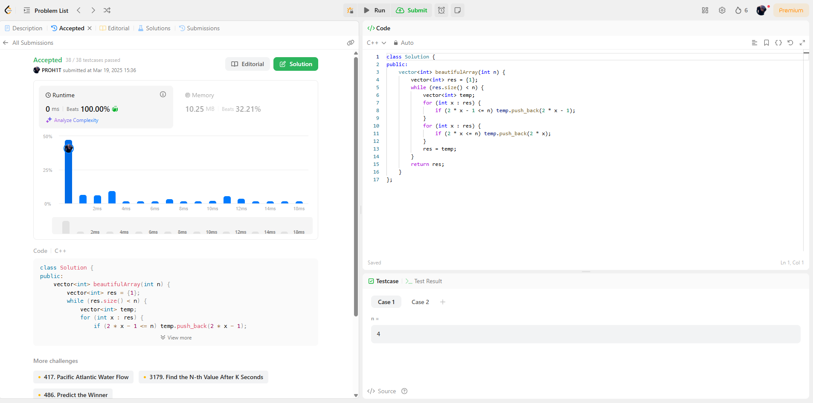[**932. Beautiful Array**](https://leetcode.com/problems/beautiful-array/)

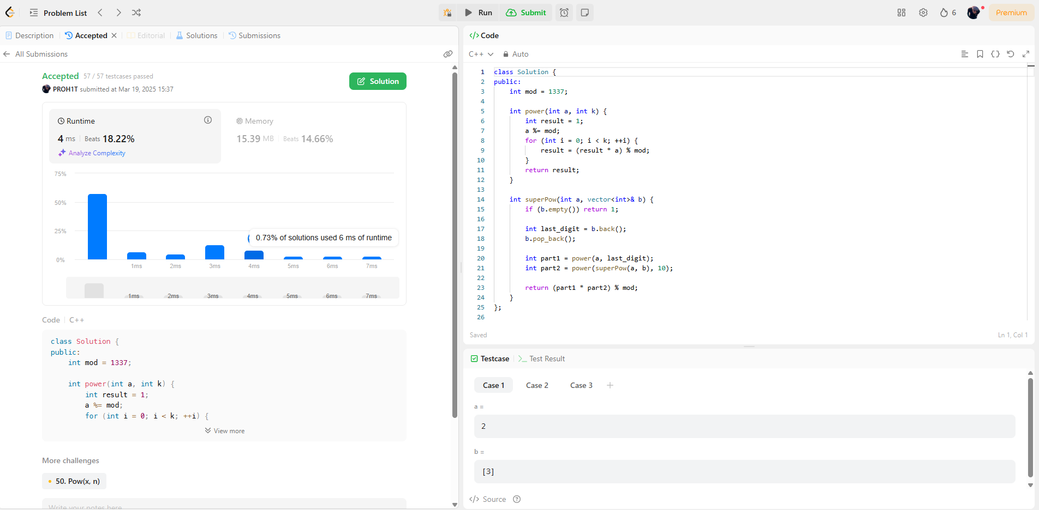[**372. Super Pow**](https://leetcode.com/problems/super-pow/)

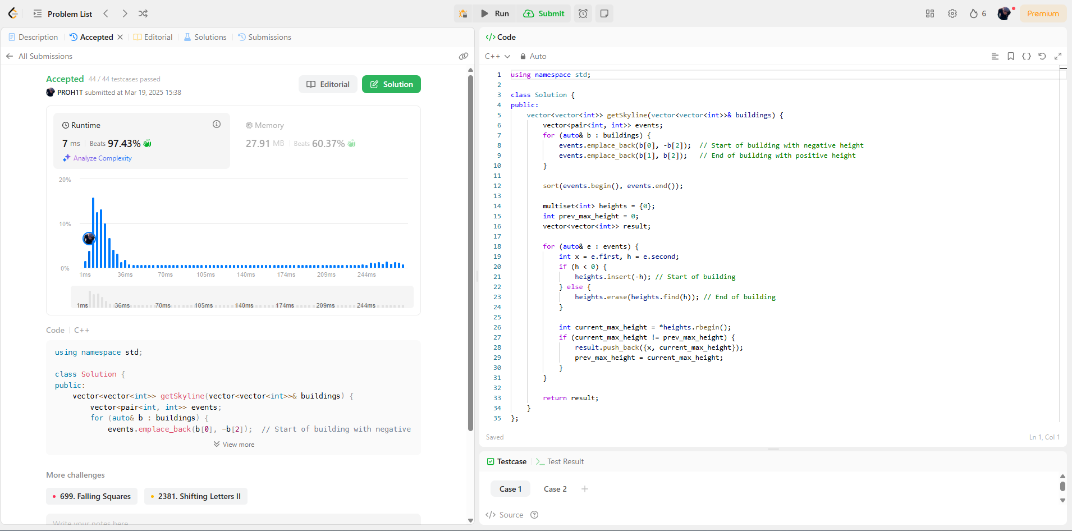[**218. The Skyline Problem**](https://leetcode.com/problems/the-skyline-problem/)