Experiment - 7
Name: Armaan UID: 22BCS12007
Aim: To solve JAVA problems

- Problem : Easy Level: User Login with Servlet

- login.html

html
CopyEdit
<!DOCTYPE html>
<html>
<head>
<title>Login</title>
</head>
<body>
<h2>User Login</h2>
<form method="post" action="LoginServlet">
Username: <input type="text" name="username" required /><br/>
Password: <input type="password" name="password" required /><br/>
<input type="submit" value="Login" />
</form>
</body>
</html>

- LoginServlet.java

java
CopyEdit
import java.io.*;
import javax.servlet.*;
import javax.servlet.http.*;

public class LoginServlet extends HttpServlet {
protected void doPost(HttpServletRequest request, HttpServletResponse response)
throws ServletException, IOException {

String user = request.getParameter("username");
String pass = request.getParameter("password");

// Static validation
if ("admin".equals(user) && "1234".equals(pass)) {
request.setAttribute("username", user);
RequestDispatcher dispatcher = request.getRequestDispatcher("welcome.jsp");
dispatcher.forward(request, response);
} else {
response.getWriter().println("Invalid login! <a href='login.html'>Try again</a>");
}
}
}

- welcome.jsp

jsp
CopyEdit
<%@ page language="java" %>
<html>
<head><title>Welcome</title></head>
<body>
<h2>Welcome, <%= request.getAttribute("username") %>!</h2>
</body>
</html>

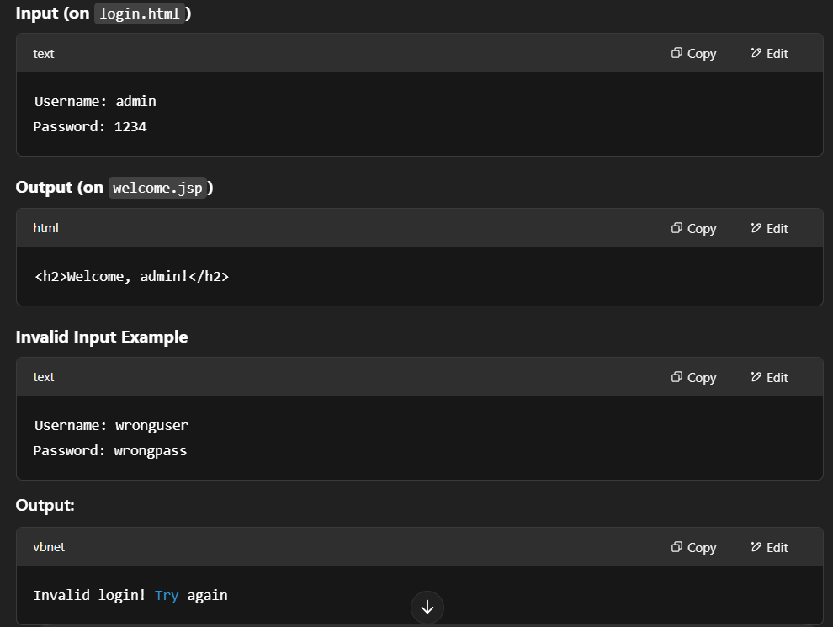
Output:

Problem : Medium Level: Employee Directory with JDBC

- employeeList.html

html
CopyEdit
<!DOCTYPE html>
<html>
<head><title>Employee Search</title></head>
<body>
<form method="get" action="EmployeeServlet">
Search by ID: <input type="text" name="id"/>
<input type="submit" value="Search" />
</form>
</body>
</html>

- db-config.properties

properties
CopyEdit
db.url=jdbc:mysql://localhost:3306/company
db.user=root
db.password=yourpassword

- EmployeeServlet.java

java
CopyEdit
import java.io.*;
import java.sql.*;
import java.util.*;
import javax.servlet.*;
import javax.servlet.http.*;

public class EmployeeServlet extends HttpServlet {
private Properties dbProps = new Properties();

public void init() throws ServletException {
try (InputStream in = getServletContext().getResourceAsStream("/WEB-INF/db-config.properties")) {
dbProps.load(in);
} catch (IOException e) {
throw new ServletException("Could not load DB config", e);
}
}

protected void doGet(HttpServletRequest request, HttpServletResponse response)
throws ServletException, IOException {

String id = request.getParameter("id");
PrintWriter out = response.getWriter();
response.setContentType("text/html");

try {
Class.forName("com.mysql.cj.jdbc.Driver");
Connection conn = DriverManager.getConnection(
dbProps.getProperty("db.url"),
dbProps.getProperty("db.user"),

dbProps.getProperty("db.password")
);

String query = (id == null || id.isEmpty()) ?
"SELECT * FROM employees" :
"SELECT * FROM employees WHERE id = ?";

PreparedStatement stmt = conn.prepareStatement(query);
if (id != null && !id.isEmpty()) stmt.setInt(1, Integer.parseInt(id));

ResultSet rs = stmt.executeQuery();
out.println("<h2>Employee List</h2><ul>");
while (rs.next()) {
out.println("<li>" + rs.getString("name") + " - " + rs.getString("department") + "</li>");
}
out.println("</ul>");

conn.close();
} catch (Exception e) {
out.println("Error: " + e.getMessage());
}
}
}

Output :

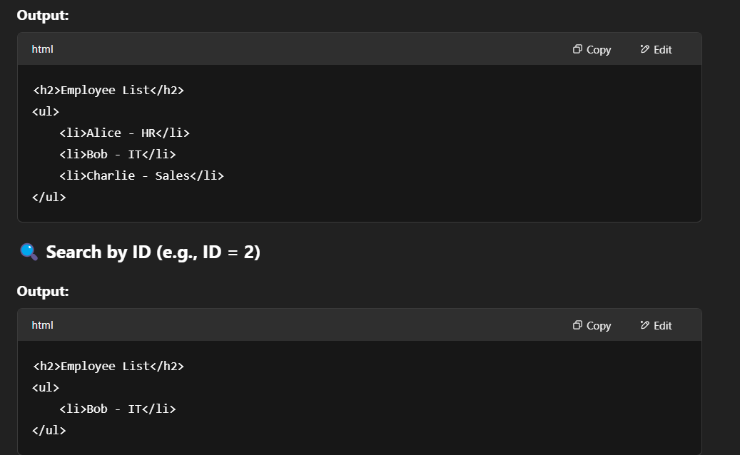

Problem : JSP-Based Student Attendance Portal

- attendance.jsp

jsp
CopyEdit
<html>
<head><title>Attendance Form</title></head>
<body>
<h2>Student Attendance</h2>
<form method="post" action="AttendanceServlet">
Name: <input type="text" name="name" required /><br/>
Date: <input type="date" name="date" required /><br/>
Status:
<select name="status">
<option>Present</option>
<option>Absent</option>

</select><br/>
<input type="submit" value="Submit Attendance" />
</form>
</body>
</html>

- StudentAttendance.java

java
CopyEdit
public class StudentAttendance {
private String name, date, status;

public StudentAttendance(String name, String date, String status) {
this.name = name;
this.date = date;
this.status = status;
}

// Getters
public String getName() { return name; }
public String getDate() { return date; }
public String getStatus() { return status; }
}

- AttendanceServlet.java

java
CopyEdit
import java.io.*;
import java.sql.*;
import javax.servlet.*;
import javax.servlet.http.*;

public class AttendanceServlet extends HttpServlet {
protected void doPost(HttpServletRequest request, HttpServletResponse response)
throws ServletException, IOException {

String name = request.getParameter("name");
String date = request.getParameter("date");
String status = request.getParameter("status");

try {
Class.forName("com.mysql.cj.jdbc.Driver");
Connection conn = DriverManager.getConnection(
"jdbc:mysql://localhost:3306/school", "root", "yourpassword");

PreparedStatement stmt = conn.prepareStatement(
"INSERT INTO attendance (name, date, status) VALUES (?, ?, ?)");
stmt.setString(1, name);
stmt.setString(2, date);
stmt.setString(3, status);
stmt.executeUpdate();

request.setAttribute("student", new StudentAttendance(name, date, status));
request.getRequestDispatcher("attendance-success.jsp").forward(request, response);

} catch (Exception e) {
throw new ServletException("Database error", e);
}
}
}

- attendance-success.jsp

jsp
CopyEdit
<%@ page import="StudentAttendance" %>
<%
StudentAttendance student = (StudentAttendance) request.getAttribute("student");
%>
<html>
<head><title>Success</title></head>
<body>
<h2>✅ Attendance Submitted</h2>
<p>Name: <%= student.getName() %></p>
<p>Date: <%= student.getDate() %></p>
<p>Status: <%= student.getStatus() %></p>
</body>
</html>

Output :

