**Advanced Pragramming**

**ASSIGNMENT 01**

**Q1. Print Linked list.**

**Code:**

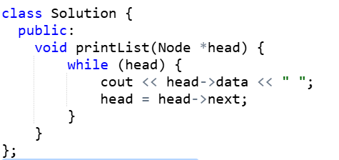

**Output:**

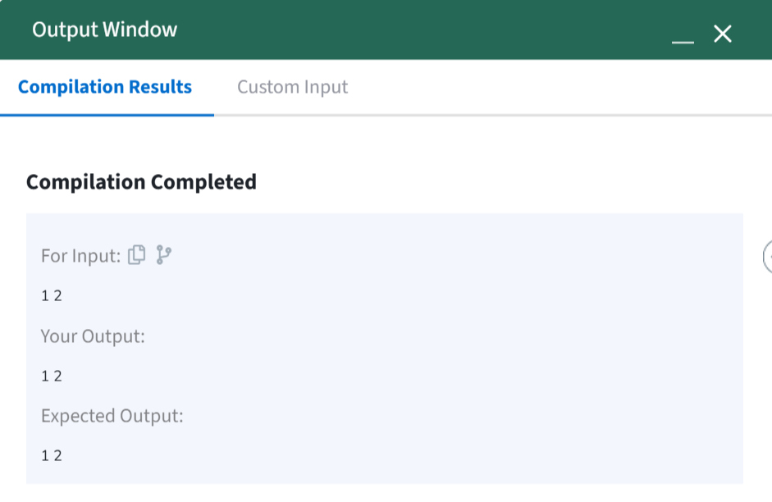

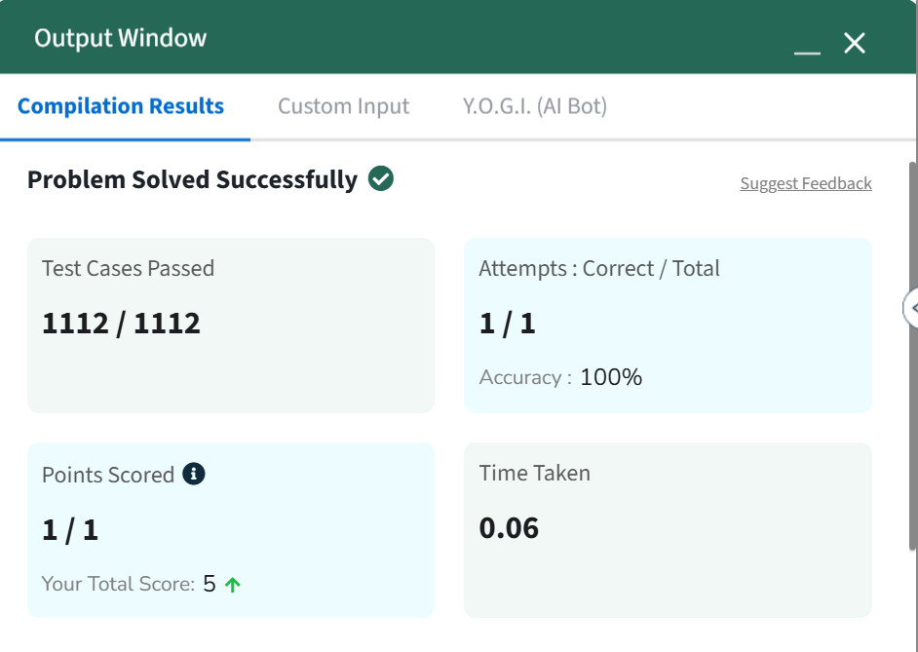

**Q2. Remove duplicates from a sorted list.**

**Code:**

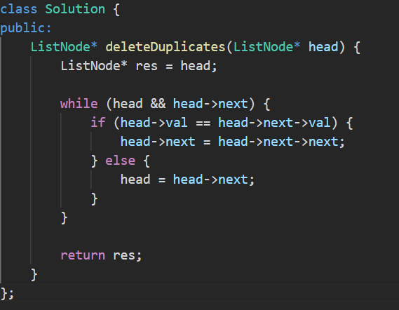

**Output:**

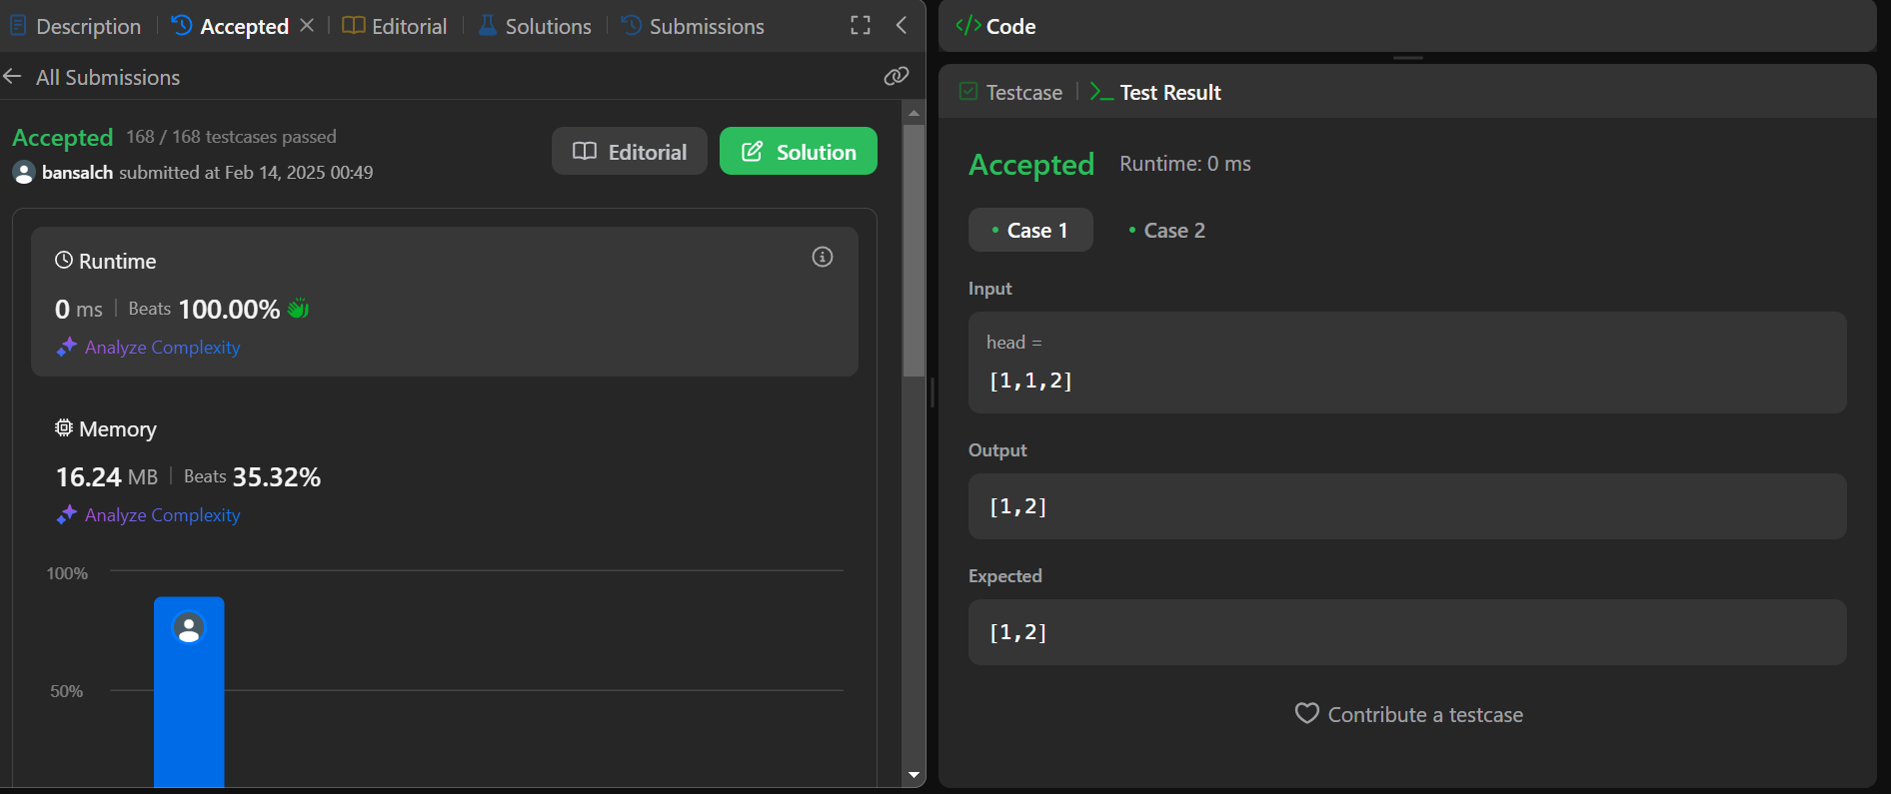

**Q3. Reverse a linked list.**

**Code:**

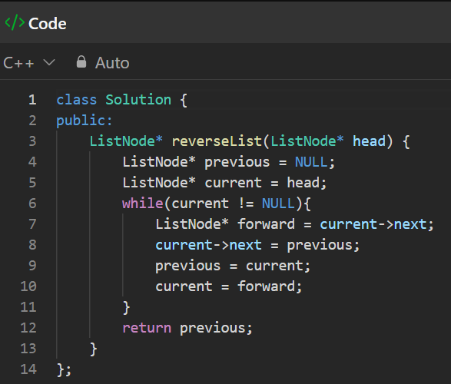

**Output:** 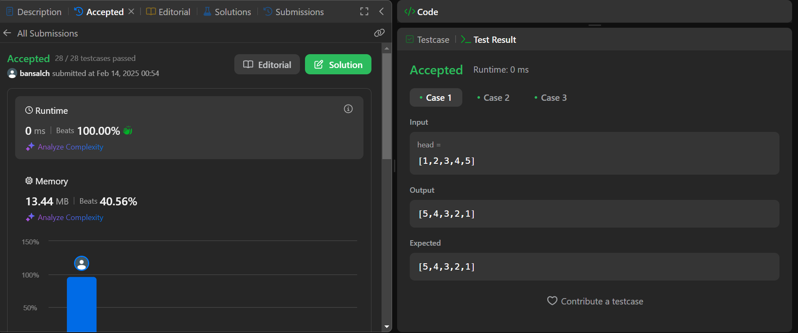

**Q4. Delete middle node of a list.**

**Code:**

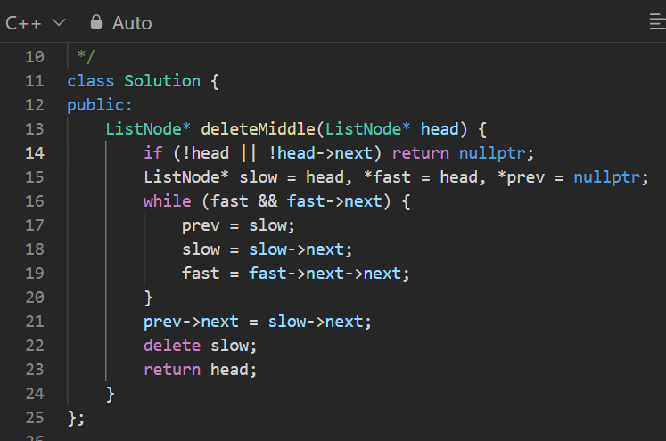

**Output:** 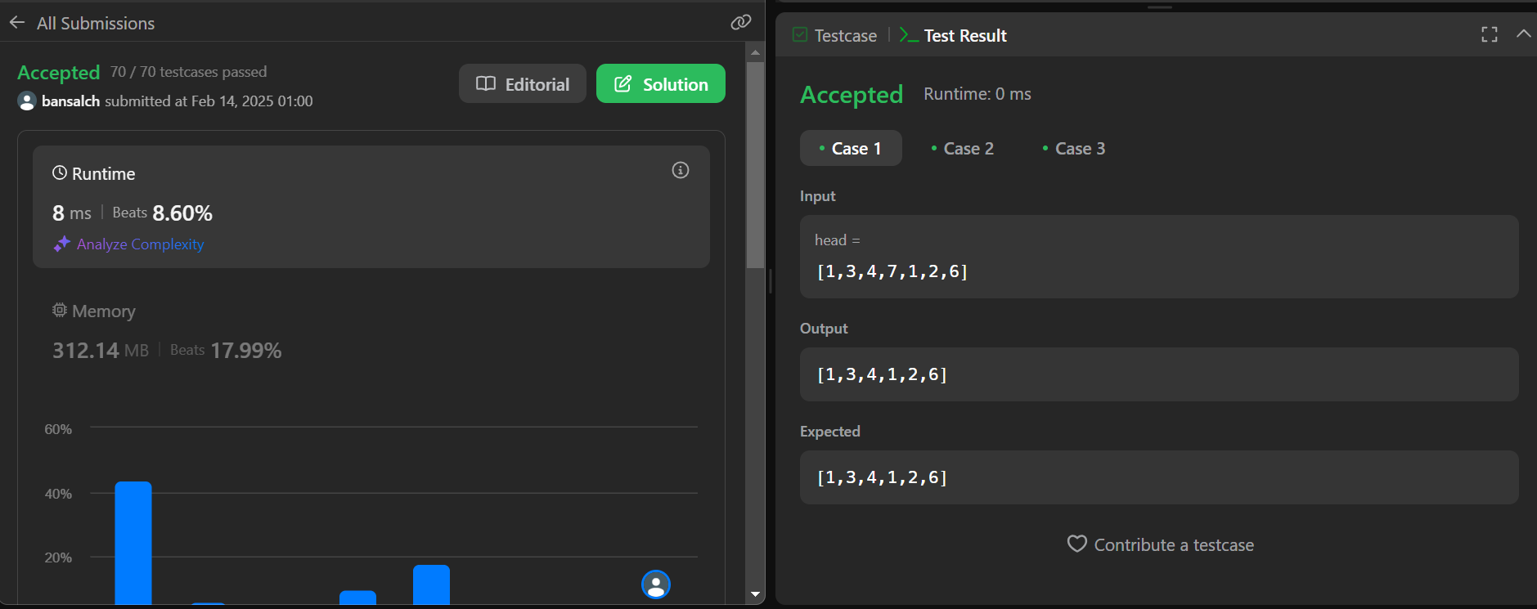

**Q5. Merge two sorted linked list.**

**Code:**

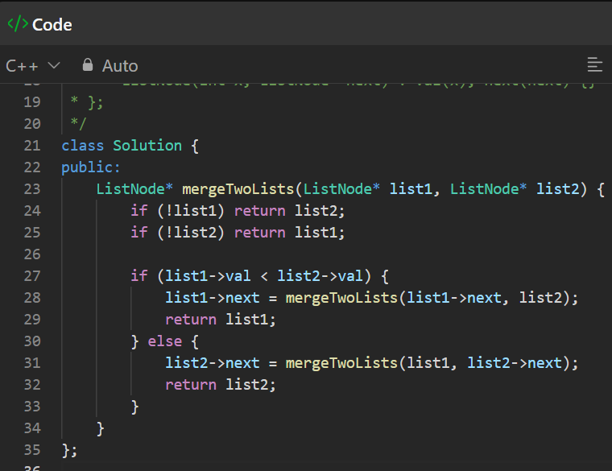

**Output:**

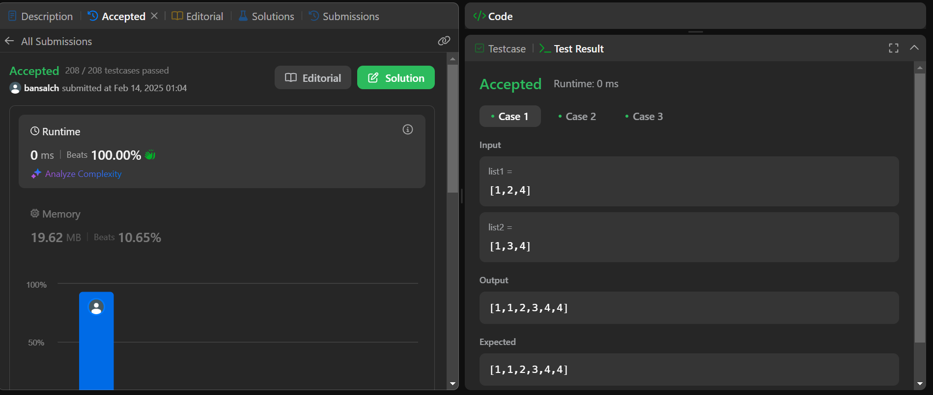

**Q6. Remove duplicates from sorted list 11.**

**Code:**

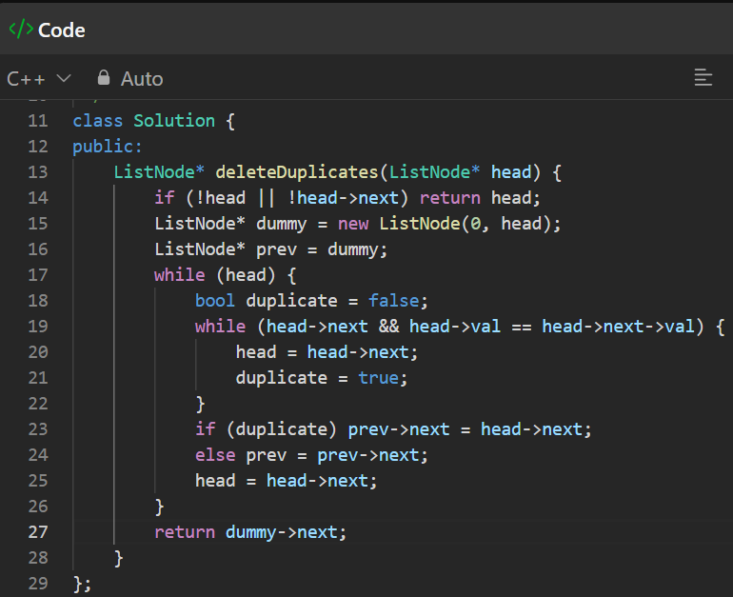

**Output:**

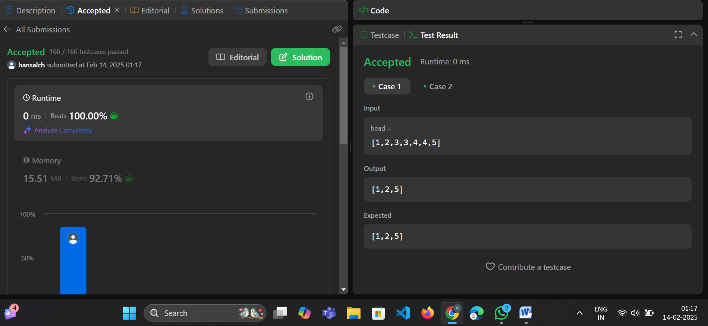

**Q7. Detect a cycle in a linked list.**

**Code:** 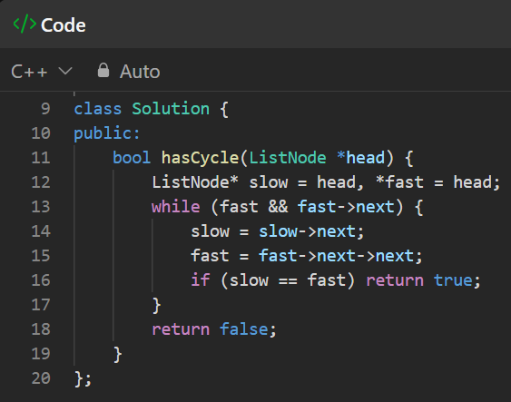

**Output:**

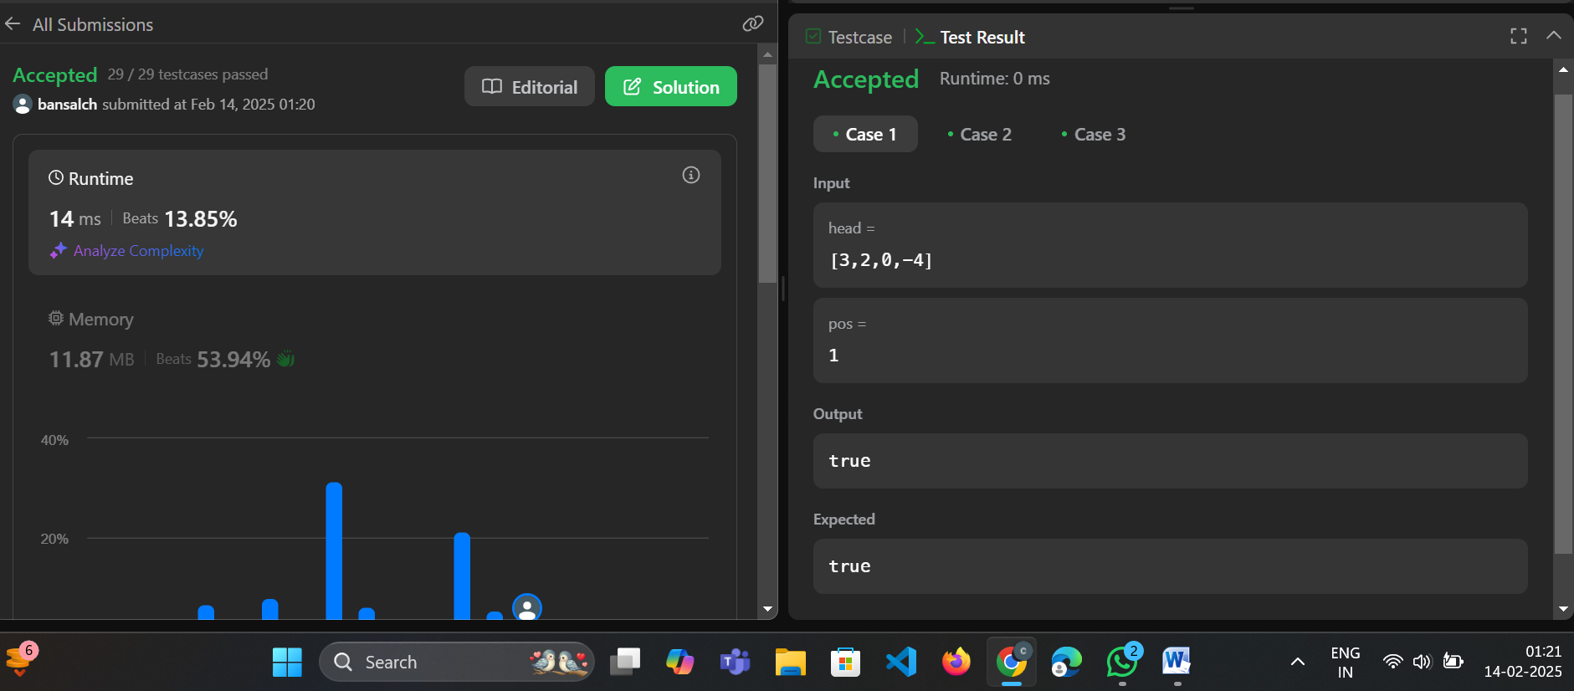

**Q8. Reverse linked list 2.**

**Code:**

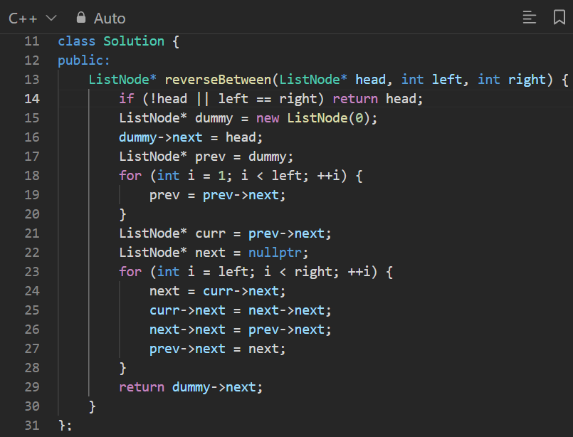

**Output:**

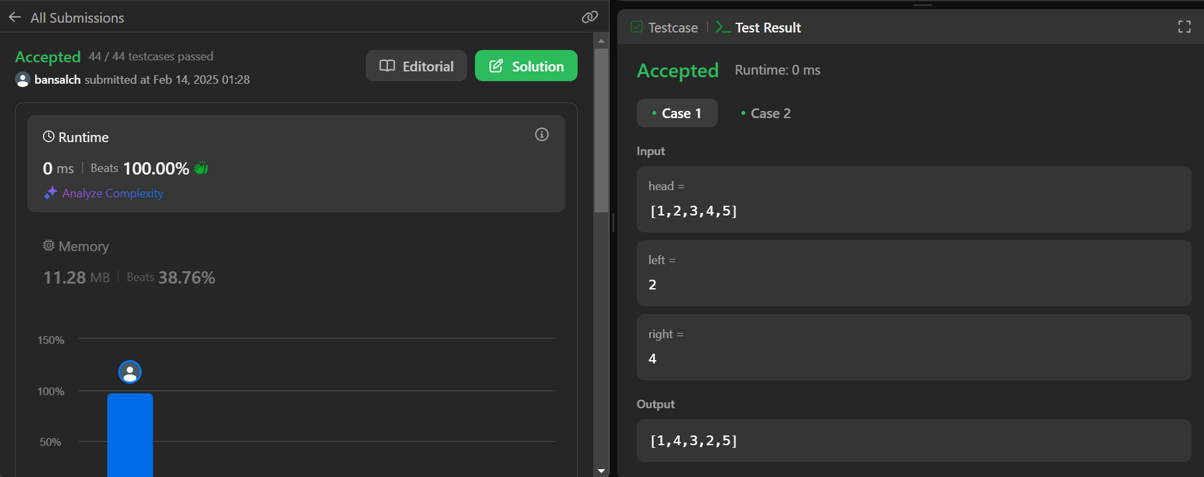

**Q9. Rotate a list.**

**Code:**

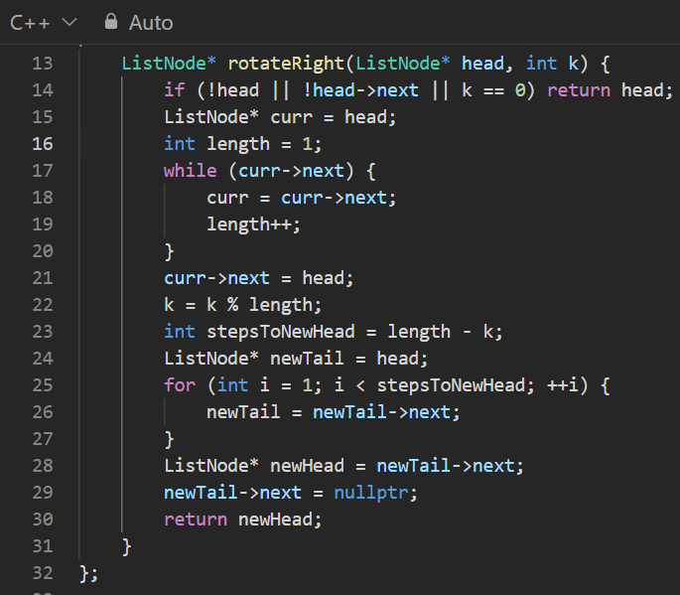

**Output:**

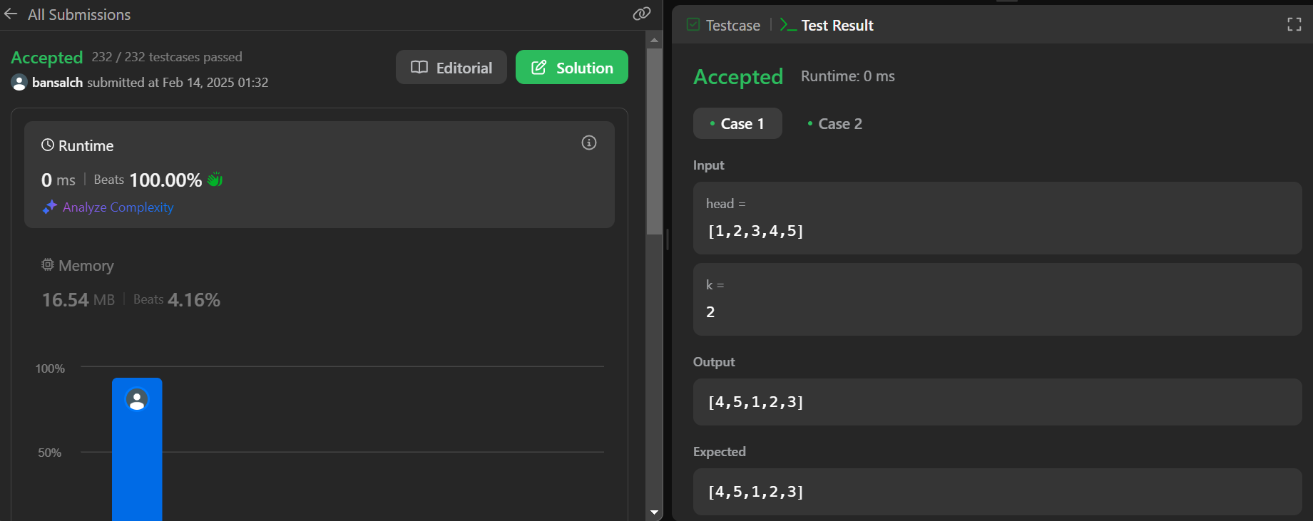

**Q10. Sort list**

**Code:** 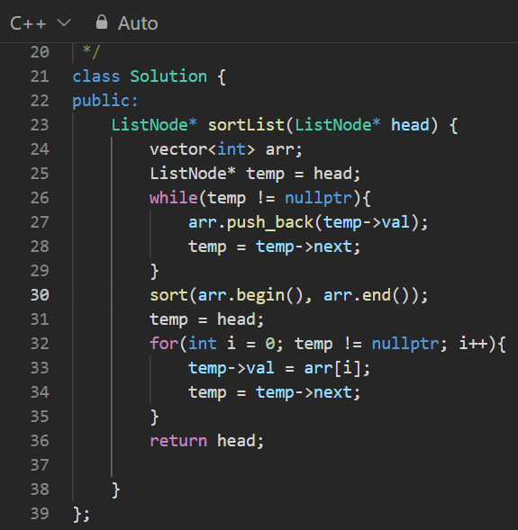

**Output:**

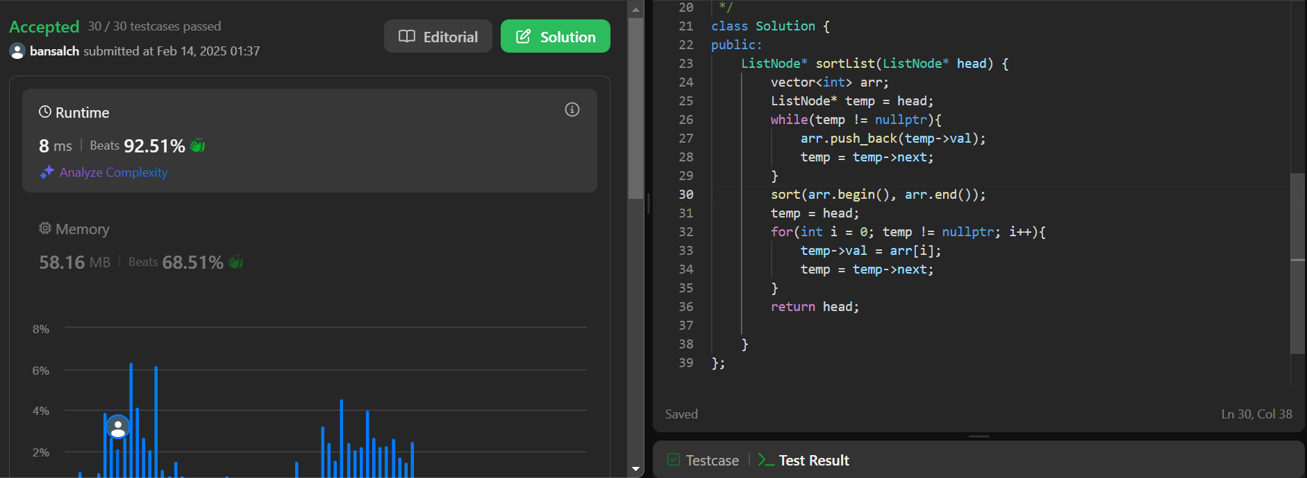

**Q11. Detect a cycle in linked list 2.**

**Code:**

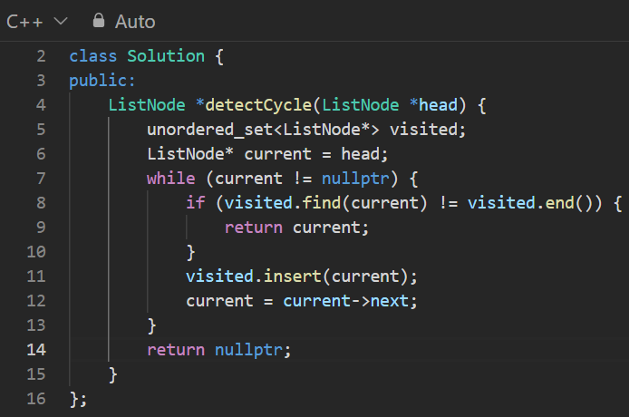

**Output:** 