AP- ASSIGNMENT

1. 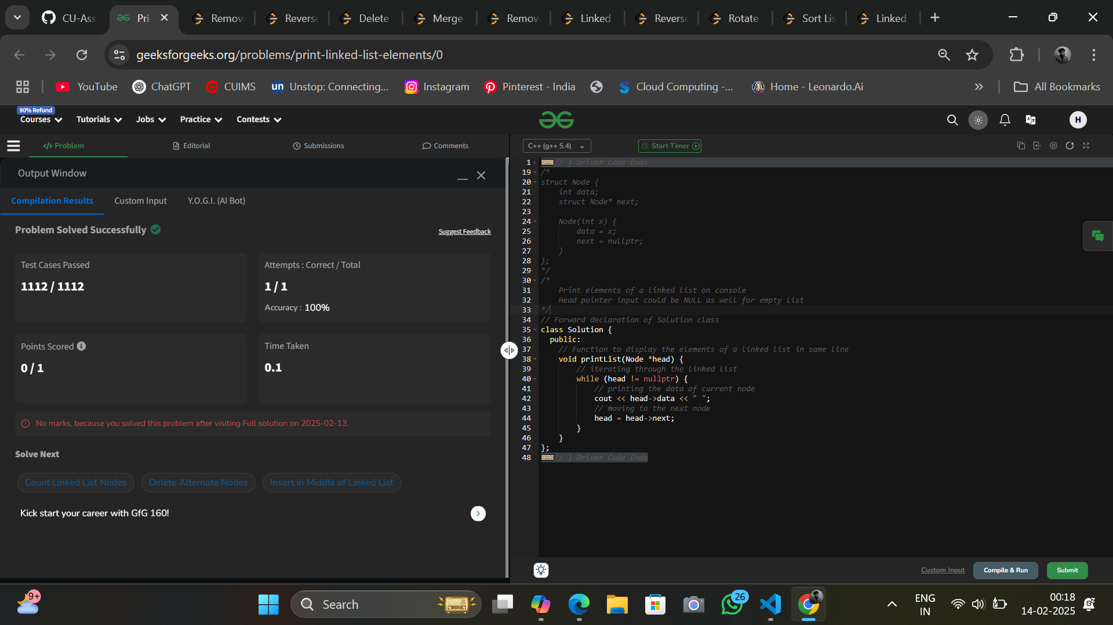<https://www.geeksforgeeks.org/problems/print-linked-list-elements/0>
2. 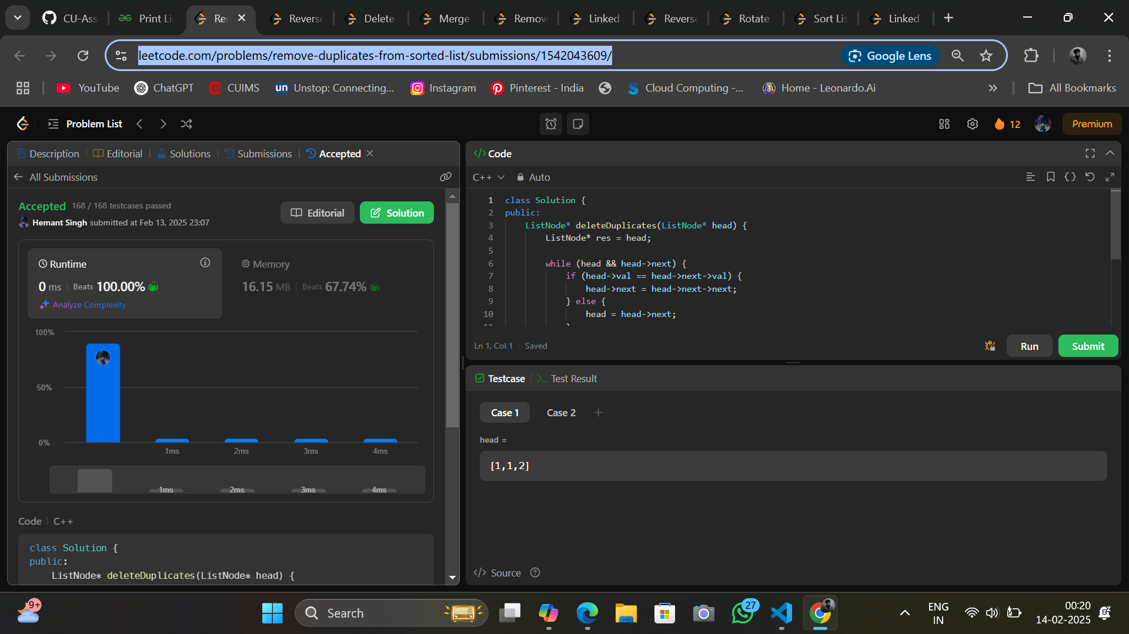<https://leetcode.com/problems/remove-duplicates-from-sorted-list/submissions/1542043609/>
3. <https://leetcode.com/problems/reverse-linked-list/description/>

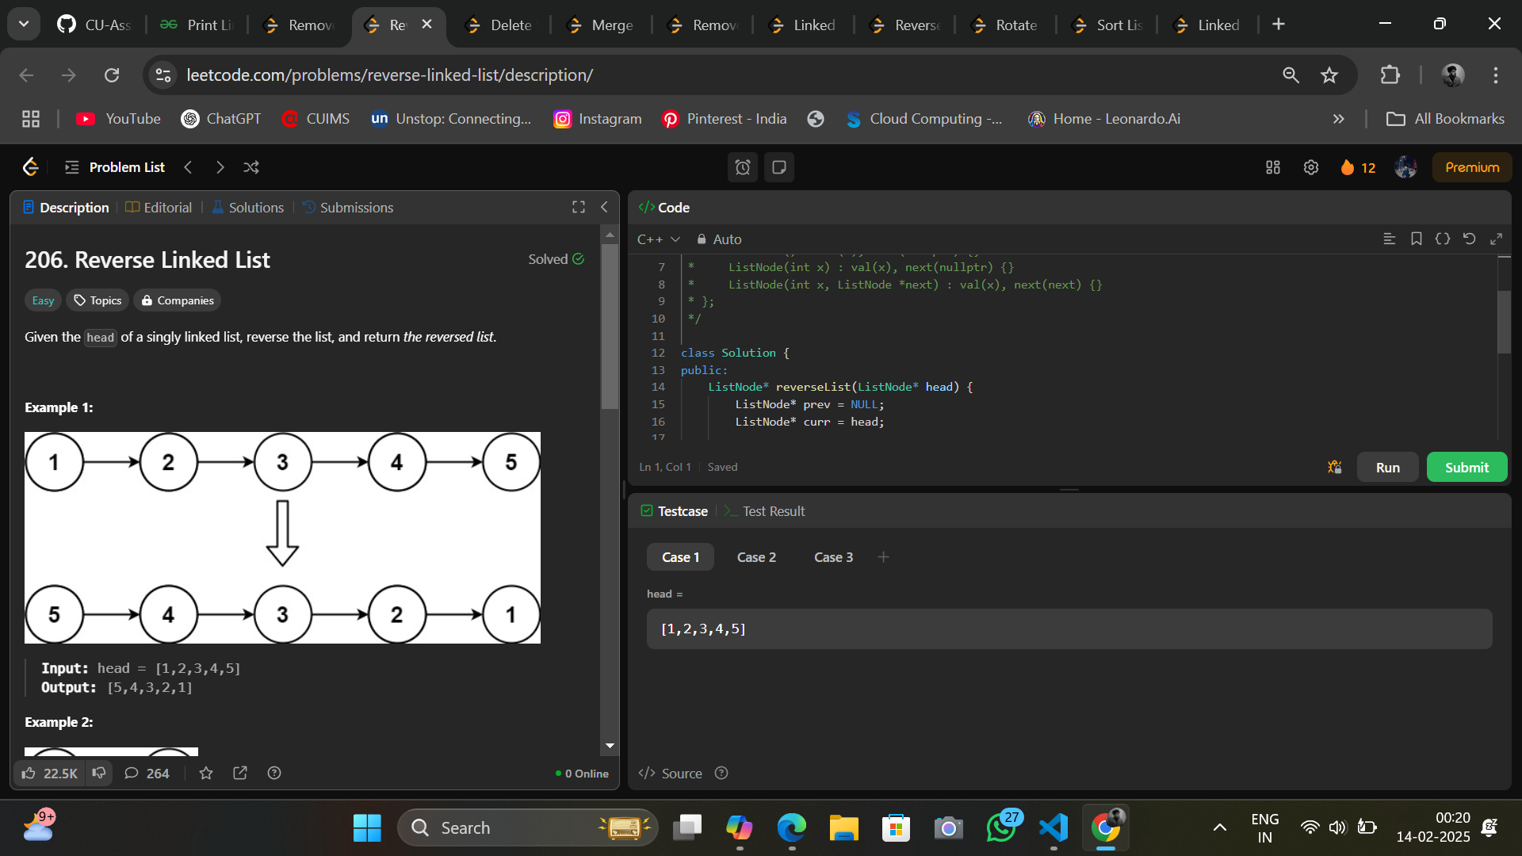

1. 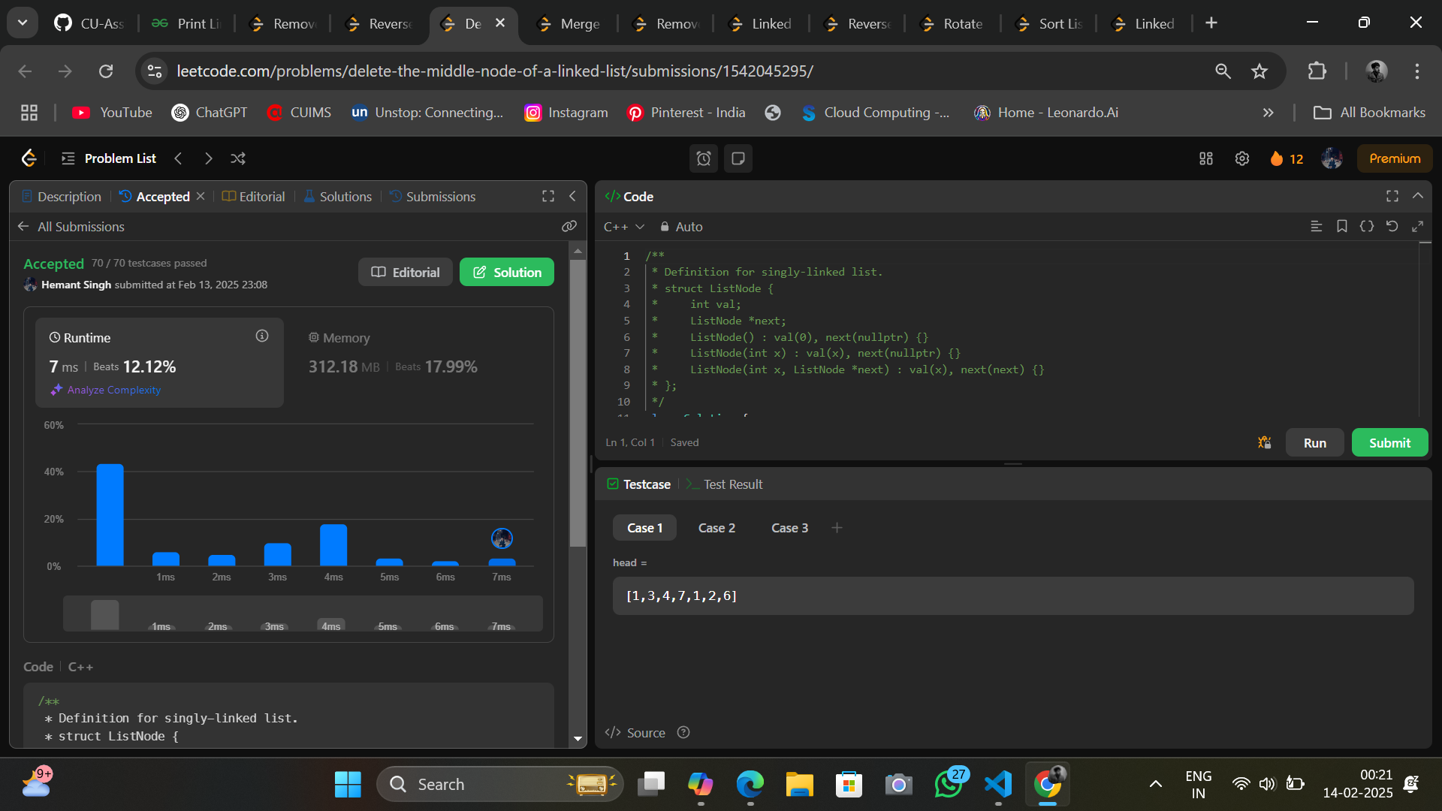<https://leetcode.com/problems/delete-the-middle-node-of-a-linked-list/submissions/1542045295/>

1. <https://leetcode.com/problems/merge-two-sorted-lists/submissions/1542046736/>

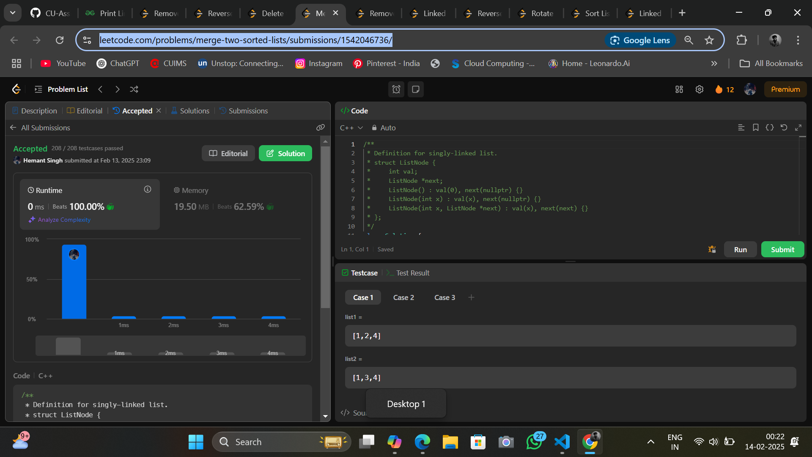

1. <https://leetcode.com/problems/remove-duplicates-from-sorted-list-ii/submissions/1542047817/>

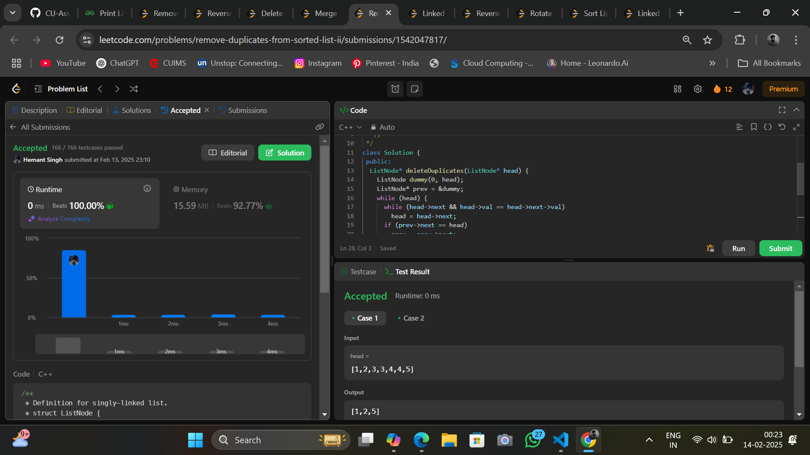

1. <https://leetcode.com/problems/linked-list-cycle/description/>

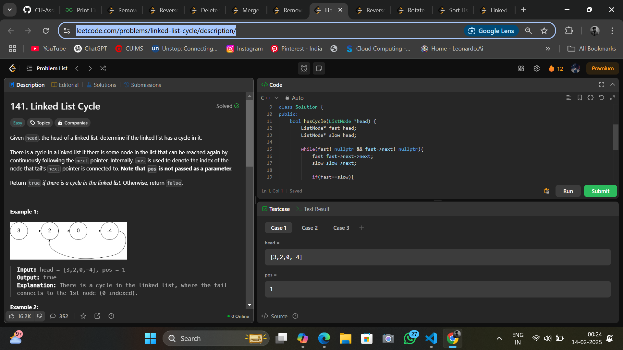

1. <https://leetcode.com/problems/reverse-linked-list-ii/submissions/1542049829/>

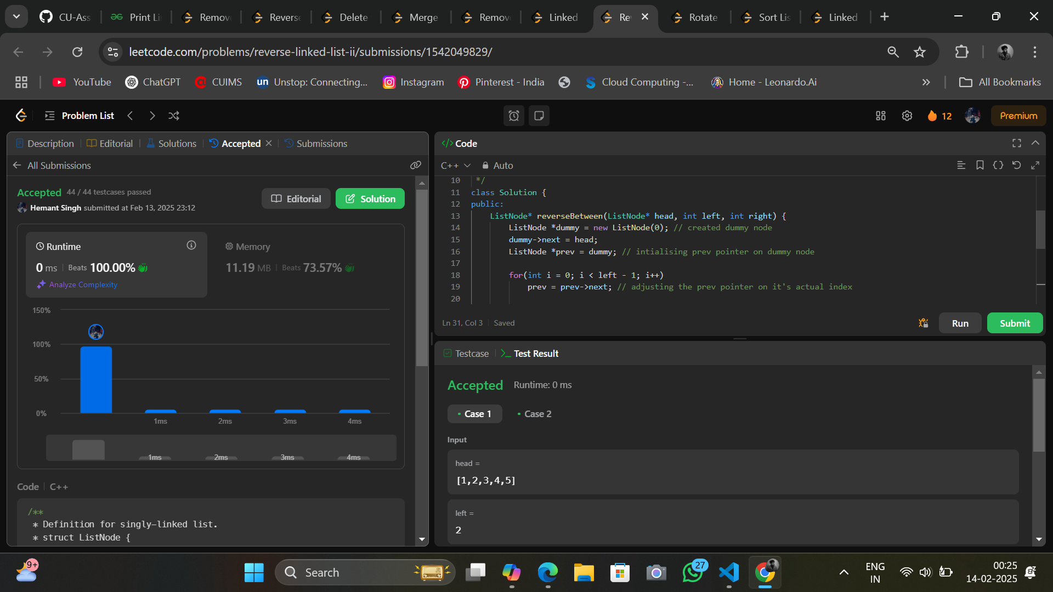

1. <https://leetcode.com/problems/rotate-list/submissions/1542051356/>

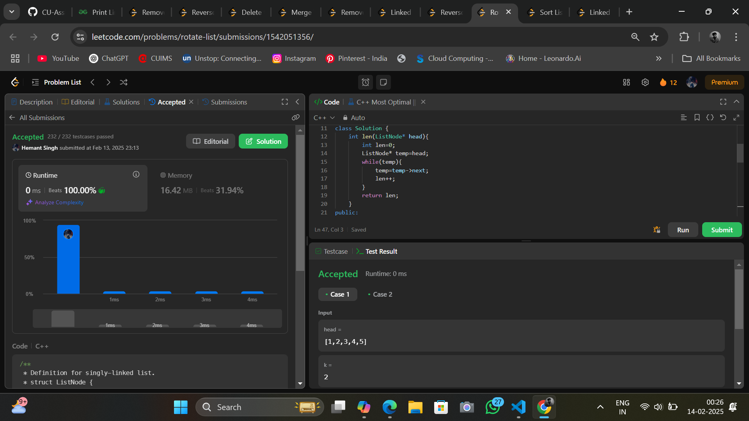

1. <https://leetcode.com/problems/sort-list/submissions/1542053062/>

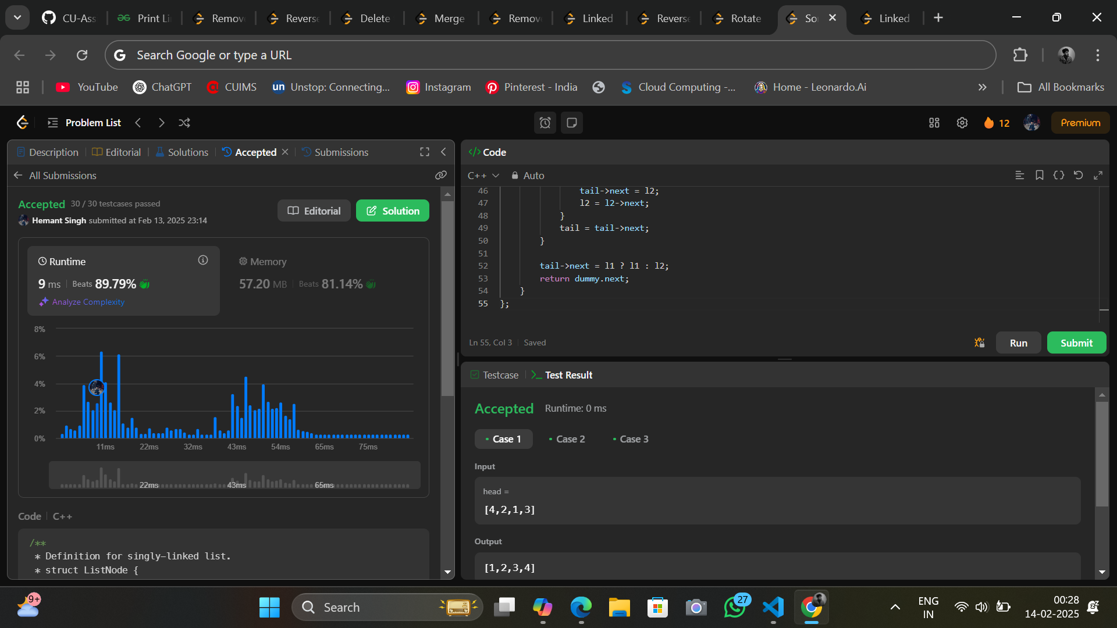

1. <https://leetcode.com/problems/linked-list-cycle-ii/description/>

