**Name: Piyush Goyal UID: 22BCS15659**

**Section/Group: 609(B)**

# Print Linked List

## Code:

class Solution {

// Function to display the elements of a linked list in the same line

void printList(Node head) {

// Iterate through the linked list and print each element

Node current = head;

while (current != null) {

System.out.print(current.data + " ");

current = current.next;

}

}

}

**Output:**

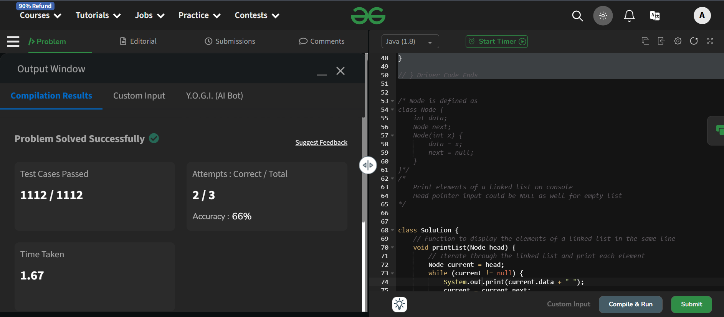

# Remove duplicates from a sorted list

## Code:

class Solution {

    public ListNode deleteDuplicates(ListNode head)

    {

        if (head == null) {

            return null;

        }

        ListNode current = head;

        while (current != null && current.next != null) {

            if (current.val == current.next.val)

            {

                current.next = current.next.next;

            }

            else

            {

                current = current.next;

            }

        }

        return head;

    }

}

**Output:**

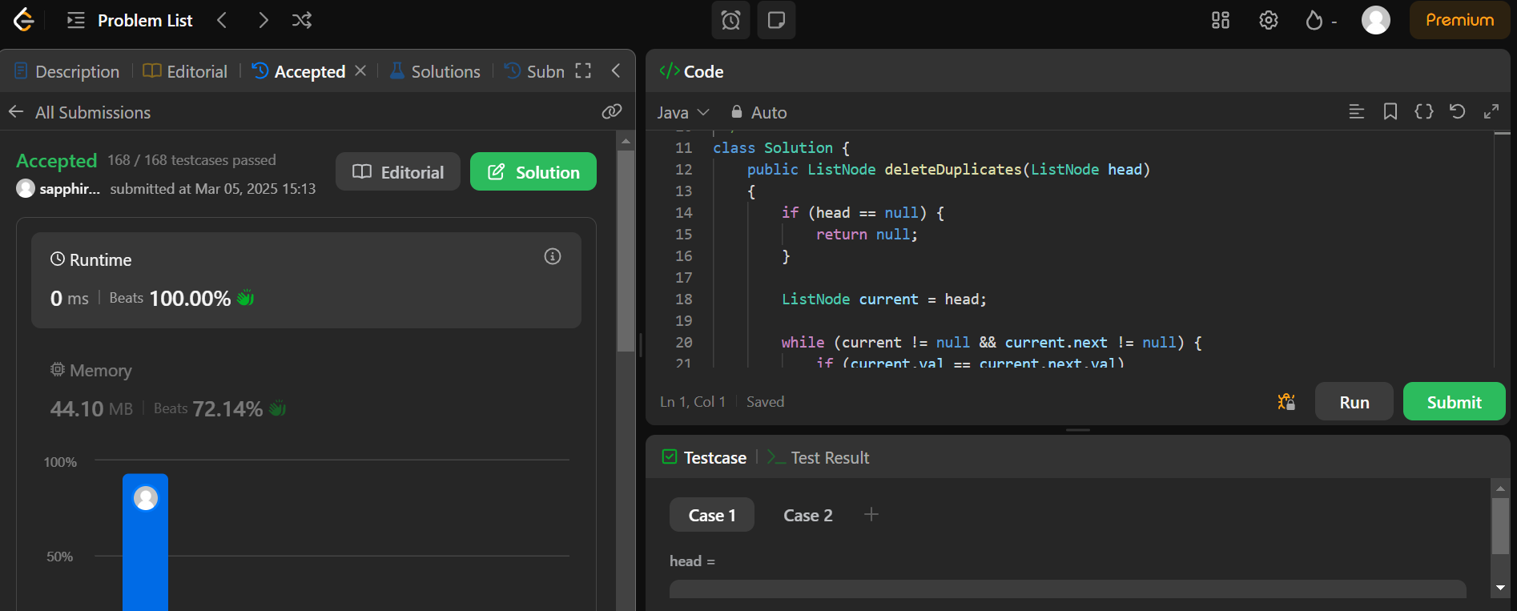

# Reverse Linked List

## Code:

## class Solution {

## public ListNode reverseList(ListNode head) {

## ListNode prev = null;

## ListNode current = head;

## 

## while (current != null) {

## ListNode nextNode = current.next;

## current.next = prev;

## prev = current;

## current = nextNode;

## }

## 

## return prev;

## }

## }

**Output:** 

# Delete middle node of a list

## Code:

## class Solution {

## public ListNode deleteMiddle(ListNode head)

## {

## if (head == null || head.next == null) {

## return null;

## }

## 

## ListNode slow = head;

## ListNode fast = head;

## ListNode prev = null;

## 

## while (fast != null && fast.next != null) {

## prev = slow;

## slow = slow.next;

## fast = fast.next.next;

## }

## 

## prev.next = slow.next;

## return head;

## }

## }

**Output:**

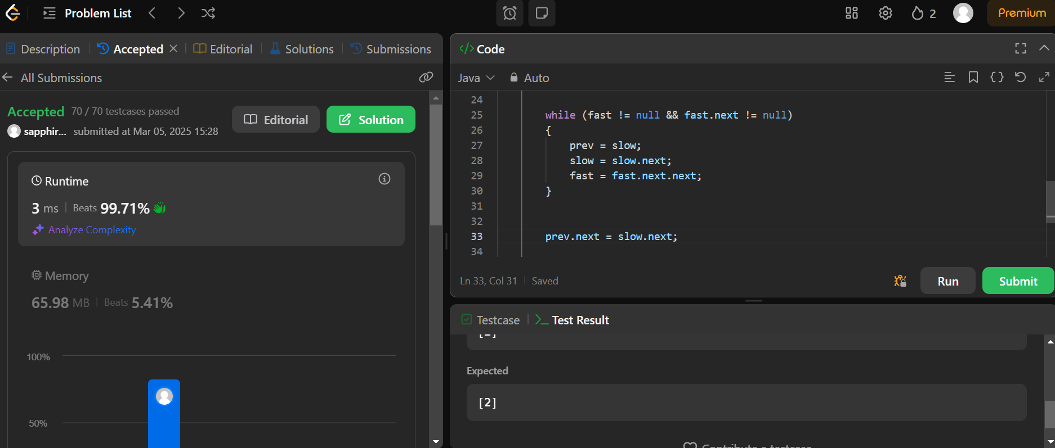

# [Merge Two Sorted Lists](https://leetcode.com/problems/merge-two-sorted-lists/)

## Code:

class Solution {

    public ListNode mergeTwoLists(ListNode list1, ListNode list2) {

        ListNode dummy = new ListNode();

        ListNode current = dummy;

        while (list1 != null && list2 != null) {

            if (list1.val <= list2.val)

            {

                current.next = list1;

                list1 = list1.next;

            }

            else

            {

                current.next = list2;

                list2 = list2.next;

            }

            current = current.next;

        }

        if (list1 != null)

        {

            current.next = list1;

        }

        else

        {

            current.next = list2;

        }

        return dummy.next;

    }

}

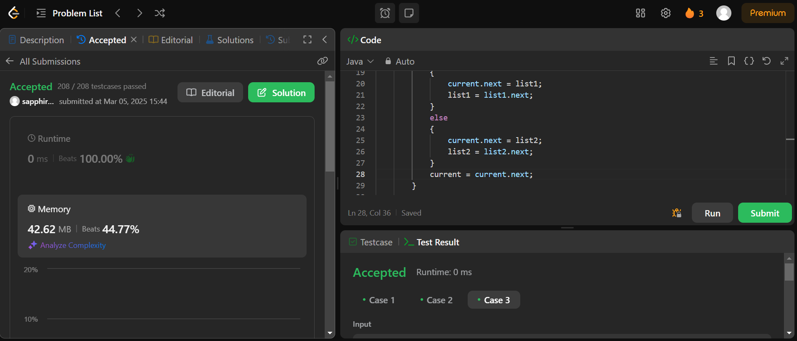

# Detect a cycle in a linked list

## Code:

public class Solution {

    public boolean hasCycle(ListNode head) {

        if (head == null || head.next == null) {

            return false;  // No cycle if list is empty or has only one node

        }

        ListNode slow = head;

        ListNode fast = head.next;

        while (slow != fast) {

            if (fast == null || fast.next == null) {

                return false;  // No cycle if fast pointer reaches the end of the list

            }

            slow = slow.next;

            fast = fast.next.next;

        }

        return true;  // Cycle detected if slow pointer meets fast pointer

    }

}

**Output:**

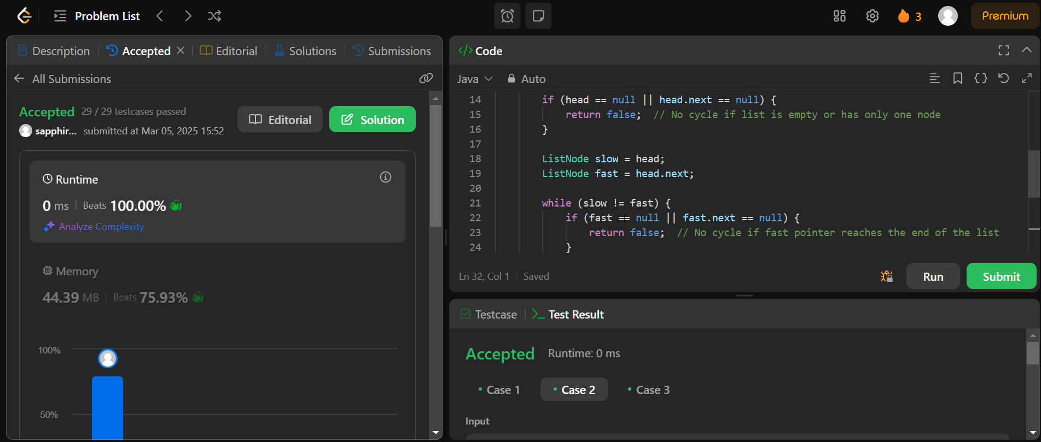

# Rotate a list

## Code:

class Solution {

    public ListNode rotateRight(ListNode head, int k) {

        if (head == null || head.next == null || k == 0) {

            return head;

        }

        // Calculate the length of the linked list

        ListNode current = head;

        int length = 1;

        while (current.next != null) {

            current = current.next;

            length = length + 1;

        }

        // Adjust k if it is greater than the length

        k = k % length;

        // If k is 0, no rotation is needed

        if (k == 0) {

            return head;

        }

        // Make the linked list circular

        current.next = head;

        // Find the new head and tail

        int stepsToNewHead = length - k;

        ListNode newTail = head;

        for (int i = 1; i < stepsToNewHead; i++) {

            newTail = newTail.next;

        }

        ListNode newHead = newTail.next;

        newTail.next = null;

        return newHead;

    }

}

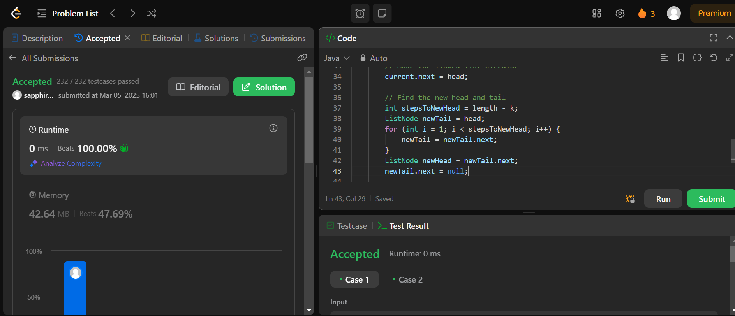

# Sort List

## Code:

## class Solution {

## public ListNode sortList(ListNode head) {

## if(head == null || head.next == null)

## return head;

## 

## ListNode left = head;

## ListNode mid = findMid(left);

## ListNode right = mid.next;

## mid.next = null;

## left = sortList(left);

## right = sortList(right);

## return merge(left, right);

## }

## private ListNode findMid(ListNode node) {

## ListNode slow = node;

## ListNode fast = node.next;

## while(fast != null && fast.next!=null) {

## slow = slow.next;

## fast = fast.next.next;

## }

## return slow;

## }

## private ListNode merge(ListNode left, ListNode right) {

## ListNode node = new ListNode();

## ListNode merged = node;

## while(left != null && right != null) {

## if(left.val < right.val) {

## node.next = left;

## left = left.next;

## } else {

## node.next = right;

## right = right.next;

## }

## node = node.next;

## }

## if(left!=null) {

## node.next = left;

## node = node.next;

## }

## if(right!=null) {

## node.next = right;

## node = node.next;

## }

## return merged.next;

## }

## }

**Output:**

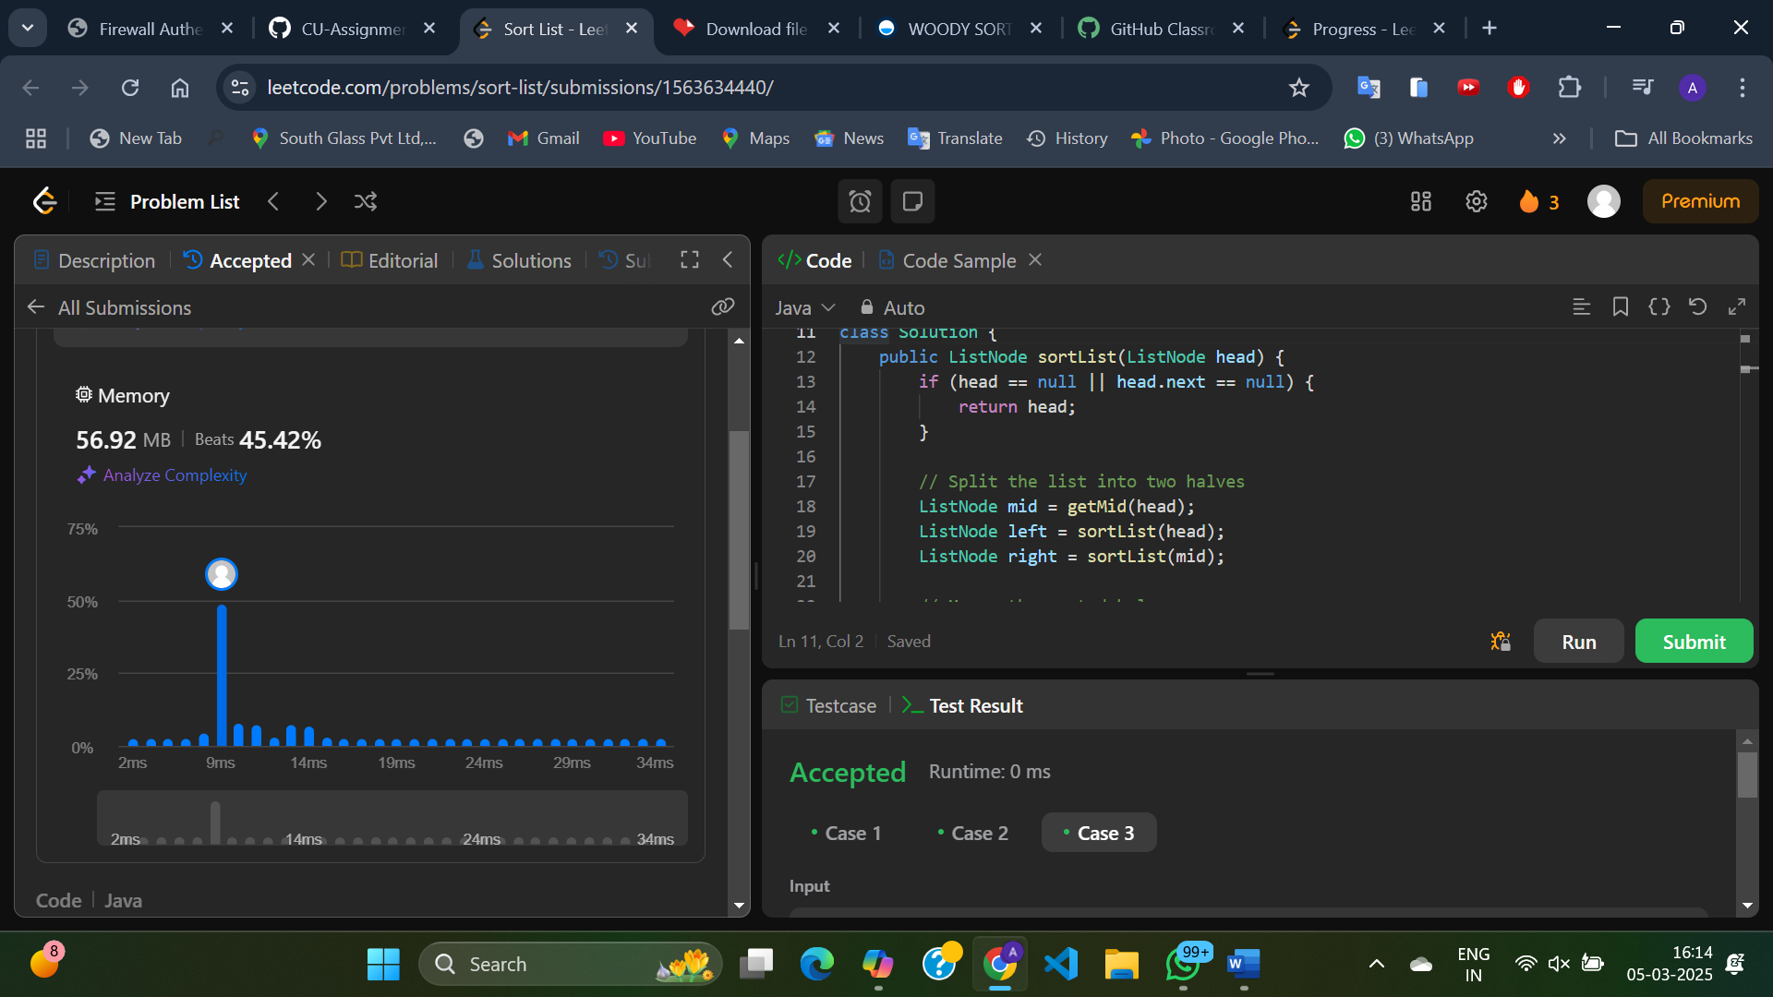

# Merge k sorted lists :

# Code:

# class Solution {

# public ListNode mergeKLists(ListNode[] lists) {

# if (lists == null || lists.length == 0) {

# return null;

# }

# // Create a min-heap (priority queue) to store the nodes

# PriorityQueue<ListNode> minHeap = new PriorityQueue<>((a, b) -> a.val - b.val);

# // Add the head of each list to the min-heap

# for (ListNode node : lists) {

# if (node != null) {

# minHeap.add(node);

# }

# }

# // Create a dummy node to build the merged list

# ListNode dummy = new ListNode(0);

# ListNode current = dummy;

# // Extract the smallest node from the min-heap and add it to the merged list

# while (!minHeap.isEmpty()) {

# ListNode smallest = minHeap.poll();

# current.next = smallest;

# current = current.next;

# // If the extracted node has a next node, add it to the min-heap

# if (smallest.next != null) {

# minHeap.add(smallest.next);

# }

# }

# return dummy.next;

# }

# }

**Output:** 