**ASSIGNMENT-3**

**NAME:** SAGAR

**UID:** 22BCS17062

**SUBJECT:** AP-2

**CLASS-** IOT-610/B

1. **Print Linked**

**List:** [**https://www.geeksforgeeks.org/problems/printlinked-list-elements/0**](https://www.geeksforgeeks.org/problems/print-linked-list-elements/0)

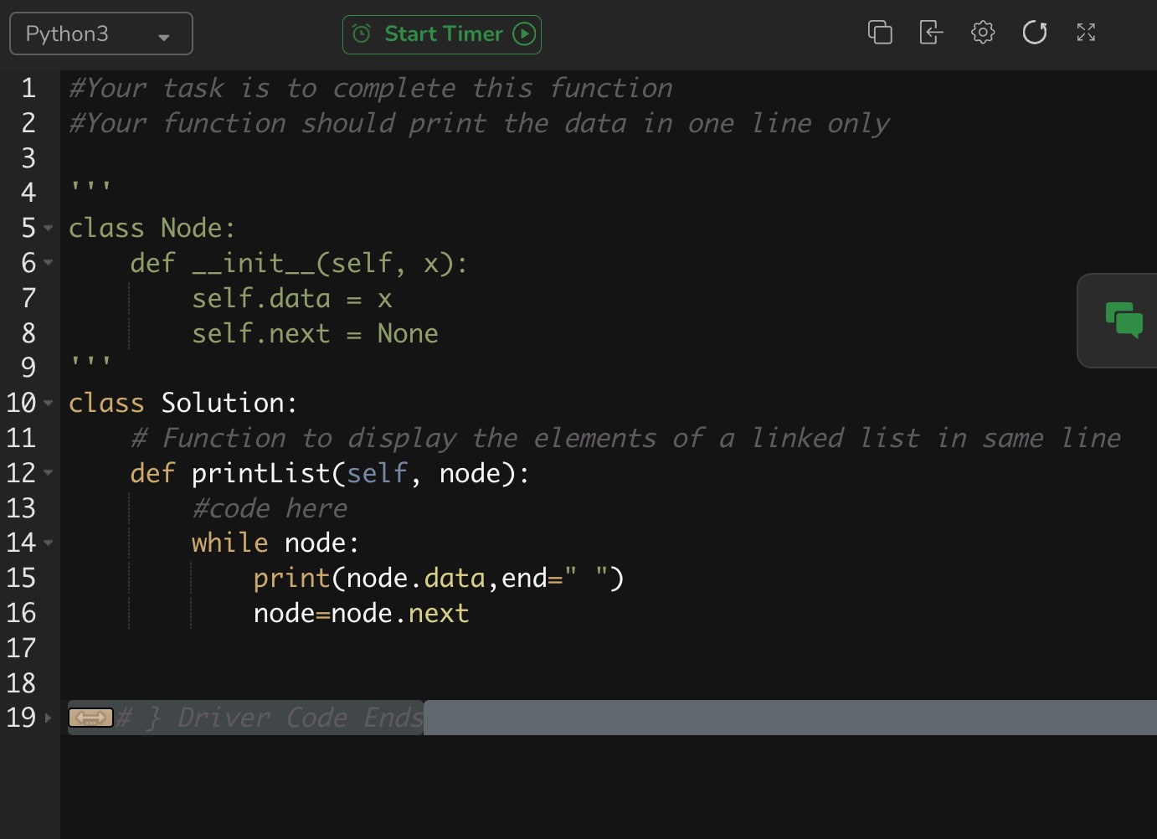

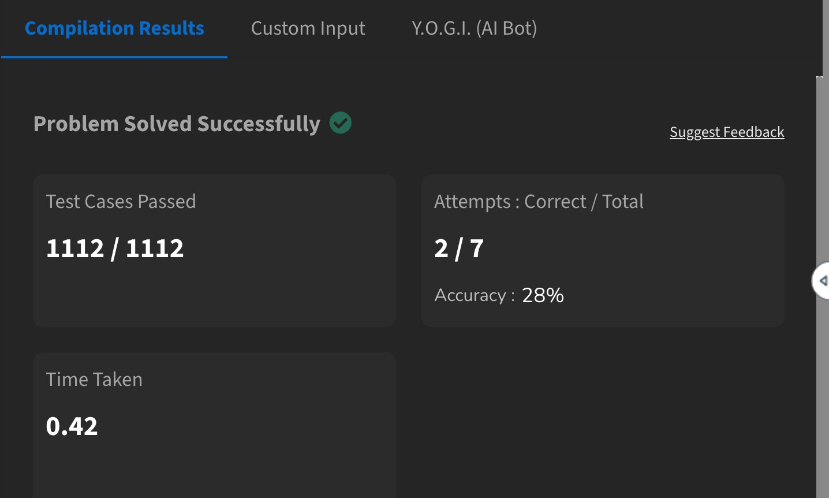

1. **Remove duplicates from a sorted list:** [**https://leetcode.com/problems/remove-duplicatesfrom-sorted-list/description/**](https://leetcode.com/problems/remove-duplicates-from-sorted-list/description/)

|  |
| --- |
| class Solution { public:  ListNode* deleteDuplicates(ListNode* head) {  ListNode* curr = head;    while (curr != nullptr) { while (curr->next && curr->val == curr->next->val) curr->next = curr->next->next; curr = curr->next;  }  return head;  }  }; |



1. **Reverse a linked list:** [**https://leetcode.com/problems/reverse-linkedlist/description/**](https://leetcode.com/problems/reverse-linked-list/description/)

|  |
| --- |
| class Solution { public:  ListNode* reverseList(ListNode* head) {  ListNode* prev = nullptr;    while (head != nullptr) { ListNode* next = head->next; head->next = prev; prev = head; head = next;  }  return prev;  }  }; |



1. **Delete middle node of a list:** [**https://leetcode.com/problems/delete-the-middlenode-of-a-linked-list/description/**](https://leetcode.com/problems/delete-the-middle-node-of-a-linked-list/description/)

|  |
| --- |
| class Solution {  public:  ListNode* deleteMiddle(ListNode* head) {  ListNode dummy(0, head);  ListNode* slow = &dummy;  ListNode* fast = &dummy;    while (fast->next != nullptr && fast->next->next != nullptr) { slow = slow->next; fast = fast->next->next;  }    // Delete the middle node.  slow->next = slow->next->next; return dummy.next;  }  }; |



1. **Merge two sorted linked lists:** [**https://leetcode.com/problems/merge-two-sortedlists/description/**](https://leetcode.com/problems/merge-two-sorted-lists/description/)

|  |
| --- |
| class Solution { public:  ListNode* mergeTwoLists(ListNode* list1, ListNode* list2) { if (!list1 || !list2) return list1 ? list1 : list2; if (list1->val > list2->val) swap(list1, list2);  list1->next = mergeTwoLists(list1->next, list2); return list1;  }  }; |



1. **Detect a cycle in a linked list:** [**https://leetcode.com/problems/linked-listcycle/description/**](https://leetcode.com/problems/linked-list-cycle/description/)

|  |
| --- |
| class Solution { public:  bool hasCycle(ListNode* head) {  ListNode* slow = head;  ListNode* fast = head;    while (fast != nullptr && fast->next != nullptr) { slow = slow->next; fast = fast->next->next; if (slow == fast) return true;  }  return false;  }  }; |



1. **Rotate a list:** [**https://leetcode.com/problems/rotatelist/description/**](https://leetcode.com/problems/rotate-list/description/)

|  |
| --- |
| class Solution { public:  ListNode* rotateRight(ListNode* head, int k) { if (!head || !head->next || k == 0) return head;    ListNode* tail; int length = 1;  for (tail = head; tail->next; tail = tail->next)  ++length; tail->next = head; // Circle the list.    const int t = length - k % length; for (int i = 0; i < t; ++i) tail = tail->next;  ListNode* newHead = tail->next; tail->next = nullptr; |

return newHead;

} };



1. **Sort List:** [**https://leetcode.com/problems/sortlist/description/**](https://leetcode.com/problems/sort-list/description/)

class Solution { public:

ListNode* sortList(ListNode* head) { const int length = getLength(head);

ListNode dummy(0, head);

for (int k = 1; k < length; k *= 2) {

ListNode* curr = dummy.next;

ListNode* tail = &dummy;

|  |
| --- |
| while (curr != nullptr) { ListNode* l = curr; ListNode* r = split(l, k); curr = split(r, k); auto [mergedHead, mergedTail] = merge(l, r); tail->next = mergedHead; tail = mergedTail;  }  }  return dummy.next;  } private:  int getLength(ListNode* head) { int length = 0; for (ListNode* curr = head; curr; curr = curr->next)  ++length; return length;  }    ListNode* split(ListNode* head, int k) { while (--k && head) head = head->next;  ListNode* rest = head ? head->next : nullptr; if (head != nullptr) head->next = nullptr; return rest;  }  pair<ListNode*, ListNode*> merge(ListNode* l1, ListNode* l2) {  ListNode dummy(0);  ListNode* tail = &dummy;    while (l1 && l2) { if (l1->val > l2->val) swap(l1, l2); tail->next = l1; l1 = l1->next; tail = tail->next;  }  tail->next = l1 ? l1 : l2; while (tail->next != nullptr) |

tail = tail->next;

return {dummy.next, tail};

}

};



**9. Merge k sorted lists:** [**https://leetcode.com/problems/merge-k-sortedlists/description/**](https://leetcode.com/problems/merge-k-sorted-lists/description/)

|  |
| --- |
| class Solution { public:  ListNode* mergeKLists(vector<ListNode*>& lists) {  ListNode dummy(0); ListNode* curr = &dummy;  auto compare = [](ListNode* a, ListNode* b) { return a->val > b->val; }; priority_queue<ListNode*, vector<ListNode*>, decltype(compare)> minHeap( compare); |
| for (ListNode* list : lists) if (list != nullptr) minHeap.push(list);    while (!minHeap.empty()) {  ListNode* minNode = minHeap.top(); minHeap.pop(); if (minNode->next) minHeap.push(minNode->next); curr->next = minNode; curr = curr->next;  }  return dummy.next;  }  }; |

