AKSHAT TIWARI 22BCS10655  
 608-B Advance Programming Lab-2

1. Longest Nice Substring: <https://leetcode.com/problems/longest-nice-substring/description/>

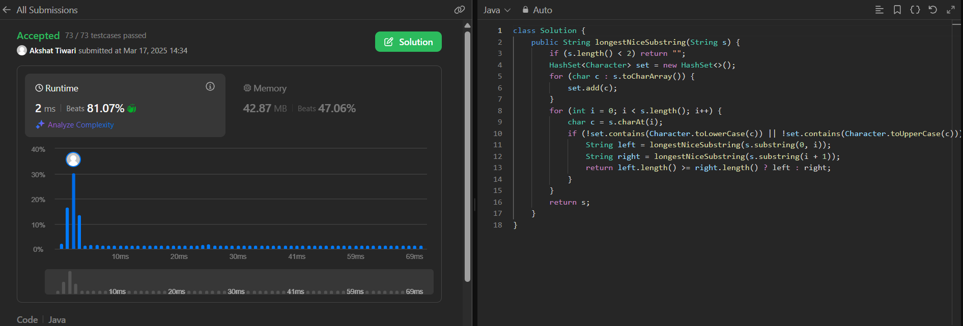

1. Reverse Bits: <https://leetcode.com/problems/reverse-bits/description/>

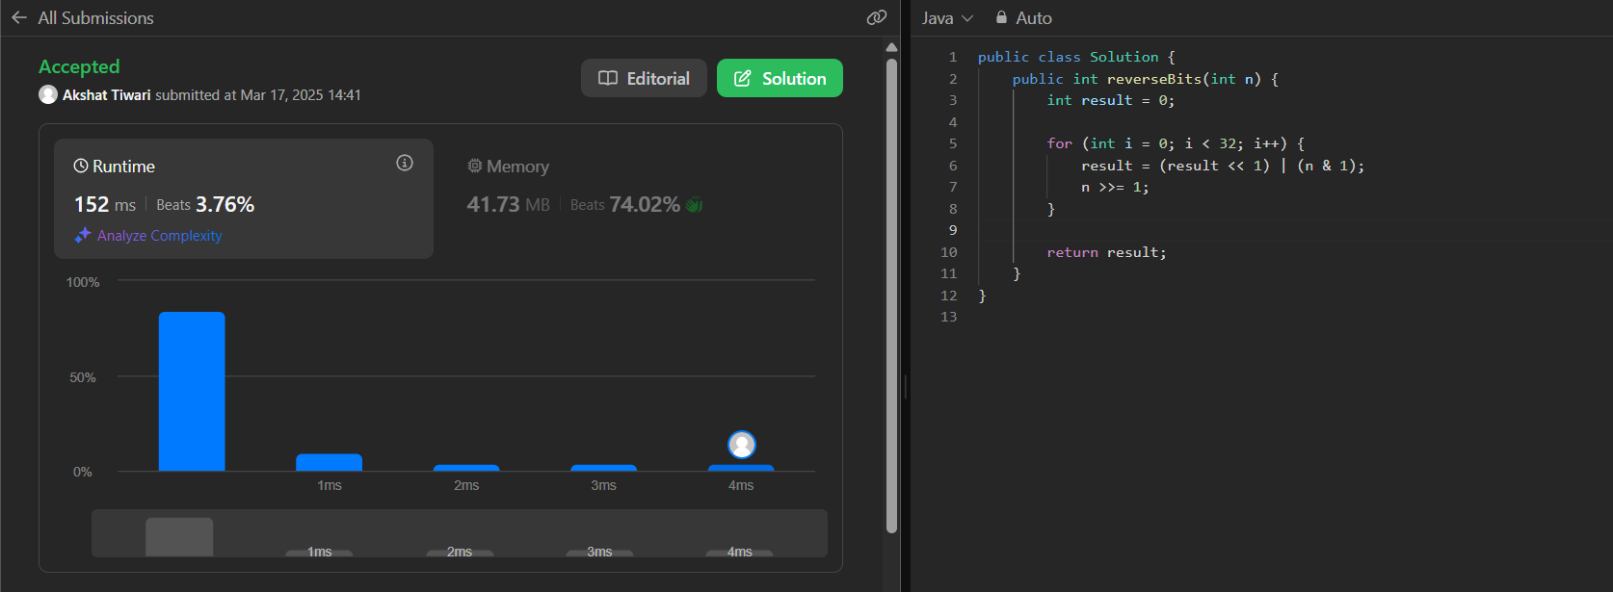

1. Number of 1 Bits: <https://leetcode.com/problems/number-of-1-bits/description/>

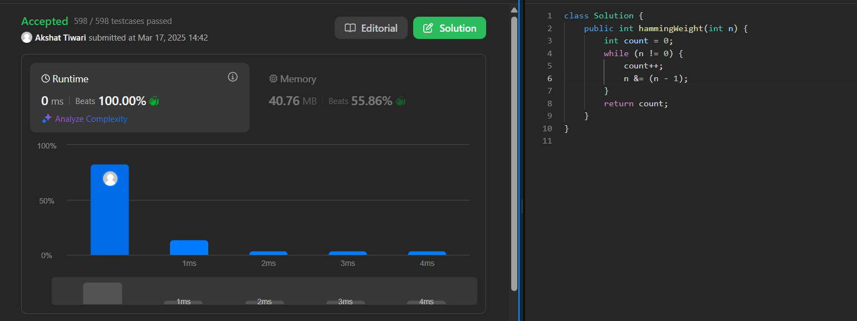

1. Maximum Subarray: <https://leetcode.com/problems/maximum-subarray/description/>

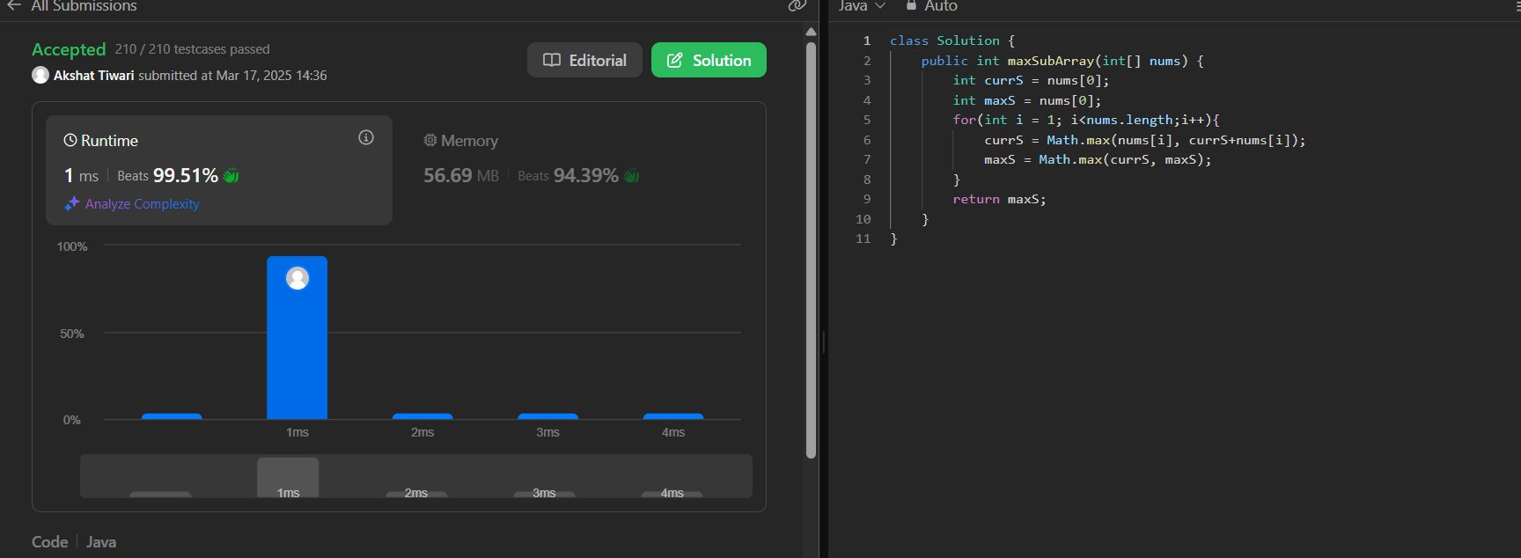

1. Search a 2D Matrix II: <https://leetcode.com/problems/search-a-2d-matrix-ii/description/>

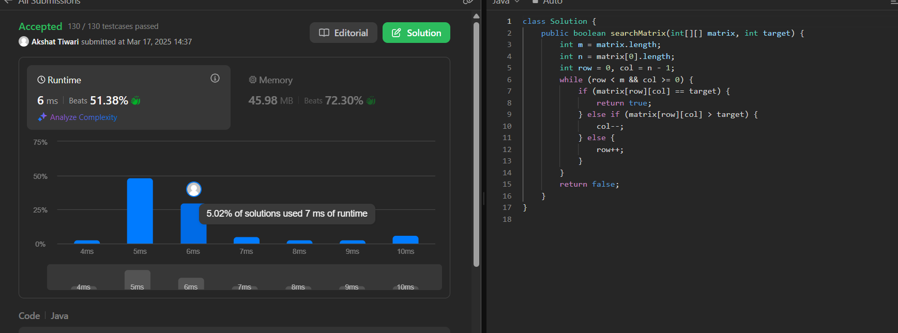

1. Super Pow:  <https://leetcode.com/problems/super-pow/description/>

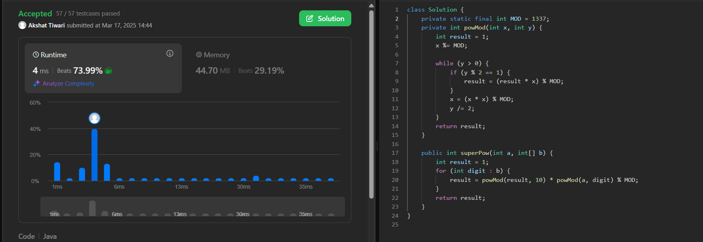

1. Beautiful Array: <https://leetcode.com/problems/beautiful-array/description/>

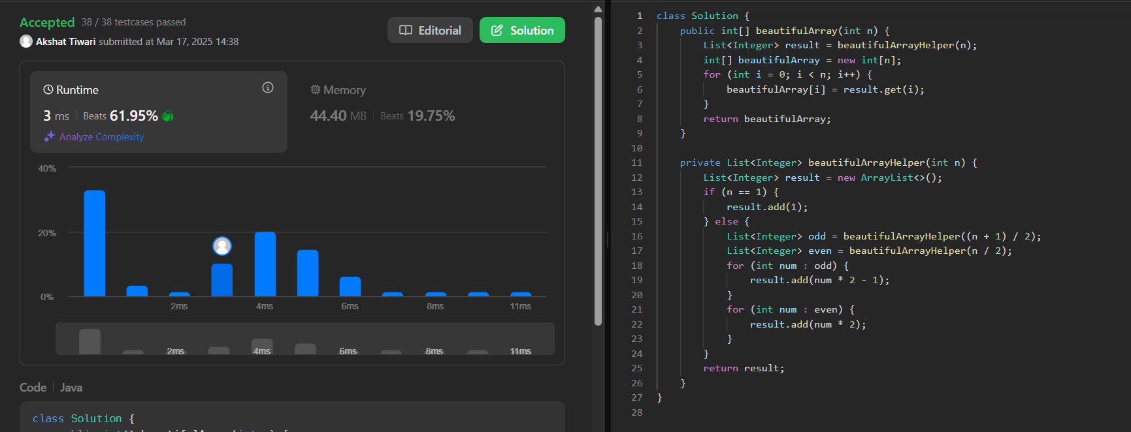

1. The Skyline Problem: <https://leetcode.com/problems/the-skyline-problem/description/>

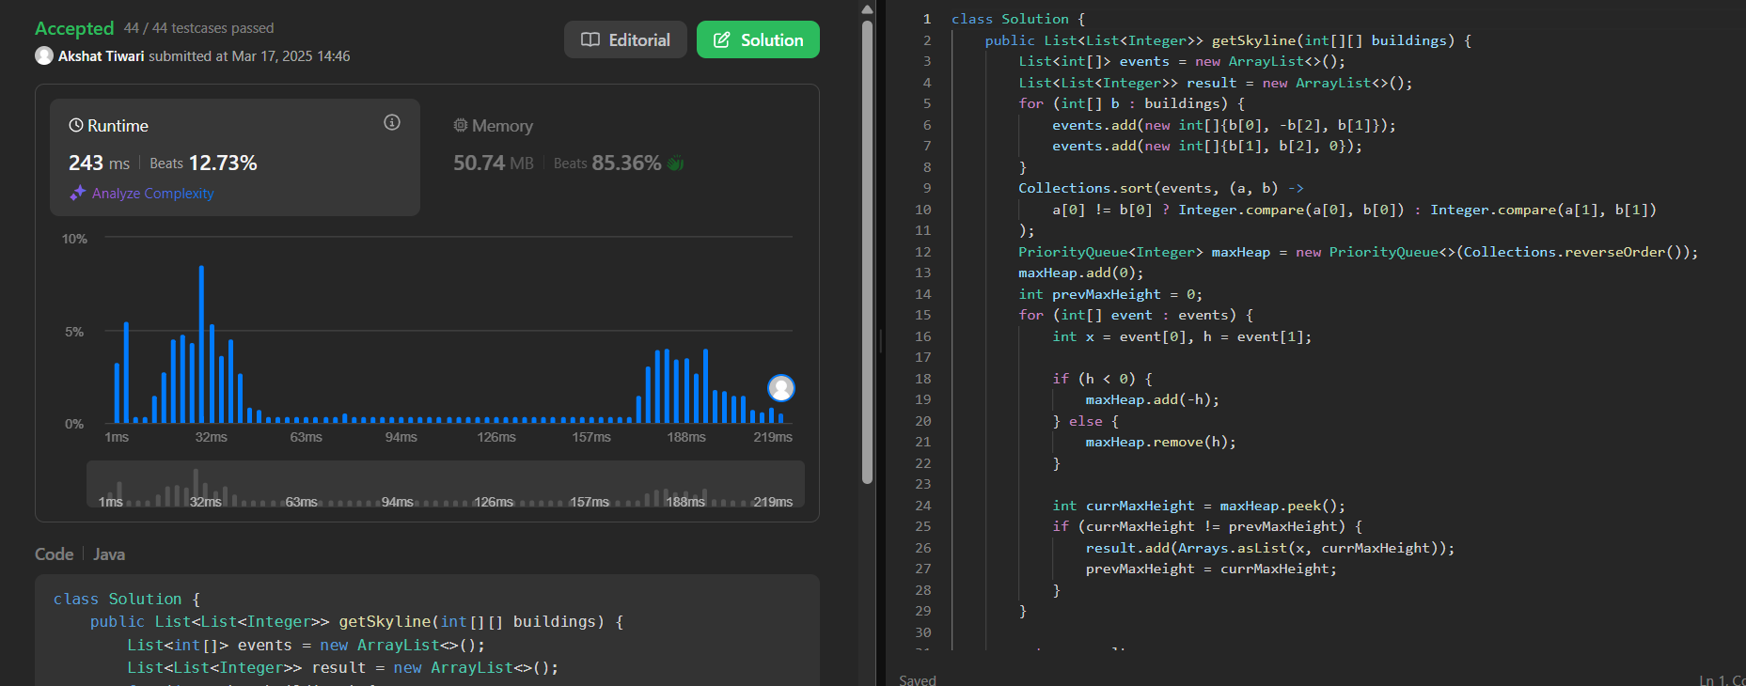

1. Reverse Pairs: <https://leetcode.com/problems/reverse-pairs/description/>

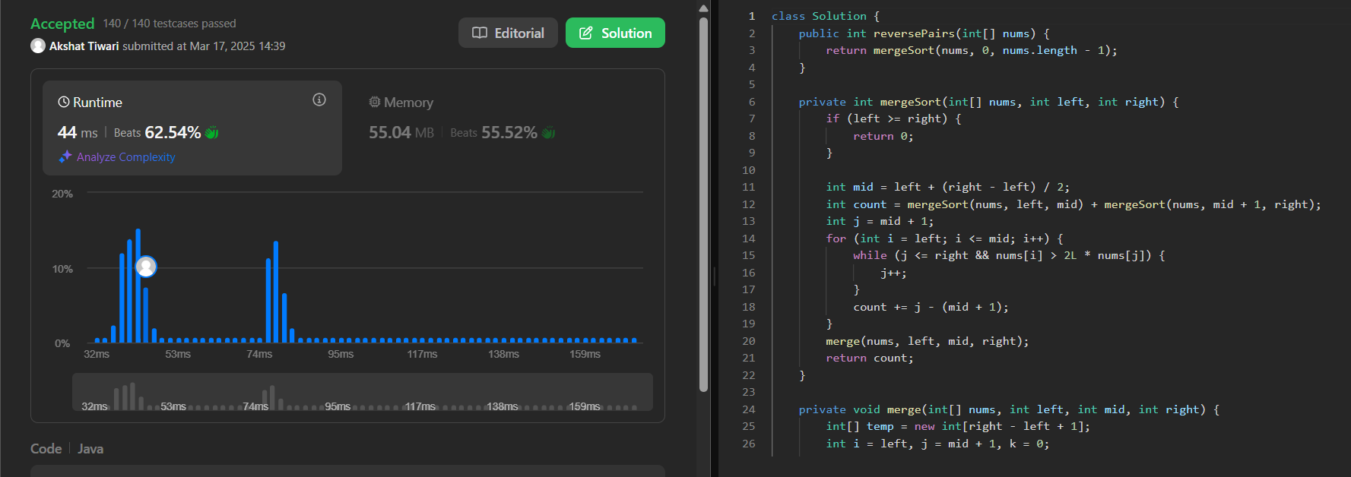

1. Longest Increasing Subsequence II: <https://leetcode.com/problems/longest-increasing-subsequence-ii/description/>

