**Advance Programming**

**Student Name:** Deshveer Singh **UID:** 22BCS14259

**Branch:** CSE **Section/Group:** 612-B

**Semester:** 6th **Date of Performance:** 20/02/25

**Subject Name:** Advance Programming **Subject Code:** 22CSP-367

1. **104:**

class Solution {

    public int maxDepth(TreeNode root) {

        if(root == null) return 0;

        int nodeRight = maxDepth(root.left);

        int nodeLeft = maxDepth(root.right);

        return 1 + Math.max( nodeLeft, nodeRight);

    }

}

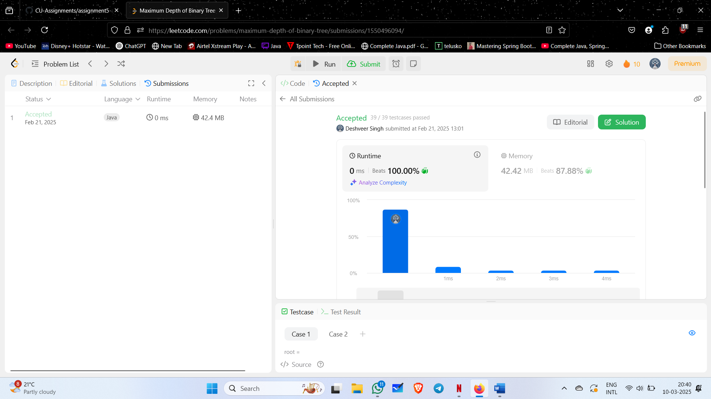

1. **98:**

class Solution {

    public boolean isValidBST(TreeNode root) {

        return valid(root, Long.MIN_VALUE, Long.MAX_VALUE);

    }

    private boolean valid(TreeNode root, long min, long max) {

        if (root == null) {

            return true;

        }

        if (root.val <= min || root.val >= max) {

            return false;

        }

        return valid(root.left, min, root.val) && valid(root.right, root.val, max);

    }

}

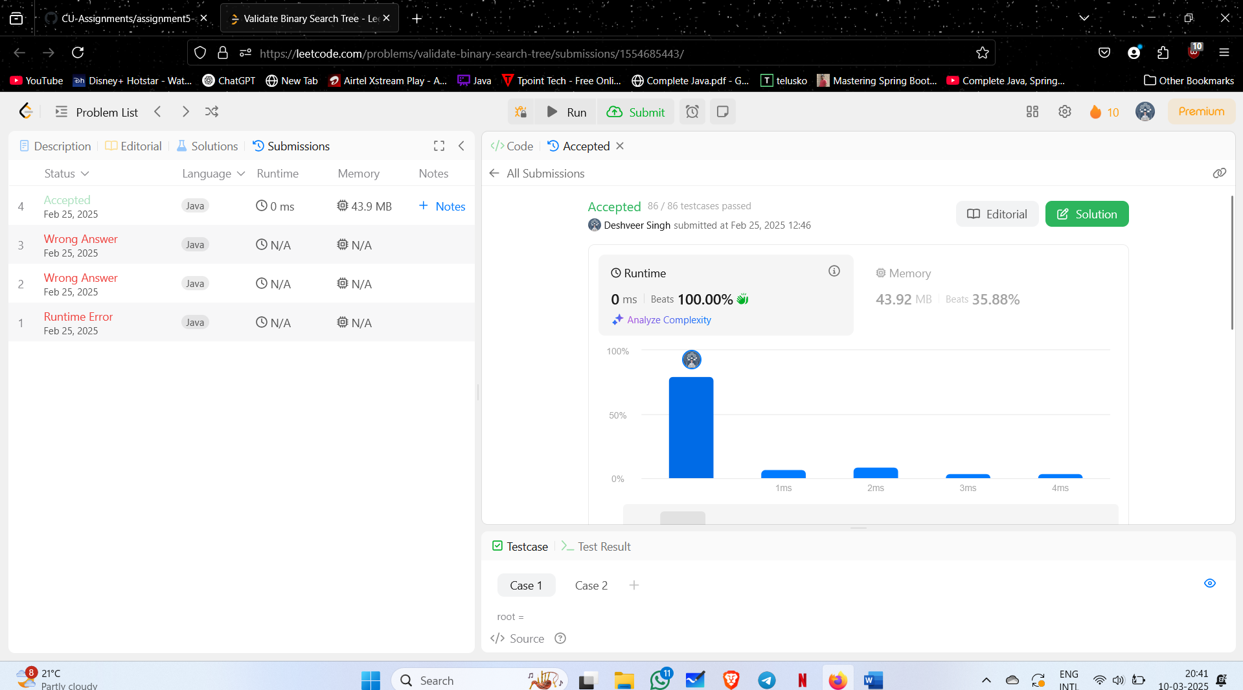

1. **101:**

class Solution {

public boolean isSymmetric(TreeNode root) {

return isMirror(root.left, root.right);

}

private boolean isMirror(TreeNode n1, TreeNode n2) {

if (n1 == null && n2 == null) {

return true;

}

if (n1 == null || n2 == null) {

return false;

}

return n1.val == n2.val && isMirror(n1.left, n2.right) && isMirror(n1.right, n2.left);

}

}



1. **103:**

class Solution {

    public List<List<Integer>> zigzagLevelOrder(TreeNode root) {

        Queue<TreeNode> st = new LinkedList<>();

        List<List<Integer>> ans = new ArrayList<>();

        if(root!=null)st.add(root);

        int k = 0;

        while(!st.isEmpty()){

            ArrayList<Integer> arr = new ArrayList<>();

            int n = st.size();

            // PUSHING TILL QUEUE.SIZE()

            for(int i = 0 ; i<n ; i++){

                TreeNode temp = st.poll();

                if(temp==null)break;

                arr.add(temp.val);

                if(temp.left!=null)st.add(temp.left);

                if(temp.right!=null)st.add(temp.right);

            }

               // REVERSING IF K IS ODD

            if(k%2!=0){

                Collections.reverse(arr);

                ans.add(new ArrayList<>(arr));

            }else ans.add(new ArrayList<>(arr));

                // INCREASING COUNTER

            k++;

        }return ans;

    }

}

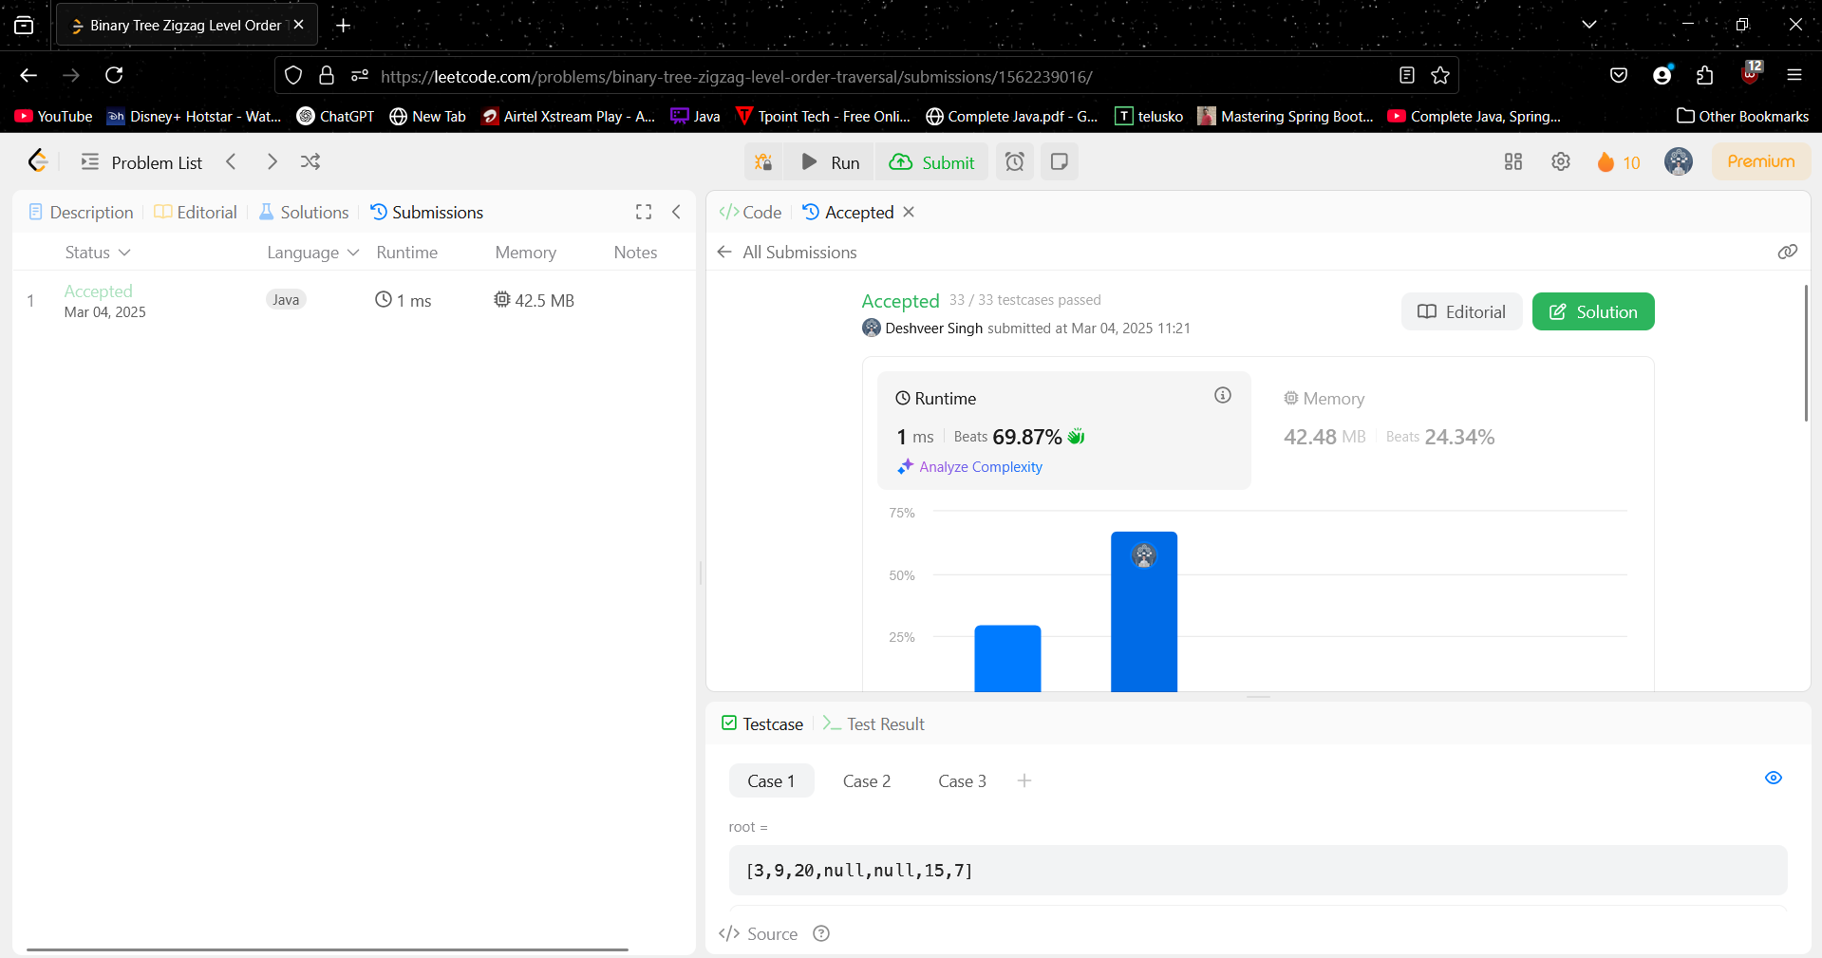

1. **236:**

class Solution {

public TreeNode lowestCommonAncestor(TreeNode root, TreeNode p, TreeNode q) {

if (root == null || root == p || root == q) {

return root;

}

TreeNode left = lowestCommonAncestor(root.left, p, q);

TreeNode right = lowestCommonAncestor(root.right, p, q);

if (left != null && right != null) {

return root;

}

return left != null ? left : right;

}

}

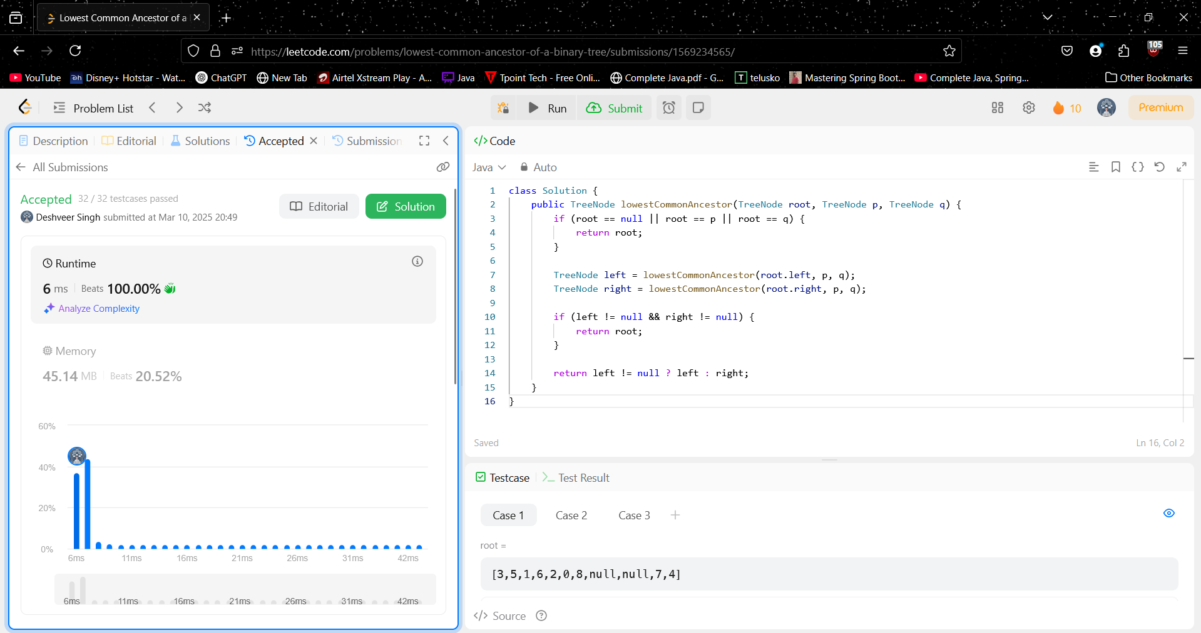

1. **94:**

class Solution {

    private List<Integer> res = new ArrayList<>();

    public List<Integer> inorderTraversal(TreeNode root) {

        traverse(root);

        return res;

    }

    private void traverse(TreeNode root) {

        if (root == null) {

            return;

        }

        traverse(root.left);

        res.add(root.val);

        traverse(root.right);

    }

}

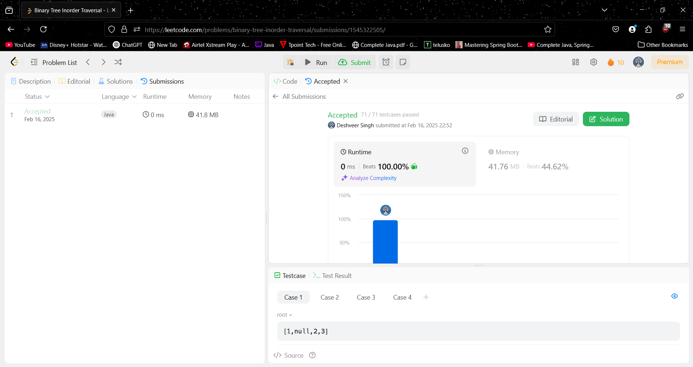

1. **102:**

class Solution {

public List<List<Integer>> levelOrder(TreeNode root) {

Queue<TreeNode> q = new LinkedList<>();

List<List<Integer>> finalAns = new ArrayList<List<Integer>>();

if(root==null){

return finalAns;

}

q.add(root);

while(!q.isEmpty()){

int levels = q.size();

List<Integer> subLevels = new ArrayList<>();

for(int i=0;i<levels;i++){

if(q.peek().left!=null){

q.add(q.peek().left);

}

if(q.peek().right!=null){

q.add(q.peek().right);

}

subLevels.add(q.remove().val);

}

finalAns.add(subLevels);

}

return finalAns;

}

}

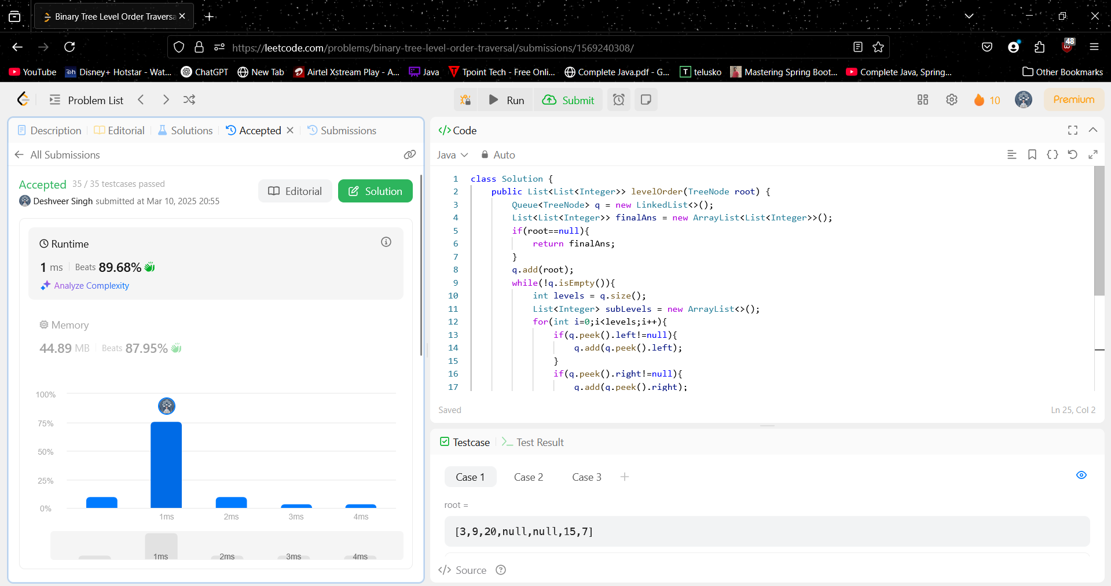

1. **230:**

class Solution {

private int count = 0; // Counter for visited nodes

public int kthSmallest(TreeNode root, int k) {

TreeNode result = helper(root, k);

return result != null ? result.val : 0; // Return value or 0 if not found

}

private TreeNode helper(TreeNode root, int k) {

if (root == null) return null;

// Traverse left subtree

TreeNode left = helper(root.left, k);

if (left != null) return left; // If found in left subtree

count++; // Increment count for current node

if (count == k) return root; // Found k-th smallest

// Traverse right subtree

return helper(root.right, k);

}

}

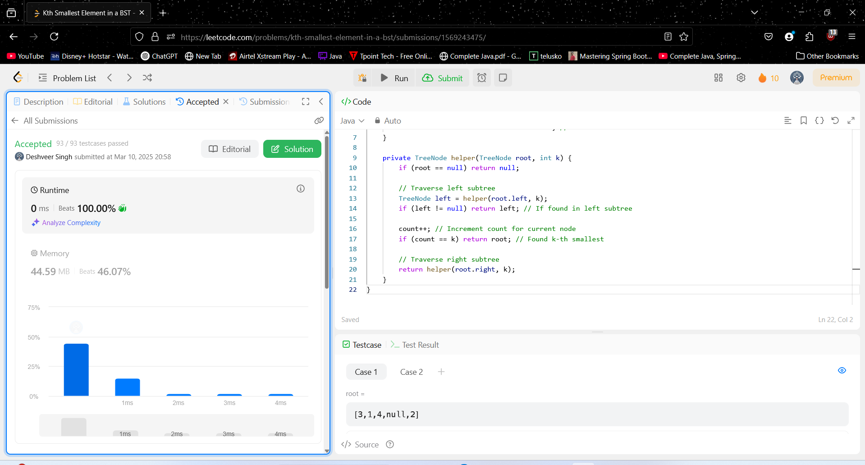

1. **116:**

class Solution {

    public Node connect(Node root) {

        if (root == null) return null;

        if (root.left != null) root.left.next = root.right;

        if (root.right != null && root.next != null) root.right.next = root.next.left;

        connect(root.left);

        connect(root.right);

        return root;

    }

}

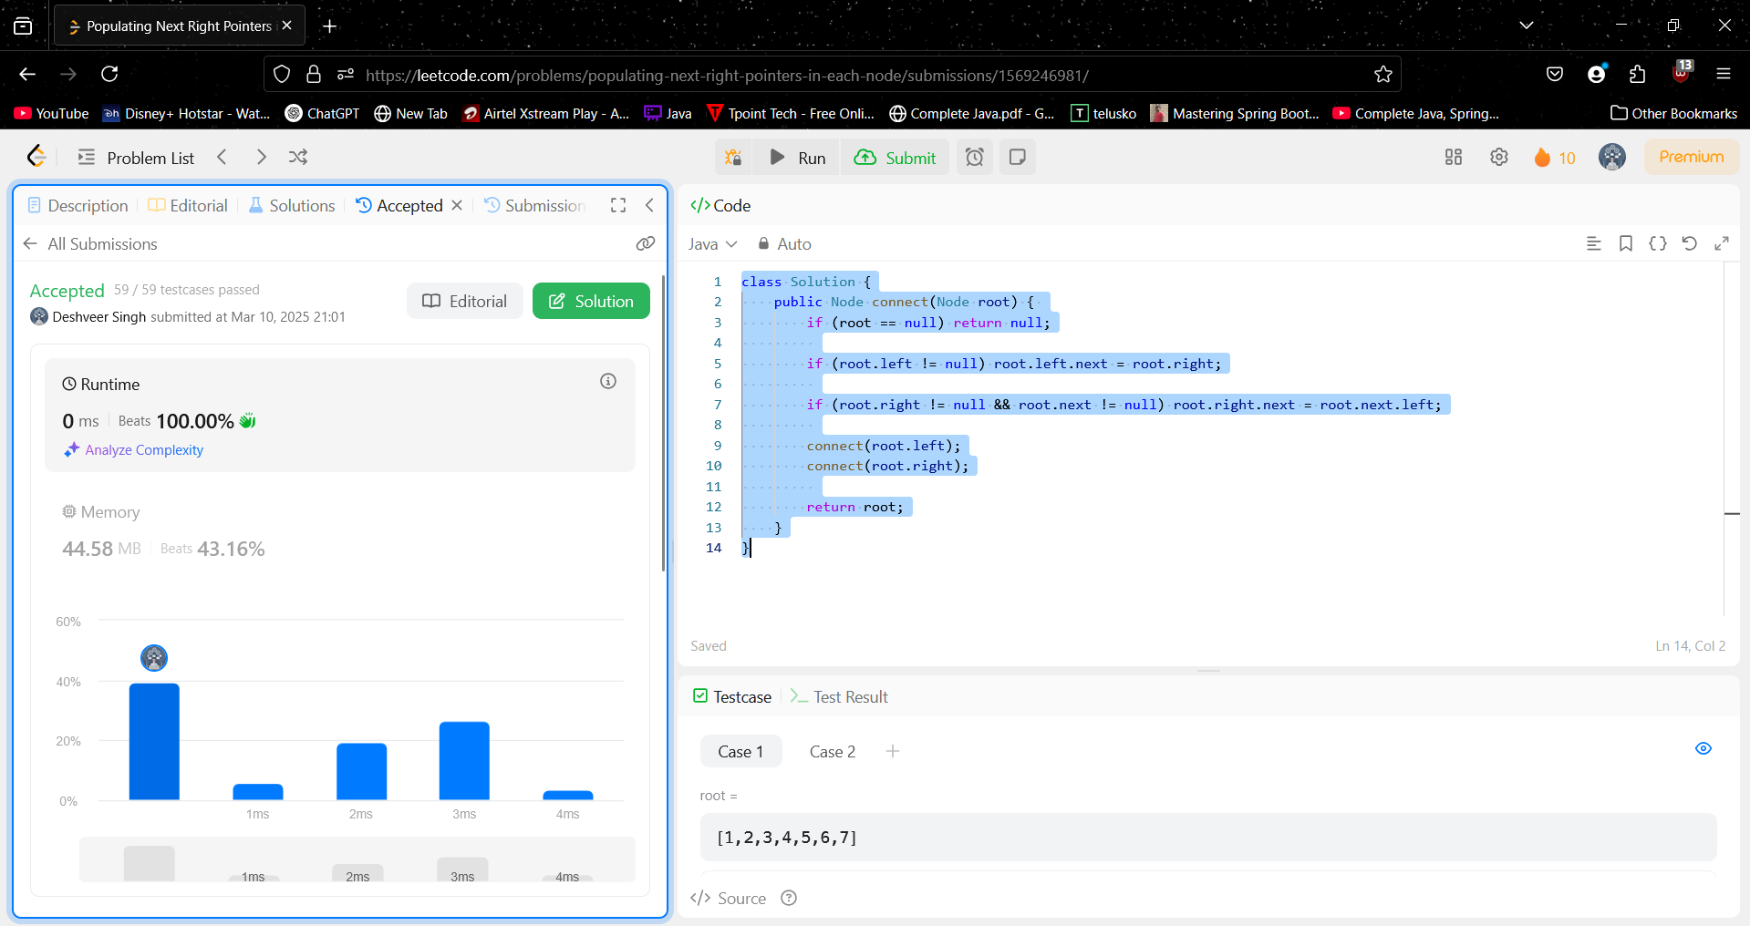

1. **404:**

class Solution {

    private int sum = 0;

    public int sumOfLeftLeaves(TreeNode root) {

        sumTree(root, false);

        return sum;

    }

    private void sumTree(TreeNode node, boolean flag){

        if(node == null) return;

        if(node.left == null && node.right == null && flag == true){

            sum += node.val;

        }

        sumTree(node.left, true);

        sumTree(node.right, false);

        return;

    }

}

