**Experiment 5**

**Student Name: Ramit Chaturvedi UID:22BCS15597**

**Branch: CSE Section/Group:614-B**

**Semester: 6 Date of Performance:20-2-25**

**Subject Name: AP LAB-II Subject Code: 22CSP-351**

Q 1) <https://leetcode.com/problems/maximum-depth-of-binary-tree/submissions/1569126565/>

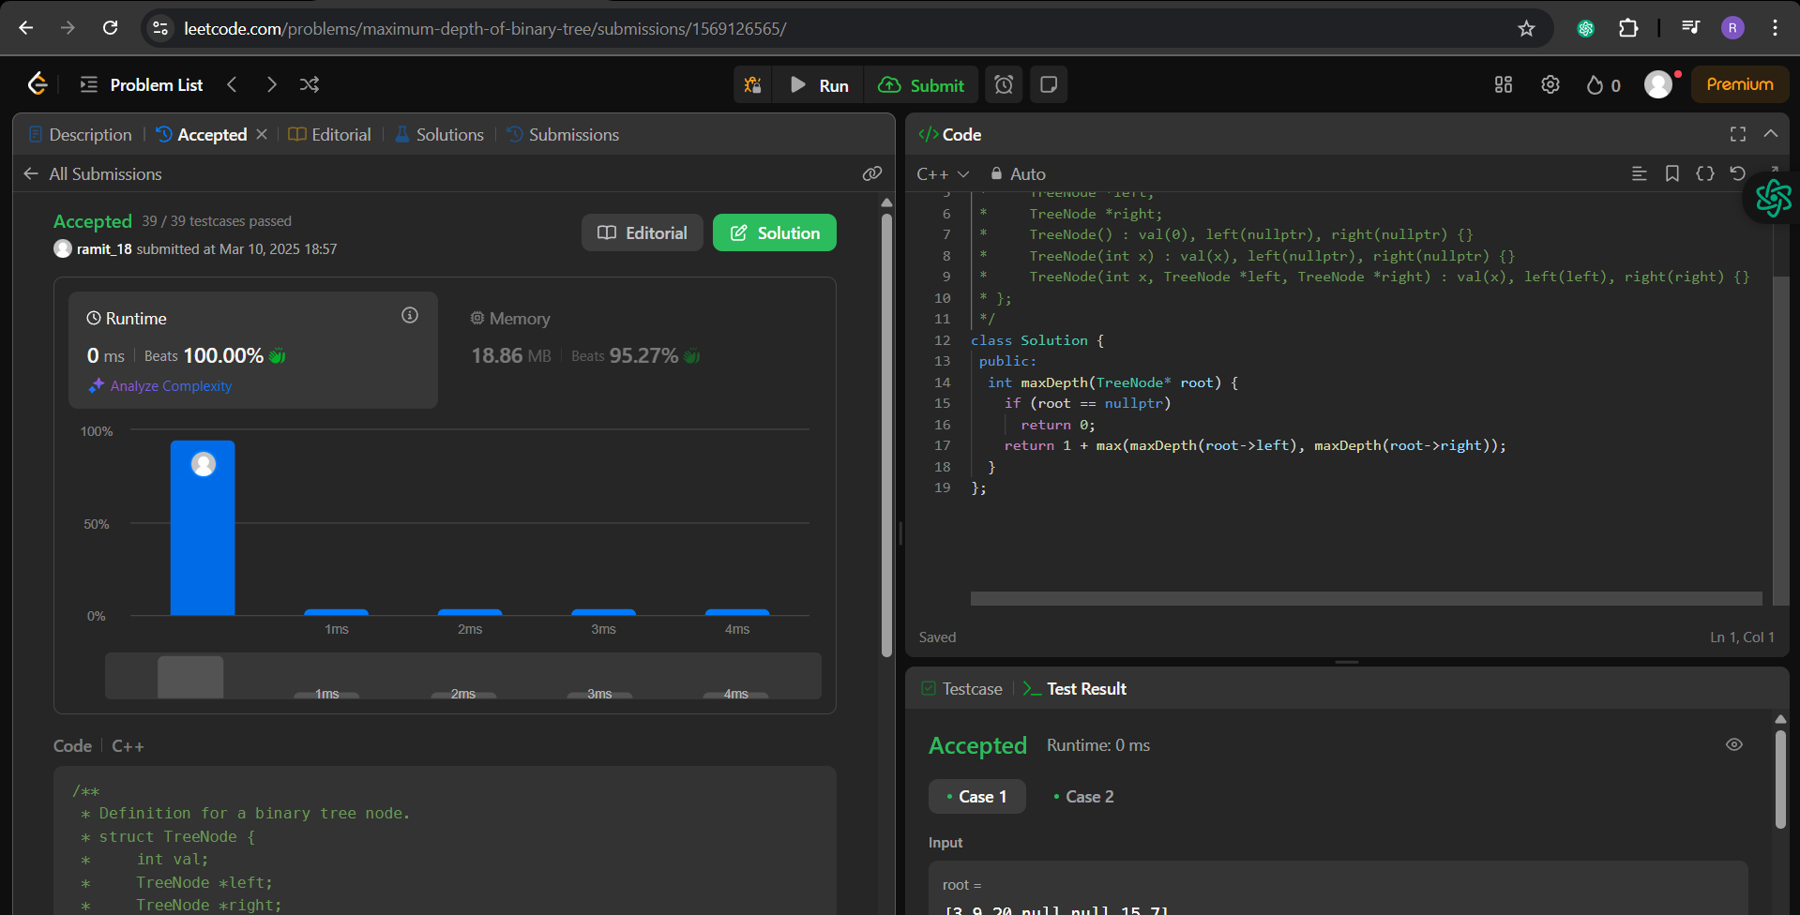

Q 2) <https://leetcode.com/problems/validate-binary-search-tree/submissions/1569128818/>

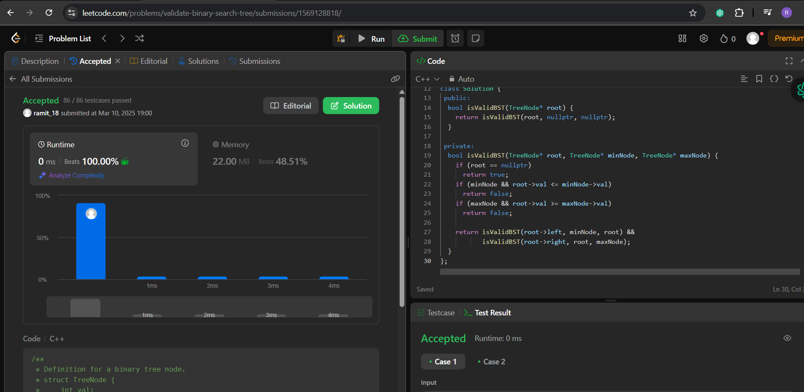

Q 3) <https://leetcode.com/problems/symmetric-tree/submissions/1569131734/>

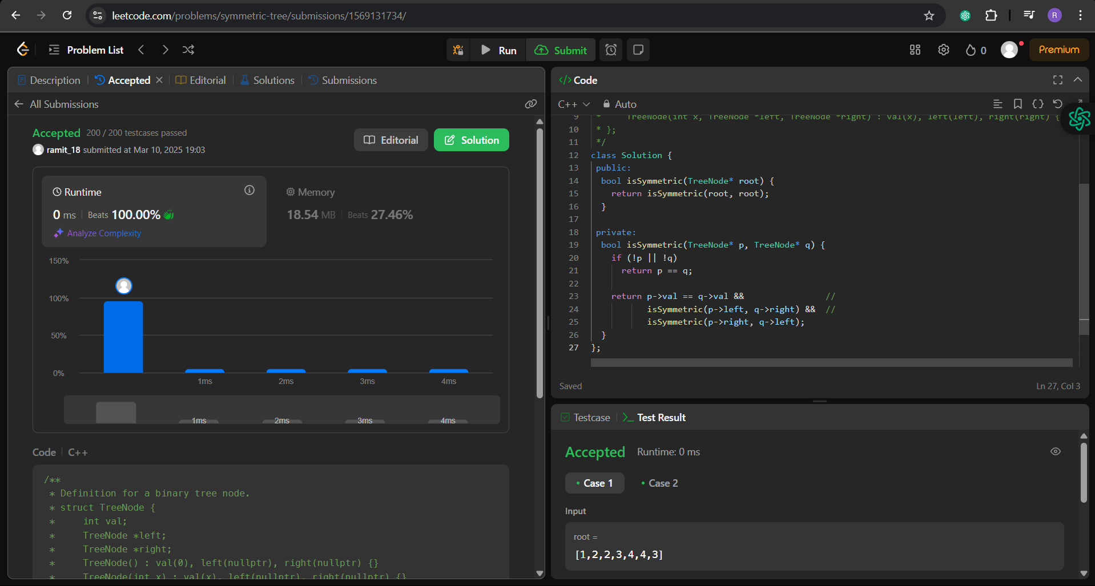

Q 4) <https://leetcode.com/problems/binary-tree-zigzag-level-order-traversal/description/>

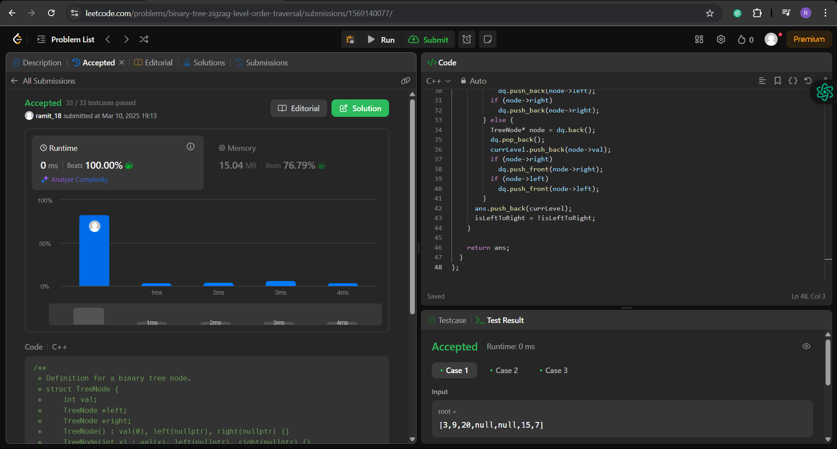

Q 5) <https://leetcode.com/problems/lowest-common-ancestor-of-a-binary-tree/submissions/1569144789/>

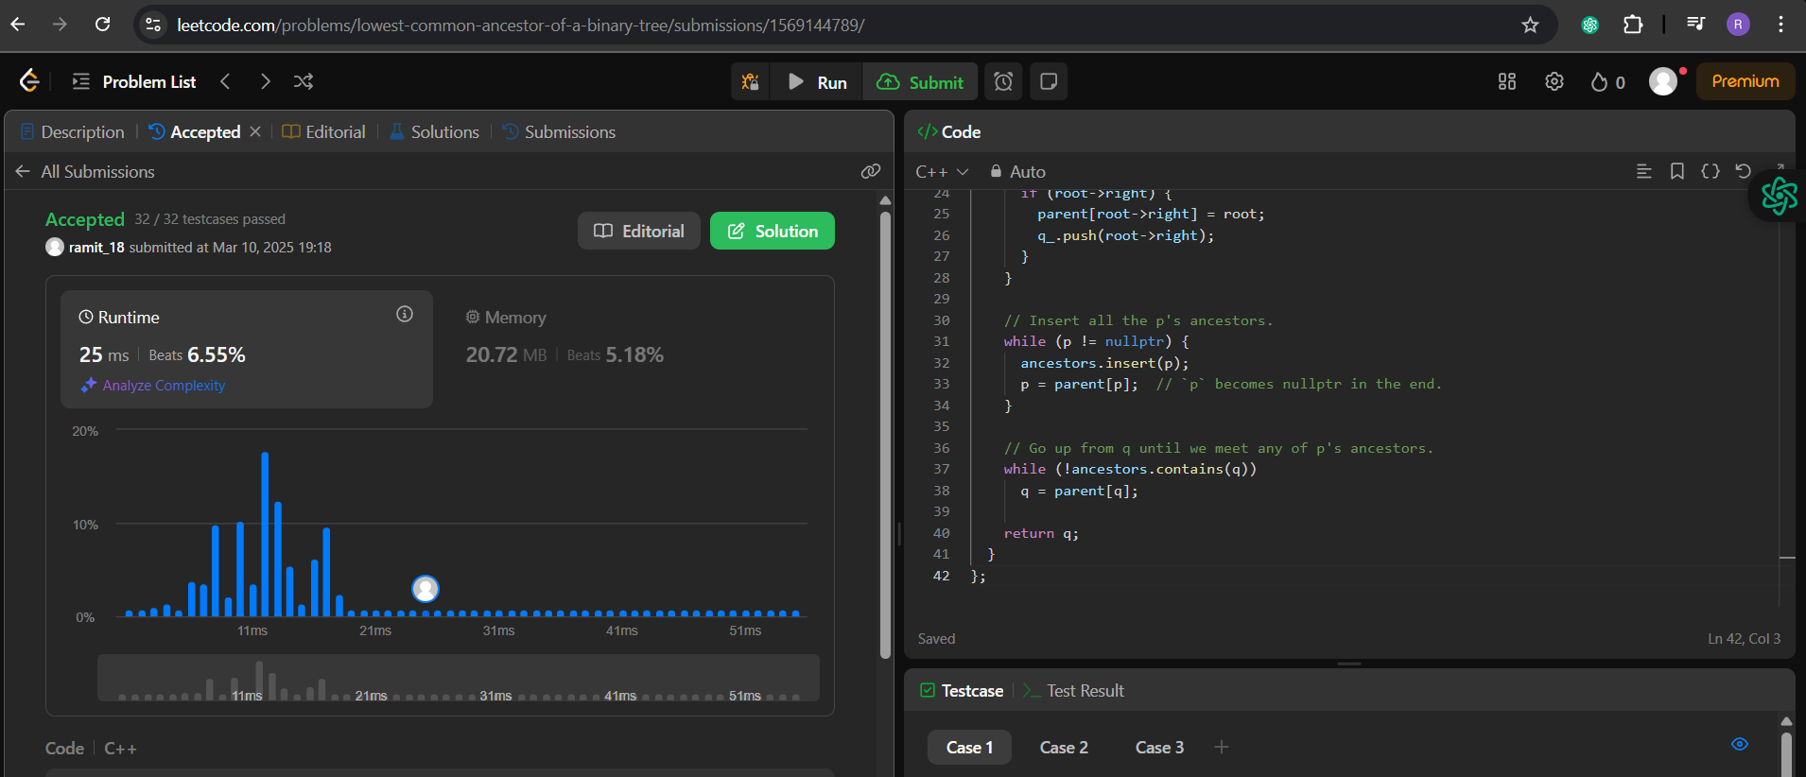

Q 6) <https://leetcode.com/problems/binary-tree-inorder-traversal/description/>

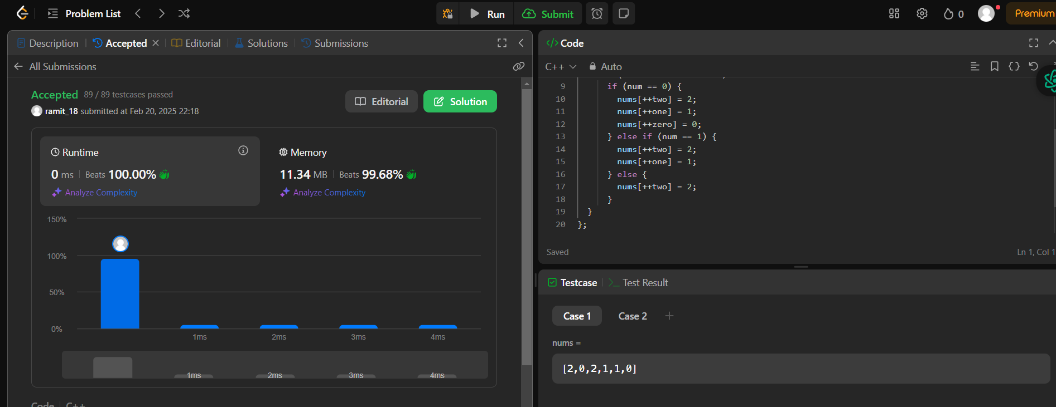

Q7) <https://leetcode.com/problems/binary-tree-level-order-traversal/submissions/1569149661/>

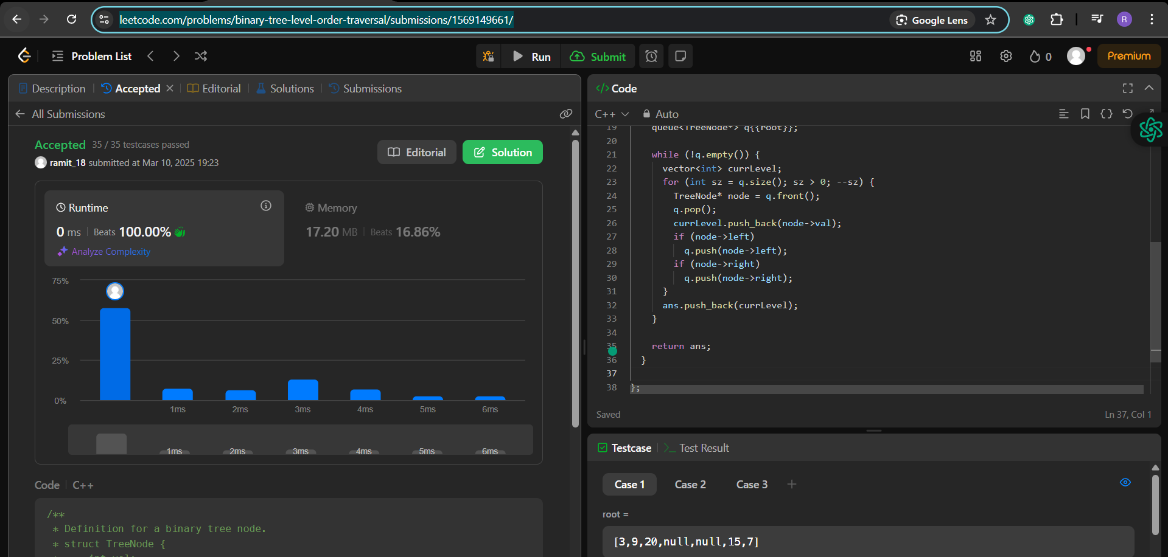

Q 8) <https://leetcode.com/problems/kth-smallest-element-in-a-bst/>

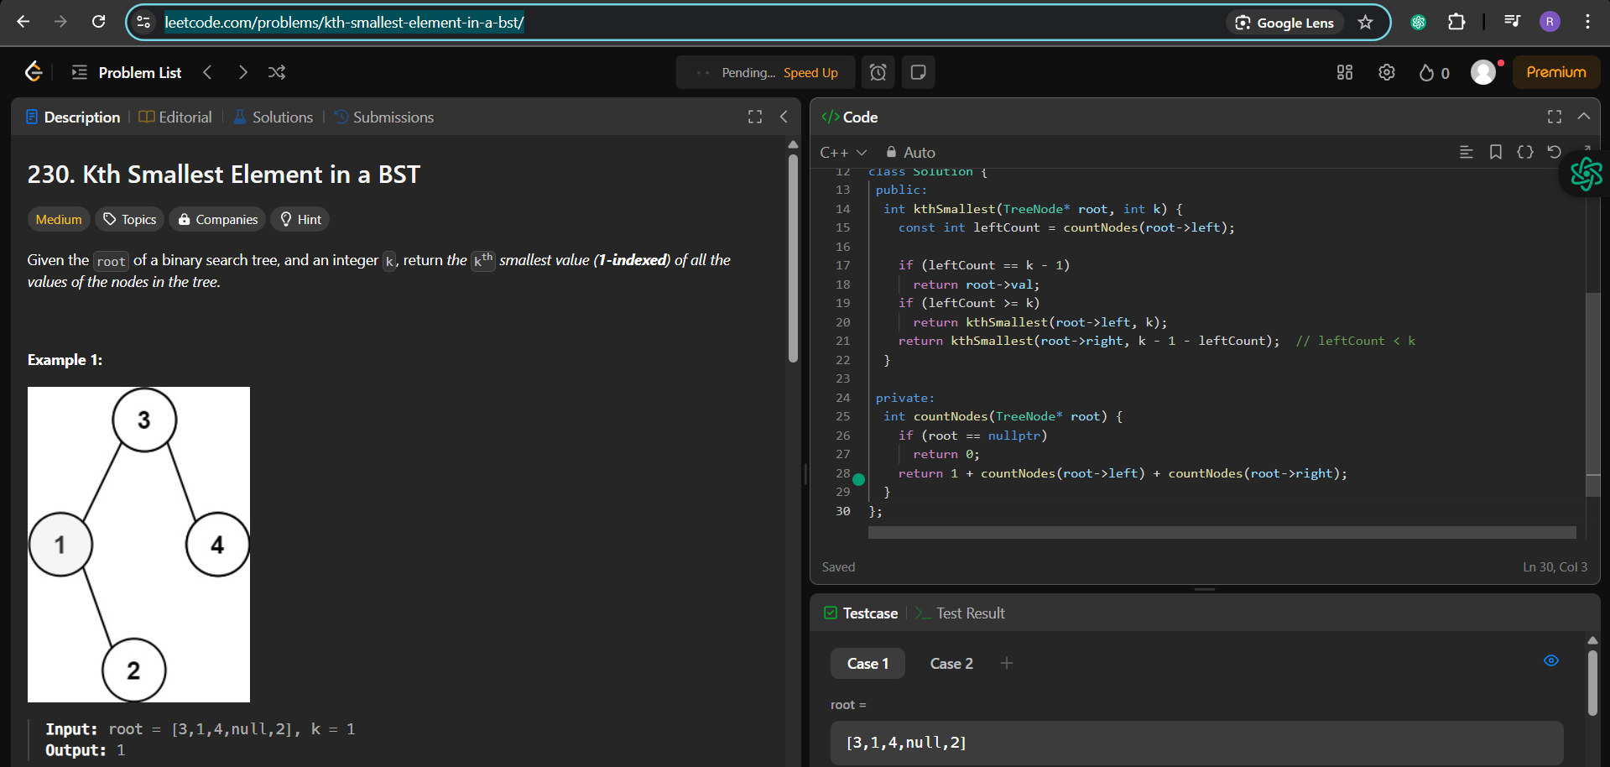

Q 9) <https://leetcode.com/problems/populating-next-right-pointers-in-each-node/>

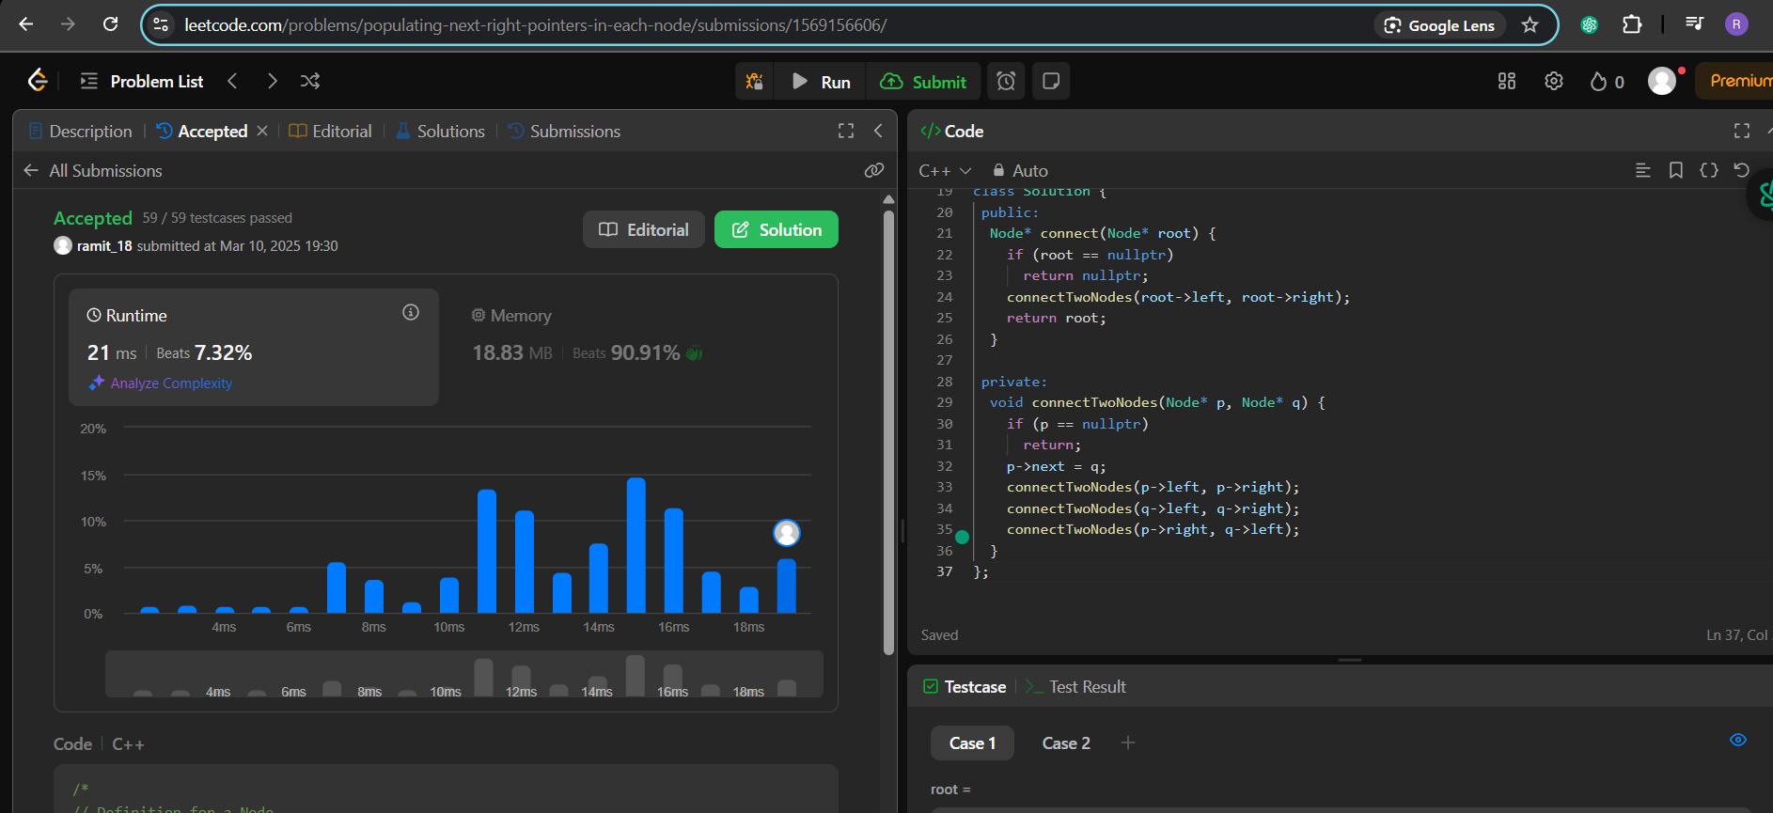

Q10) <https://leetcode.com/problems/sum-of-left-leaves/>

