JASNOOR SINGH(22BCS16282)

1.Implement Queue using Stack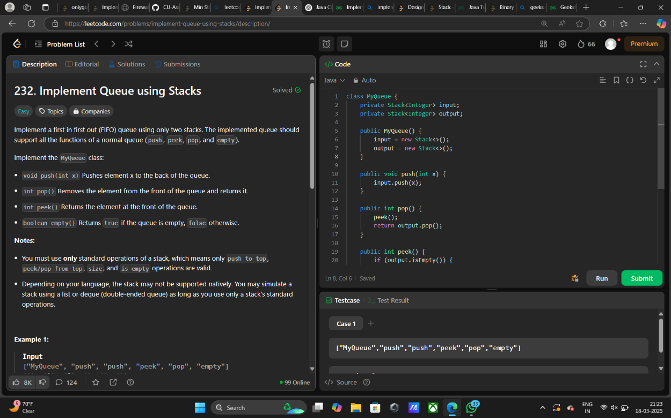

3.Implement Min Stack using Two Stacks

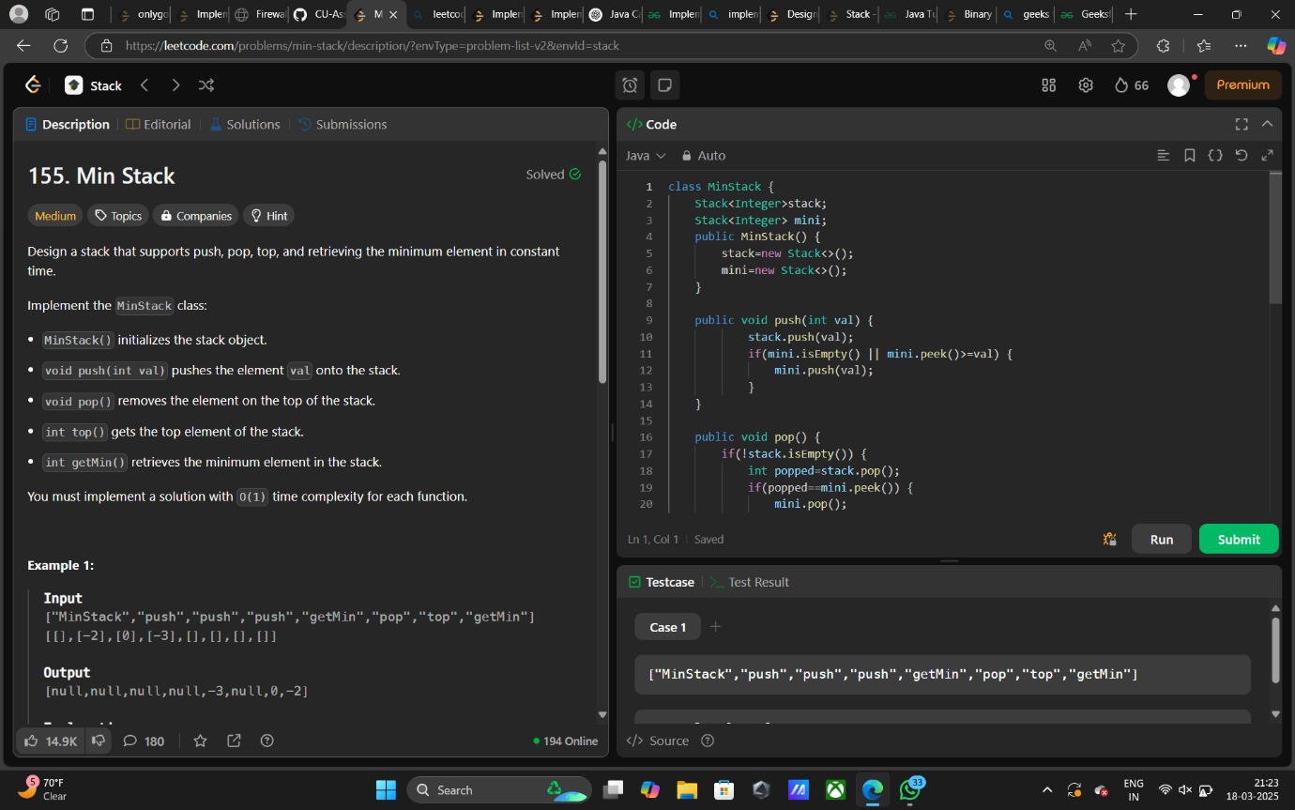

8. Implement Stack using Queue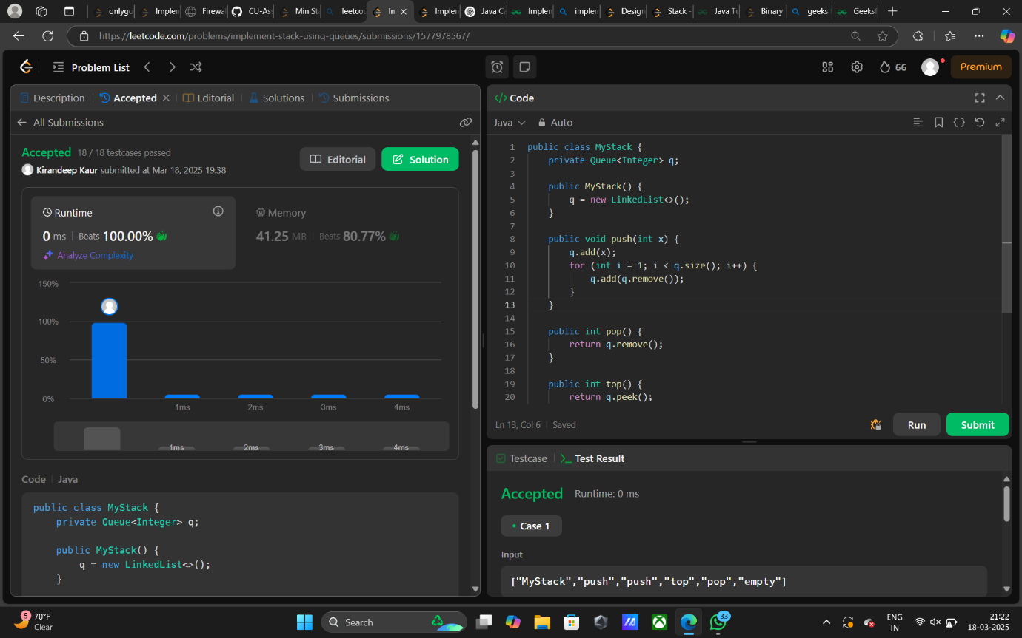

 Implement Circular Queue using Queue

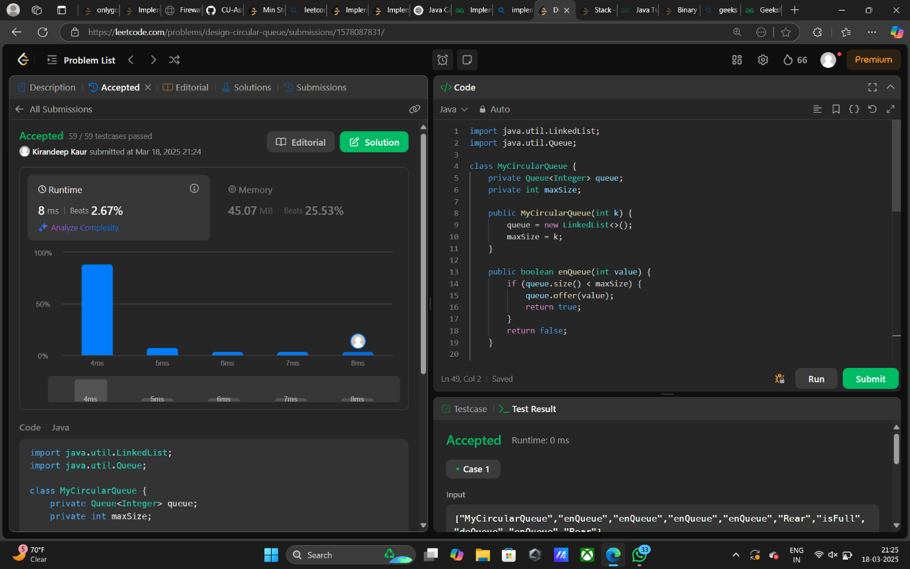

Implement Circular Queue using an Array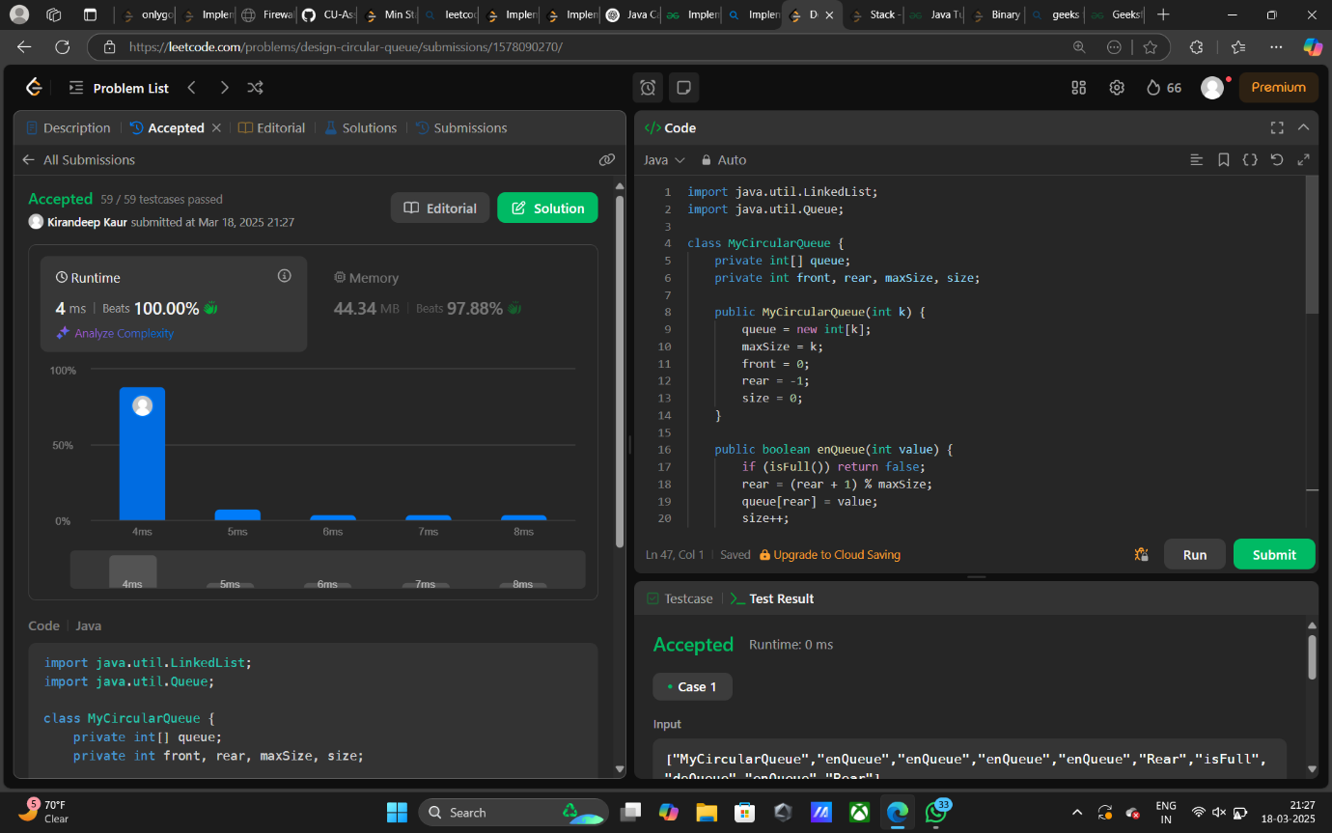

Implement Min Stack using Linked List

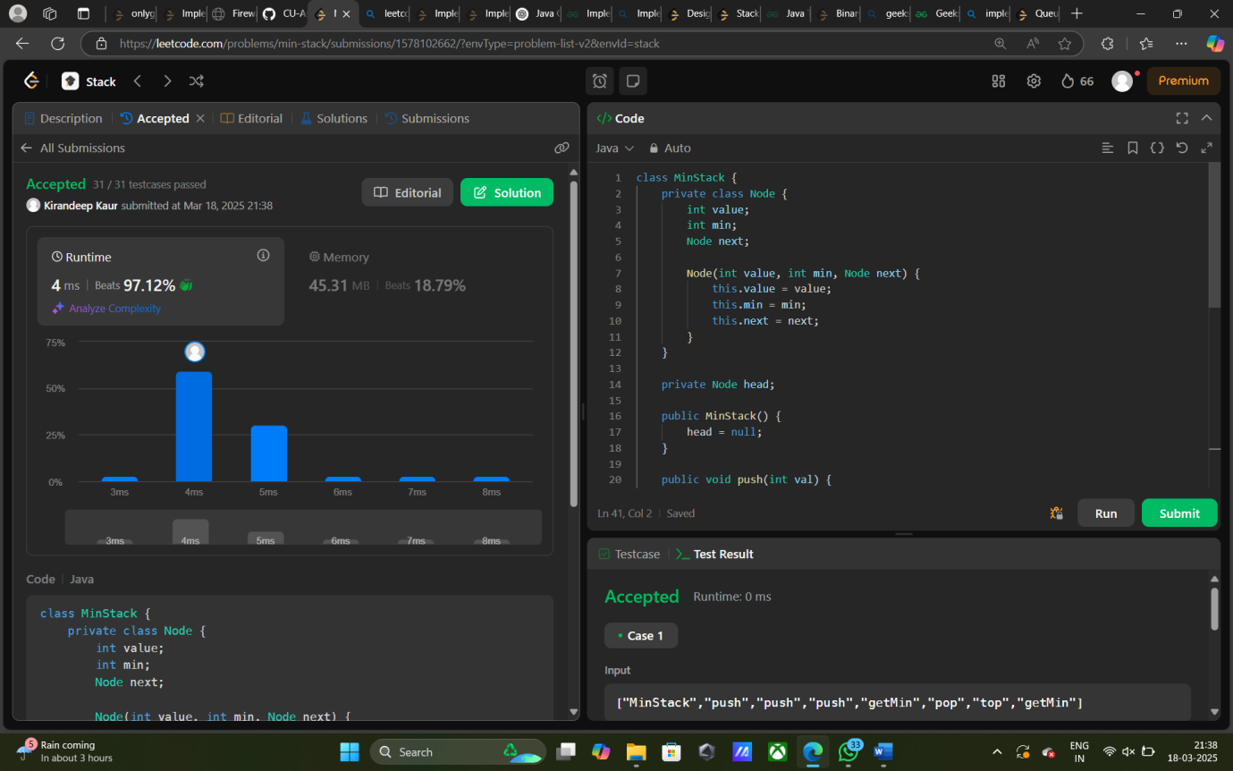

 Implement Circular Queue using Linked List

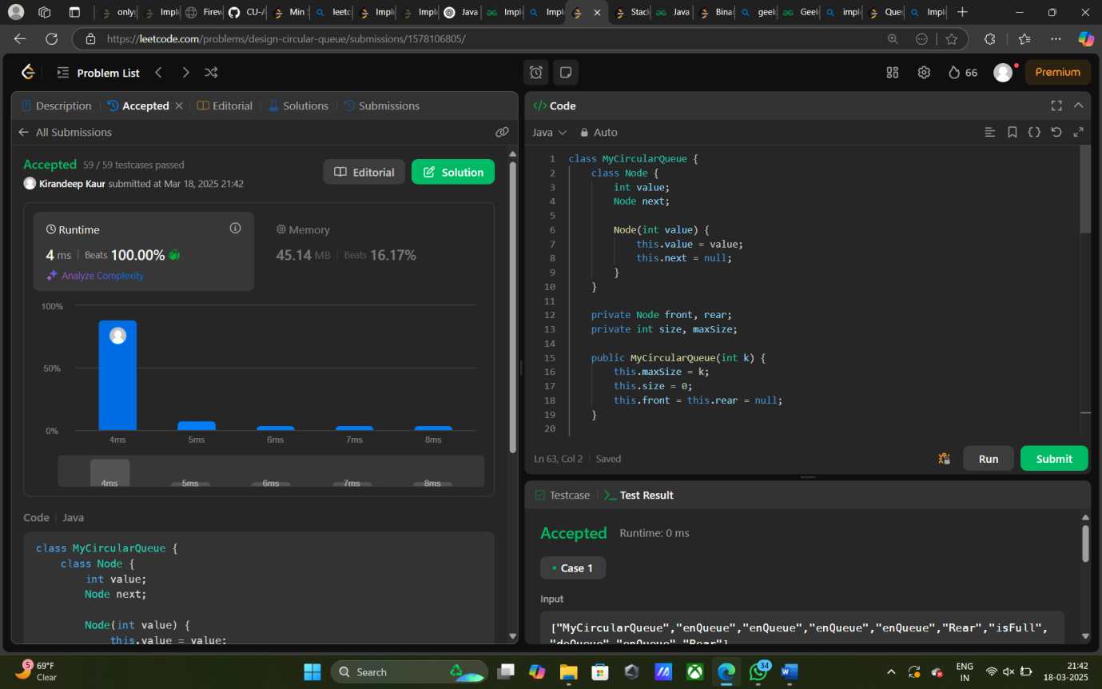

Implement BST (Inorder Traversal) using Stack (Iterative DFS)

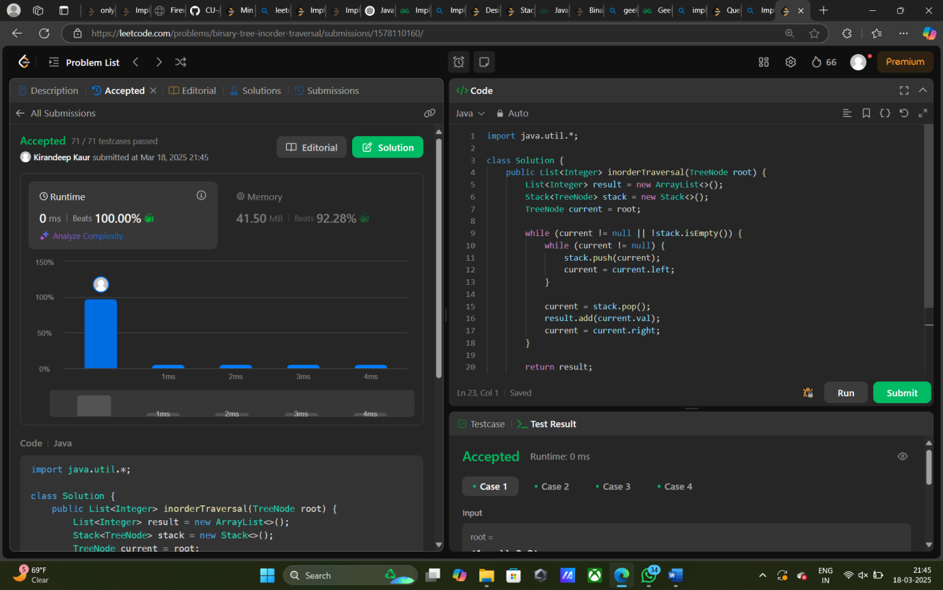

 Implement BST Level Order Traversal using Queue (BFS)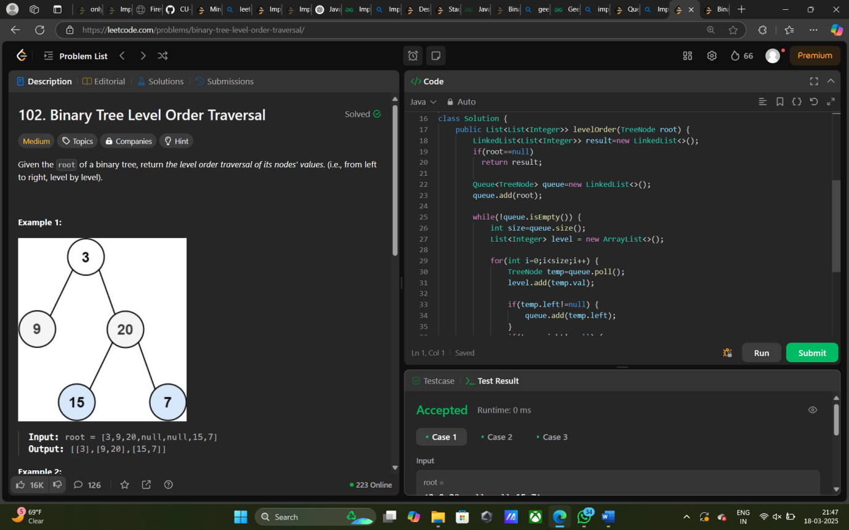

Implement Deque using Stack

