# ADVANCED PROGRAMMING LAB – ASSIGNMENT 6

NAME- KESHAV KUMAR

UID- 22BCS14105

Ques 1 Implement Stack using Linked List

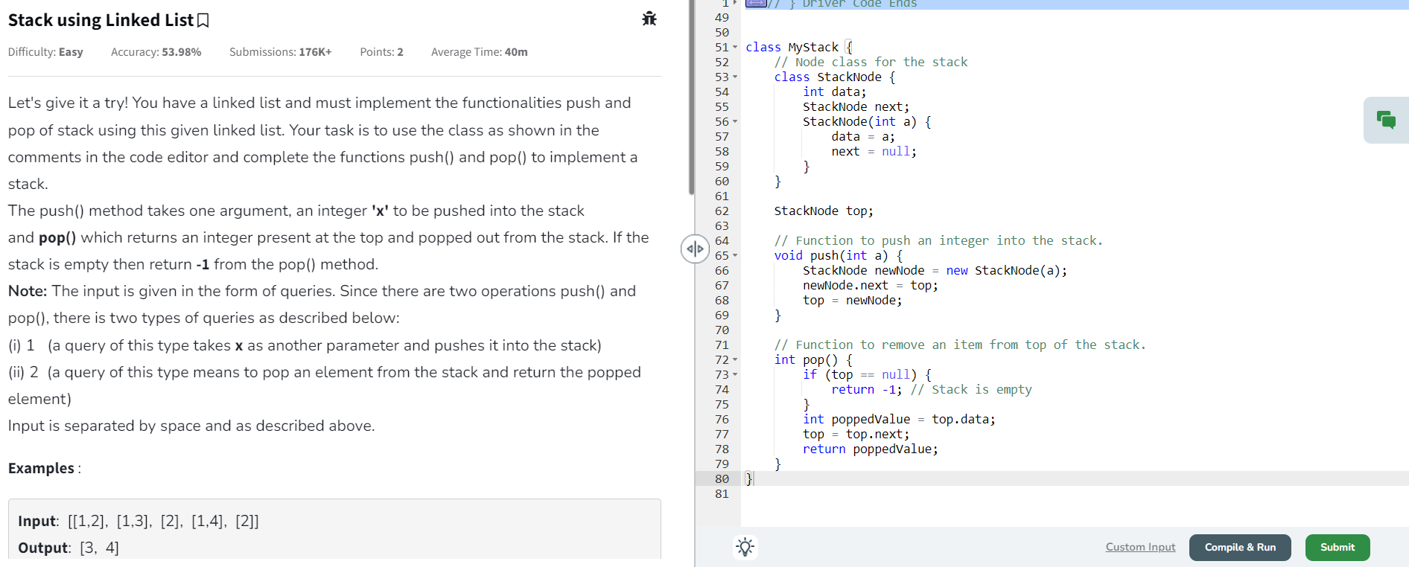

Ques 2

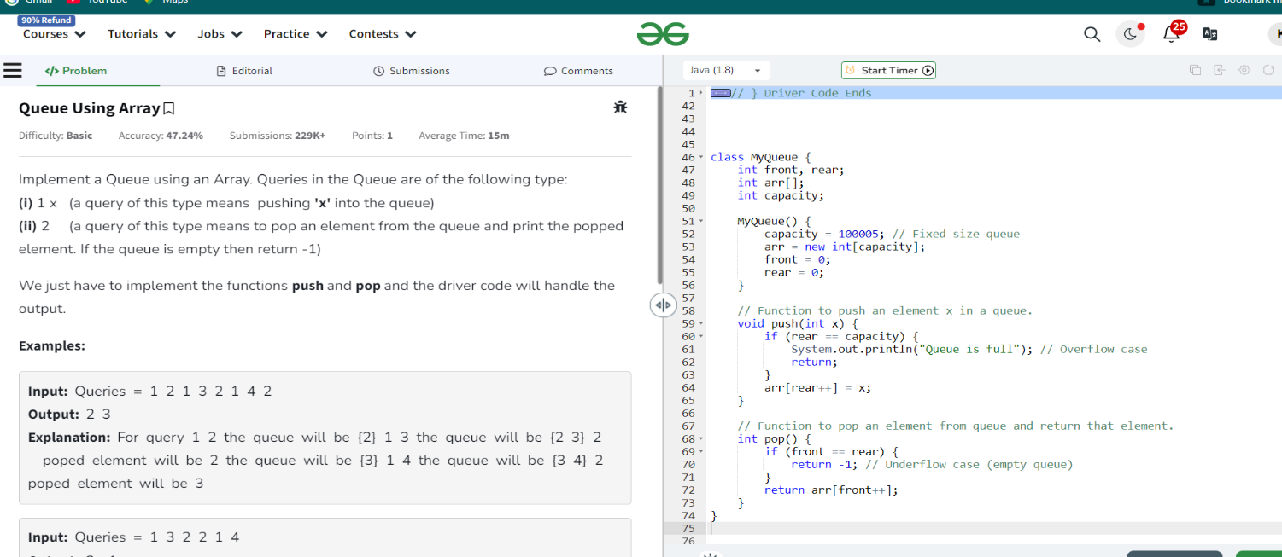

Ques 3

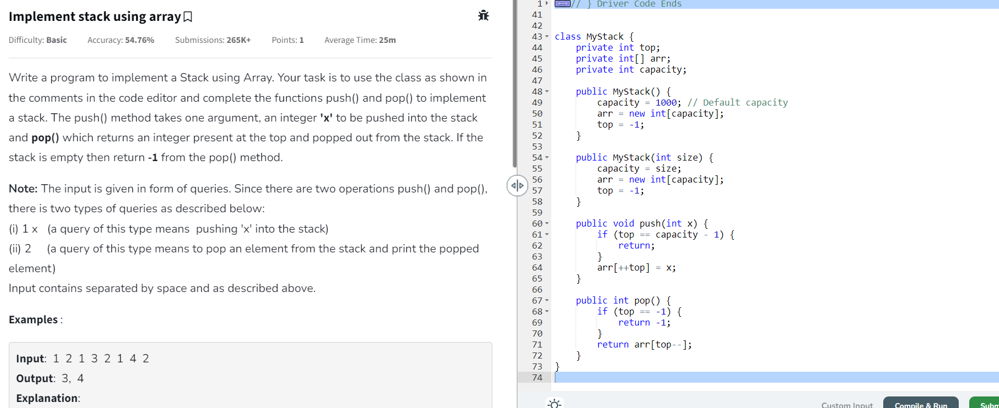

Ques 4

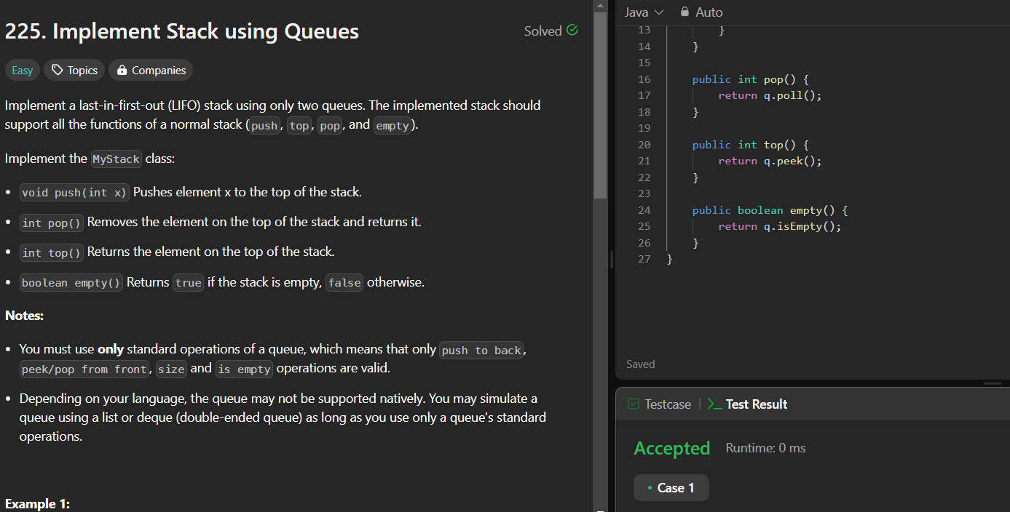

Ques 5

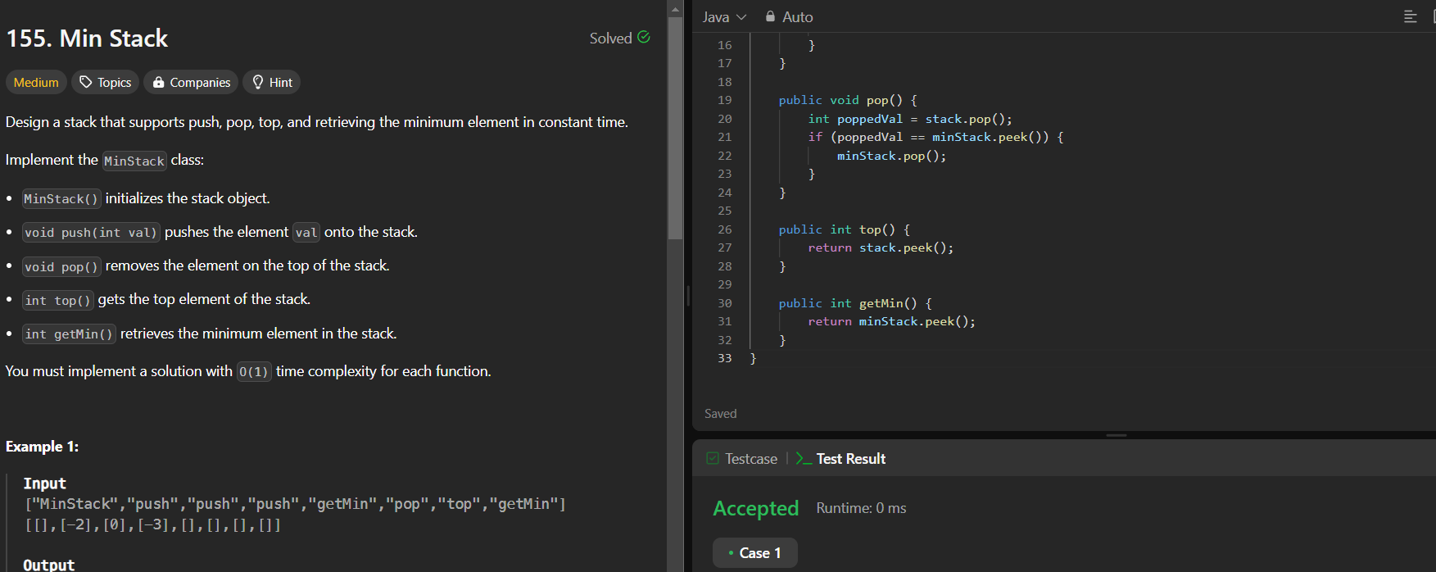

Ques 6

