**Name:** Utkarsh Prakhar

**UID:** 22BCS16208

**Section:** 22BCS_IOT-612-B

**Subject:** Advanced Programming Lab-2

**Assignment - 6**

**Implement Queue using Stack**

import java.util.Stack;

public class Tutorial {

Stack<Integer> stack1 = new Stack<>(); Stack<Integer> stack2 = new Stack<>();

public void enqueue(int value) { stack1.push(value);

}

public int dequeue() { if (isEmpty()) {

throw new RuntimeException("Queue is empty");

}

if (stack2.isEmpty()) {

while (!stack1.isEmpty()) { stack2.push(stack1.pop());

}

}

return stack2.pop();

}

public int peek() {

if (isEmpty()) {

throw new RuntimeException("Queue is empty");

}

if (stack2.isEmpty()) {

while (!stack1.isEmpty()) { stack2.push(stack1.pop());

}

}

return stack2.peek();

}

public boolean isEmpty() {

return stack1.isEmpty() && stack2.isEmpty();

}

public static void main(String[] args) { Tutorial queue = new Tutorial();

queue.enqueue(10); queue.enqueue(20); queue.enqueue(30);

System.out.println("Dequeued: " + queue.dequeue()); System.out.println("Peek: " + queue.peek()); System.out.println("Dequeued: " + queue.dequeue()); System.out.println("Is Empty: " + queue.isEmpty()); System.out.println("Dequeued: " + queue.dequeue()); System.out.println("Is Empty: " + queue.isEmpty());

}

}

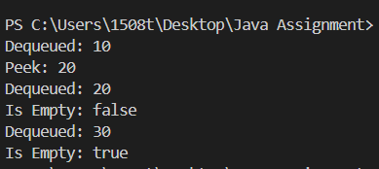

# Implement Deque using Stack

import java.util.Stack;

public class Tutorial {

Stack<Integer> frontStack = new Stack<>(); Stack<Integer> backStack = new Stack<>();

public void addFront(int value) { frontStack.push(value);

}

public void addBack(int value) { backStack.push(value);

}

public int removeFront() { if (isEmpty()) {

throw new RuntimeException("Deque is empty");

}

if (frontStack.isEmpty()) {

while (!backStack.isEmpty()) { frontStack.push(backStack.pop());

}

}

return frontStack.pop();

}

public int removeBack() { if (isEmpty()) {

throw new RuntimeException("Deque is empty");

}

if (backStack.isEmpty()) {

while (!frontStack.isEmpty()) { backStack.push(frontStack.pop());

}

}

return backStack.pop();

}

public int peekFront() { if (isEmpty()) {

throw new RuntimeException("Deque is empty");

}

if (frontStack.isEmpty()) {

while (!backStack.isEmpty()) { frontStack.push(backStack.pop());

}

}

return frontStack.peek();

}

public int peekBack() { if (isEmpty()) {

throw new RuntimeException("Deque is empty");

}

if (backStack.isEmpty()) {

while (!frontStack.isEmpty()) { backStack.push(frontStack.pop());

}

}

return backStack.peek();

}

public boolean isEmpty() {

return frontStack.isEmpty() && backStack.isEmpty();

}

public static void main(String[] args) { Tutorial deque = new Tutorial();

deque.addFront(10); deque.addBack(20); deque.addFront(5);

System.out.println("Remove Front: " + deque.removeFront()); System.out.println("Peek Back: " + deque.peekBack()); System.out.println("Remove Back: " + deque.removeBack()); System.out.println("Is Empty: " + deque.isEmpty()); System.out.println("Remove Front: " + deque.removeFront()); System.out.println("Is Empty: " + deque.isEmpty());

}

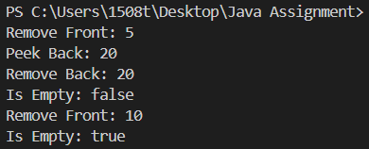}

# Implement Min Stack using Two Stacks

import java.util.Stack;

public class Tutorial {

Stack<Integer> mainStack = new Stack<>(); Stack<Integer> minStack = new Stack<>();

public void push(int value) { mainStack.push(value);

if (minStack.isEmpty() || value <= minStack.peek()) { minStack.push(value);

}

}

public int pop() {

if (mainStack.isEmpty()) {

throw new RuntimeException("Stack is empty");

}

int value = mainStack.pop();

if (value == minStack.peek()) { minStack.pop();

}

return value;

}

public int getMin() {

if (minStack.isEmpty()) {

throw new RuntimeException("Stack is empty");

}

return minStack.peek();

}

public int top() {

if (mainStack.isEmpty()) {

throw new RuntimeException("Stack is empty");

}

return mainStack.peek();

}

public static void main(String[] args) { Tutorial minStack = new Tutorial();

minStack.push(5); minStack.push(3); minStack.push(7); minStack.push(2);

System.out.println("Minimum: " + minStack.getMin()); // Output: 2 minStack.pop();

System.out.println("Minimum: " + minStack.getMin()); // Output: 3 minStack.pop();

System.out.println("Top: " + minStack.top()); // Output: 3

System.out.println("Minimum: " + minStack.getMin()); // Output: 3

}

} 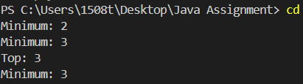

# .Implement Max Stack using Two Stacks

import java.util.Stack;

public class Tutorial {

Stack<Integer> mainStack = new Stack<>(); Stack<Integer> maxStack = new Stack<>();

public void push(int value) { mainStack.push(value);

if (maxStack.isEmpty() || value >= maxStack.peek()) { maxStack.push(value);

}

}

public int pop() {

if (mainStack.isEmpty()) {

throw new RuntimeException("Stack is empty");

}

int value = mainStack.pop();

if (value == maxStack.peek()) { maxStack.pop();

}

return value;

}

public int getMax() {

if (maxStack.isEmpty()) {

throw new RuntimeException("Stack is empty");

}

return maxStack.peek();

}

public int top() {

if (mainStack.isEmpty()) {

throw new RuntimeException("Stack is empty");

}

return mainStack.peek();

}

public static void main(String[] args) { Tutorial maxStack = new Tutorial();

maxStack.push(5); maxStack.push(3); maxStack.push(7); maxStack.push(2);

System.out.println("Maximum: " + maxStack.getMax()); // Output: 7 maxStack.pop();

System.out.println("Maximum: " + maxStack.getMax()); // Output: 7 maxStack.pop();

System.out.println("Top: " + maxStack.top()); // Output: 3

System.out.println("Maximum: " + maxStack.getMax()); // Output: 5

}

} 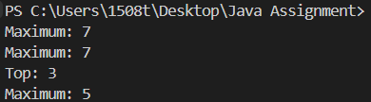

Implement Stack using Queue

import java.util.LinkedList; import java.util.Queue;

public class Tutorial {

Queue<Integer> queue1 = new LinkedList<>(); Queue<Integer> queue2 = new LinkedList<>();

public void push(int value) { queue2.add(value);

while (!queue1.isEmpty()) { queue2.add(queue1.remove());

}

Queue<Integer> temp = queue1; queue1 = queue2;

queue2 = temp;

}

public int pop() {

if (queue1.isEmpty()) {

throw new RuntimeException("Stack is empty");

}

return queue1.remove();

}

public int top() {

if (queue1.isEmpty()) {

throw new RuntimeException("Stack is empty");

}

return queue1.peek();

}

public boolean isEmpty() { return queue1.isEmpty();

}

public static void main(String[] args) { Tutorial stack = new Tutorial();

stack.push(5); stack.push(3); stack.push(7); stack.push(2);

System.out.println("Top: " + stack.top()); // Output: 2 stack.pop();

System.out.println("Top: " + stack.top()); // Output: 7 stack.pop();

System.out.println("Is Empty: " + stack.isEmpty()); // Output: false stack.pop();

stack.pop();

System.out.println("Is Empty: " + stack.isEmpty()); // Output: true

}

} 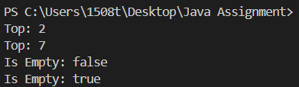

# Implement Deque using Queue

import java.util.LinkedList; import java.util.Queue;

public class Tutorial {

Queue<Integer> frontQueue = new LinkedList<>(); Queue<Integer> backQueue = new LinkedList<>();

public void addFront(int value) { frontQueue.add(value);

}

public void addBack(int value) { backQueue.add(value);

}

public int removeFront() {

if (!frontQueue.isEmpty()) { return frontQueue.remove();

} else if (!backQueue.isEmpty()) { while (backQueue.size() > 1) {

frontQueue.add(backQueue.remove());

}

return backQueue.remove();

}

throw new RuntimeException("Deque is empty");

}

public int removeBack() {

if (!backQueue.isEmpty()) { return backQueue.remove();

} else if (!frontQueue.isEmpty()) { while (frontQueue.size() > 1) {

backQueue.add(frontQueue.remove());

}

return frontQueue.remove();

}

throw new RuntimeException("Deque is empty");

}

public int peekFront() {

if (!frontQueue.isEmpty()) { return frontQueue.peek();

} else if (!backQueue.isEmpty()) { while (!backQueue.isEmpty()) {

frontQueue.add(backQueue.remove());

}

return frontQueue.peek();

}

throw new RuntimeException("Deque is empty");

}

public int peekBack() {

if (!backQueue.isEmpty()) { return backQueue.peek();

} else if (!frontQueue.isEmpty()) { while (!frontQueue.isEmpty()) {

backQueue.add(frontQueue.remove());

}

return backQueue.peek();

}

throw new RuntimeException("Deque is empty");

}

public static void main(String[] args) { Tutorial deque = new Tutorial();

deque.addFront(5); deque.addBack(3); deque.addFront(7); deque.addBack(2);

System.out.println("Front: " + deque.peekFront()); // Output: 7 System.out.println("Back: " + deque.peekBack()); // Output: 2

deque.removeFront();

System.out.println("Front after remove: " + deque.peekFront()); // Output: 5

deque.removeBack();

System.out.println("Back after remove: " + deque.peekBack()); // Output: 3

}

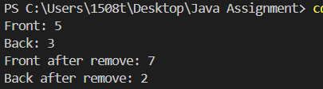}}

# Implement Circular Queue using Queue

import java.util.LinkedList; import java.util.Queue;

public class Tutorial { private int[] queue; private int front; private int rear; private int size; private int capacity;

public Tutorial(int k) { capacity = k;

queue = new int[k]; front = -1;

rear = -1;

size = 0;

}

public boolean enQueue(int value) { if (isFull()) {

return false;

}

if (isEmpty()) { front = 0;

}

rear = (rear + 1) % capacity; queue[rear] = value;

size++; return true;

}

public boolean deQueue() { if (isEmpty()) {

return false;

}

if (front == rear) { front = -1;

rear = -1;

} else {

front = (front + 1) % capacity;

}

size--; return true;

}

public int Front() { if (isEmpty()) {

return -1;

}

return queue[front];

}

public int Rear() { if (isEmpty()) {

return -1;

}

return queue[rear];

}

public boolean isEmpty() { return size == 0;

}

public boolean isFull() { return size == capacity;

}

public static void main(String[] args) { Tutorial circularQueue = new Tutorial(3);

System.out.println(circularQueue.enQueue(1)); // Output: true System.out.println(circularQueue.enQueue(2)); // Output: true System.out.println(circularQueue.enQueue(3)); // Output: true System.out.println(circularQueue.enQueue(4)); // Output: false (Queue is full)

System.out.println("Rear: " + circularQueue.Rear()); // Output: 3 System.out.println(circularQueue.isFull()); // Output: true

System.out.println(circularQueue.deQueue()); // Output: true System.out.println(circularQueue.enQueue(4)); // Output: true System.out.println("Rear: " + circularQueue.Rear()); // Output: 4

}

}

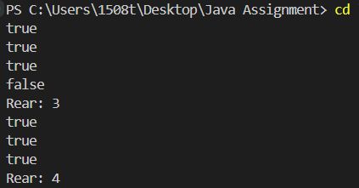

# Implement Stack using an Array

public class Tutorial { private int[] stack; private int top; private int capacity;

public Tutorial(int size) { stack = new int[size]; top = -1;

capacity = size;

}

public boolean push(int value) { if (isFull()) {

return false;

}

stack[++top] = value; return true;

}

public int pop() { if (isEmpty()) {

throw new RuntimeException("Stack is empty");

}

return stack[top--];

}

public int peek() { if (isEmpty()) {

throw new RuntimeException("Stack is empty");

}

return stack[top];

}

public boolean isEmpty() { return top == -1;

}

public boolean isFull() { return top == capacity - 1;

}

public static void main(String[] args) { Tutorial stack = new Tutorial(5); stack.push(10);

stack.push(20); stack.push(30);

System.out.println("Top element: " + stack.peek()); // Output: 30 System.out.println("Pop element: " + stack.pop()); // Output: 30 System.out.println("Top element after pop: " + stack.peek()); // Output: 20

}

}

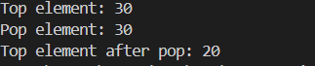

Implement Queue using an Array

public class Tutorial { private int[] queue; private int front; private int rear; private int capacity; private int size;

public Tutorial(int capacity) { this.capacity = capacity; this.queue = new int[capacity]; this.front = 0;

this.rear = -1;

this.size = 0;

}

public boolean enqueue(int value) { if (isFull()) {

return false;

}

rear = (rear + 1) % capacity; queue[rear] = value;

size++; return true;

}

public int dequeue() { if (isEmpty()) {

throw new RuntimeException("Queue is empty");

}

int value = queue[front];

front = (front + 1) % capacity; size--;

return value;

}

public int front() { if (isEmpty()) {

throw new RuntimeException("Queue is empty");

}

return queue[front];

}

public boolean isEmpty() { return size == 0;

}

public boolean isFull() { return size == capacity;

}

public static void main(String[] args) { Tutorial queue = new Tutorial(5); queue.enqueue(10); queue.enqueue(20); queue.enqueue(30);

System.out.println("Front element: " + queue.front()); // Output: 10

System.out.println("Dequeue element: " + queue.dequeue()); // Output: 10 System.out.println("Front element after dequeue: " + queue.front()); // Output: 20

}

} 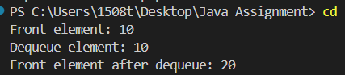

# Implement Circular Queue using an Array

public class Tutorial { private int[] queue; private int front; private int rear; private int capacity; private int size;

public Tutorial(int capacity) { this.capacity = capacity; this.queue = new int[capacity]; this.front = -1;

this.rear = -1;

this.size = 0;

}

public boolean enqueue(int value) { if (isFull()) {

return false;

}

if (isEmpty()) { front = 0;

}

rear = (rear + 1) % capacity;

queue[rear] = value; size++;

return true;

}

public int dequeue() { if (isEmpty()) {

throw new RuntimeException("Queue is empty");

}

int value = queue[front]; if (front == rear) {

front = -1;

rear = -1;

} else {

front = (front + 1) % capacity;

}

size--; return value;

}

public int front() { if (isEmpty()) {

throw new RuntimeException("Queue is empty");

}

return queue[front];

}

public int rear() { if (isEmpty()) {

throw new RuntimeException("Queue is empty");

}

return queue[rear];

}

public boolean isEmpty() { return size == 0;

}

public boolean isFull() { return size == capacity;

}

public static void main(String[] args) { Tutorial circularQueue = new Tutorial(5); circularQueue.enqueue(10); circularQueue.enqueue(20); circularQueue.enqueue(30); circularQueue.enqueue(40); circularQueue.enqueue(50);

System.out.println("Front element: " + circularQueue.front()); // Output: 10 System.out.println("Rear element: " + circularQueue.rear()); // Output: 50

System.out.println("Dequeue element: " + circularQueue.dequeue()); // Output: 10 System.out.println("Front element after dequeue: " + circularQueue.front()); // Output: 20

}

}

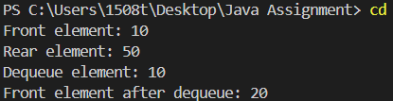

# Implement Min Stack using Linked List

class Node { int value; int min; Node next;

Node(int value, int min) { this.value = value; this.min = min; this.next = null;

}

}

public class Tutorial { private Node head;

public Tutorial() { head = null;

}

public void push(int value) { if (head == null) {

head = new Node(value, value);

} else {

Node newNode = new Node(value, Math.min(value, head.min));

newNode.next = head; head = newNode;

}

}

public int pop() {

if (head == null) {

throw new RuntimeException("Stack is empty");

}

int value = head.value; head = head.next; return value;

}

public int top() {

if (head == null) {

throw new RuntimeException("Stack is empty");

}

return head.value;

}

public int getMin() { if (head == null) {

throw new RuntimeException("Stack is empty");

}

return head.min;

}

public static void main(String[] args) { Tutorial minStack = new Tutorial();

minStack.push(5); minStack.push(3); minStack.push(7); minStack.push(2);

System.out.println("Minimum element: " + minStack.getMin()); // Output: 2 minStack.pop();

System.out.println("Minimum element after pop: " + minStack.getMin()); // Output: 3

}

}

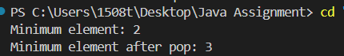

# Implement Hash Table using Linked List (Chaining Method)

import java.util.LinkedList; import java.util.List;

class HashNode { int key;

int value;

HashNode(int key, int value) { this.key = key;

this.value = value;

}

}

public class Tutorial {

private List<HashNode>[] table;

private int capacity;

public Tutorial(int capacity) { this.capacity = capacity;

table = new LinkedList[capacity]; for (int i = 0; i < capacity; i++) {

table[i] = new LinkedList<>();

}

}

private int hash(int key) { return key % capacity;

}

public void put(int key, int value) { int index = hash(key);

for (HashNode node : table[index]) { if (node.key == key) {

node.value = value; return;

}

}

table[index].add(new HashNode(key, value));

}

public int get(int key) { int index = hash(key);

for (HashNode node : table[index]) { if (node.key == key) {

return node.value;

}

}

throw new RuntimeException("Key not found");

}

public void remove(int key) { int index = hash(key);

table[index].removeIf(node -> node.key == key);

}

public static void main(String[] args) { Tutorial hashTable = new Tutorial(10); hashTable.put(1, 100);

hashTable.put(2, 200);

hashTable.put(12, 1200);

System.out.println("Value for key 1: " + hashTable.get(1)); // Output: 100 System.out.println("Value for key 2: " + hashTable.get(2)); // Output: 200 System.out.println("Value for key 12: " + hashTable.get(12)); // Output: 1200

hashTable.remove(2);

System.out.println("Value for key 2 after removal: " + (hashTable.get(2))); // Throws exception

}

}

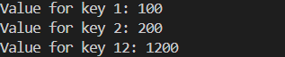

# Implement Graph using Linked List

import java.util.LinkedList; import java.util.List;

class GraphNode { int value;

List<GraphNode> neighbors;

GraphNode(int value) { this.value = value;

this.neighbors = new LinkedList<>();

}

}

public class Tutorial {

private List<GraphNode> graph;

public Tutorial() {

graph = new LinkedList<>();

}

public void addNode(int value) { graph.add(new GraphNode(value));

}

public void addEdge(int src, int dest) { GraphNode srcNode = findNode(src); GraphNode destNode = findNode(dest);

if (srcNode != null && destNode != null) { srcNode.neighbors.add(destNode);

destNode.neighbors.add(srcNode); // Undirected graph

}

}

public void displayGraph() {

for (GraphNode node : graph) { System.out.print(node.value + " -> ");

for (GraphNode neighbor : node.neighbors) { System.out.print(neighbor.value + " ");

}

System.out.println();

}

}

private GraphNode findNode(int value) { for (GraphNode node : graph) {

if (node.value == value) { return node;

}

}

return null;

}

public static void main(String[] args) { Tutorial graph = new Tutorial(); graph.addNode(1); graph.addNode(2); graph.addNode(3); graph.addNode(4);

graph.addEdge(1, 2);

graph.addEdge(1, 3);

graph.addEdge(3, 4);

graph.displayGraph();

}

}

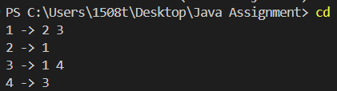

# Implement Priority Queue using Heap

import java.util.PriorityQueue;

public class Tutorial {

private PriorityQueue<Integer> heap;

public Tutorial() {

heap = new PriorityQueue<>();

}

public void insert(int value) { heap.offer(value);

}

public int extractMin() { if (heap.isEmpty()) {

throw new RuntimeException("Priority Queue is empty");

}

return heap.poll();

}

public int getMin() {

if (heap.isEmpty()) {

throw new RuntimeException("Priority Queue is empty");

}

return heap.peek();

}

public boolean isEmpty() { return heap.isEmpty();

}

public static void main(String[] args) { Tutorial pq = new Tutorial(); pq.insert(5);

pq.insert(3);

pq.insert(7);

pq.insert(2);

System.out.println("Minimum element: " + pq.getMin()); // Output: 2 System.out.println("Extracted element: " + pq.extractMin()); // Output: 2 System.out.println("New minimum element: " + pq.getMin()); // Output: 3

}

}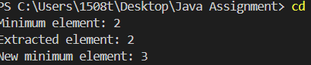

# Implement Median Finder using Two Heaps (Min Heap + Max Heap)

import java.util.Collections; import java.util.PriorityQueue;

public class Tutorial {

private PriorityQueue<Integer> maxHeap; private PriorityQueue<Integer> minHeap;

public Tutorial() {

maxHeap = new PriorityQueue<>(Collections.reverseOrder()); minHeap = new PriorityQueue<>();

}

public void addNum(int num) {

if (maxHeap.isEmpty() || num <= maxHeap.peek()) { maxHeap.offer(num);

} else {

minHeap.offer(num);

}

if (maxHeap.size() > minHeap.size() + 1) { minHeap.offer(maxHeap.poll());

} else if (minHeap.size() > maxHeap.size()) { maxHeap.offer(minHeap.poll());

}

}

public double findMedian() {

if (maxHeap.size() == minHeap.size()) {

return (maxHeap.peek() + minHeap.peek()) / 2.0;

} else {

return maxHeap.peek();

}

}

public static void main(String[] args) { Tutorial medianFinder = new Tutorial(); medianFinder.addNum(1); medianFinder.addNum(2);

System.out.println("Median: " + medianFinder.findMedian()); // Output: 1.5 medianFinder.addNum(3);

System.out.println("Median: " + medianFinder.findMedian()); // Output: 2

}

}

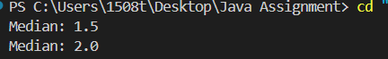

# Implement Kth Largest Element Finder using Heap

import java.util.PriorityQueue;

public class Tutorial {

private PriorityQueue<Integer> minHeap; private int k;

public Tutorial(int k) { this.k = k;

minHeap = new PriorityQueue<>();

}

public void add(int num) { if (minHeap.size() < k) {

minHeap.offer(num);

} else if (num > minHeap.peek()) { minHeap.poll(); minHeap.offer(num);

}

}

public int getKthLargest() { if (minHeap.size() < k) {

throw new IllegalStateException("Less than " + k + " elements present.");

}

return minHeap.peek();

}

public static void main(String[] args) { Tutorial kthLargestFinder = new Tutorial(3); kthLargestFinder.add(4); kthLargestFinder.add(5); kthLargestFinder.add(8); kthLargestFinder.add(2);

System.out.println("3rd Largest: " + kthLargestFinder.getKthLargest()); // Output: 4 kthLargestFinder.add(10);

System.out.println("3rd Largest: " + kthLargestFinder.getKthLargest()); // Output: 5

}

}

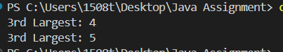

# Implement BST using Linked List

class TreeNode {

int value;

TreeNode left, right;

TreeNode(int value) { this.value = value; left = right = null;

}

}

public class Tutorial { private TreeNode root;

public void insert(int value) { root = insertRec(root, value);

}

private TreeNode insertRec(TreeNode root, int value) { if (root == null) {

return new TreeNode(value);

}

if (value < root.value) {

root.left = insertRec(root.left, value);

} else if (value > root.value) {

root.right = insertRec(root.right, value);

}

return root;

}

public boolean search(int value) { return searchRec(root, value);

}

private boolean searchRec(TreeNode root, int value) { if (root == null) {

return false;

}

if (root.value == value) { return true;

}

return value < root.value ? searchRec(root.left, value) : searchRec(root.right, value);

}

public void inorderTraversal() { inorderRec(root); System.out.println();

}

private void inorderRec(TreeNode root) { if (root != null) {

inorderRec(root.left); System.out.print(root.value + " "); inorderRec(root.right);

}

}

public static void main(String[] args) { Tutorial bst = new Tutorial(); bst.insert(50);

bst.insert(30); bst.insert(70);

bst.insert(20); bst.insert(40); bst.insert(60); bst.insert(80);

bst.inorderTraversal();

System.out.println("Search 40: " + bst.search(40)); // Output: true System.out.println("Search 25: " + bst.search(25)); // Output: false

}

}

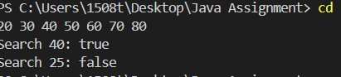

# Implement Heap using BST

import java.util.PriorityQueue;

class TreeNode { int value;

TreeNode left, right;

TreeNode(int value) { this.value = value; left = right = null;

}

}

public class Tutorial {

private PriorityQueue<Integer> heap;

public Tutorial() {

heap = new PriorityQueue<>();

}

public void insert(int value) { heap.offer(value);

}

public int extractMin() { if (heap.isEmpty()) {

throw new IllegalStateException("Heap is empty");

}

return heap.poll();

}

public int getMin() {

if (heap.isEmpty()) {

throw new IllegalStateException("Heap is empty");

}

return heap.peek();

}

public void displayHeap() { System.out.println("Heap Elements: " + heap);

}

public static void main(String[] args) { Tutorial heap = new Tutorial(); heap.insert(10);

heap.insert(20); heap.insert(15); heap.insert(30); heap.insert(40);

heap.displayHeap();

System.out.println("Minimum Element: " + heap.getMin()); // Output: 10 System.out.println("Extracted Minimum: " + heap.extractMin()); // Output: 10 heap.displayHeap();

}

}

