**Experiment 6**

**Student Name : Payal UID: 22BCS15824**

**Branch: CSE Section/Group: 637-B**

**Semester: 6th Date of Performance:27/2/25**

**Subject Name: Advanced Programming - 2 Subject Code: 22CSH-351**

**Ques 1:**

**Aim:** Climbing Stairs

**Code:**

class Solution(object):

def climbStairs(self, n):

if n <= 2:

return n

a, b = 1, 2

for _ in range(3, n + 1):

a, b = b, a + b

return b

**Submission Screenshot:** 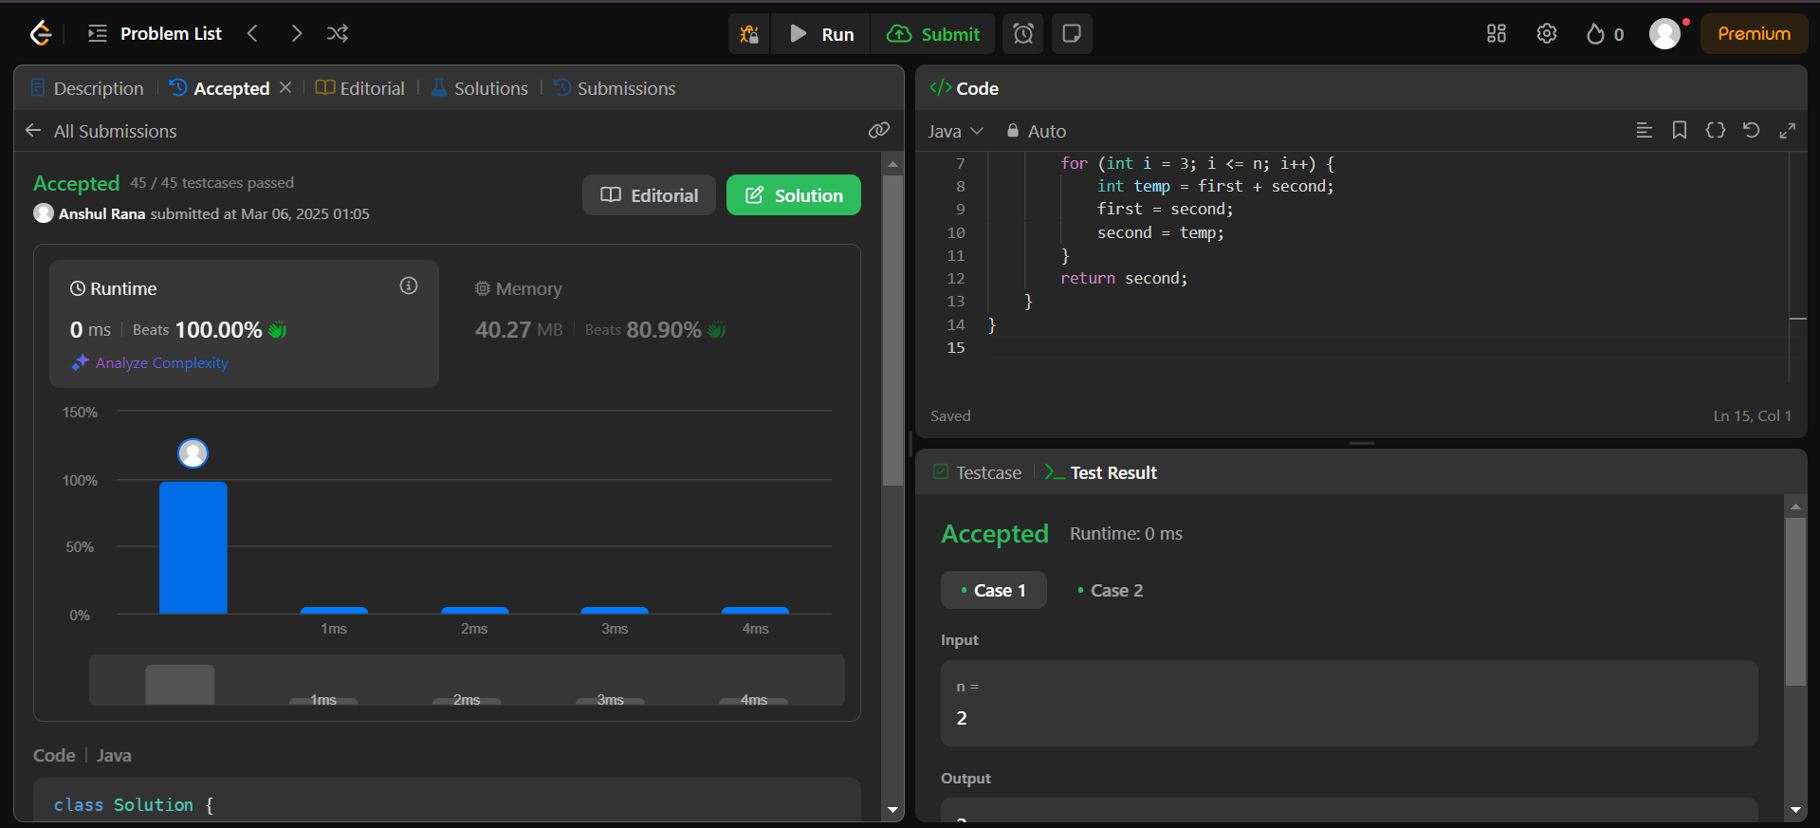

**Submission Link:**

<https://leetcode.com/problems/climbing-stairs/submissions/1564063485/>

**Ques 2:**

**Aim:** Maximum Subarray

**Code:**

class Solution(object):

def maxSubArray(self, nums):

max_sum = cur_sum = nums[0]

for num in nums[1:]:

cur_sum = max(num, cur_sum + num)

max_sum = max(max_sum, cur_sum)

return max_sum

**Submission Screenshot:**

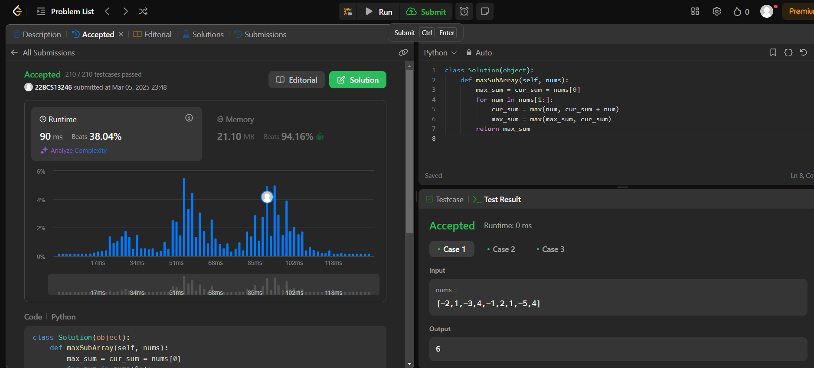

**Submission Link:**

https://leetcode.com/problems/maximum-subarray/submissions/1564066747/

**Ques 3:**

**Aim:** Jump Game

**Code:**

class Solution(object):

def canJump(self, nums):

max_reach = 0

for i, num in enumerate(nums):

if i > max_reach:

return False # If we reach an index we cannot jump to

max_reach = max(max_reach, i + num)

if max_reach >= len(nums) - 1:

return True # If we can reach the last index

return False

**Submission Screenshot:**

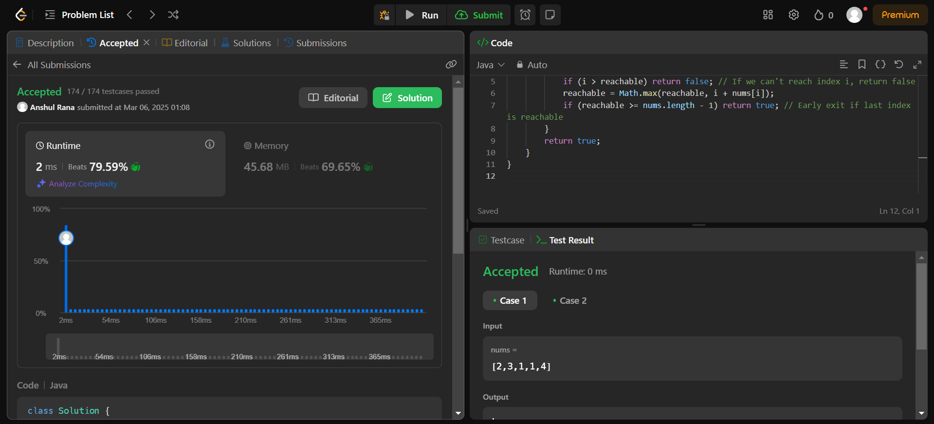

**Submission Link:**

https://leetcode.com/problems/jump-game/submissions/1564068298/